ASSIGNMENT – 4.3
2303A51083
BATCH – 17
SAI KAPIL

TASK-1 : Use zero-shot prompting to instruct an AI tool to generate a Python function that:
• Accepts a year as input
• Checks whether the given year is a leap year
• Returns an appropriate result

PROMPT ; # leap year check
CODE :

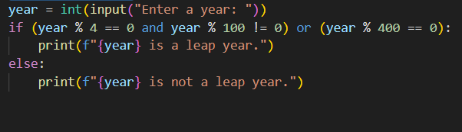
OUTPUT :
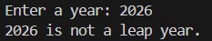
MY ANALYSIS : The AI generated a correct Python function using logical conditions without any examples. The leap year rules were applied properly, showing that clear instructions are sufficient for simple logical problems.

TASK -2 : Task Description
Use one-shot prompting by providing one input-output example to generate a Python
function that:
• Converts centimeters to inches
• Uses the correct mathematical formula
PROMPT : # CENTIMETERS TO INCHES CONVERTER EXAMPLE 10CM=3.937INCHES

CODE :
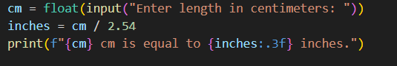
OUTPUT ;
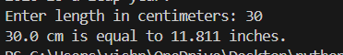

MY ANALYSIS : Providing one input-output example helped the AI understand the conversion formula accurately. The generated function was correct, readable, and produced precise results.

TASK -3 ; Description
Use few-shot prompting with 2–3 examples to generate a Python function that:
• Accepts a full name as input
• Formats it as “Last, First”
PROMPT : # NAME FORMATTING SCENERIO EXAMPLE john smith to smith, john
CODE :
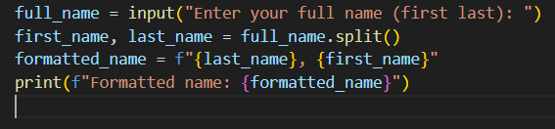
OUTPUT :
MY ANALYSIS ; Multiple examples guided the AI to follow the exact output format. The function correctly rearranged names as “Last, First,” demonstrating improved accuracy and consistency.

TASK- 4 : DESCRIPTION
Task Description
• Use zero-shot prompting to generate a function that counts vowels in a string
• Use few-shot prompting for the same problem
• Compare both outputs based on:
o Accuracy
o Readability
o Logical clarity
Prompt : #generate a function that counts vowels in a string
CODE : 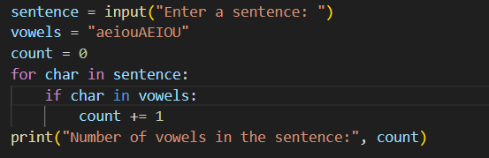

OUTPUT :
MY ANALYSIS : The zero-shot function worked but lacked clarity and structure. The few-shot version was more accurate, readable, and logically clear, proving that examples improve code quality.

TASK-5 : Description
Use few-shot prompting to generate a Python function that:
• Reads a .txt file
• Counts the number of lines in the file
• Returns the line count
PROMPT : #read a .txt file and count number of lines in file and return file count
CODE :
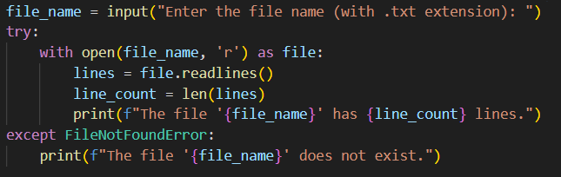
OUTPUT :
MY ANALYSIS : With examples, the AI generated a reliable function to count lines in a text file. The logic was clear and handled file reading correctly.

