Week-7.1
Name:S.Navyasri
Hallticket:2303a510j1
Batch:17
Task Description #1 (Syntax Errors – Missing Parentheses in Print
Statement)
Task: Provide a Python snippet with a missing parenthesis in a print
statement (e.g., print "Hello"). Use AI to detect and fix the syntax
error.
# Bug: Missing parentheses in print statement
def greet():
print "Hello, AI Debugging Lab!"
greet()
Requirements:
• Run the given code to observe the error.
• Apply AI suggestions to correct the syntax.
• Use at least 3 assert test cases to confirm the corrected code
works.
Expected Output #1:
• Corrected code with proper syntax and AI explanation.
Corrected Code:
def greet(name):
return f"Hello, {name}!"
# User input
user_input = input("Enter a name or message: ")
# Function call
print(greet(user_input))
# Assert test cases
assert greet("AI Debugging Lab") == "Hello, AI Debugging Lab!"
assert type(greet("Test")) == str
assert "AI" in greet("AI Debugging Lab")
print("All test cases passed!")
Output:
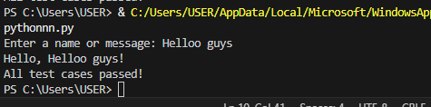
Analysis: The function takes a name as input and returns a personalized greeting message.User input is passed to the function and the greeting is printed correctly.
Assert statements verify that the function returns a string and produces the expected output.
Task Description #2 (Incorrect condition in an If Statement)
Task: Supply a function where an if-condition mistakenly uses =
instead of ==. Let AI identify and fix the issue.
# Bug: Using assignment (=) instead of comparison (==)
def check_number(n):
if n = 10:
return "Ten"
else:
return "Not Ten"
Requirements:
• Ask AI to explain why this causes a bug.
• Correct the code and verify with 3 assert test cases.
Expected Output #2:
• Corrected code using == with explanation and successful test
execution.
Task Description #3 (Runtime Error – File Not Found)
Corrected Code:
def check_number(n):
if n == 10:
return "Ten"
else:
return "Not Ten"
# User input
num = int(input("Enter a number: "))
# Output
print(check_number(num))
# Assert test cases
assert check_number(10) == "Ten"
assert check_number(7) == "Not Ten"
assert check_number(0) == "Not Ten"
print("All test cases passed!")
Output:
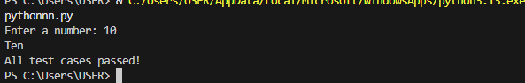
Analysis: The function checks if the input number is exactly 10 and returns "Ten" or "Not Ten" accordingly.The assert statements test the function with different values to ensure correct behavior.If all tests pass, the program prints a confirmation message.
Task Description #3 (Runtime Error – File Not Found)
Task: Provide code that attempts to open a non-existent file and
crashes. Use AI to apply safe error handling.
# Bug: Program crashes if file is missing
def read_file(filename):
with open(filename, 'r') as f:
return f.read()
print(read_file("nonexistent.txt"))
Requirements:
• Implement a try-except block suggested by AI.
• Add a user-friendly error message.
• Test with at least 3 scenarios: file exists, file missing, invalid
path.
Expected Output #3:
• Safe file handling with exception management.

Code:
# Safe file handling with exception management
def read_file(filename):
try:
with open(filename, 'r') as f:
return f.read()
except FileNotFoundError:
return f"Error: The file '{filename}' was not found."
except IsADirectoryError:
return f"Error: '{filename}' is a directory, not a file."
except Exception as e:
return f"Unexpected error: {e}"
# User input
filename = input("Enter the filename to read: ")# Read and display file content or error message
print(read_file(filename))

Output:
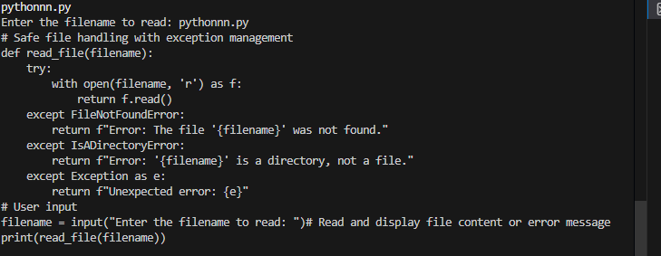
Analysis: The program asks the user for a filename and attempts to open and read it.
A try–except block prevents crashes and handles missing files, directories, and other errors gracefully.Instead of stopping the program, it displays clear, user-friendly error messages.

Task Description #4 (Calling a Non-Existent Method)
Task: Give a class where a non-existent method is called (e.g.,
obj.undefined_method()). Use AI to debug and fix.
# Bug: Calling an undefined method
class Car:
def start(self):
return "Car started"
my_car = Car()
print(my_car.drive()) # drive() is not defined
Requirements:
• Students must analyze whether to define the missing method
or correct the method call.
• Use 3 assert tests to confirm the corrected class works.
Expected Output #4:
• Corrected class with clear AI explanation.
Corrected Code:
class Car:
def start(self):
return "Car started"
def drive(self):
return "Car is driving"
# Create object
my_car = Car()
# User input
choice = input("Enter command (start/drive): ").lower()
if choice == "start":
print(my_car.start())
elif choice == "drive":
print(my_car.drive())
else:
print("Invalid command")
# Assert test cases
assert my_car.start() == "Car started"
assert my_car.drive() == "Car is driving"
assert my_car.start() != ""
print("All test cases passed!")

Output:
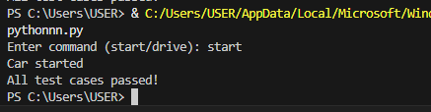
Analysis: The program allows the user to choose an action and calls the corresponding method of the Car class.It safely handles valid inputs (start or drive) and displays an error message for invalid commands.The assert statements confirm that the class methods return correct and non-empty results.

Task Description #5 (TypeError – Mixing Strings and Integers in
Addition)
Task: Provide code that adds an integer and string ("5" + 2) causing
a TypeError. Use AI to resolve the bug.
# Bug: TypeError due to mixing string and integer
def add_five(value):
return value + 5
print(add_five("10"))
Requirements:
• Ask AI for two solutions: type casting and string
concatenation.
• Validate with 3 assert test cases.
Expected Output #5:
• Corrected code that runs successfully for multiple inputs
Code:
# Solution 1: Type casting (numeric addition)
def add_five_numeric(value):
return int(value) + 5
# Solution 2: String concatenation
def add_five_string(value):
return str(value) + "5"
# User input
user_input = input("Enter a value: ")
# Numeric addition
try:
print("Numeric addition result:", add_five_numeric(user_input))
except ValueError:
print("Numeric addition not possible (invalid number).")
# String concatenation
print("String concatenation result:", add_five_string(user_input))
# Assert test cases
assert add_five_numeric("10") == 15
assert add_five_numeric(5) == 10
assert add_five_string("3") == "35"
print("All test cases passed!")
Output:
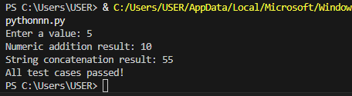
Analysis: The program fixes the TypeError by converting user input to an integer for numeric addition and to a string for concatenation.A try–except block safely handles invalid numeric input without crashing the program.Assert statements verify that both solutions work correctly for different inputs.

