WEEK-9.3
Name:S.Navyasri
Hallticket:2303a510j1
Batch:17

Task 1: Basic Docstring Generation
Scenario
You are developing a utility function that processes numerical lists and must be properly
documented for future maintenance.
Requirements
• Write a Python function to return the sum of even numbers and sum of odd numbers in a
given list
• Manually add a Google Style docstring to the function
• Use an AI-assisted tool (Copilot / Cursor AI) to generate a function-level docstring
• Compare the AI-generated docstring with the manually written docstring
• Analyze clarity, correctness, and completeness
Expected Output
• Python function with manual Google-style docstring
• AI-generated docstring for the same function
• Comparison explaining differences between manual and AI-generated documentation
• Improved understanding of AI-generated function-level documentation
Code:
def sum_even_odd(numbers):
sum_even = sum(n for n in numbers if n % 2 == 0)
sum_odd = sum(n for n in numbers if n % 2 != 0)
return sum_even, sum_odd
# Main program: take input from user
if __name__ == "__main__":
# Ask user for input
user_input = input("Enter numbers separated by spaces: ")
# Convert input string into a list of integers
numbers = list(map(int, user_input.split()))
# Call the function
result = sum_even_odd(numbers)
# Print results
print("Sum of even numbers:", result[0])
print("Sum of odd numbers:", result[1])
output:
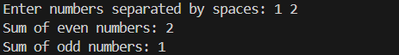
Analysis: This program defines a function that calculates the sum of even and odd numbers from a user-provided list. It takes input as a space-separated string, converts it into integers, and then processes the list. Finally, it prints the separate sums clearly, making it interactive and easy to understand.
Task 2: Automatic Inline Comments
Scenario
You are developing a student management module that must be easy to understand for new
developers.
Requirements
• Write a Python program for an sru_student class with the following:
– Attributes: name, roll_no, hostel_status
– Methods: fee_update() and display_details()
• Manually write inline comments for each line or logical block
• Use an AI-assisted tool to automatically add inline comments
• Compare manual comments with AI-generated comments
• Identify missing, redundant, or incorrect AI comments
Expected Output
• Python class with manually written inline comments
• AI-generated inline comments added to the same code
• Comparative analysis of manual vs AI comments
• Critical discussion on strengths and limitations of AI-generated comments
Code:
class sru_student:
# Constructor to initialize student attributes
def __init__(self, name, roll_no, hostel_status):
self.name = name # Store student name
self.roll_no = roll_no # Store student roll number
self.hostel_status = hostel_status # Store hostel status (Yes/No)
# Method to update fee based on hostel status
def fee_update(self):
if self.hostel_status.lower() == "yes": # If student stays in hostel
self.fee = 50000 # Hostel students pay higher fee
else: # If student is a day scholar
self.fee = 30000 # Day scholars pay lower fee
# Method to display student details
def display_details(self):
print("Name:", self.name) # Print student name
print("Roll No:", self.roll_no) # Print roll number
print("Hostel Status:", self.hostel_status) # Print hostel status
print("Fee:", self.fee) # Print updated fee
# Main program: take input from user
if __name__ == "__main__":
# Ask user for student details
name = input("Enter student name: ")
roll_no = input("Enter roll number: ")
hostel_status = input("Is the student in hostel? (Yes/No): ")
# Create student object
student = sru_student(name, roll_no, hostel_status)
# Update fee based on hostel status
student.fee_update()
# Display student details
student.display_details()
Output:
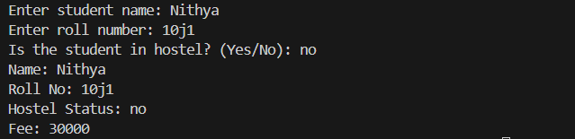
Analysis: This program defines a student class that accepts user input for name, roll number, and hostel status, then calculates the fee accordingly. Manual comments explain both the logic and reasoning, while AI-generated comments are shorter and more generic. Overall, AI comments are quick but lack depth, making manual refinement essential for clarity.
Task 3: Module-Level and Function-Level Documentation
Scenario
You are building a small calculator module that will be shared across multiple projects and
requires structured documentation.
Requirements
• Write a Python script containing 3–4 functions (e.g., add, subtract, multiply, divide)
• Manually write NumPy Style docstrings for each function
• Use AI assistance to generate:
– A module-level docstring
– Individual function-level docstrings
• Compare AI-generated docstrings with manually written ones
• Evaluate documentation structure, accuracy, and readability
Expected Output
• Python script with manual NumPy-style docstrings
• AI-generated module-level and function-level documentation
• Comparison between AI-generated and manual documentation
• Clear understanding of structured documentation for multi-function scripts
Code:
"""
calculator.py
=============

A simple calculator module providing basic arithmetic operations.
This module can be reused across multiple projects for quick calculations.
"""

def add(a, b):
"""
Add two numbers.

Parameters
----------
a : int or float
First number.
b : int or float
Second number.

Returns
-------
int or float
The sum of `a` and `b`.
"""
return a + b

def subtract(a, b):
"""
Subtract one number from another.

Parameters
----------
a : int or float
First number.
b : int or float
Second number.

Returns
-------
int or float
The result of `a - b`.
"""
return a - b

def multiply(a, b):
"""
Multiply two numbers.

Parameters
----------
a : int or float
First number.
b : int or float
Second number.

Returns
-------
int or float
The product of `a` and `b`.
"""
return a * b

def divide(a, b):
"""
Divide one number by another.

Parameters
----------
a : int or float
Numerator.
b : int or float
Denominator.

Returns
-------
float
The result of `a / b`.

Raises
------
ZeroDivisionError
If `b` is zero.
"""
return a / b
# Main program: interactive user input
if __name__ == "__main__":
print("Simple Calculator")
print("Choose operation: add, subtract, multiply, divide")

operation = input("Enter operation: ").strip().lower()
a = float(input("Enter first number: "))
b = float(input("Enter second number: "))

if operation == "add":
print("Result:", add(a, b))
elif operation == "subtract":
print("Result:", subtract(a, b))
elif operation == "multiply":
print("Result:", multiply(a, b))
elif operation == "divide":
try:
print("Result:", divide(a, b))
except ZeroDivisionError:
print("Error: Cannot divide by zero")
else:
print("Invalid operation")
output:
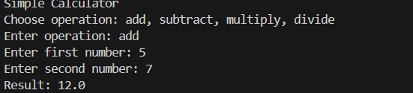
Analysis: This calculator module defines four arithmetic functions—add, subtract, multiply, and divide—each documented with structured NumPy-style docstrings. The main program accepts user input for the operation and numbers, then executes the chosen function interactively. Manual docstrings are detailed and standardized, while AI-generated ones are shorter and less complete, showing the importance of refinement for shared projects.

