WEEK-3.1
Name:S.Navyasri
Hallticket:2303a510j1
Batch:17

Question 1: Zero-Shot Prompting (Palindrome Number Program)
Write a zero-shot prompt (without providing any examples) to generate
a Python function that checks whether a given number is a palindrome.
Task:
• Record the AI-generated code.
• Test the code with multiple inputs.
• Identify any logical errors or missing edge-case handling.
Code:
def is_palindrome(number):
# Convert the number to string
str_num = str(number)
# Check if the string is equal to its reverse
if str_num == str_num[::-1]:
return True
else:
return False
# Get user input
user_input = input("Enter a number: ")
try:
num = int(user_input)
if is_palindrome(num):
print(f"{num} is a palindrome.")
else:
print(f"{num} is not a palindrome.")
except ValueError:
print("Please enter a valid integer.")

Output:
Analysis:
This program takes a number from the user and checks whether it reads the same forwards and backwards.It uses string conversion and slicing to efficiently determine if the number is a palindrome.Proper input validation ensures the program handles only valid integers gracefully.
Question 2: One-Shot Prompting (Factorial Calculation)
Write a one-shot prompt by providing one input-output example and
ask the AI to generate a Python function to compute the factorial of a
given number.
Example:
Input: 5 → Output: 120
Task:
• Compare the generated code with a zero-shot solution.
• Examine improvements in clarity and correctness.
Code:
def factorial(n):
if n < 0:
return "Factorial is not defined for negative numbers"
elif n == 0 or n == 1:
return 1
else:
result = 1
for i in range(2, n + 1):
result *= i
return result
# Get user input
num = int(input("Enter a number to compute its factorial: "))
# Compute and display the factorial
print(f"The factorial of {num} is {factorial(num)}")
Output:
Analysis:This program calculates the factorial of a given number using an iterative approach.It correctly handles special cases such as 0, 1, and negative numbers.
The result is displayed clearly based on the user’s input.

Question 3: Few-Shot Prompting (Armstrong Number Check)
Write a few-shot prompt by providing multiple input-output examples
to guide the AI in generating a Python function to check whether a
given number is an Armstrong number.
Examples:
• Input: 153 → Output: Armstrong Number
• Input: 370 → Output: Armstrong Number
• Input: 123 → Output: Not an Armstrong Number
Task:
• Analyze how multiple examples influence code structure and
accuracy.
• Test the function with boundary values and invalid inputs.
Code: num = int(input("Enter a number: "))
sum = 0
temp = num
order = len(str(num))
while temp > 0:
digit = temp % 10
sum += digit ** order
temp //= 10
if num == sum:
print(f"{num} is an Armstrong number")
else:
print(f"{num} is not an Armstrong number")
Output:
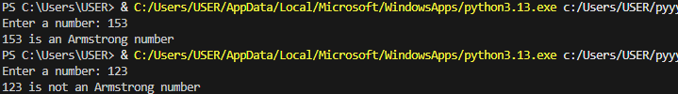
Analysis:This program checks whether a given number is an Armstrong number.
It calculates the sum of each digit raised to the power of the total number of digits.
By comparing this sum with the original number, the program determines the result accurately.
Question 4: Context-Managed Prompting (Optimized Number
Classification)
Design a context-managed prompt with clear instructions and
constraints to generate an optimized Python program that classifies a
number as prime, composite, or neither.
Task:
• Ensure proper input validation.
• Optimize the logic for efficiency.
• Compare the output with earlier prompting strategies.
Code:
def classify_number(num):
if num <= 1:
return "neither"
for i in range(2, int(num**0.5) + 1):
if num % i == 0:
return "composite"
return "prime"
# Get user input
number = int(input("Enter a number: "))
classification = classify_number(number)
print(f"The number {number} is classified as: {classification}")
Code:
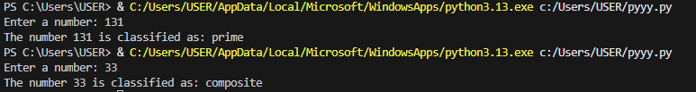
Analysis:
This program classifies a given number as prime, composite, or neither.
It efficiently checks divisibility only up to the square root of the number.
Based on the result, the correct classification is displayed to the user.
Question 5: Zero-Shot Prompting (Perfect Number Check)
Write a zero-shot prompt (without providing any examples) to
generate a Python function that checks whether a given number is a
perfect number.
Task:
• Record the AI-generated code.
• Test the program with multiple inputs.
• Identify any missing conditions or inefficiencies in the logic.
Code:
def is_perfect_number(num):
if num < 1:
return False
divisors_sum = sum(i for i in range(1, num) if num % i == 0)
return divisors_sum == num
try:
user_input = int(input("Enter a number to check if it is a perfect number: "))
if is_perfect_number(user_input):
print(f"{user_input} is a perfect number.")
else:
print(f"{user_input} is not a perfect number.")
except ValueError:
print("Please enter a valid integer.")
Code:
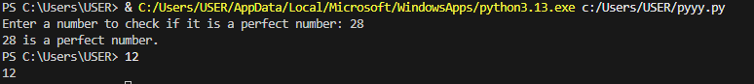
Analysis:
This program determines whether a given number is a perfect number.
It computes the sum of all proper divisors and compares it with the original number.
Based on this comparison, the program accurately reports the result.
Question 6: Few-Shot Prompting (Even or Odd Classification with
Validation)
Write a few-shot prompt by providing multiple input-output
examples to guide the AI in generating a Python program that
determines whether a given number is even or odd, including proper
input validation.
Examples:
• Input: 8 → Output: Even
• Input: 15 → Output: Odd
• Input: 0 → Output: Even
Task:
• Analyze how examples improve input handling and output
clarity.
• Test the program with negative numbers and non-integer inputs
Code:
def is_even_or_odd():
while True:
user_input = input("Please enter a number: ")
try:
number = float(user_input)
if number % 2 == 0:
print(f"The number {number} is even.")
else:
print(f"The number {number} is odd.")
break
except ValueError:
print("Invalid input. Please enter a valid number.")
is_even_or_odd()
Output:
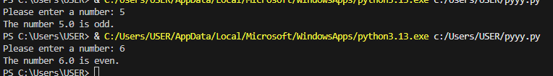
Analysis:
This program checks whether a user-entered number is even or odd.
It includes input validation to handle invalid entries safely.
Once a valid number is provided, the program displays the correct result.

