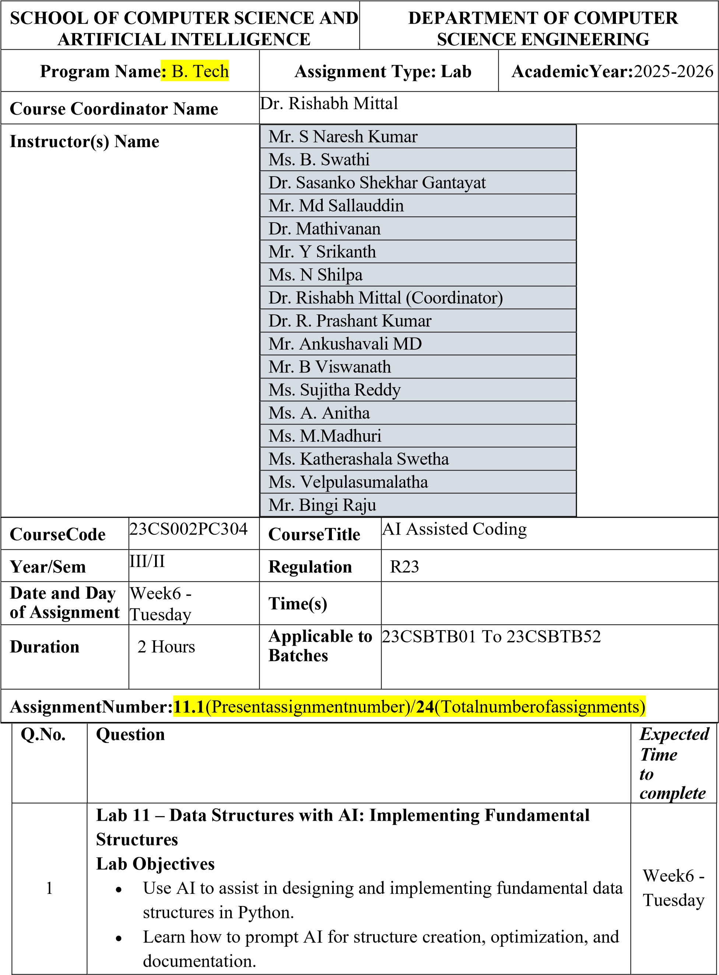

- Improve understanding of Lists, Stacks, Queues, Linked Lists, Trees, Graphs, and Hash Tables.
- Enhance code quality with AI-generated comments and performance suggestions.

Task Description -1 – (Stack Using AI Guidance)
- Task: With the help of AI, design and implement a Stack data structure supporting basic stack operations.
Expected Output:
- A Python Stack class supporting push, pop, peek, and emptycheck operations with proper documentation.
Prompt
Design a Python program to implement a Stack data structure with basic operations such as push, pop, peek, and isEmpty.

Code
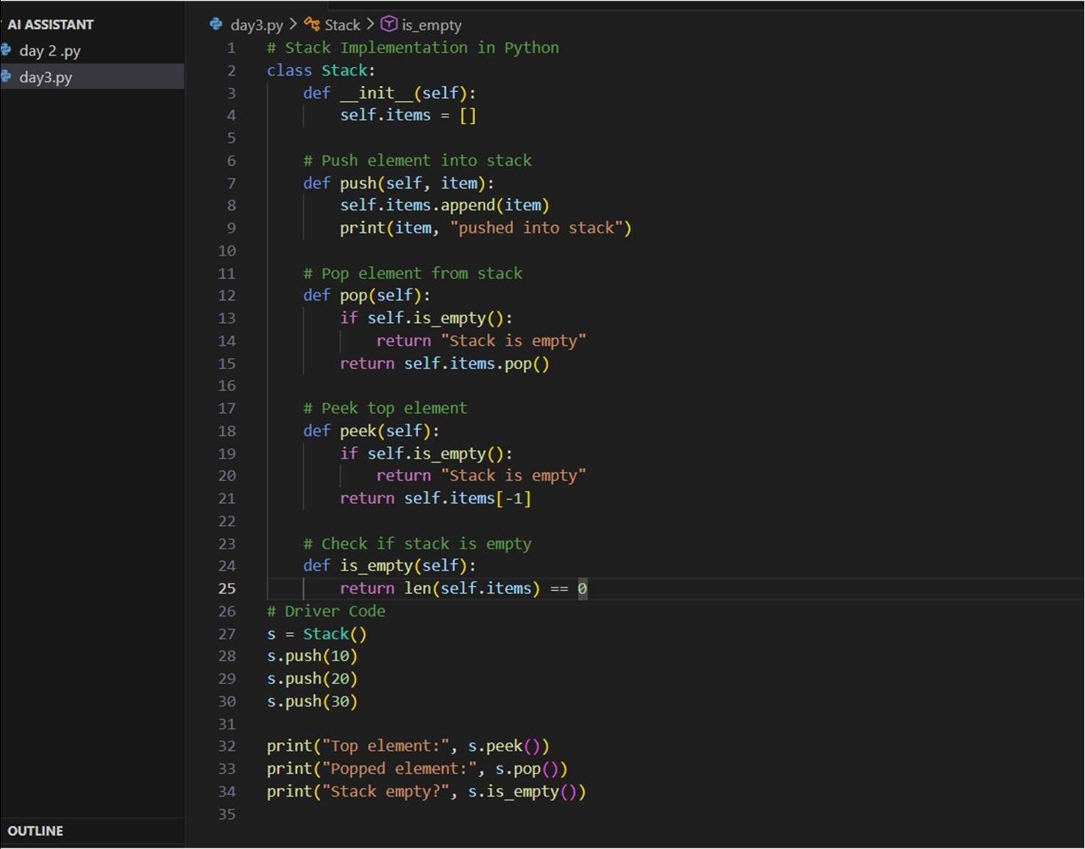

Output

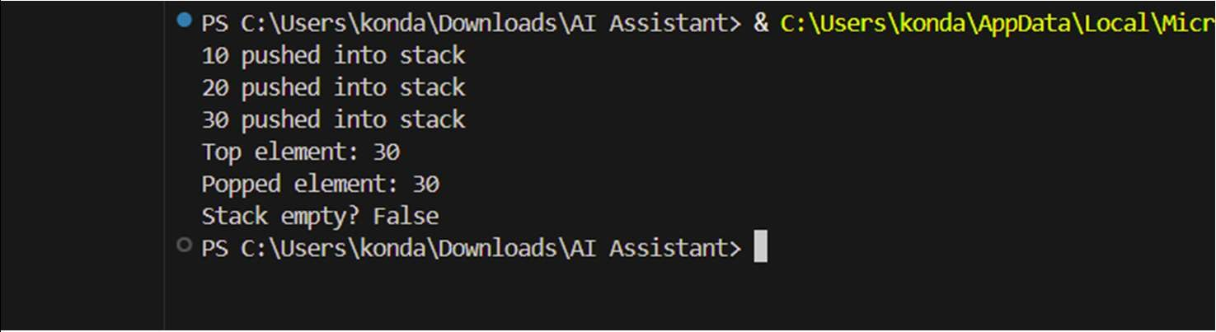

Explanation
- A Stack follows LIFO (Last In First Out) principle.
- The program uses a list to store stack elements.
- push() → adds an element to the top
- pop() → removes the top element
- peek() → shows the top element without removing • is_empty() → checks whether the stack is empty

Task Description -2 – (Queue Design)
- Task:Use AI assistance to create a Queue data structure following FIFO principles Expected Output:
- A complete Queue implementation including enqueue, dequeue, front element access, and size calculation

Prompt
Design a Python program to implement a Queue data structure that follows the FIFO (First In First Out) principle.

Code

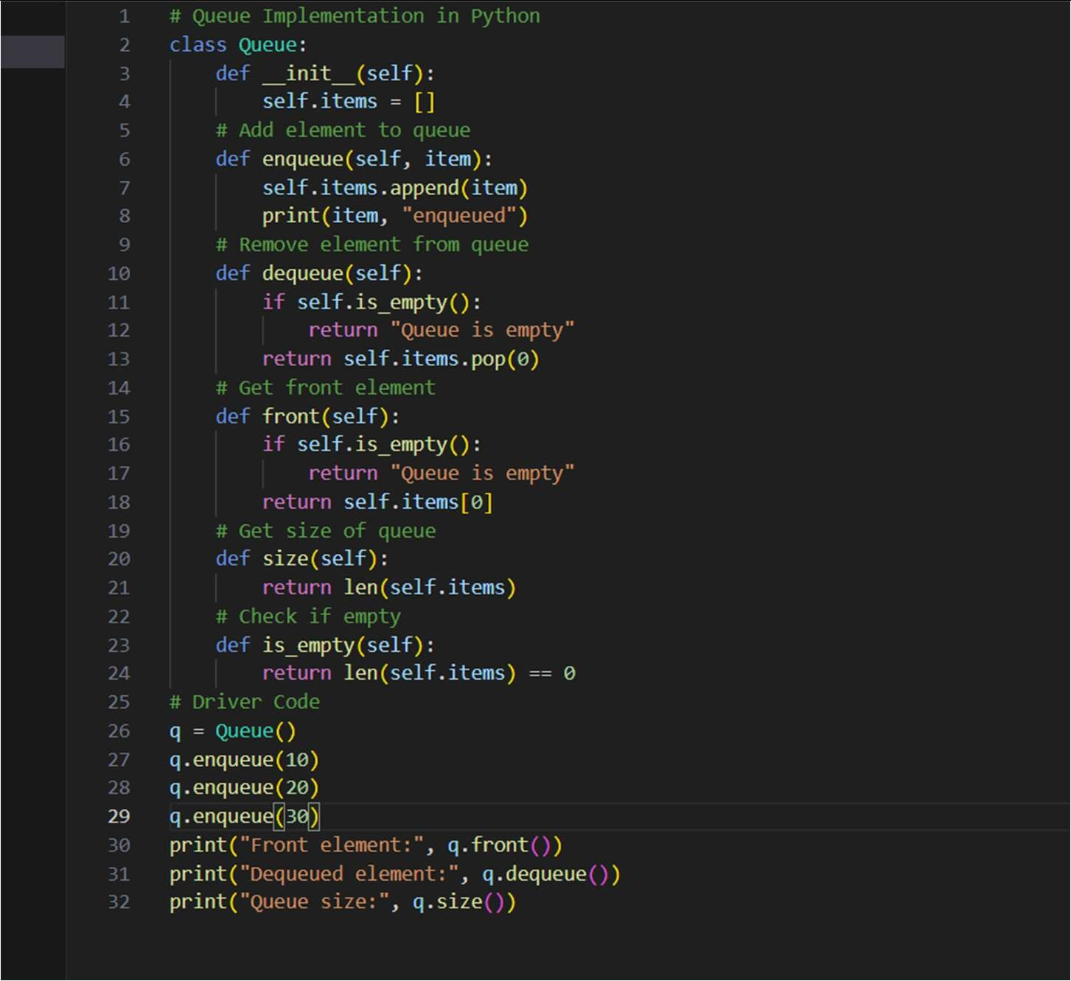

Output
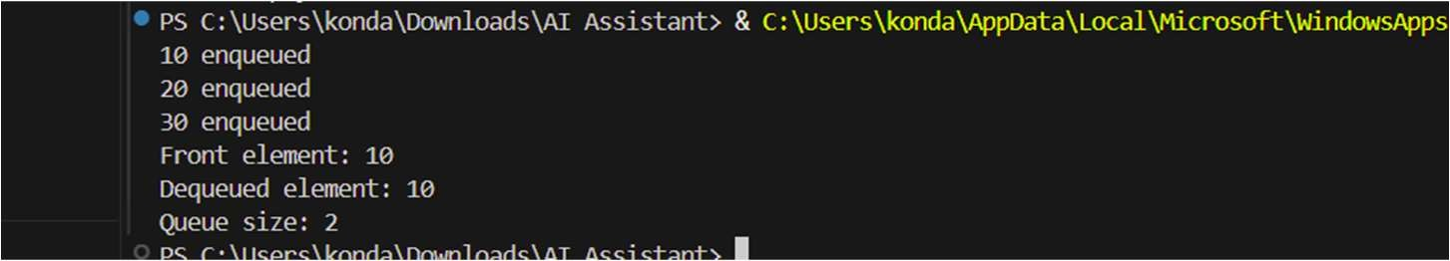

Explanation
- A Queue follows FIFO (First In First Out).
- The program uses a Python list to store elements.
- enqueue() → adds element at rear
- dequeue() → removes element from front
- front() → shows first element without removing
- size() → returns number of elements

Task Description -3 –(Singly Linked List Construction)
- Task: Utilize AI to build a singly linked list supporting insertion and traversal.
Expected Output:
- Correctly functioning linked list with node creation, insertion

logic, and display functionality.

Prompt
Implement singly linked list with insertion and traversal.

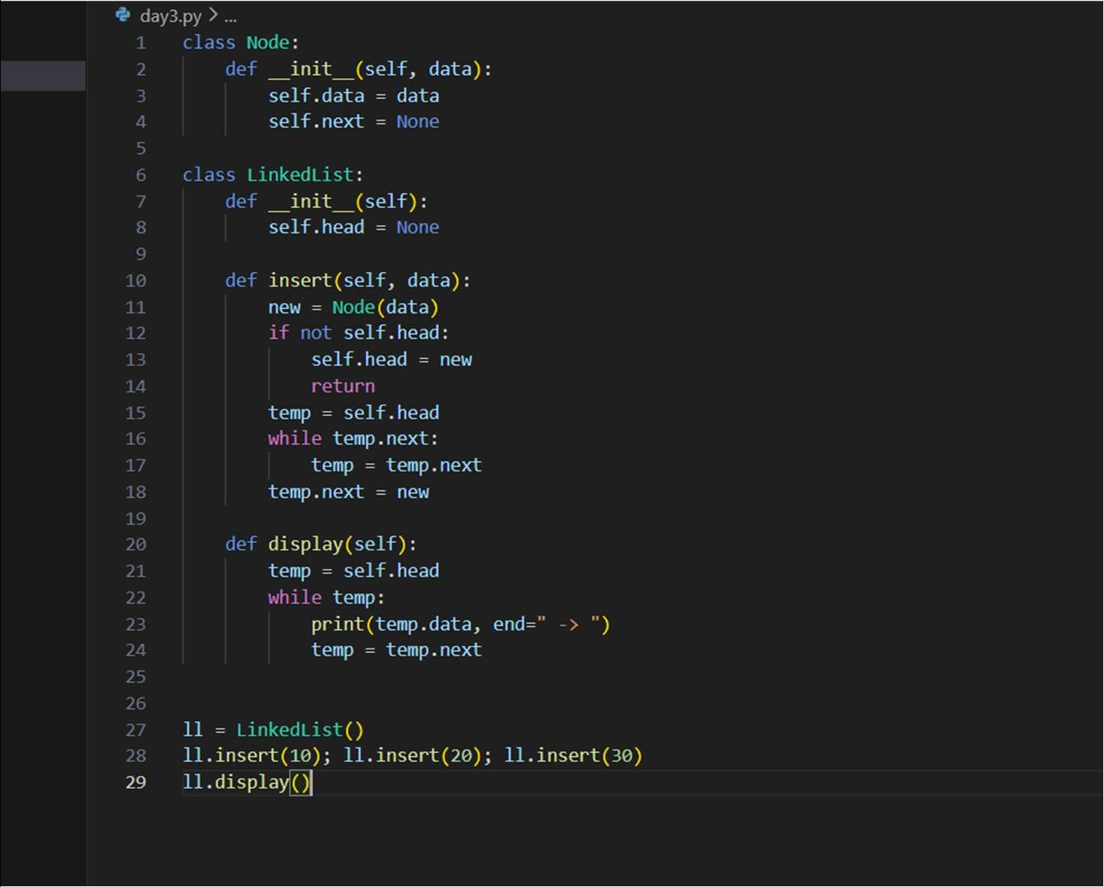Code

Output

Explanation
Nodes are connected sequentially using pointers. Traversal prints all elements.

Task Description -4 – (Binary Search Tree Operations)
- Task: Implement a Binary Search Tree with AI support focusing on insertion and traversal.
Expected Output:
- BST program with correct node insertion and in-order traversal output.
Prompt
Implement BST with insertion and in-order traversal.

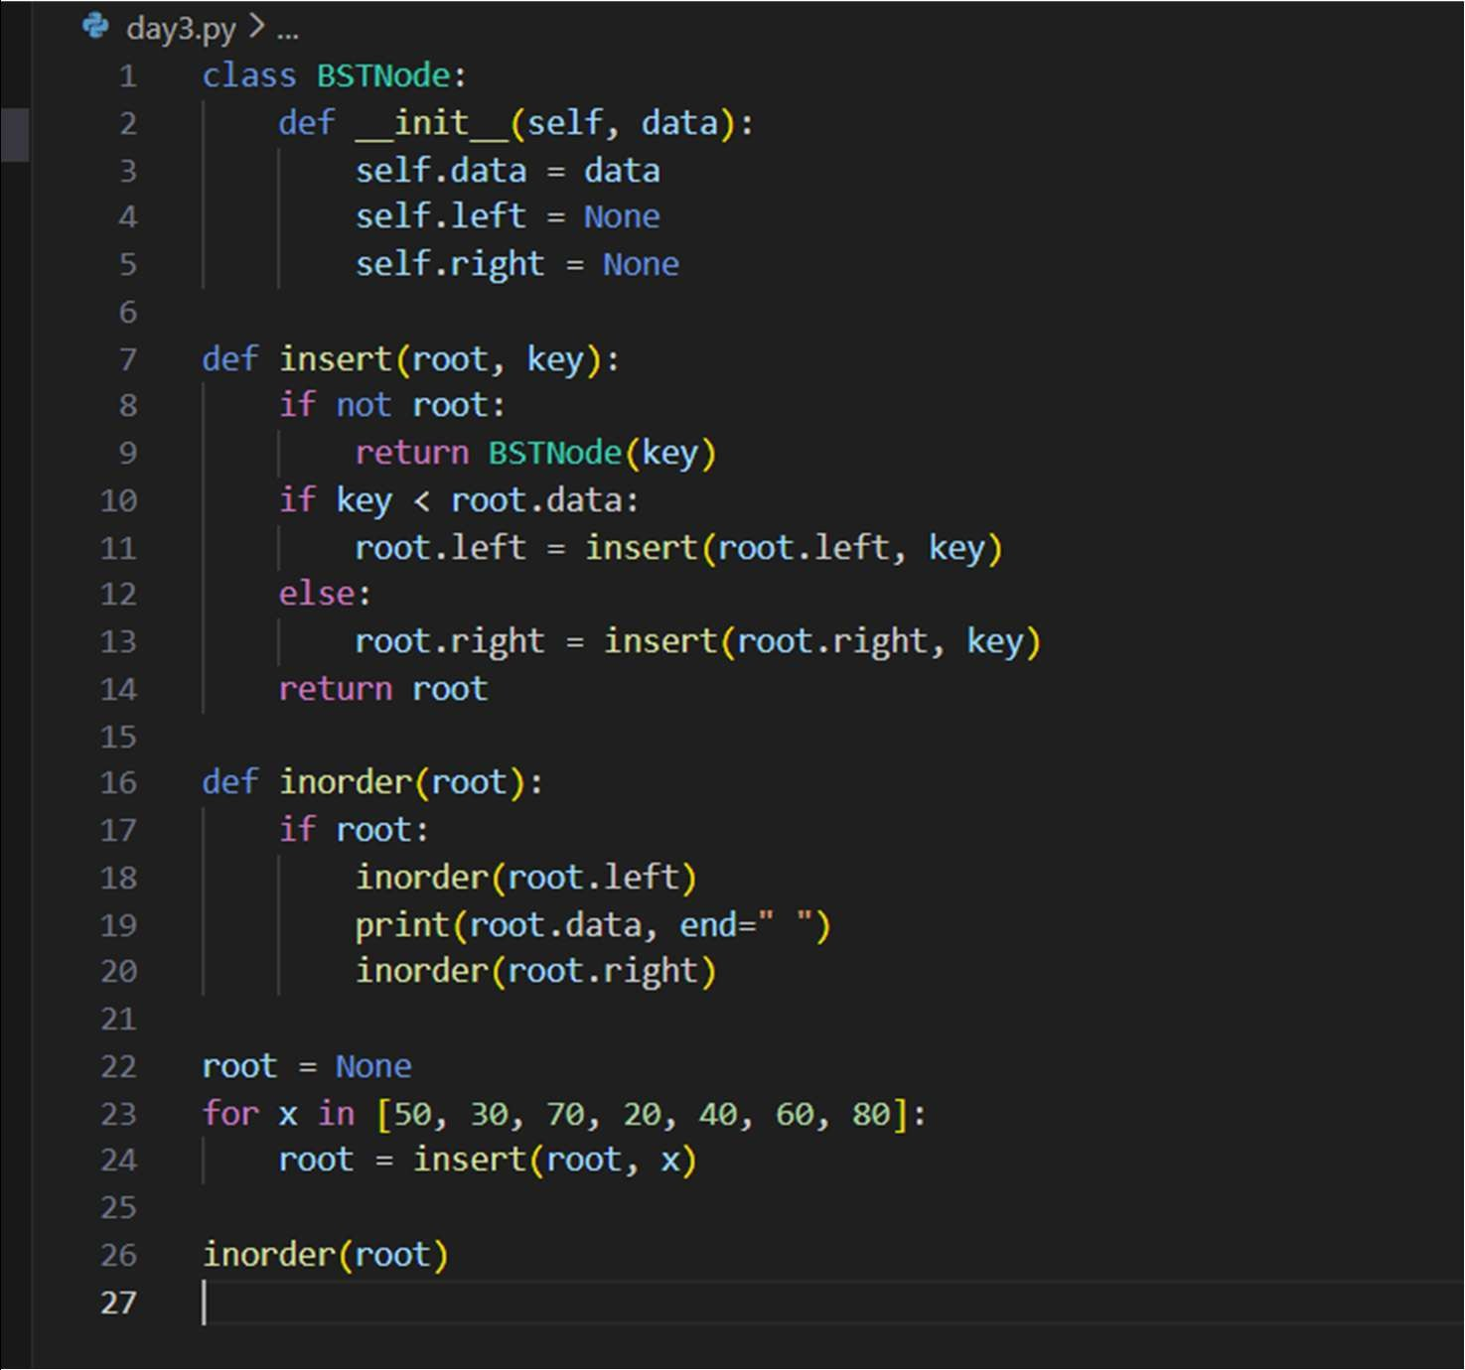Code

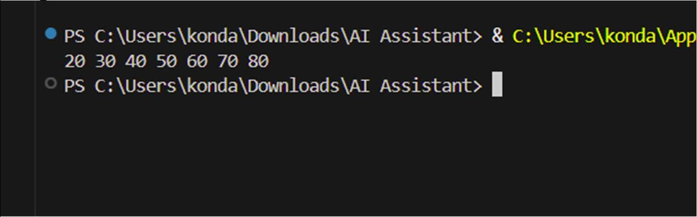Output

Explanation

BST maintains sorted order. In-order traversal prints elements in ascending order.

Task Description -5 – (Hash Table Implementation)
- Task: Create a hash table using AI with collision handling
Expected Output:
- Hash table supporting insert, search, and delete using chaining
or open
Prompt
Create a hash table with collision handling using chaining.

Code

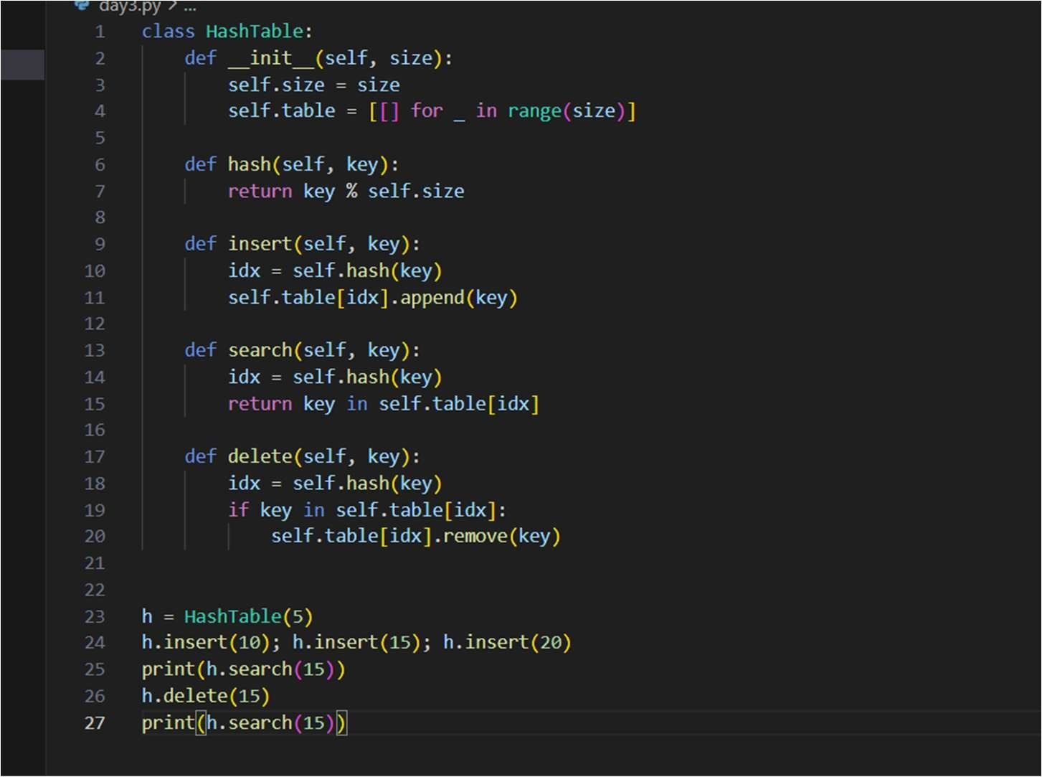

Output
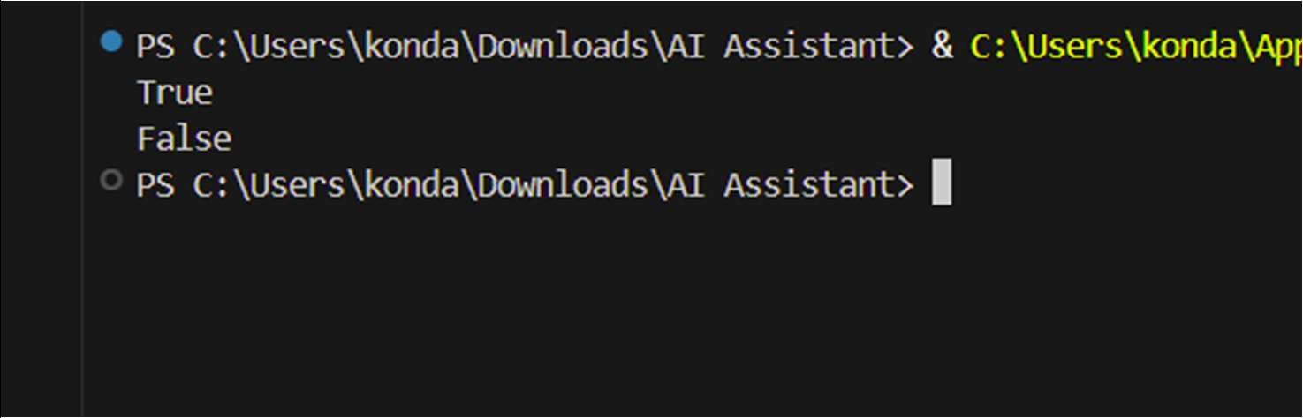

Explanation
Hash function maps keys to index. Collisions handled using list chaining.

Note: Report should be submitted a word document for all tasks in a single document with prompts, comments & code explanation, and output and if required, screenshots.

