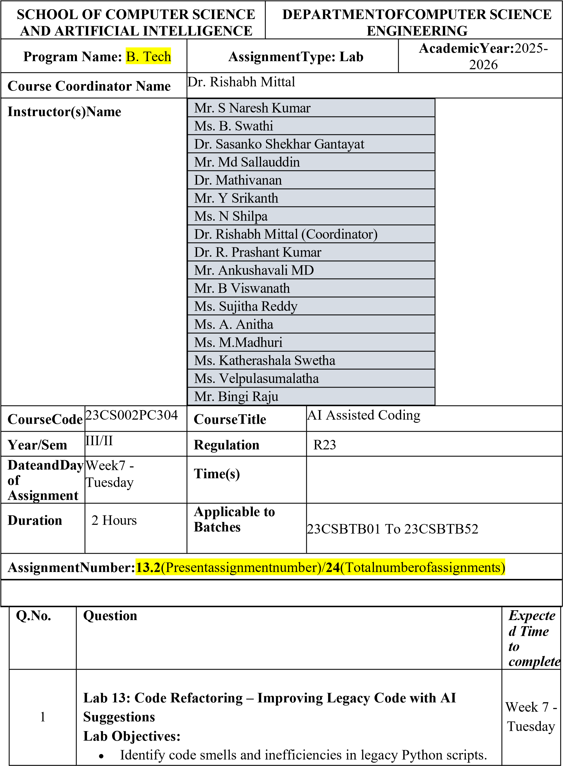
•

Use AI
-
assisted coding tools to
refactor

for readability,
maintainability, and performance.

•

Apply
modern Python best practices

while ensuring output
correctness.

Task Description
-
(

1
Refactoring
–

Eliminating Repetitive Logic
)

•

Task:
Use AI
-
assisted coding techniques to restructure a Python
program that performs repeated calculations, transforming it into
a reusable and maintainable design.

Instructions:

•

Ask AI to locate repeated computations within the program.

•

Encapsulate repeated logic into reusable functions.

•

Verify that program output remains unchanged after refactoring.

•

Add proper docstrings to all defined functions.

Sample

Code:

length = 8

width = 4

print("Area:", length * width)

print("Perimeter:", 2 * (length + width))

length = 12

width = 6

print("Area:", length * width)

print("Perimeter:", 2 * (length + width))

Expected Output:

A refactored Python script that uses a single reusable function to
compute area and perimeter without repeating code.

Step 1: Identify the Problem

The code repeats the
same area and perimeter calculation

multiple
times.

Step 2: Create a Function

Move the repeated logic into a reusable function.

Step 3: Call the Function for Different Values

Refactored Code

def

calculate_rectangle
(
length
,
width
):

"""
Function to calculate area and perimeter of a rectangle
""" area = length * width
perimeter = 2 * (length + width)

print("Area:", area) print("Perimeter:", perimeter)

# First rectangle calculate_rectangle(8, 4)

# Second rectangle calculate_rectangle(12, 6)
CODE OUTPUT

Area: 32
Perimeter: 24 Area: 72 Perimeter: 36
Explanation
- Created function calculate_rectangle()
- Eliminates duplicate code
- Improves readability and reuse

Task Description -2 (Refactoring – Modularizing Inline Calculations)
- Task: Use AI to refactor a Python script by extracting repeated inline calculations into reusable and well-documented functions.
Instructions:
- Identify repeated calculation patterns in the code.
- Convert them into reusable functions.
- Ensure readability and proper documentation.
Sample Code: amount = 1000 discount = amount * 0.10

final_amount = amount - discount print("Final Amount:", final_amount)

amount = 2000 discount = amount * 0.10 final_amount = amount - discount print("Final Amount:", final_amount) Expected Output:
A modular Python program that uses a reusable function to compute final amounts for different inputs.

Step 1: Identify Repeated Logic
Discount calculation is repeated.
Step 2: Create Function
Create a reusable function for calculating final amount.
Refactored Code
def calculate_final_amount(amount): discount = amount * 0.10 final_amount = amount - discount print("Final Amount:", final_amount)

calculate_final_amount(1000) calculate_final_amount(2000)
CODE OUTPUT
Final Amount: 900.0
Final Amount: 1800.0
Explanation
- Created function calculate_final_amount()
- Avoids repeating discount logic.

Task Description -3 (Refactoring – Improving Loop and Conditional Performance)
- Task: Apply AI-based suggestions to enhance the performance of Python code that relies on nested loops and repeated conditional checks.
Instructions:
- Use AI to recommend more efficient data structures or logic simplifications.
- Replace inefficient constructs while preserving program behavior.
- Compare execution efficiency before and after refactoring.
Sample Code:
students = ["Anil", "Bhavya", "Charan", "Divya"] check_list = ["Charan", "Esha", "Bhavya"]

for name in check_list:
exists = False for student in students: if name == student:
exists = True if exists:
print(name, "found") else:
print(name, "not found") Expected Output:
An optimized Python program that performs faster lookups using efficient logic, along with execution performance comparison.

Step 1: Identify Inefficient Logic
The code uses nested loops, which is slow.
Step 2: Use Python Set
Set lookup is faster (O(1)) than list search.
Refactored Code
students = {"Anil", "Bhavya", "Charan", "Divya"}

check_list = ["Charan", "Esha", "Bhavya"]

for name in check_list: if name in students:
print(name, "found") else: print(name, "not found")
CODE OUTPUT
Charan found
Esha not found
Bhavya found

Explanation
- Converted list → set • Removed nested loop
- Faster lookup.

Task Description -4 (Refactoring – Replacing Hardcoded Values with Constants)
- Task: Utilize AI assistance to improve maintainability by replacing hardcoded numerical values with named constants.

Instructions:
- Detect hardcoded numeric values used directly in expressions.
- Define descriptive constants at the beginning of the program.
- Update calculations to use these constants without changing results.
Sample Code:
print("Simple Interest:", (1000 * 2 * 5) / 100) print("Simple Interest:", (2000 * 2 * 5) / 100) Expected Output:
A revised Python program using constants such as RATE and TIME for clearer and maintainable calculations..

Step 1: Identify Hardcoded Values
Numbers 2, 5, 100 are directly used.
Step 2: Create Constants
Refactored Code
RATE = 2
TIME = 5

def calculate_simple_interest(principal): interest = (principal * RATE * TIME) / 100 print("Simple Interest:", interest)

calculate_simple_interest(1000) calculate_simple_interest(2000)
CODE OUTPUT
Simple Interest: 100.0
Simple Interest: 200.0
Explanation
- Defined constants RATE and TIME
- Makes code easier to maintain.

Task Description -5 (Re factoring – Enhancing Variable Naming and Code Clarity)
- Task: Apply AI tools to improve code readability by renaming unclear variables and adding meaningful comments..
Instructions:
- Replace non-descriptive variable names with meaningful identifiers.
- Add inline comments where the logic may be unclear.

• Ensure program output remains the same.
Sample Code:
x = 50 y = 30 z = x + y print(z)
Expected Output:
A Python program with clear variable names and explanatory comments that improve readability without altering functionality.
Step 1: Identify Poor Variable Names
Variables x, y, z are unclear.
Step 2: Rename Variables
Refactored Code
# First number num1 = 50

# Second number num2 = 30

# Calculate sum total_sum = num1 + num2

# Display result print(total_sum)
CODE OUTPUT
80

Explanation
- Renamed variables to num1, num2, total_sum
- Added comments for clarity.

Note: Report should be submitted a word document for all tasks in a single document with prompts, comments & code explanation, and output and if required, screenshots

