AI ASSISTED CODING
Nishath Afroze 2303A51212
BATCH – 04 24 – 03 – 2026

ASSINGMENT – 17.2
LAB – 17 : AI for Data Processing : Data Cleaning and Preprocessing Scripts.
Task – 01 : Student Academic Data Cleaning.
Prompt : Generate a Python script using Pandas to clean student academic data by handling missing values, removing duplicates, standardizing text fields, and encoding categorical variables.
Code :

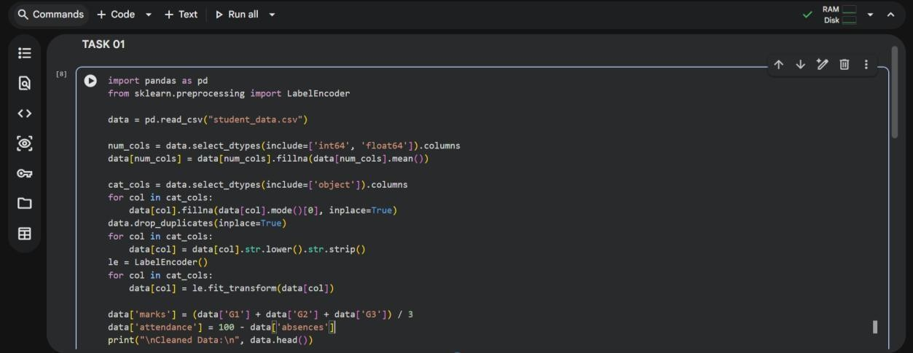
Output :

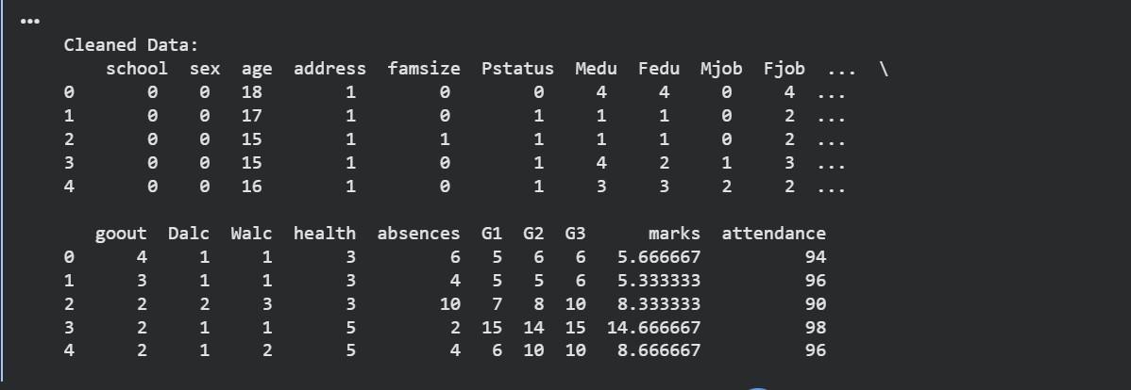
Data Set Used : Student_data[Kaggle].
Explanation : This dataset contains multiple academic and personal features, so missing values are handled using mean and mode. Duplicate rows are removed and text fields are standardized. All categorical columns are encoded using Label encoder. New features like marks are created. The final dataset is clean and ready for analysis or ML models.
Task – 02 : Financial Transaction Data Preprocessing.
Prompt : Generate Python code to preprocess financial transaction data by converting dates, extracting time features, normalizing amounts, and handling outliers.
Code :

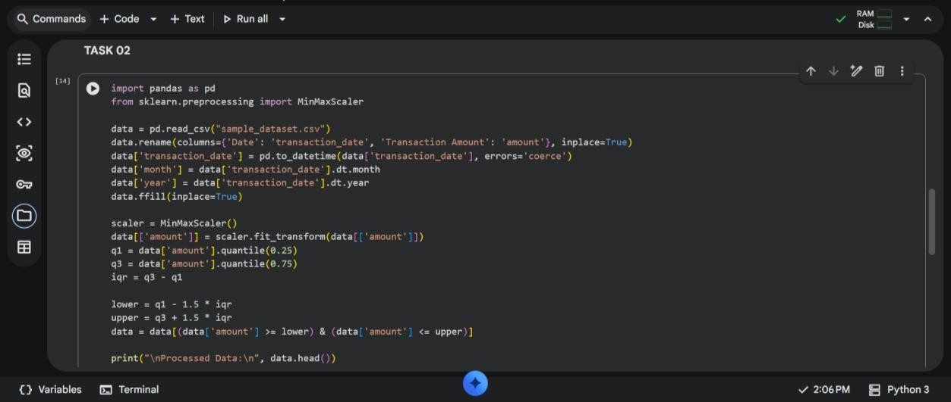
Output :

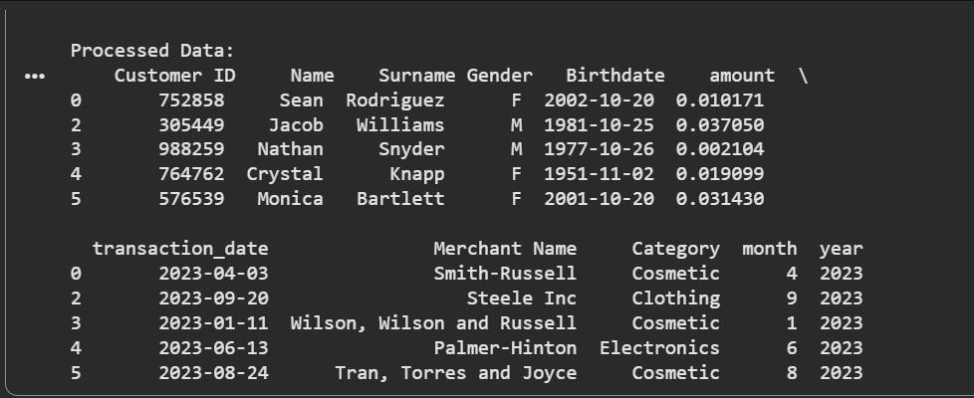
Data Set Used : Sample_data[Kaggle].
Explanation : The dataset is first loaded and the transaction date column is converted into datetime format for easier time-based analysis. New features like month and year are extracted from the date to enhance insights. Missing values are handled using forward fill to maintain data continuity. The transaction amount is normalized using MinMaxScaler to bring values into a common range. Finally, outliers are removed using the IQR method to improve data quality and model performance.

Task – 03 : Environmental Sensor Data Preparation.
Prompt : Write Python code to clean sensor data, handle missing values, scale numerical features, encode categorical variables, and split the dataset.
Code :

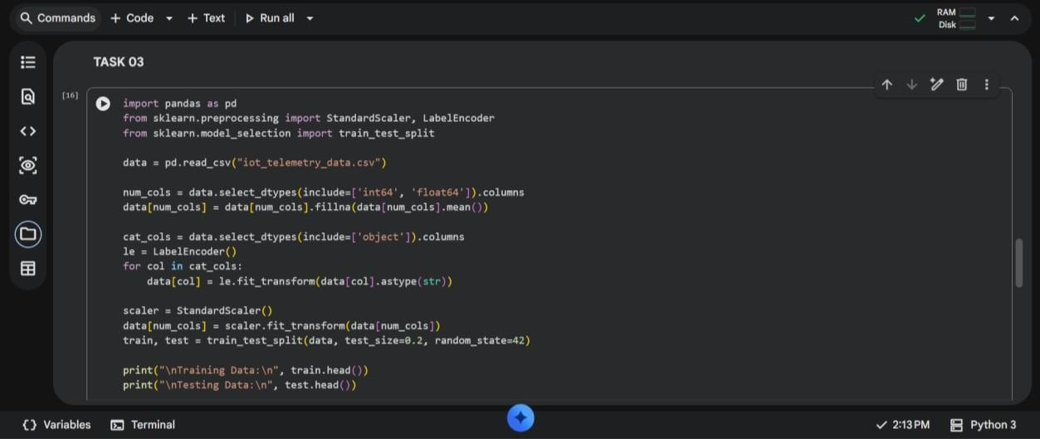
Data Set Used : Iot_Telemetry_Data[Kaggle].
Explanation :
The dataset is loaded and missing numerical values are filled using the mean to ensure completeness. Categorical columns are encoded into numerical form using LabelEncoder. All numerical features are standardized using StandardScaler to improve model performance. The dataset is then split into training and testing sets for machine learning tasks. This preprocessing makes the data clean, consistent, and ready for predictive modeling.
Output :
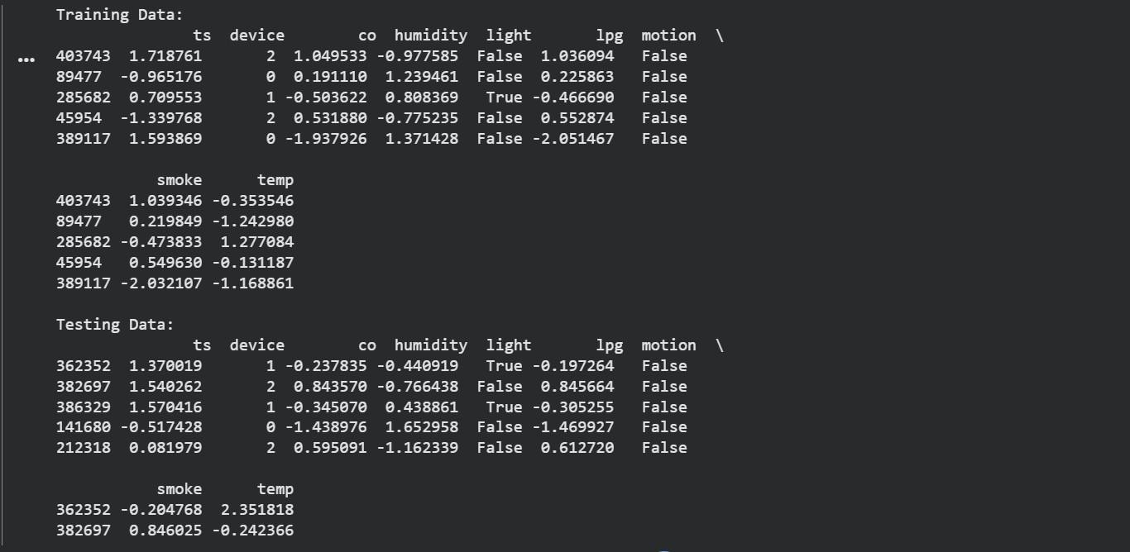

Task – 04 : Real Time Application : Smart City Traffic Data Cleaning.
Prompt : Generate Python code to clean traffic data by standardizing text, filling missing values, removing duplicates, normalizing features, and comparing dataset quality.
Code :

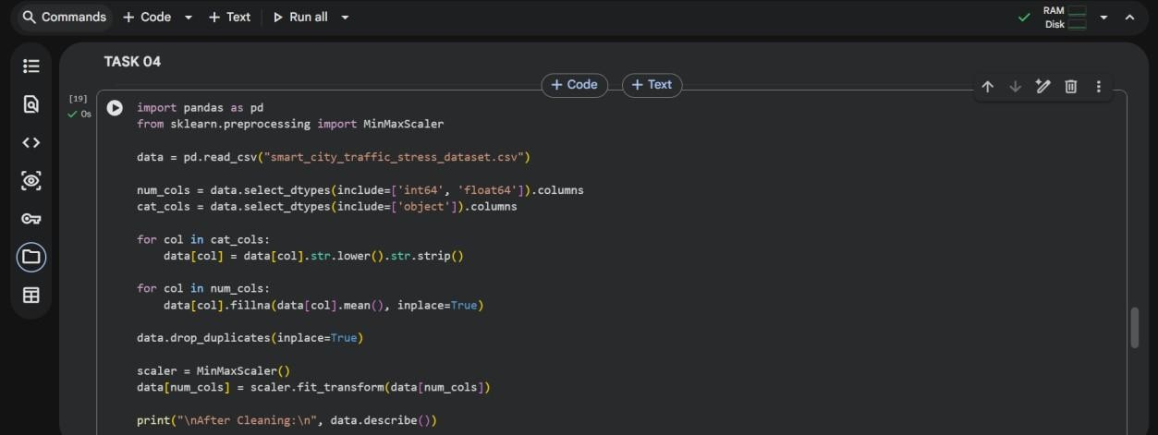
Data Set Used : Smart_city_traffic_stress_dataset[Kaggle].
Output :

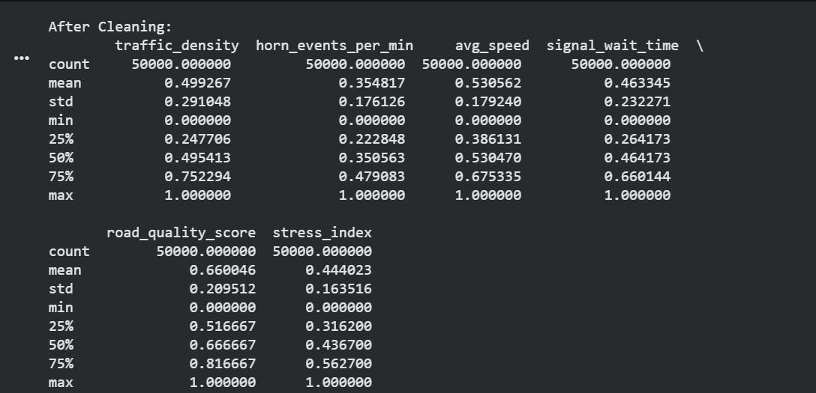
Explanation :
The dataset is cleaned by standardizing text fields to ensure consistency across categorical data. Missing numerical values are filled using the mean to avoid data loss. Duplicate records are removed to improve data accuracy. Numerical features are normalized using MinMaxScaler for better comparability. The dataset summary before and after cleaning highlights improvements in data quality.
Task – 05 : Social Media Text Data Cleaning and Feature Extraction.
Prompt : Write Python code to clean social media text data by removing duplicates, cleaning text, tokenizing, removing stopwords, and extracting features.
Code :

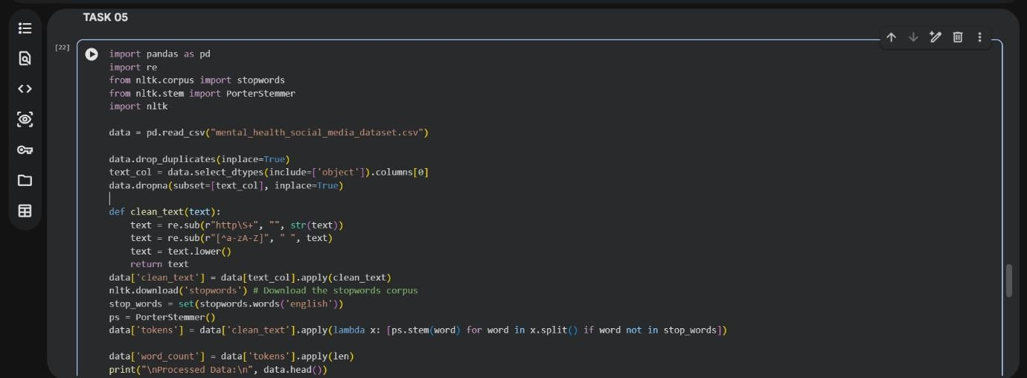
Output :

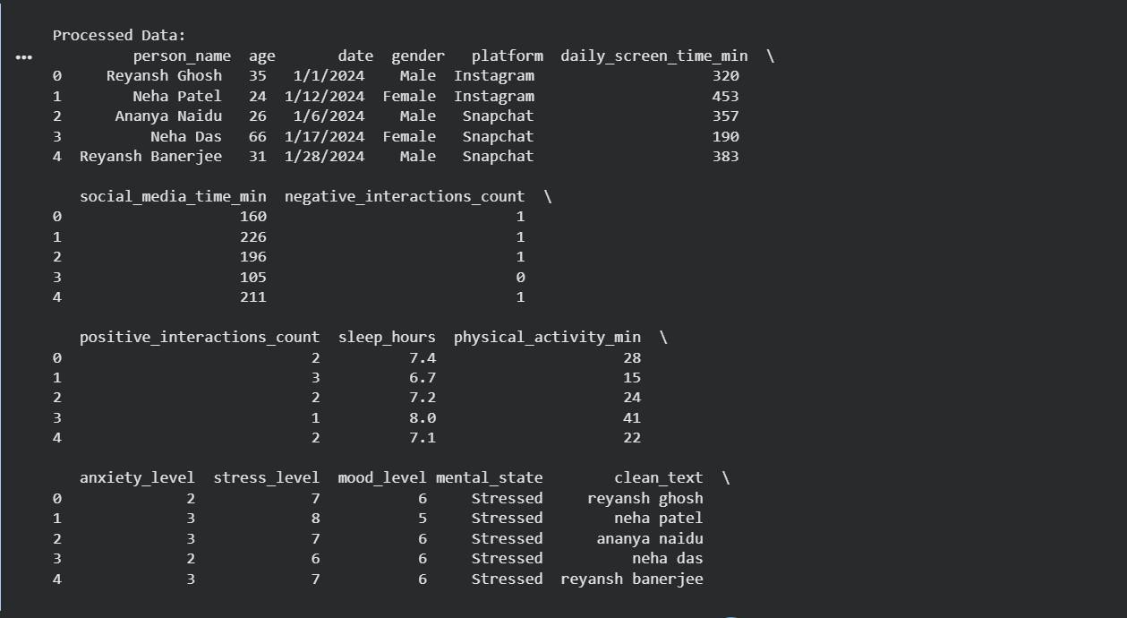
Data Set Used : Mental_health_social_media_dataset[Kaggle].
Explanation :
The dataset is cleaned by removing duplicate and missing text entries. Text data is processed by eliminating URLs, special characters, and converting everything to lowercase. Stopwords are removed and stemming is applied to simplify words. The cleaned text is tokenized into meaningful words. Additional features like word count are generated to support sentiment analysis tasks.

