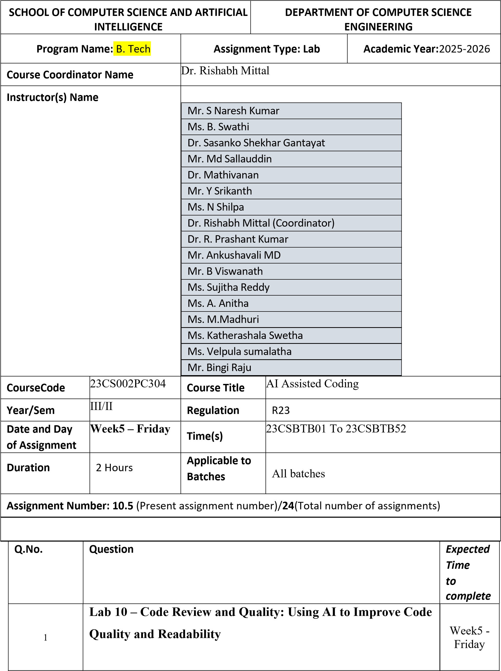

Lab Objectives
- Use AI for automated code review and quality enhancement.
- Identify and fix syntax, logical, performance, and security issues in Python code.
- Improve readability and maintainability through structured refactoring and comments.
- Apply prompt engineering for targeted improvements.
- Evaluate AI-generated suggestions against PEP 8 standards and software engineering best practices
Lab Outcomes
- Students will be able to use AI tools to review code.
- Students will be able to improve code quality and readability.
- Students will be able to identify and fix common coding issues.

Task Description #1 – Variable Naming Issues Task: Use AI to improve unclear variable names.
Sample Input Code:
def f(a, b):
return a + b print(f(10, 20))
Expected Output:
• Code rewritten with meaningful function and variable names.
Prompt
Refactor the given function by replacing unclear names with meaningful names and follow PEP 8 standards.

Code
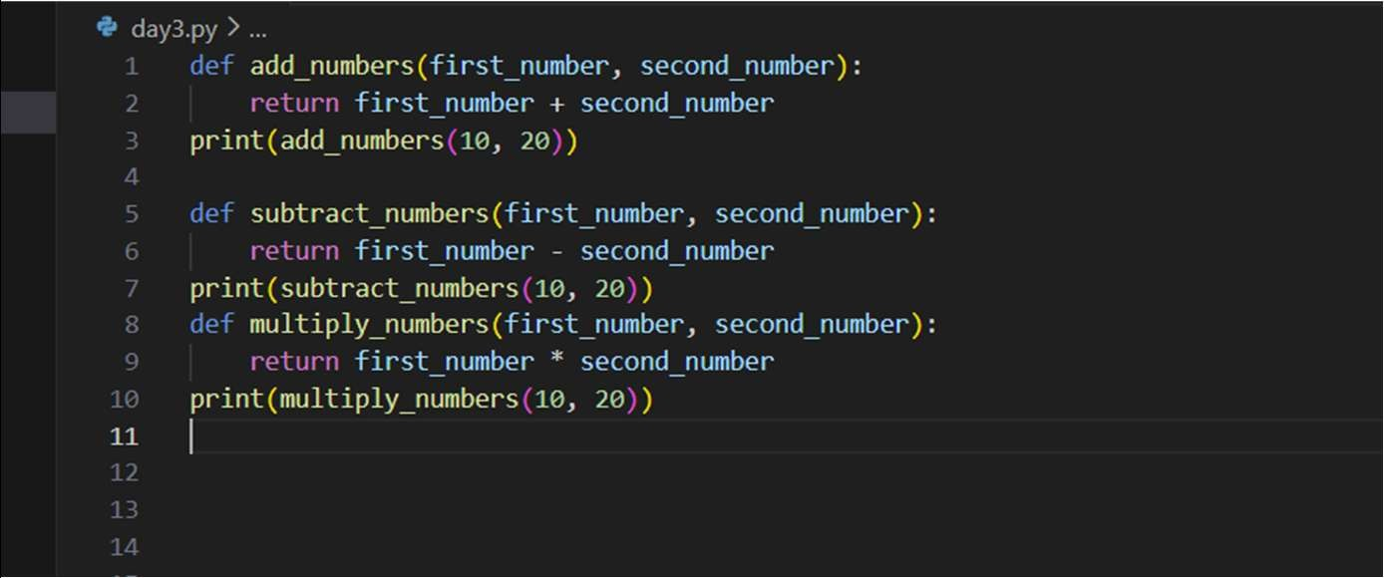
Output
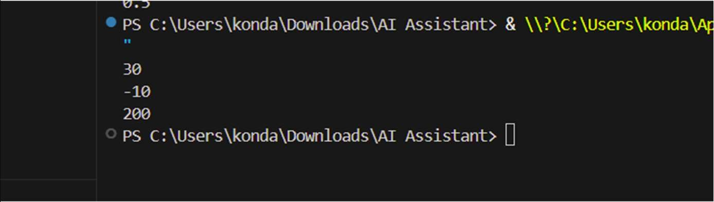
Explanation
The function name f and variables a, b were unclear. AI replaced them with meaningful names, improving readability and maintainability.

Task Description #2 – Missing Error Handling Task: Use AI to add proper error handling.
Sample Input Code:
def divide(a, b):
return a / b print(divide(10, 0)) Expected Output:
• Code with exception handling and clear error messages

Prompt
Improve the divide function by adding exception handling to prevent runtime errors.
Code
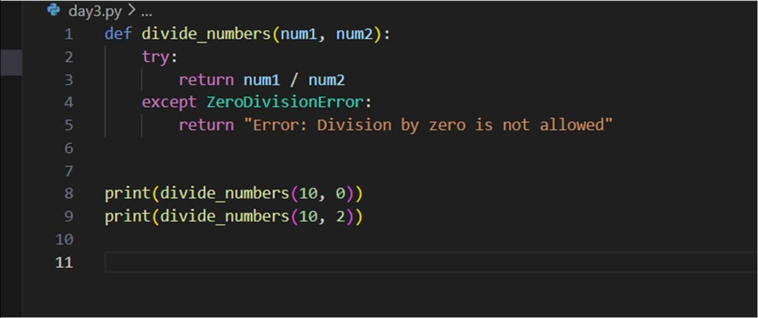
Output
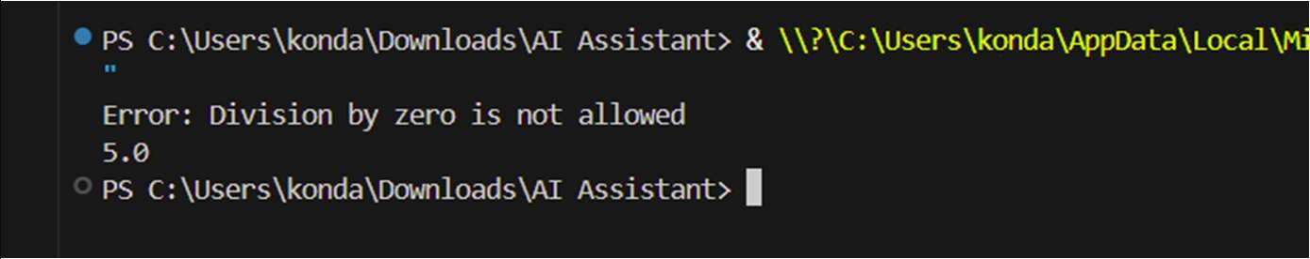
Explanation
AI added a try-except block to handle division by zero, preventing program crashes and improving reliability.

Task Description #3: Student Marks Processing System
The following program calculates total, average, and grade of a student, but it has poor readability, style issues, and no error handling.
marks=[78,85,90,66,88] t=0

for i in marks: t=t+i a=t/len(marks) if a>=90: print("A") elif a>=75: print("B") elif a>=60: print("C") else:
print("F") Task:
- Use AI to refactor the code to follow PEP 8 standards.
- Add meaningful variable names, functions, and comments.
- Add basic input validation and documentation.
Prompt
Refactor the student marks program to follow PEP 8, add functions, meaningful variables, and validation.

Code

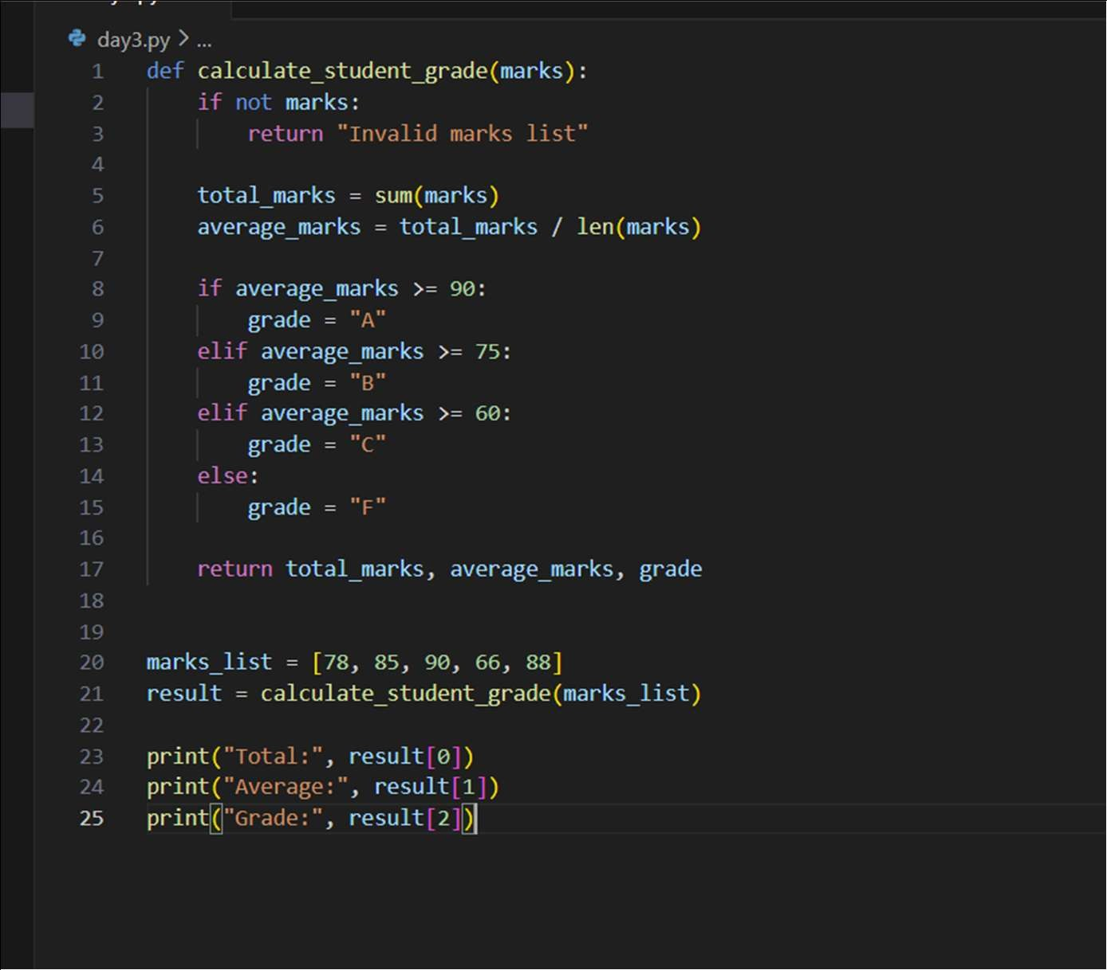
Output
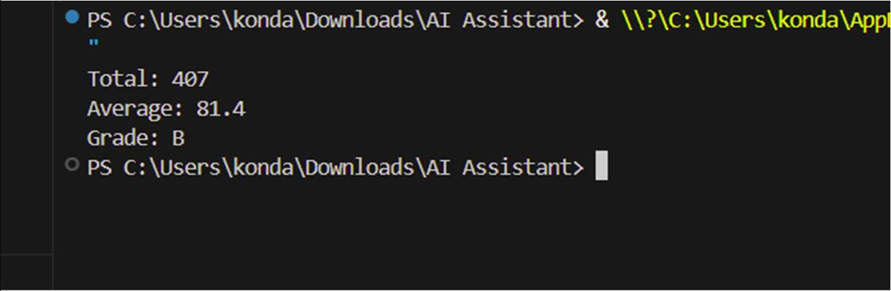

Explanation
AI improvements:
- Meaningful names
- Function-based modular design
- Used built-in sum() for efficiency
- Added validation for empty list

Task Description #4: Use AI to add docstrings and inline comments to the following function.

def factorial(n):
result = 1 for i in range(1,n+1):
result *= i return result
Prompt
Add docstring and inline comments to factorial function.
Code
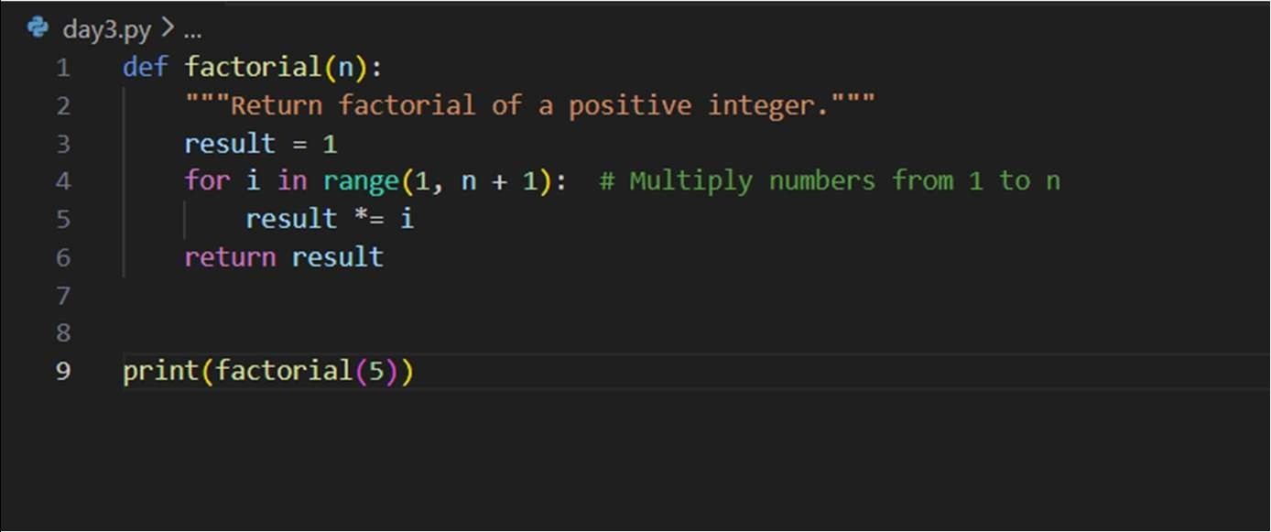
Output
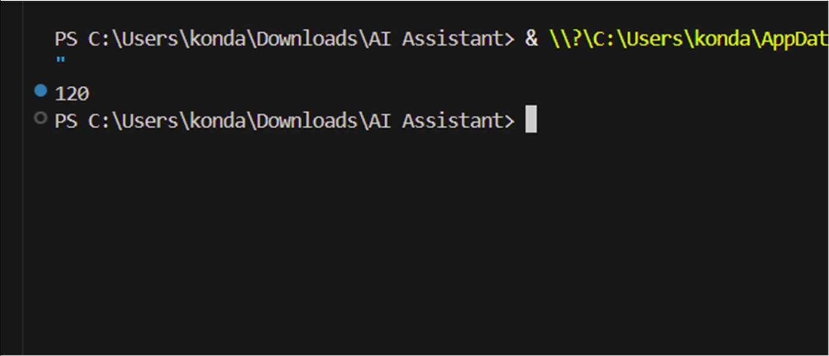
Explanation
AI added documentation and comments to explain functionality, improving clarity and maintainability.

Task Description #5: Password Validation System (Enhanced)
The following Python program validates a password using only a

 | else: p  Task:  1. | minimum length check, which is insufficient for real-world security requirements.  pwd = input("Enter password: ") if len(pwd) >= 8:  print("Strong")  rint("Weak")  Enhance password validation using AI assistance to include multiple security rules such as:  o Minimum length requirement o Presence of at least one uppercase letter o Presence of at least one lowercase letter o Presence of at least one digit o Presence of at least one special character
 | 2. | Refactor the program to:  o Use meaningful variable and function names o Follow PEP 8 coding standards o Include inline comments and a docstring
 | 3. | Analyze the improvements by comparing the original and AIenhanced versions in terms of:  o Code readability and structure o Maintainability and reusability o Security strength and robustness
 | 4.  Pr | Justify the AI-generated changes, explaining why each added rule and refactoring decision improves the overall quality of the program. ompt  Enhance password validation using multiple security rules and refactor code with functions and comments.
Code
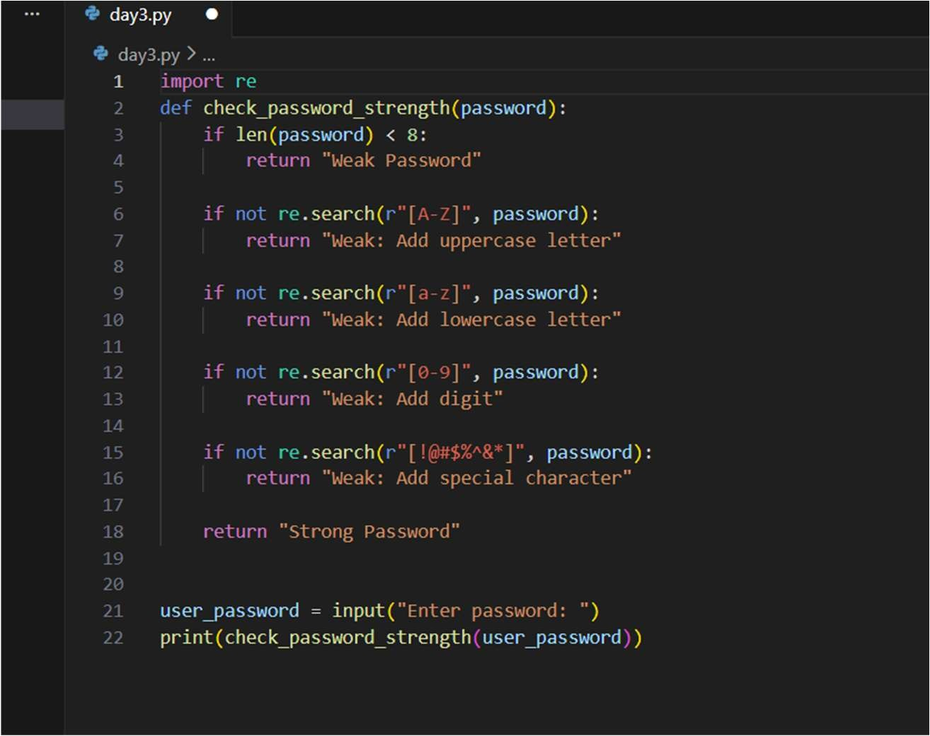
Output
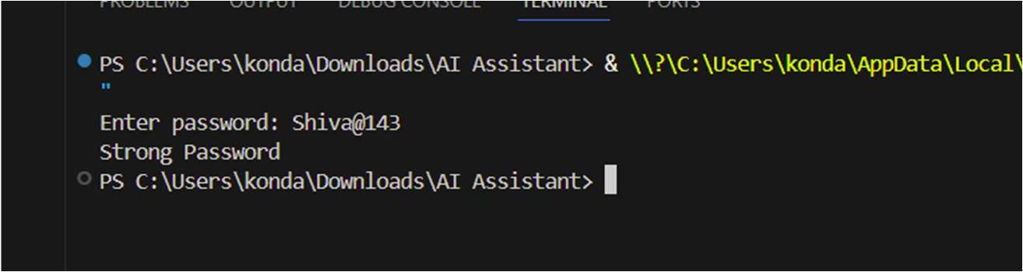
Explanation
AI added multiple security checks (uppercase, lowercase, digit, special character).
This improves password strength, security, and real-world usability.

