Lab assignment 8.2
Test Driven Development With AI

_{NAME : NISHATH}
_{BATCH:04}

Task 1 — Even/Odd Number Validator Question

Generate test cases for a function is_even(n) and implement it to pass all tests.

PROMPT
Use AI to generate test cases for an even/odd validator that handles zero, negative numbers, and large integers. Implement the function accordingly.

CODE
def is_even(n): return n % 2 == 0

print(is_even(2)) print(is_even(7)) print(is_even(0)) print(is_even(-4)) print(is_even(9))

assert is_even(2) == True assert is_even(7) == False assert is_even(0) == True assert is_even(-4) == True assert is_even(9) == False
print("All tests passed")

OUTPUT
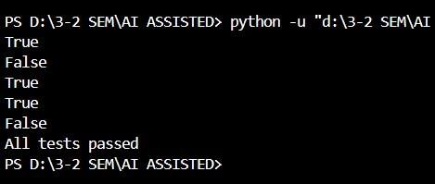

EXPLANATION
The function checks divisibility by 2 using modulus operator. If remainder is zero, the number is even. Test cases ensure handling of zero, negatives, and large integers.

Task 2 — String Case Converter QUESTION
Generate test cases for to_uppercase(text) and to_lowercase(text).

PROMPT
Create functions to convert strings to uppercase and lowercase while handling empty strings and invalid inputs safely.

CODE
def to_uppercase(text): if isinstance(text,str):
return text.upper() return
"Invalid Input" def
to_lowercase(text): if
isinstance(text,str): return text.lower() return "Invalid Input" print(to_uppercase("ai coding")) print(to_lowercase("TEST")) print(to_uppercase("")) print(to_lowercase(None)) assert to_uppercase("ai coding") == "AI
CODING" assert
to_lowercase("TEST") == "test" assert to_uppercase("") == "" assert to_lowercase(None) == "Invalid Input" print("All tests passed")
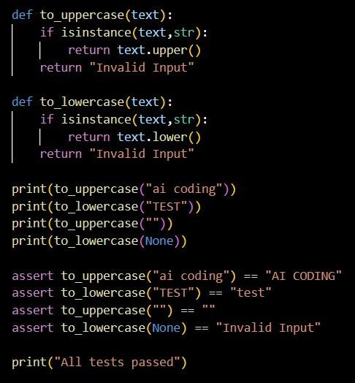

OUTPUT
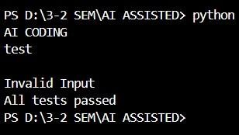

EXPLANATION
Functions check if input is string before conversion to avoid runtime errors. This ensures safe handling of invalid inputs.

Task 3 — List Sum Calculator QUESTION
Generate test cases for sum_list(numbers) to calculate sum safely.

PROMPT
Implement list summation function handling empty lists, negatives, and ignoring non-numeric values.

CODE
def sum_list(numbers):
total = 0 for n in numbers:
if isinstance(n,(int,float)): total += n return total print(sum_list([1,2,3])) print(sum_list([])) print(sum_list([-1,3,-4])) print(sum_list([2,"a",3])) assert sum_list([1,2,3]) == 6 assert sum_list([]) == 0 assert sum_list([-1,3,-4]) == -2 assert sum_list([2,"a",3]) == 5 print("All tests passed")
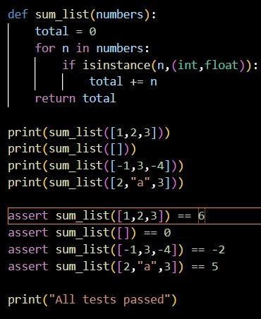

OUTPUT
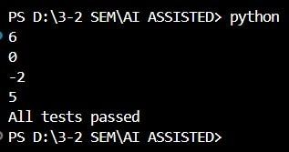

EXPLANATION
Loop iterates through list and adds only numeric values. This prevents errors caused by nonnumeric elements.

Task 4 — Student Result Class QUESTION
Generate test cases for StudentResult class with methods add_marks(), calculate_average(), get_result().
PROMPT
Implement class that calculates average and determines pass/fail based on average ≥ 40.

CODE
class StudentResult: def
__init__(self): self.marks = [] def add_marks(self,mark):
if 0 <= mark <= 100: self.marks.append(mark)
else:
return "Invalid Marks" def calculate_average(self): if not self.marks:
return 0 return sum(self.marks)/len(self.marks) def get_result(self):
avg = self.calculate_average() return "Pass" if avg >= 40 else "Fail" s =
StudentResult()
s.add_marks(60)
s.add_marks(70)
s.add_marks(80) print(s.calculate_average()) print(s.get_result()) assert
s.get_result() == "Pass" print("All tests passed")
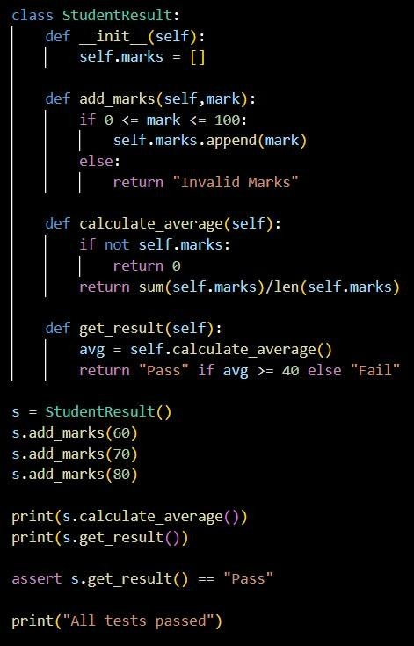

OUTPUT
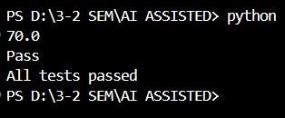

EXPLANATION
Marks are validated between 0 and 100. Average is calculated and result determined based on threshold rule.

Task 5 — Username Validator QUESTION
Generate test cases for is_valid_username(username).

PROMPT
Create validation function ensuring minimum length 5, no spaces, and only alphanumeric characters.

CODE
def is_valid_username(username):
if not isinstance(username,str):
return False if
len(username) < 5:
return False if " " in username:
return False if not
username.isalnum():
return False return True print(is_valid_username("user01")) print(is_valid_username("ai")) print(is_valid_username("user name")) print(is_valid_username("user@123")) assert is_valid_username("user01") ==
True assert is_valid_username("ai") == False assert is_valid_username("user
name") == False assert
is_valid_username("user@123") ==
False print("All tests passed")
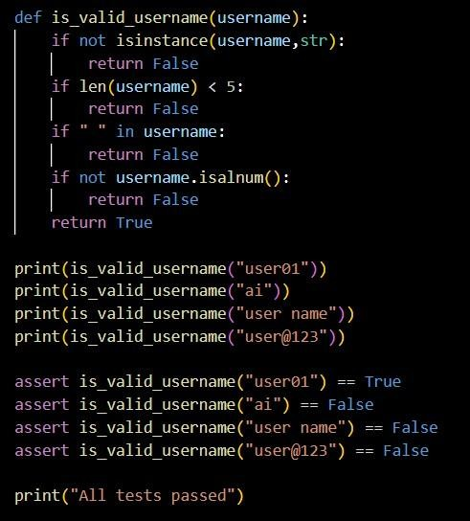

OUTPUT
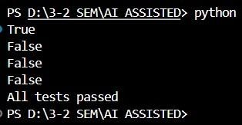

EXPALANATION
Function checks length, spaces, and allowed characters using built-in string methods. Ensures robust validation logic.

