AI ASSISTED CODING
NAME: Nishath Afroze 2303A51212
BATCH – 04 31 – 03 – 2026

ASSIGNMENT – 16.2
LAB – 16 : Database Design and Queries : Schema Design and SQL Generation.
Task – 01 : Design Database Schema for Student Management System.
Prompt : Generate SQL CREATE TABLE statements for a Student Management System with tables Students, Courses, and Enrollments. Include primary keys, foreign keys, proper data types, and ensure normalization up to 3NF.
Code :

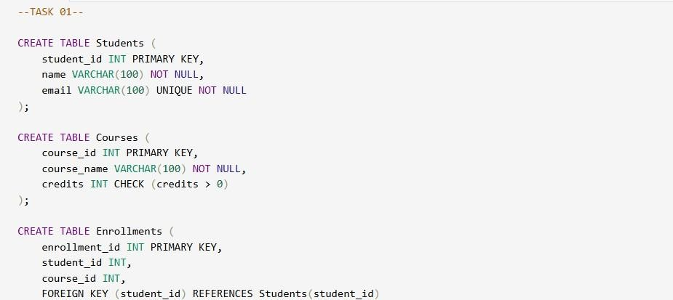
Explanation :
The schema is normalized (1NF, 2NF, 3NF) by separating entities into different tables. Primary keys uniquely identify records, while foreign keys maintain relationships. Constraints like NOT NULL, UNIQUE, and CHECK ensure data integrity. ON DELETE CASCADE ensures related records are removed automatically

Output :

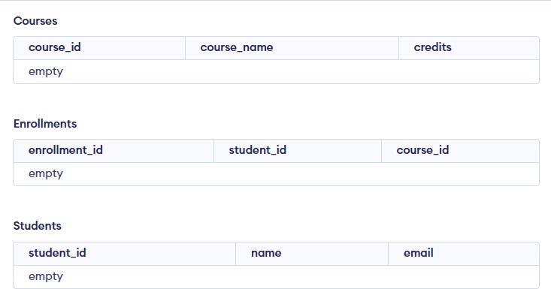

Task – 02 : Insert Sample Records.
Prompt : Generate SQL INSERT statements to populate Students, Courses, and Enrollments tables with at least 3 students, 4 courses, and 5 enrollments.
Code :

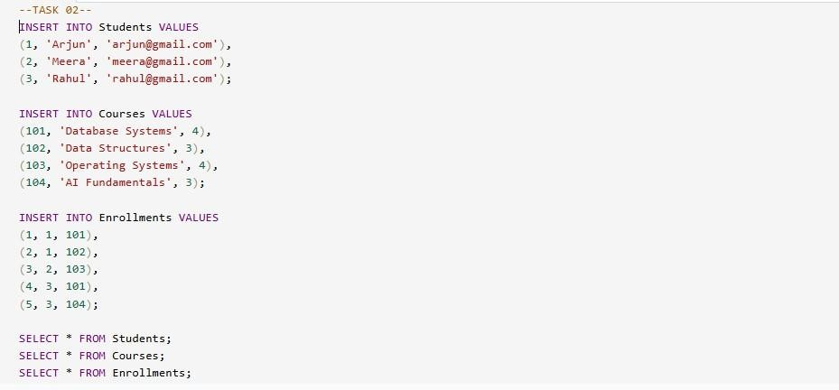
OUTPUT :

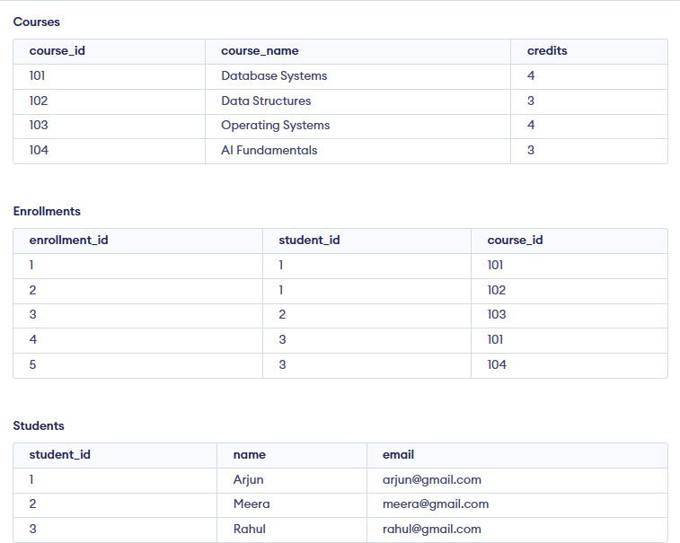

Explanation :
Sample data is inserted into all tables to simulate a real system. Each enrollment links a student to a course using foreign keys. SELECT queries help verify successful insertion of records. Ensures relational consistency across tables.

Task – 03 : Perform CURD Operations.
Prompt : Generate SQL queries to perform CRUD operations: retrieve all courses, update a student's email, and delete an enrollment record.

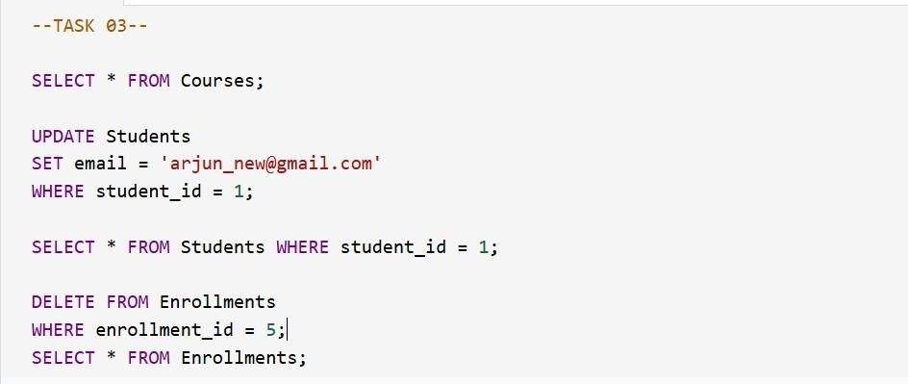

Output :

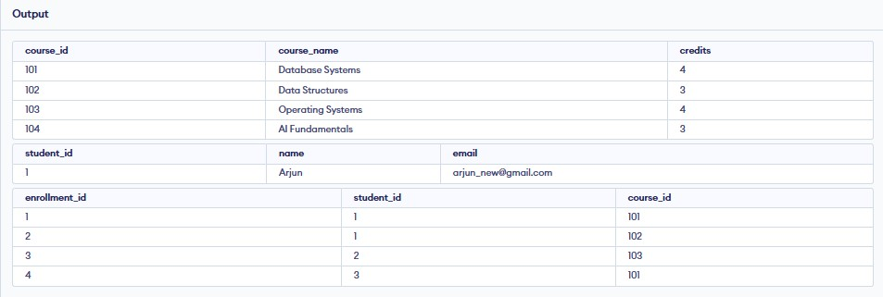

Explanation :
SELECT retrieves data from the database. UPDATE modifies existing records based on conditions. DELETE removes specific records safely using a WHERE clause. Verification queries ensure changes are correctly applied.

Task – 04 : Execute Aggregate Queries.
Prompt : Generate SQL queries to count number of students per course and display courses with more than one student enrolled.
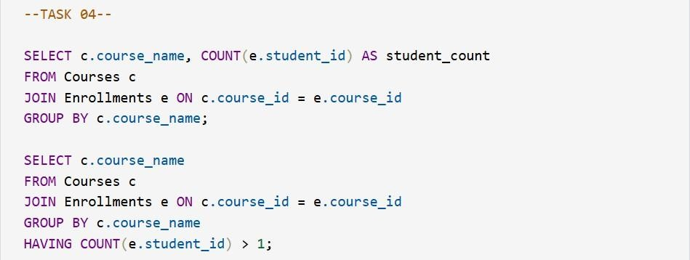
Output :

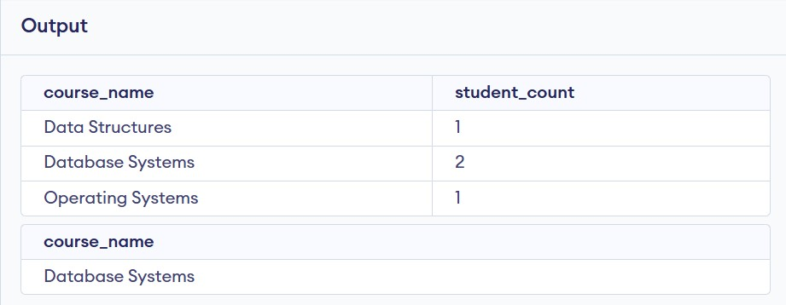

Explanation :
JOIN combines data from multiple tables based on relationships. COUNT() calculates total students in each course. GROUP BY groups results for aggregation. HAVING filters grouped results based on conditions.

Task – 05 : Query Optimization.
Prompt : Rewrite a subquery using JOIN for better performance and compare both queries.
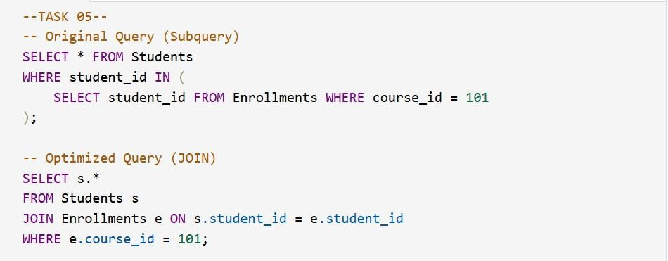

Output :

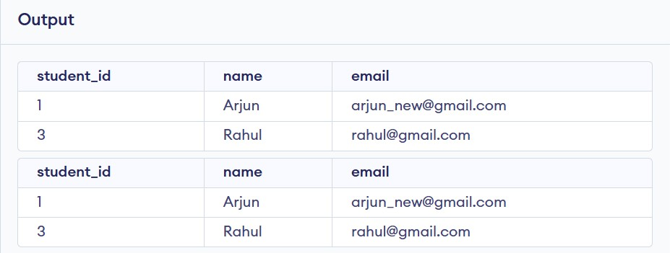

Explanation :
The original query uses a subquery, which can be slower for large datasets. The optimized query uses JOIN, improving performance and readability. Both queries return the same results (students in course 101). JOIN-based queries are preferred in real-world applications.

THANKYOUU!!

