AI ASSISTANT CODING
ASSIGNMENT-14.5

Name: Nishath Afroze
Ht.no:2303A51212
Batch:04

Task 1 – Image Gallery Website Create an image gallery web page.
Requirements:
- Display images in a grid layout.
- Use AI to:
- Optimize layout using CSS Grid.
- Add hover zoom or overlay effects.
- Ensure mobile responsiveness.

Prompt: Create a responsive image gallery using HTML and CSS Grid with a hover zoom effect.

Code:

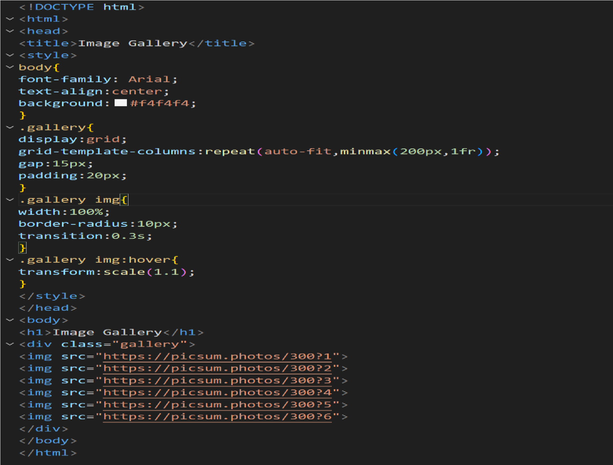

Output:



Explanation:
The image gallery displays images using CSS Grid layout.
The grid automatically adjusts columns depending on screen size, making it responsive.
A hover zoom effect is applied using CSS transform to enlarge images when the mouse pointer moves over them.

Task 2 – Profile Card Generator Create a profile card web page.
Requirements:
- Display user image, name, role, and social media links.
- Use AI to:
- Suggest modern UI colors and fonts.
- Design the card using Flexbox.
- Add hover animation and shadow effects

Prompt: Create a modern profile card using HTML and CSS Flexbox with hover animation.

Code:

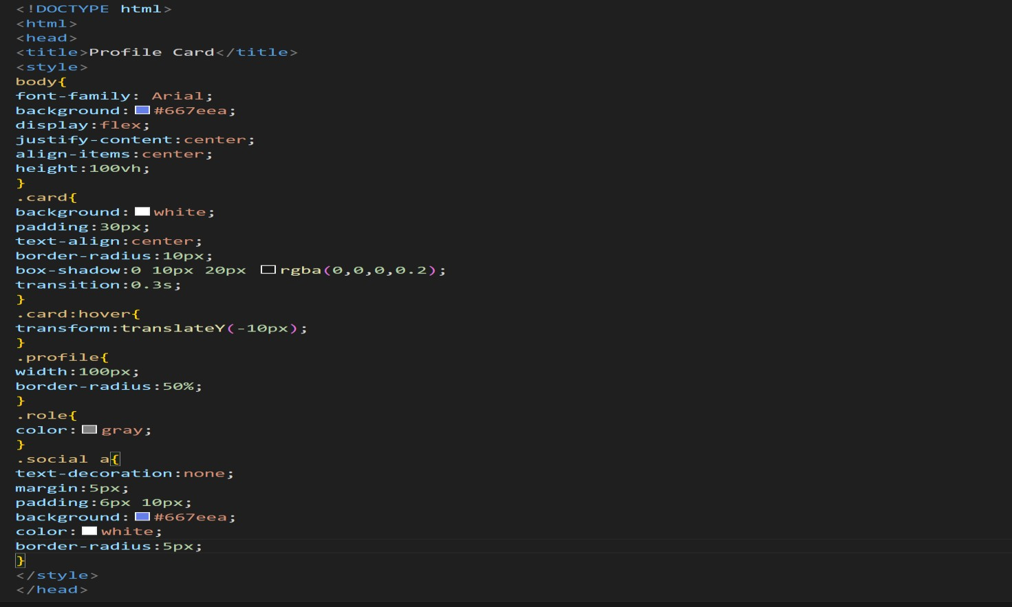

Output:

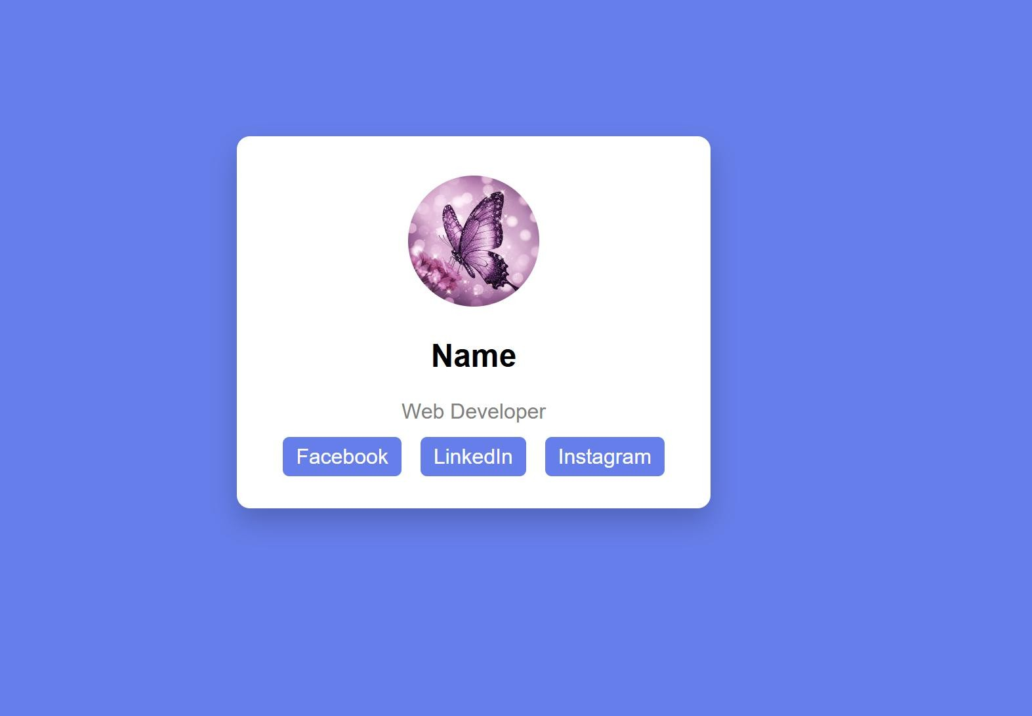

Explanation:
The profile card shows a user image, name, role, and social media links.
The layout is styled with modern colors and uses Flexbox to center the card. A hover animation moves the card slightly upward and a shadow effect gives it a modern UI appearance.

Task 3 -Develop a dynamic shopping cart system.
Requirements:
- Add, remove, and update product quantities.
- Display real-time total price.
- Use AI to:
•Manage cart state using JavaScript objects.
- Persist cart data in localStorage.

Prompt: Build a dynamic shopping cart using HTML, CSS, and JavaScript with localStorage.

Code:

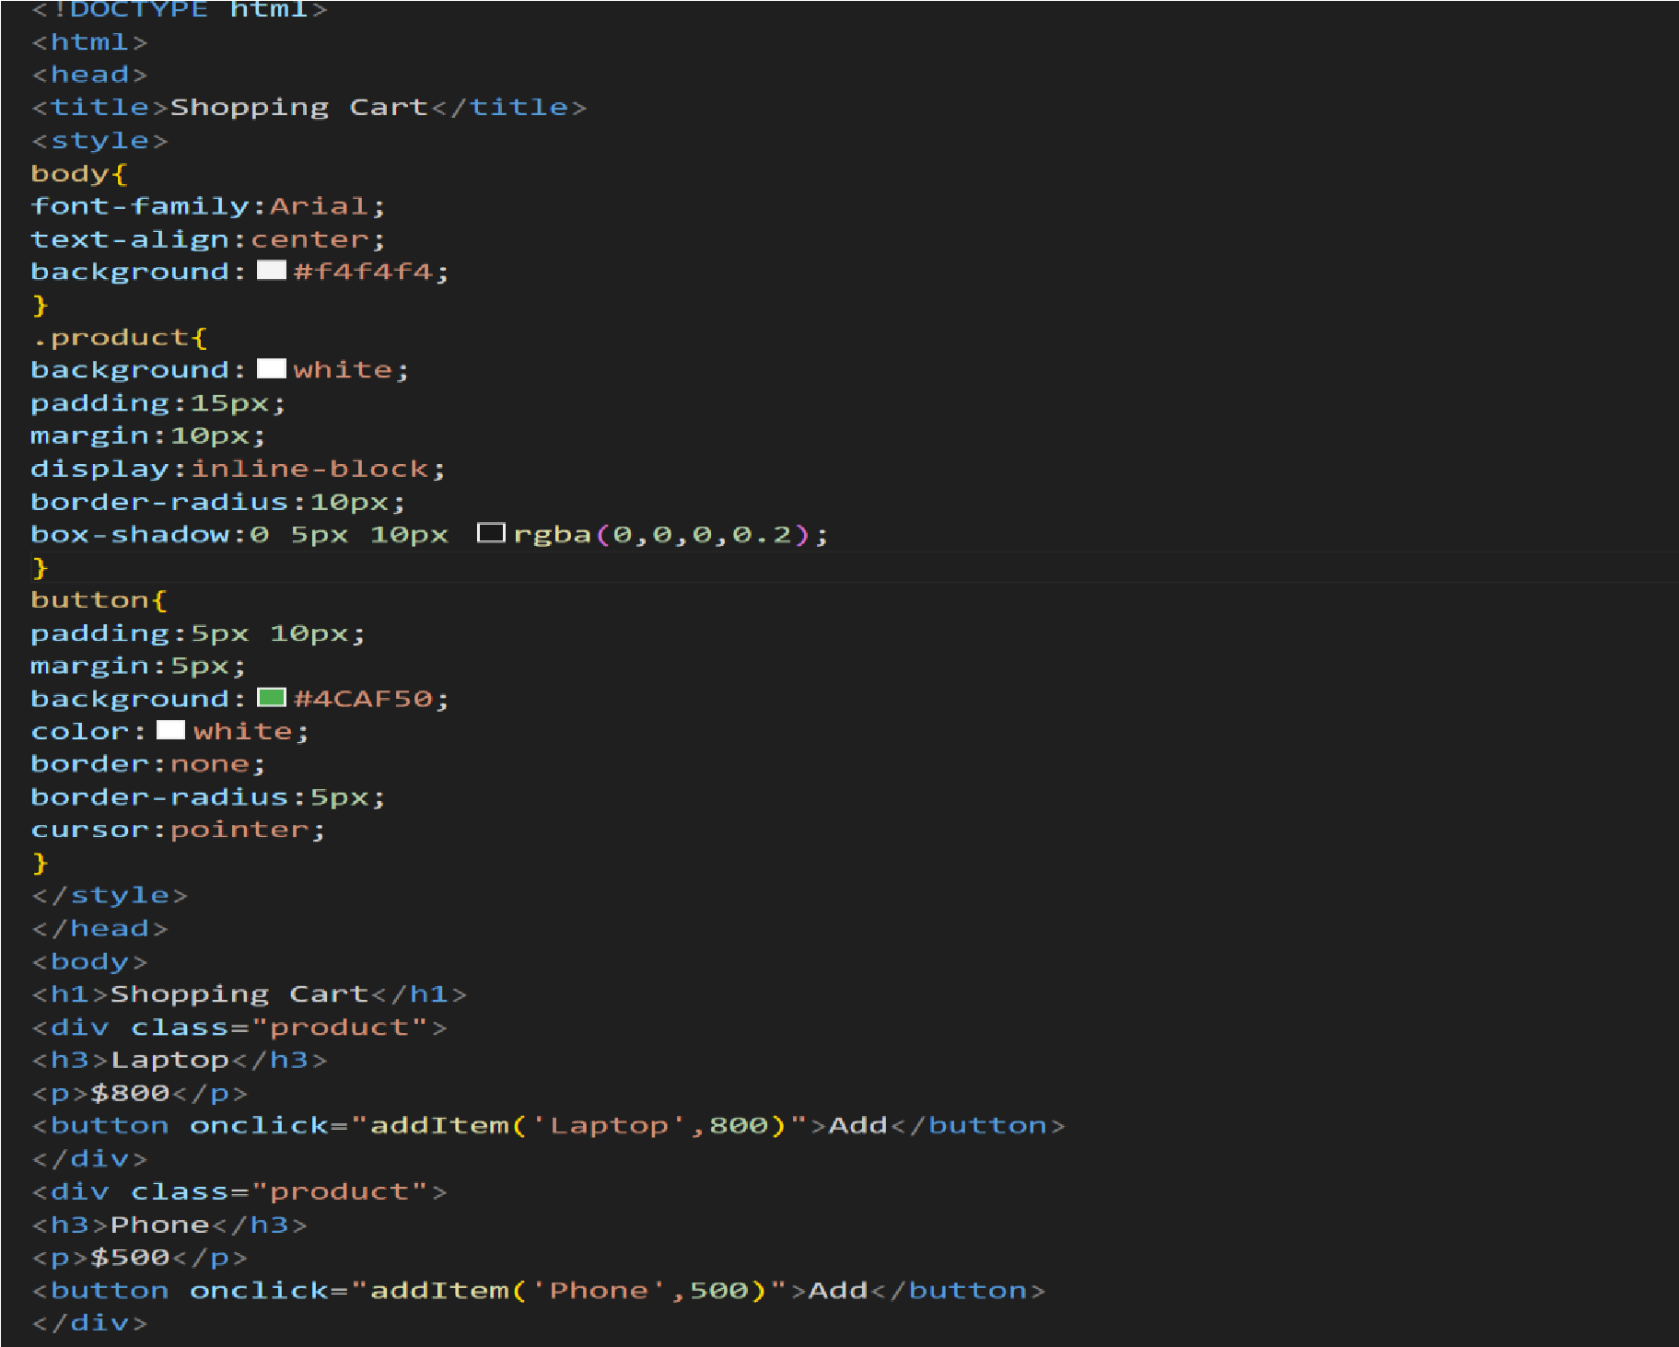

Output:

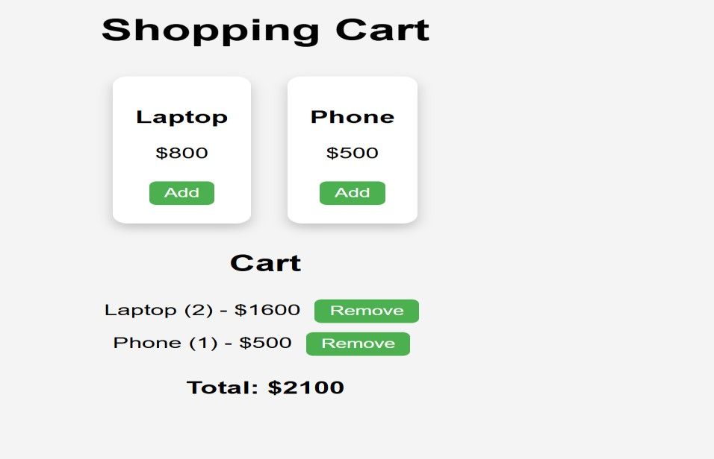

Explanation:
The shopping cart allows users to add products and view them in the cart.
JavaScript objects store product details such as name, price, and quantity.
The total price updates dynamically whenever products are added or removed. Cart data is stored in localStorage, ensuring that items remain saved even after refreshing the page.

Task 4 – Role-Based Access Control Application Create a role-based web application.
Requirements:
- Admin, Editor, User roles.
- Conditional UI rendering.
- Use AI to:
- Design access control logic.
- Maintain secure state transitions.
- Create scalable UI components.

Prompt: Create a role-based web app with Admin, Editor, and User roles using JavaScript.

Code:

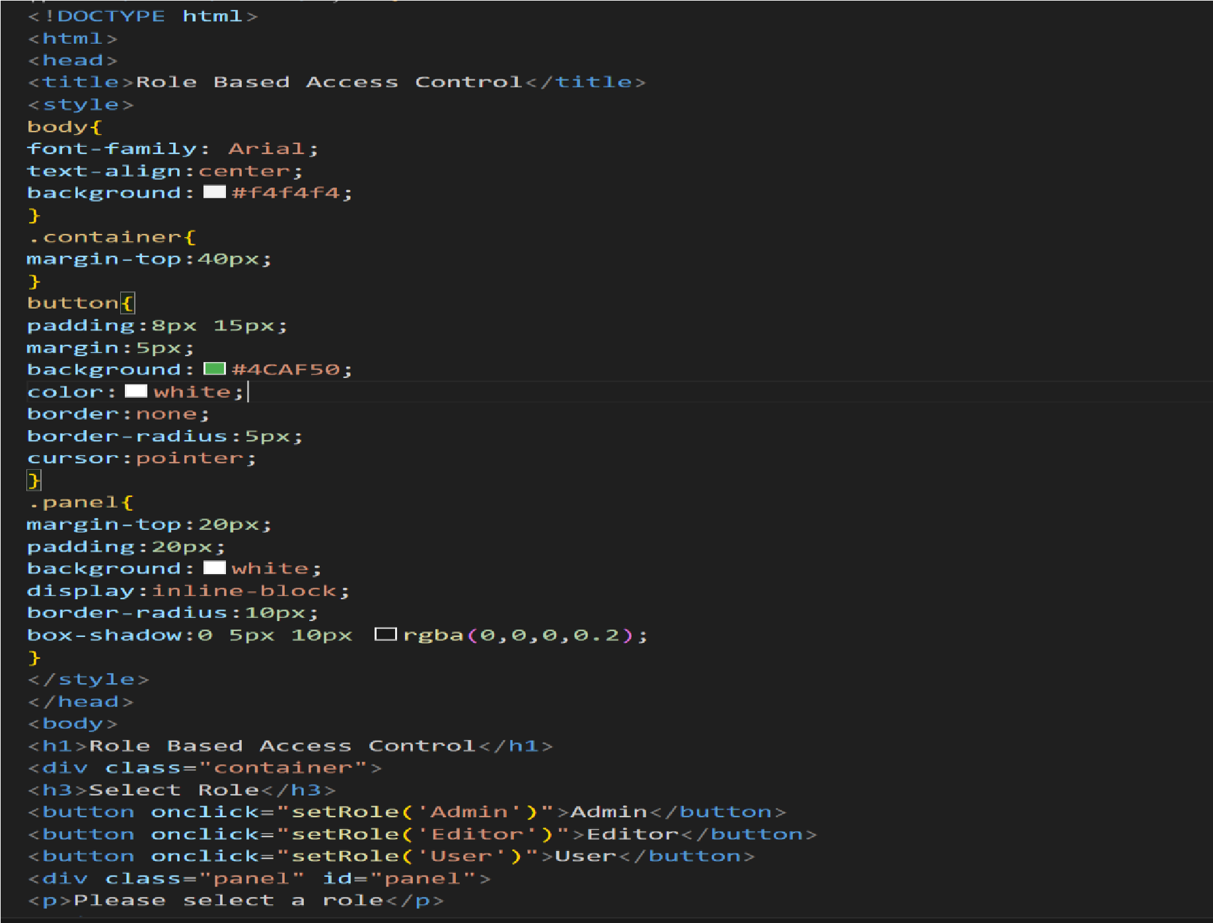

Output:

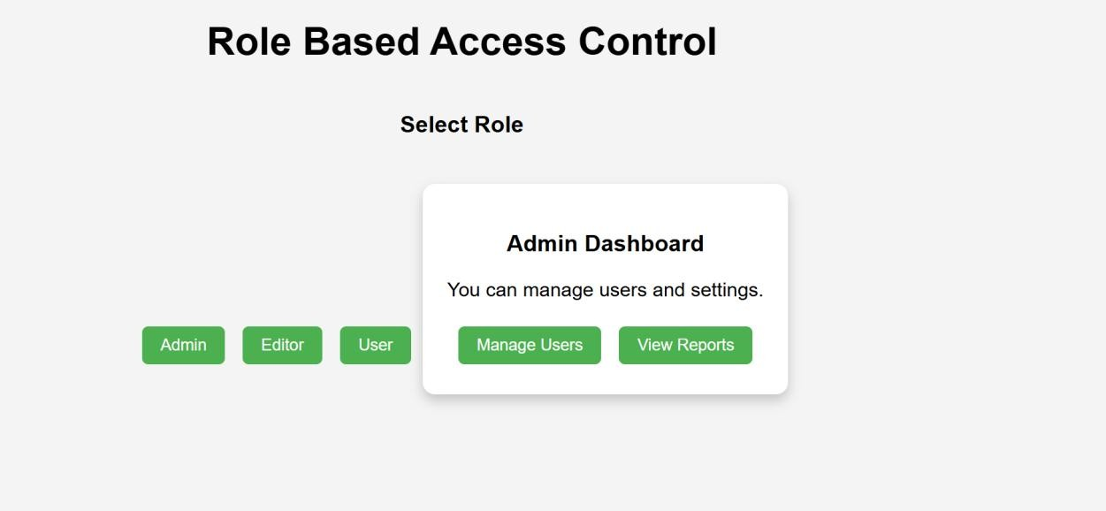

Explanation:
This application demonstrates role-based access control with Admin, Editor, and User roles.
Each role sees different interface options using conditional UI rendering. JavaScript controls the access logic to ensure users only see features allowed for their role.

Task 5 – Multi-Language Website Design a multilingual website.
Requirements:
- Switch languages dynamically.
- Persist language preference.
- Use AI to:
•Structure translation files.
•Handle RTL/LTR layouts.
•Improve accessibility

Prompt: Create a multilingual website with dynamic language switching using JavaScript.

Code:

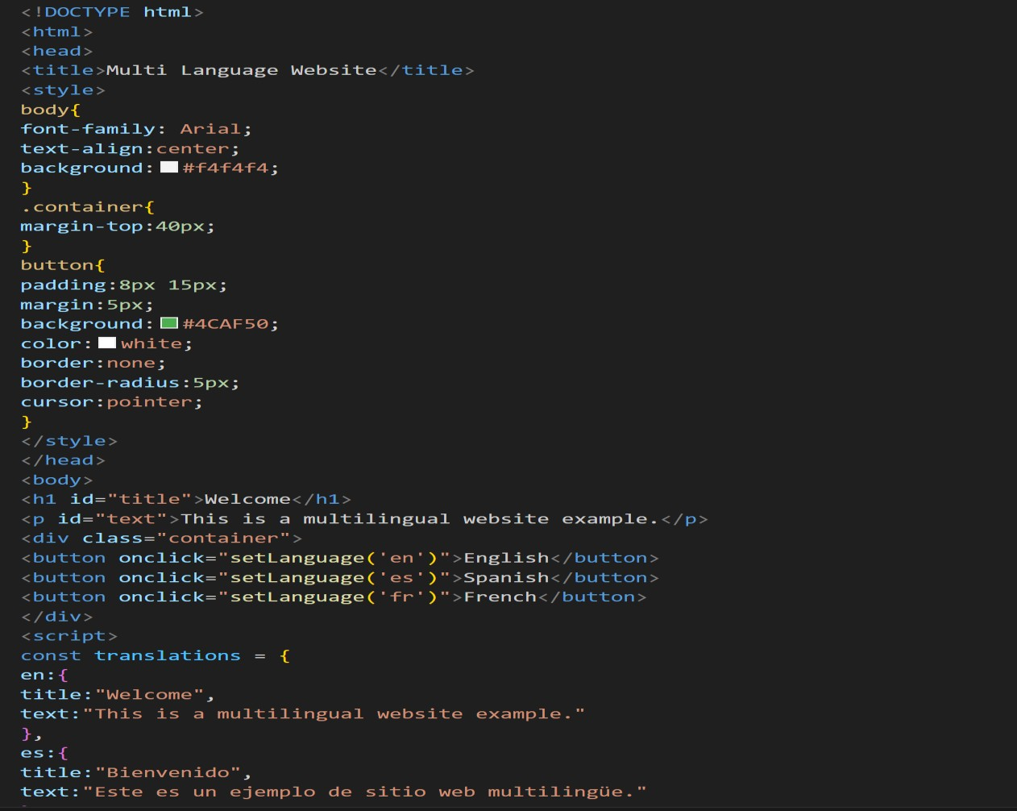

Output:

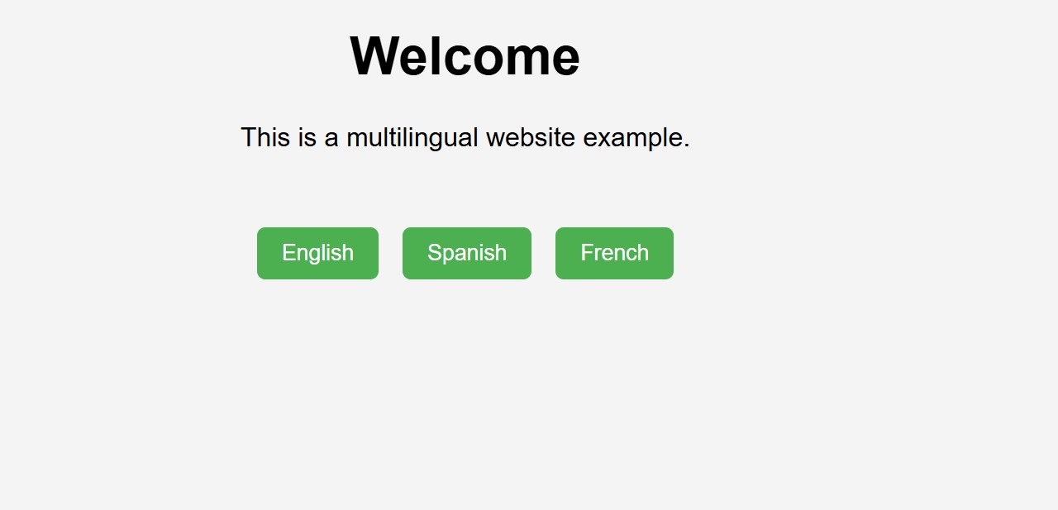

Explanation:
This multilingual website allows users to switch between different languages dynamically.
Translations are stored in JavaScript objects, making it easy to manage multiple languages.
The selected language is saved using localStorage, so the preference remains after refreshing the page.
This approach improves accessibility and usability for users from different language backgrounds.

Task 6 – Online Examination System Create an online exam interface.
Requirements:
- Timer, questions, and submission.
- Prevent multiple submissions.
- Use AI to:
•Manage exam state.
•Improve exam UX.
•Ensure accessibility.

Prompt: Create an online exam interface with questions, timer, and submission using HTML, CSS, and JavaScript.

Code:

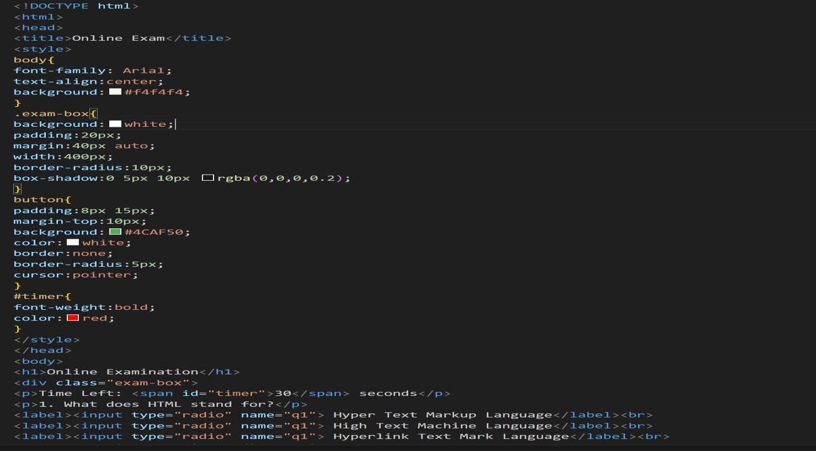

Output:

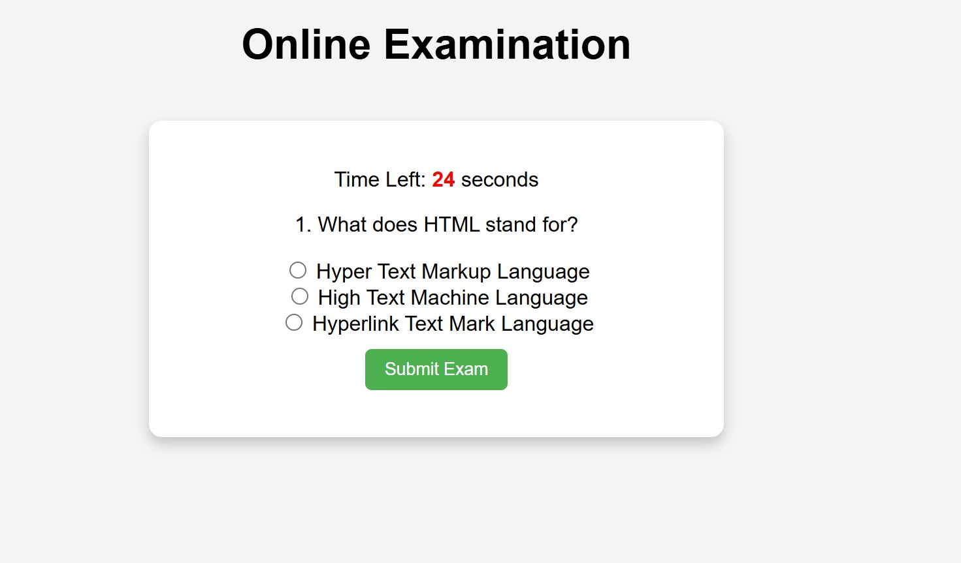

Explanation:
This online examination system displays questions with a countdown timer. Users can answer the question and submit the exam. The timer automatically submits the exam when time ends. JavaScript manages the exam state and prevents multiple submissions, improving the user experience and accessibility.

