AI Assisted Coding
Nishath Afroze
2303A51212
Batch - 04
07-01-2026

Lab 1: Environment Setup – GitHub Copilot and VS Code Integration +
Understanding AI-assisted Coding Workflow
Lab Objectives:
- To install and configure GitHub Copilot in Visual Studio Code.
- To explore AI-assisted code generation using GitHub Copilot. ● To analyze the accuracy and effectiveness of Copilot's code suggestions.
- To understand prompt-based programming using comments and code context
Lab Outcomes (LOs):
After completing this lab, students will be able to:
- Set up GitHub Copilot in VS Code successfully.
- Use inline comments and context to generate code with Copilot.
- Evaluate AI-generated code for correctness and readability. ● Compare code suggestions based on different prompts and programming styles.
Task 0
- Install and configure GitHub Copilot in VS Code. Take screenshots of each step.
Expected Output
- Install and configure GitHub Copilot in VS Code. Take screenshots of each step.
Task 0: Environment Setup:-
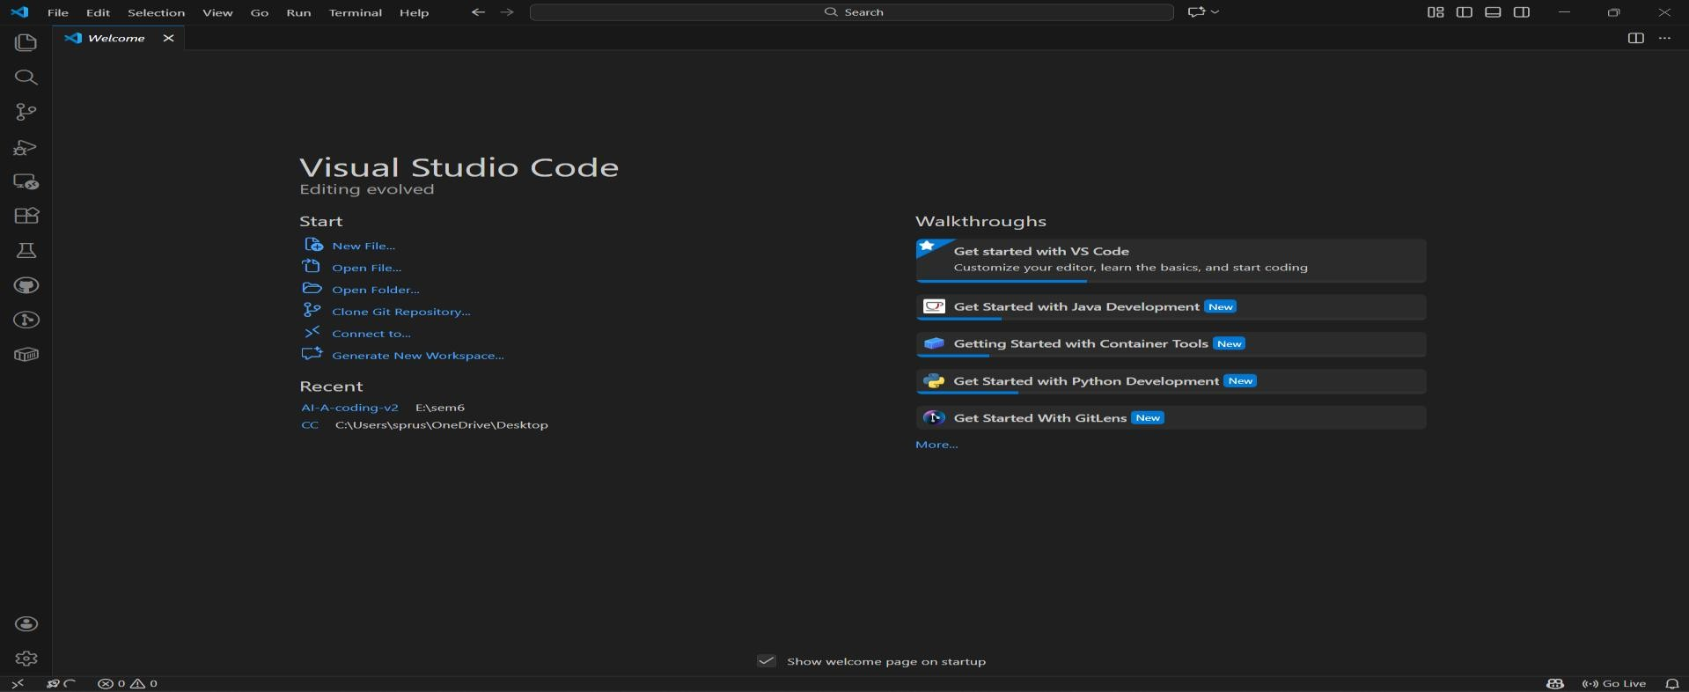
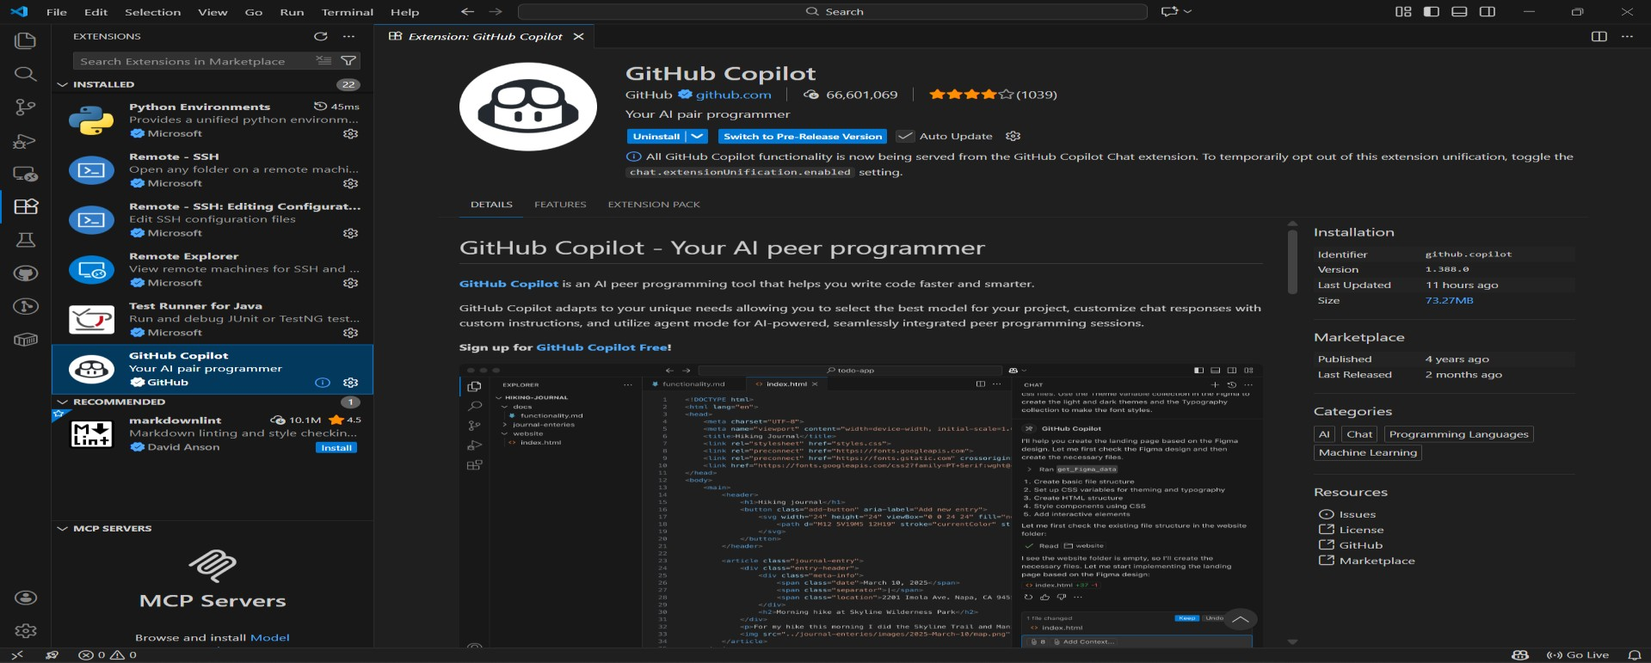

Task 1: AI-Generated Logic Without Modularization (Factorial without
Functions)
- Scenario
You are building a small command-line utility for a startup intern onboarding task. The program is simple and must be written quickly without modular design.
- Task Description
Use GitHub Copilot to generate a Python program that computes a mathematical product-based value (factorial-like logic) directly in the main execution flow, without using any user-defined functions.
- Constraint:
- Do not define any custom function
- Logic must be implemented using loops and variables only
• Expected Deliverables
- A working Python program generated with Copilot assistance ➢ Screenshot(s) showing:
- The prompt you typed ➢ Copilot’s suggestions
- Sample input/output screenshots ➢ Brief reflection (5–6 lines):
- How helpful was Copilot for a beginner?
- Did it follow best practices automatically?
Task 1: AI-Generated Logic Without Modularization (Factorial without
Functions)
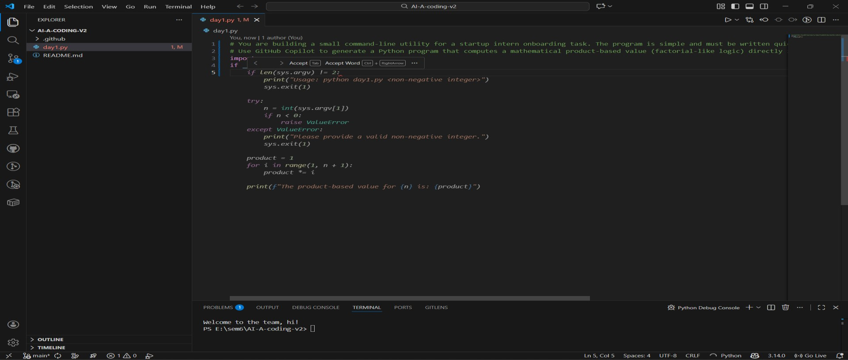
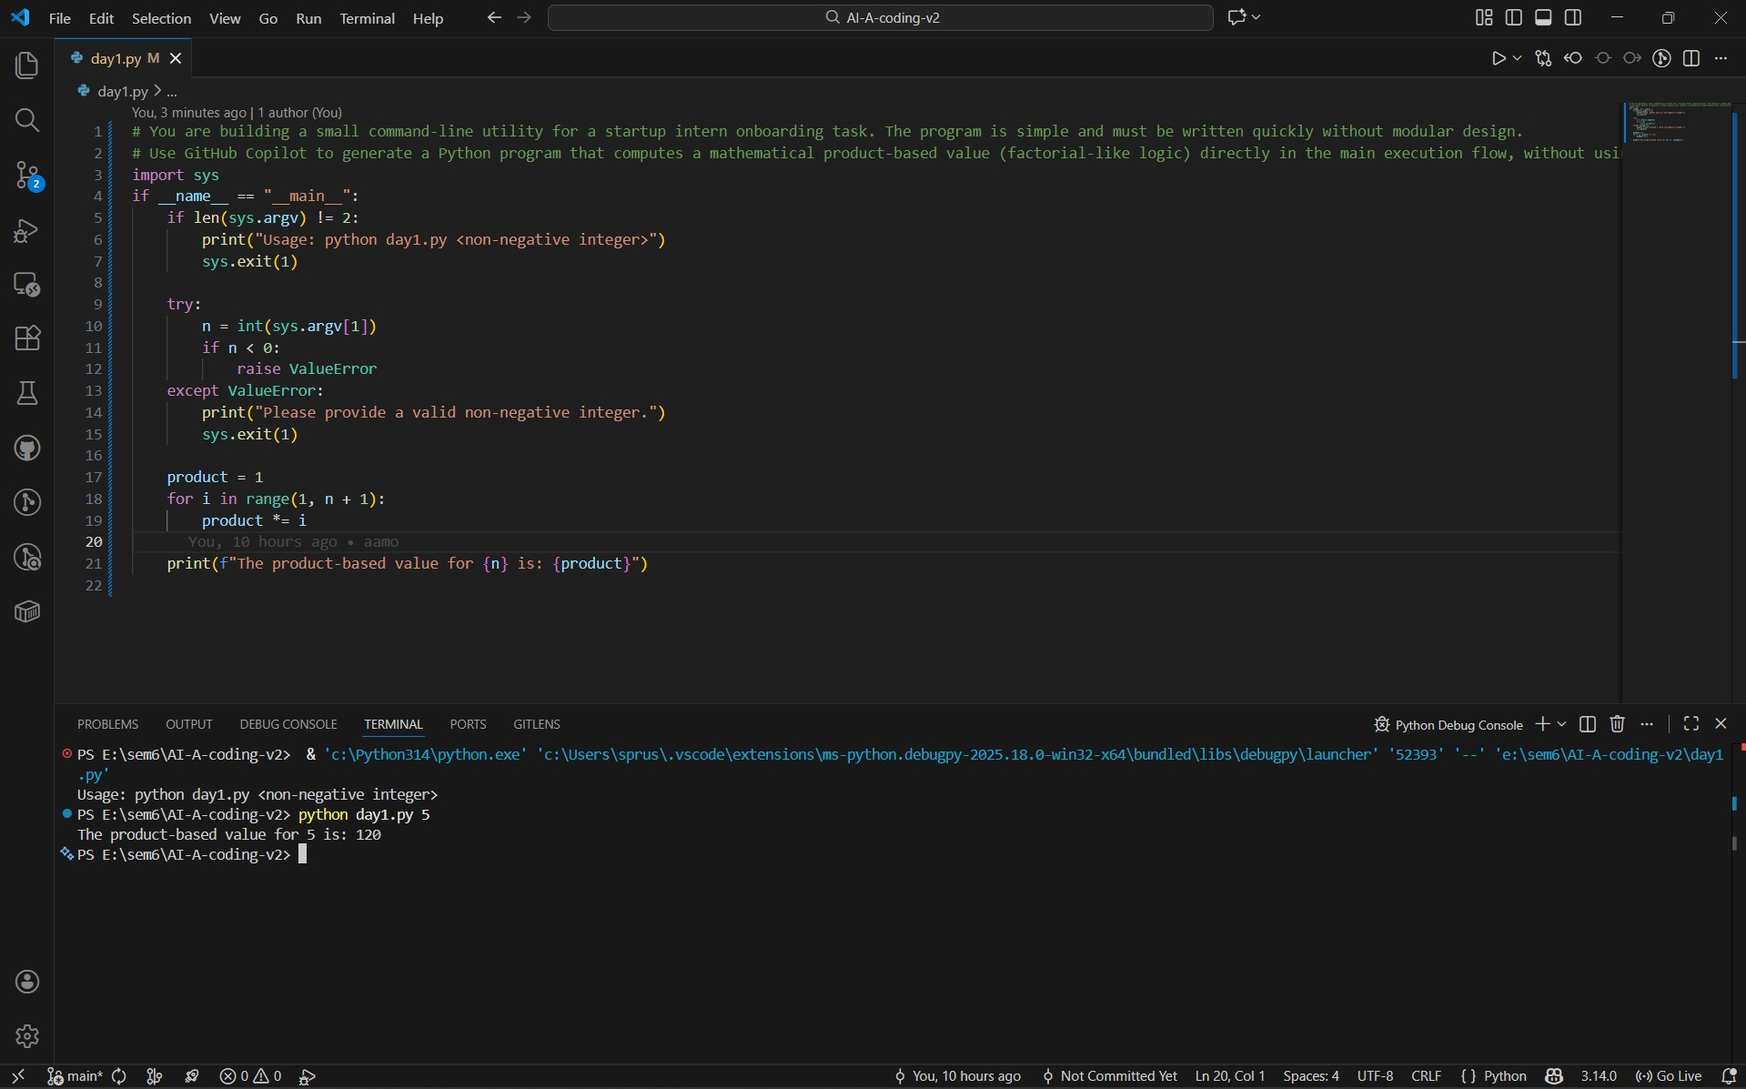

Task 2: AI Code Optimization & Cleanup (Improving Efficiency)
- Scenario
Your team lead asks you to review AI-generated code before committing it to a shared repository.
- Task Description
Analyze the code generated in Task 1 and use Copilot again to:
- Reduce unnecessary variables
- Improve loop clarity
- Enhance readability and efficiency Hint:
Prompt Copilot with phrases like
“optimize this code”, “simplify logic”, or “make it more readable”
❖ Expected Deliverables
- Original AI-generated code
- Optimized version of the same code
- Side-by-side comparison
- Written explanation:
▪ What was improved?
▪ Why the new version is better (readability, performance, maintainability.
Task 2: AI Code Optimization & Cleanup (Improving Efficiency)
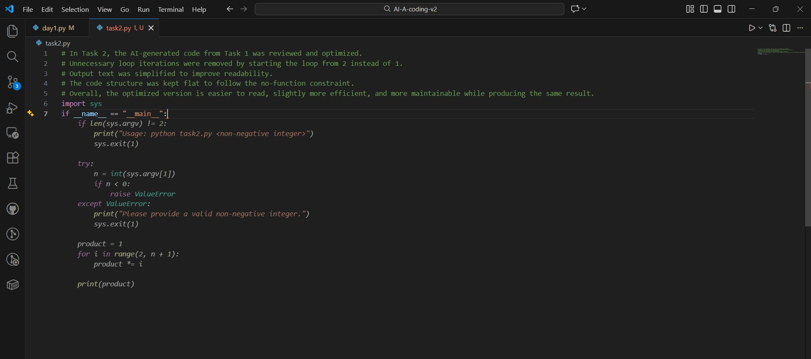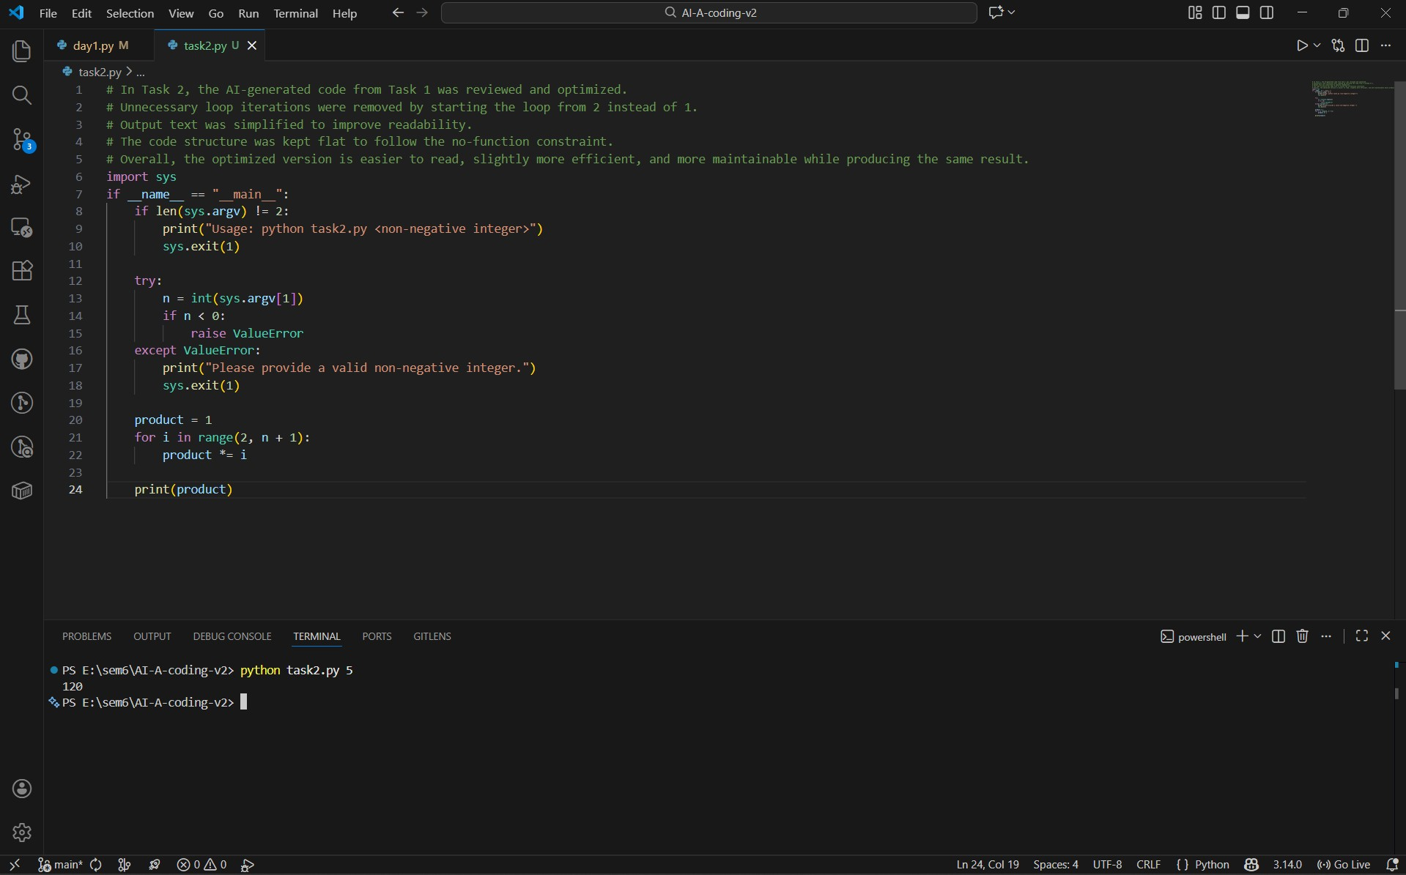

Task 3: Modular Design Using AI Assistance (Factorial with Functions) ❖ Scenario
The same logic now needs to be reused in multiple scripts.
❖ Task Description
Use GitHub Copilot to generate a modular version of the program by:
- Creating a user-defined function
- Calling the function from the main block
❖ Constraints
# Task 3: Modular Design Using AI Assistance (Factorial with Functions)
- Use meaningful function and variable names
- Include inline comments (preferably suggested by Copilot)
❖ Expected Deliverables
- AI-assisted function-based program
- Screenshots showing:
o Prompt evolution o Copilot-generated function logic
- Sample inputs/outputs
- Short note: o How modularity improves reusability.
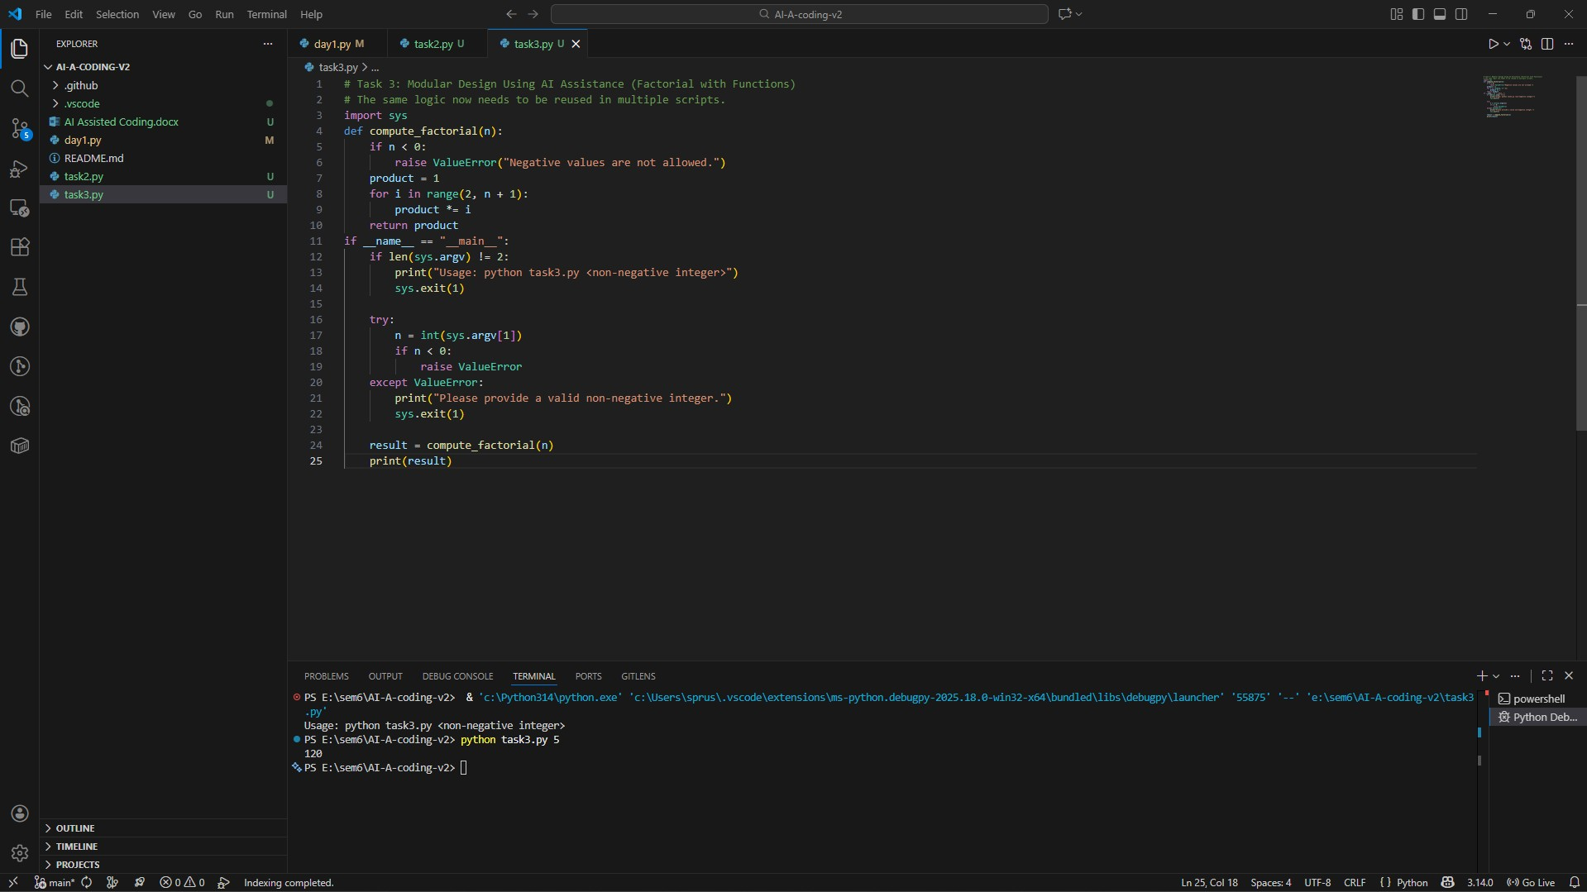
Short Note: How Modularity Improves Reusability
Modularity helps in reusability by helping separate logic in terms of different functions which may be reused in multiple programs. The factorial computation is put in a function which makes the code easier to maintain and test. If the logic has to be changed, changes can be made at one place without having any impact on the whole program. Modular code is also more readable and easier to work on in a team environment.

Task 4: Comparative Analysis – Procedural vs Modular AI Code (With vs
Without Functions)
- Scenario
As part of a code review meeting, you are asked to justify design choices.
- Task Description
Compare the non-function and function-based Copilot-generated programs on the following criteria:
- Logic clarity
- Reusability
- Debugging ease
- Suitability for large projects
- AI dependency risk
❖ Expected Deliverables Choose one:
- A comparison table
OR
- A short technical report (300–400 words).

Task 4: Comparative Analysis – Procedural vs Modular AI Code (With vs Without Functions)
Criteria  Logic Clarity  Reusability  Debugging Ease  Suitability for Large Projects  AI Dependency  Risk | Procedural Code (Without Functions)  Logic is written in one continuous flow, which is easy to follow for very small programs but becomes cluttered as code grows.  Code cannot be reused easily because the logic is tightly coupled to the main execution block.  Debugging is harder since all logic exists in one block, making it difficult to isolate issues.  Not suitable for large projects as it leads to poor organization and low maintainability.  High risk, as beginners may copy AIgenerated code without understanding the full flow. | Modular Code (With Functions)  Logic is clearly separated into functions, making the purpose of each part easier to understand.  Function-based logic can be reused across multiple scripts by importing or calling the function.  Debugging is easier because errors can be traced to specific functions.  Well suited for large projects due to better structure, scalability, and teamwork support.  Lower risk, as modular structure encourages understanding of individual components.

Task 5: AI-Generated Iterative vs Recursive Thinking
- Scenario
Your mentor wants to test how well AI understands different computational paradigms.
- Task Description
Prompt Copilot to generate:
An iterative version of the logic
A recursive version of the same logic
- Constraints
Both implementations must produce identical outputs
Students must not manually write the code first
- Expected Deliverables
Two AI-generated implementations
Execution flow explanation (in your own words)
Comparison covering:
- Readability
- Stack usage
- Performance implications
- When recursion is not recommended.

Task 5: AI-Generated Iterative vs Recursive Thinking
Iterative Thinking -
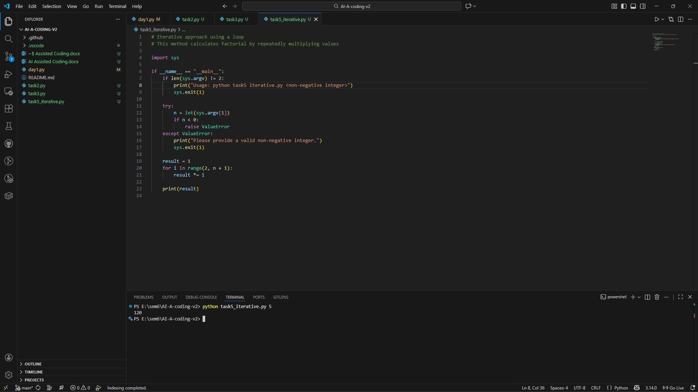

Recursive thinking –
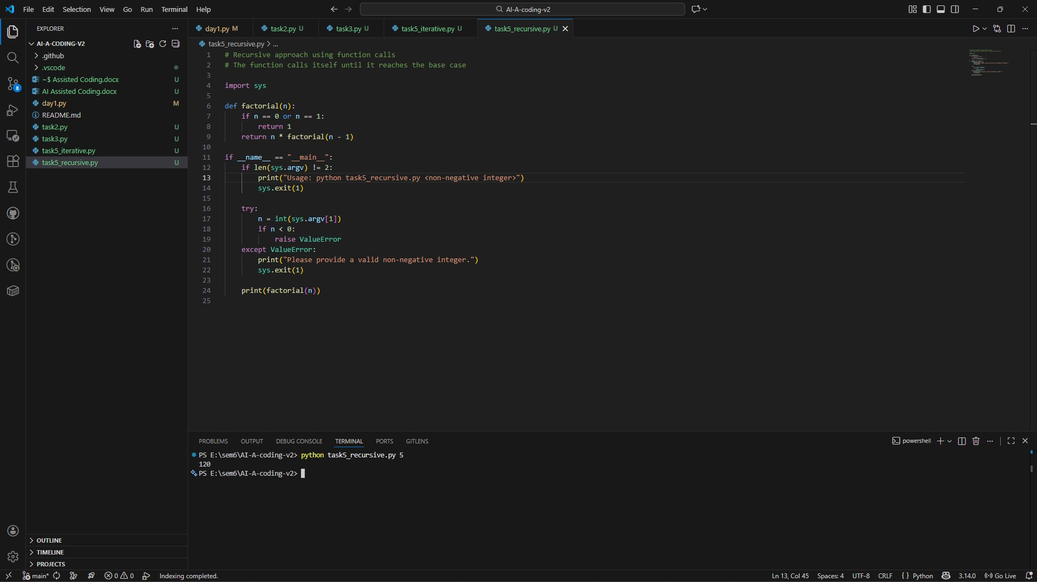

Aspect | Iterative Approach | Recursive Approach
Readability | Easy to understand for beginners | More mathematical and elegant
Stack Usage | Uses constant memory | Uses additional stack memory
Performance | Faster and memory efficient | Slower for large inputs
Error Risk | Low | Risk of stack overflow
When Not  Recommended | — | Not recommended for large input values

Assignment -1.5
AI Assisted Coding
Name:M. Sprusheeth Rao
Roll Number: 2303A51194
Batch - 04
09-01-2026
Task 0: Environment Setup:-
Task 0
- Install and configure GitHub Copilot in VS Code. Take screenshots of each step.
Expected Output
- Install and configure GitHub Copilot in VS Code. Take screenshots of each step.
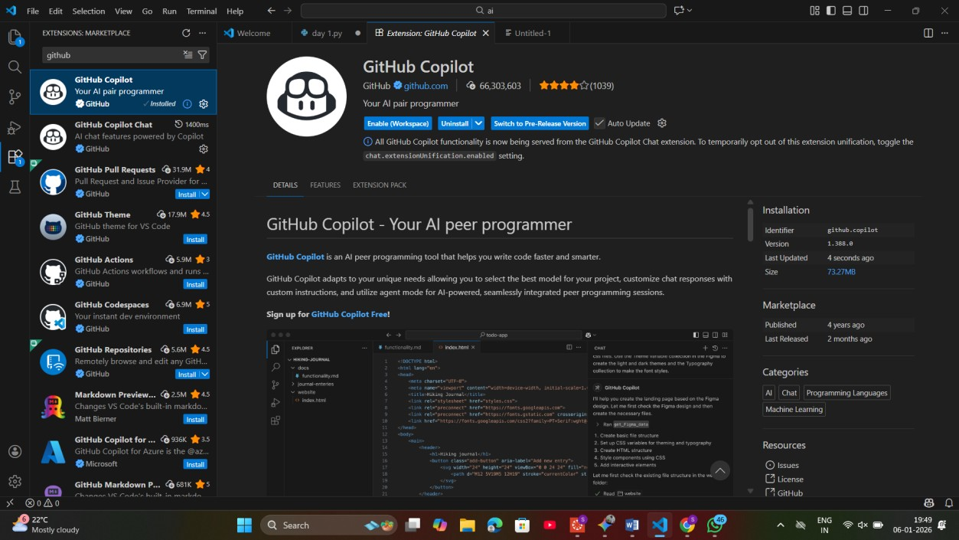

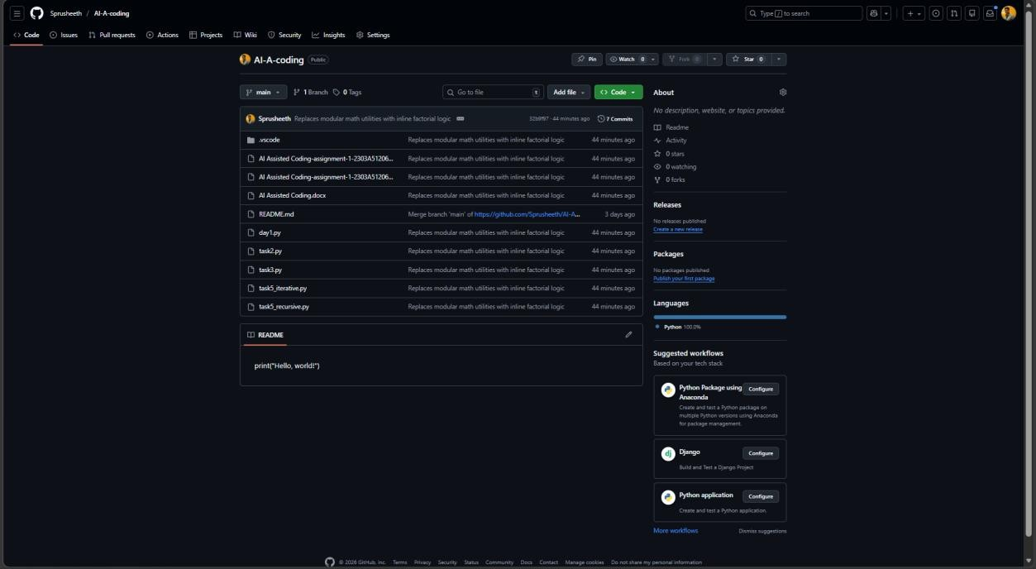
Task 1: Non-Modular Logic (Factorial):-
: AI-Generated Logic Without Modularization (String Reversal Without
Functions)
- Scenario
You are developing a basic text-processing utility for a messaging application.
- Task Description
Use GitHub Copilot to generate a Python program that:
- Reverses a given string
- Accepts user input
- Implements the logic directly in the main code
- Does not use any user-defined functions
❖ Expected Output
- Correct reversed string
- Screenshots showing Copilot-generated code suggestions
- Sample inputs and outputs
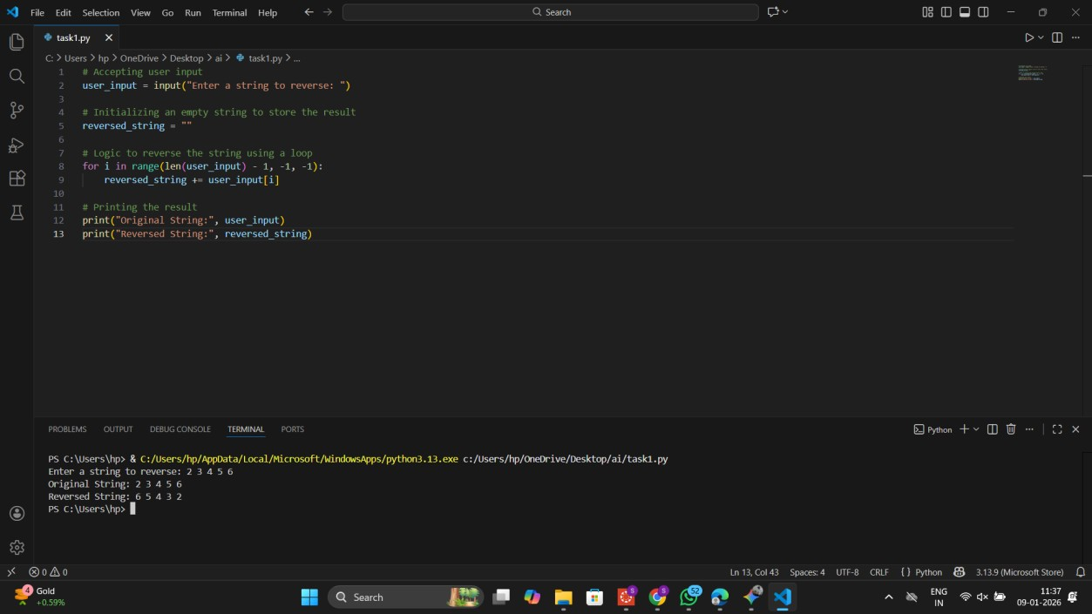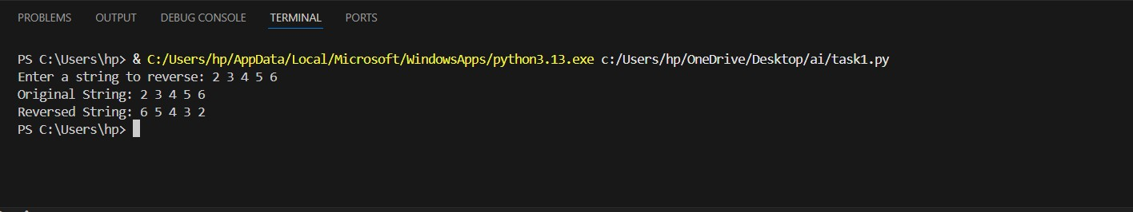
Task 2: AI Code Optimization:-
Efficiency & Logic Optimization (Readability Improvement)
- Scenario
The code will be reviewed by other developers.
- Task Description
Examine the Copilot-generated code from Task 1 and improve it by:
- Removing unnecessary variables ➢ Simplifying loop or indexing logic
- Improving readability
- Use Copilot prompts like:
▪ “Simplify this string reversal code”
▪ “Improve readability and efficiency”
Hint:
Prompt Copilot with phrases like
“optimize this code”, “simplify logic”, or “make it more readable”
❖ Expected Output
- Original and optimized code versions
- Explanation of how the improvements reduce time complexity
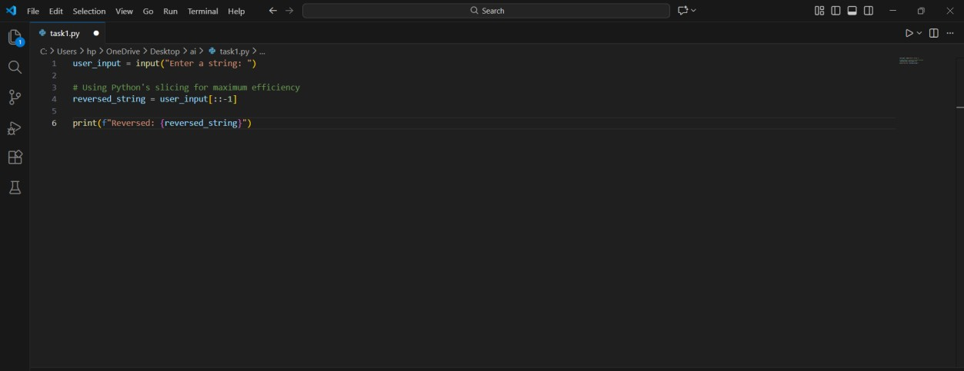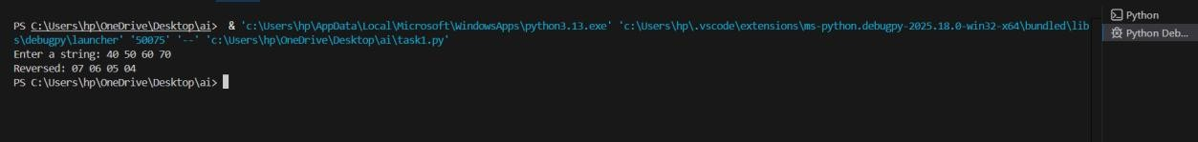
Task 3: Modular Design Using AI Assistance (String Reversal Using Functions)
- Scenario
The string reversal logic is needed in multiple parts of an application.
- Task Description
Use GitHub Copilot to generate a function-based Python program that:
- Uses a user-defined function to reverse a string
- Returns the reversed string
- Includes meaningful comments (AI-assisted)
❖ Expected Output
- Correct function-based implementation
- Screenshots documenting Copilot’s function generation
- Sample test cases and outputs
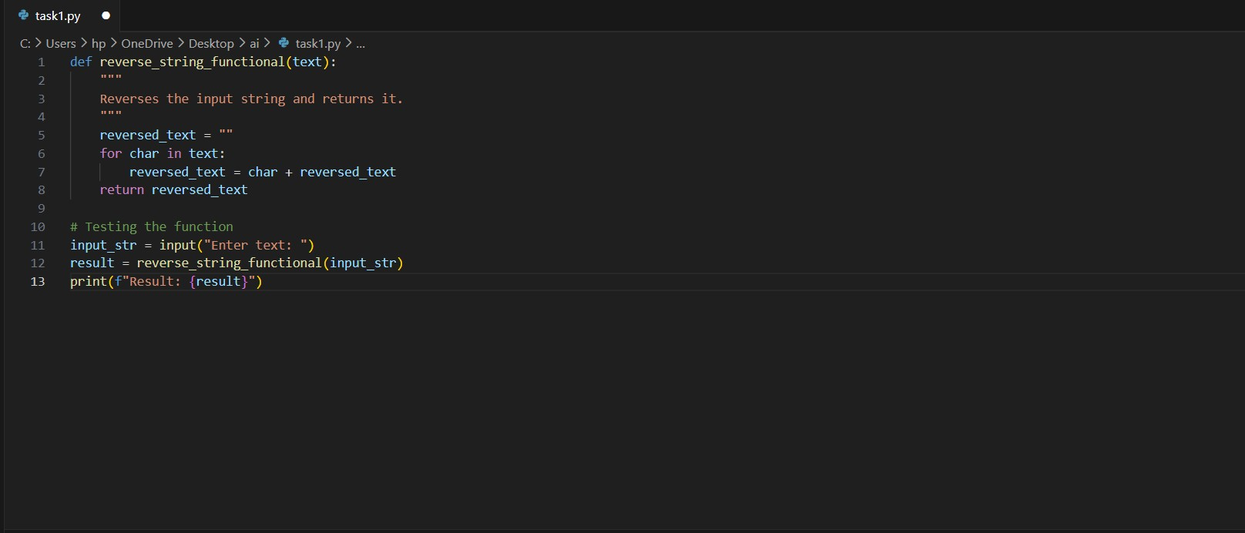
Task 4: Comparative Analysis – Procedural vs Modular Approach (With vs
Without Functions)
- Scenario
You are asked to justify design choices during a code review.
- Task Description
Compare the Copilot-generated programs:
- Without functions (Task 1)
- With functions (Task 3) Analyze them based on:
- Code clarity
- Reusability
- Debugging ease
- Suitability for large-scale applications
- Expected Output
Comparison table or short analytical report
Feature  Code  Clarity  Reusability  Debugging  Scalability | Procedural (Without Functions)  Easy for tiny scripts; messy for large ones.  Must copy-paste code to use it again.  Harder to isolate where an error occurs.  Not suitable for large applications. | Modular (With Functions)  Very high; logic is isolated and named.  Can be called anywhere in the app.  Easy to unit test the specific function.  Essential for professional development.

Task 5: AI-Generated Iterative vs Recursive Fibonacci Approaches (Different
Algorithmic Approaches to String Reversal)
- Scenario
Your mentor wants to evaluate how AI handles alternative logic paths.
- Task Description
Prompt GitHub Copilot to generate:
- A loop-based string reversal approach
- A built-in / slicing-based string reversal approach
❖ Expected Output
- Two correct implementations
- Comparison discussing:
▪ Execution flow
▪ Time complexity
▪ Performance for large inputs
▪ When each approach is appropriate.
