AI ASSISTED CODING
Nishath Afroze 2303A51212
BATCH – 04 07 – 04 – 2026

ASSIGNMENT – 20.2
Lab 20 : Security Testing : Identifying Vulnerabilities in AI – Generated Code.
Task – 01 : Password Security Enhancement.
Prompt : Generate a Python user registration and login script that stores usernames and passwords.
Code & Output :

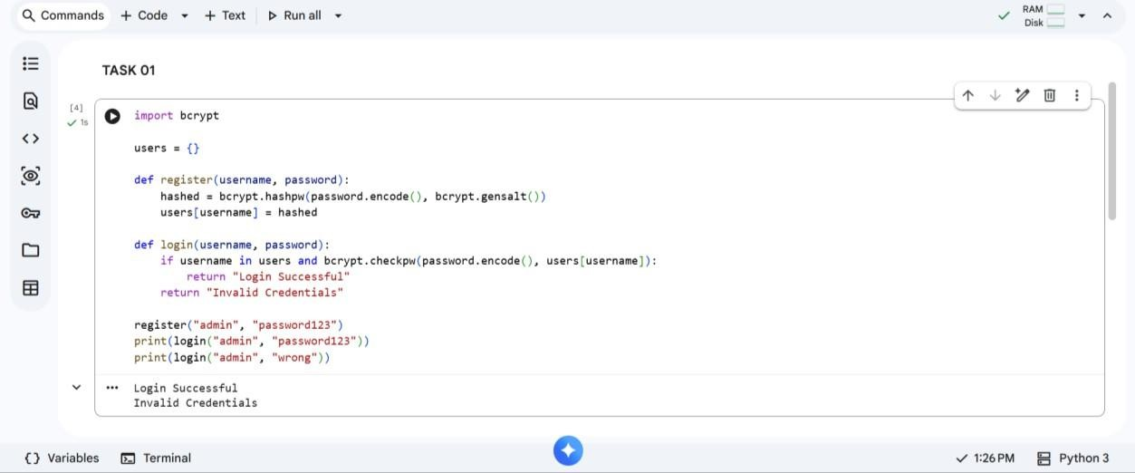

Explanation :
Plain text passwords are unsafe because they can be easily exposed in data breaches. Hashing converts passwords into irreversible values, improving security. bcrypt adds salting, preventing attacks like rainbow tables. The updated script securely verifies login without storing real passwords.
Task – 02 : Secure API Key Management.
Prompt : Generate a Python script that fetches data from an API using an API key.
Code :

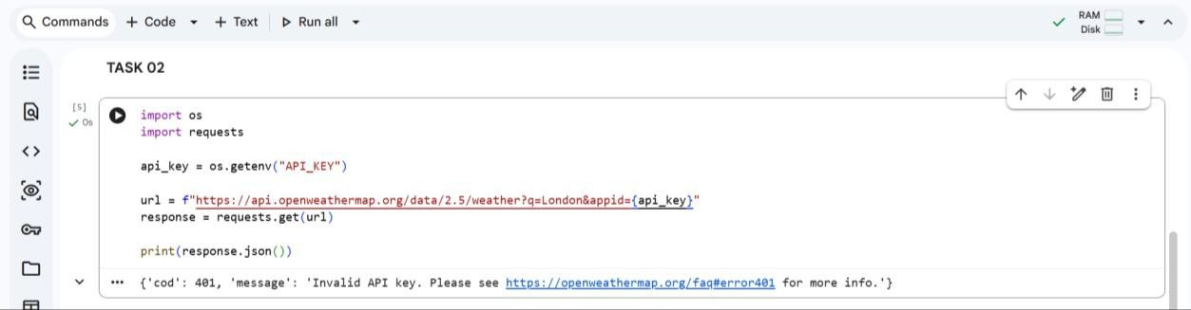

Output :

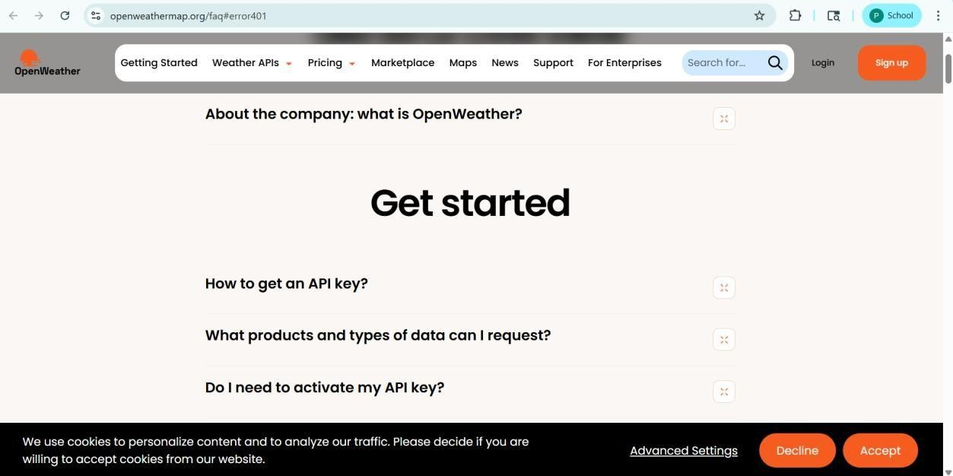

Explanation :
Hardcoding API keys exposes them in source code and version control. Environment variables securely store sensitive data outside the code. This prevents unauthorized access and improves deployment security. The script still works normally while keeping credentials hidden.
Task – 03 : Weak Encryption Detection.
Prompt : Generate a Python encryption-decryption program using a simple method.
Code & Output :

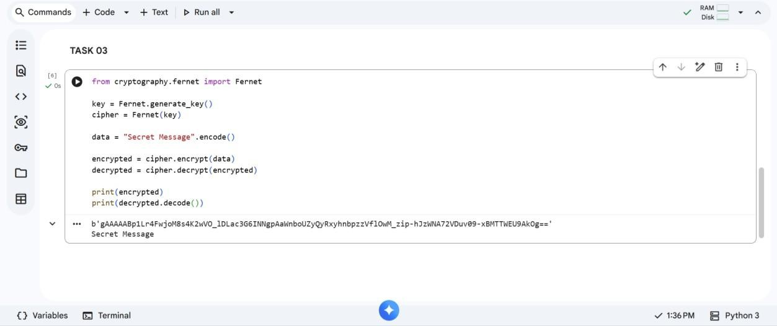

Explanation :
Basic encoding like base64 is reversible and not secure encryption. Fernet provides strong symmetric encryption using secure algorithms. Data cannot be decrypted without the correct key. This ensures confidentiality and protects sensitive information.

Task – 04 : Real Time Application : Security Review of AI – Generated Web Service.
Prompt : Generate a simple Flask API for user login.
Code & Output :

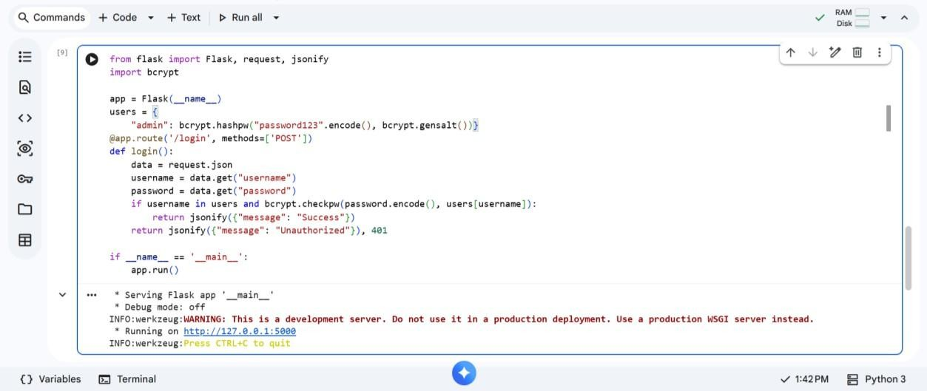
Explanation :
Common vulnerabilities include plain-text passwords, no validation, and insecure responses. bcrypt ensures passwords are securely stored and verified. Input is handled safely using JSON parsing. The API now reduces authentication risks and improves overall security.

Task – 05 : Exception Handling Improvement.
Prompt : Generate a Python program that takes two numbers and performs division.
Code & Output :

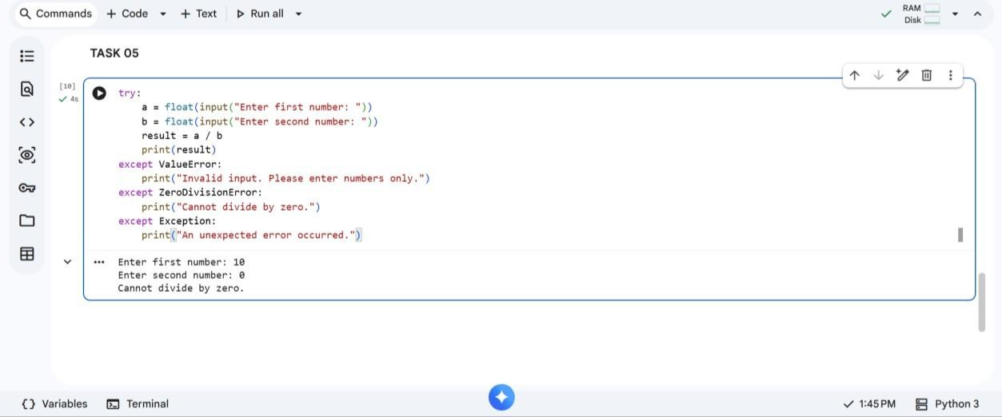
Explanation :
Programs without exception handling may crash during runtime errors. Invalid inputs and division by zero are common issues. try-except blocks ensure smooth execution and prevent crashes. Users receive clear error messages instead of program failure.

THANK YOU!!

