2303A51217 lab _5.5
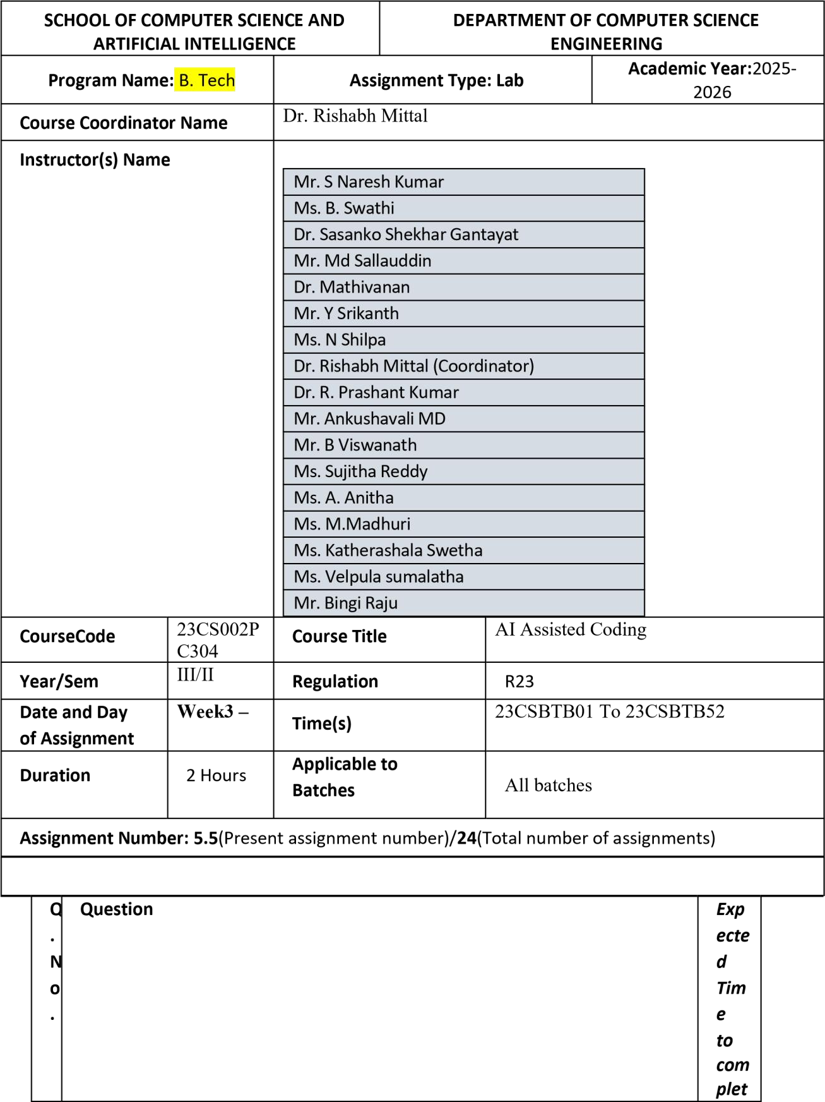

e

1 | Lab 5: Ethical Foundations – Responsible AI Coding Practices Lab Objectives:  - To explore the ethical risks associated with AI-generated code.  - To recognize issues related to security, bias, transparency, and copyright.  - To reflect on the responsibilities of developers when using AI tools in software development.  - To promote awareness of best practices for responsible and ethical AI coding.  Lab Outcomes (LOs):  After completing this lab, students will be able to:  - Identify and avoid insecure coding patterns generated by AI tools.  - Detect and analyze potential bias or discriminatory logic in AIgenerated outputs.  - Evaluate originality and licensing concerns in reused AIgenerated code.  - Understand the importance of explainability and transparency in AI-assisted programming.  - Reflect on accountability and the human role in ethical AI coding practices.  Task Description #1 (Transparency in Algorithm Optimization)  Task: Use AI to generate two solutions for checking prime numbers:  - Naive approach(basic)  - Optimized approach Prompt:  “Generate Python code for two prime-checking methods and explain how the optimized version improves performance.” Expected Output:  - Code for both methods. | Wee  k3 -

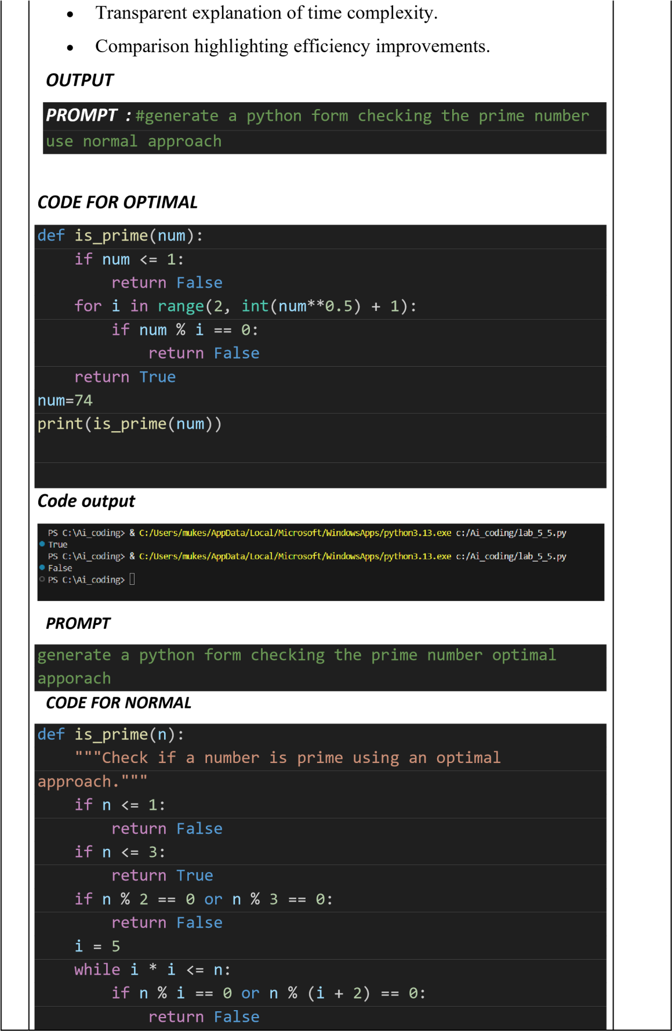

 |   CODE OUTPUT i |   += | 6
 |     return | True


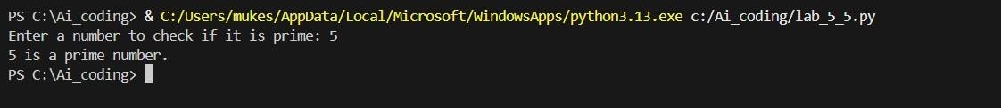
def main try

():

:






num = int ( input( "Enter a number to check if it is prime: ")) if is_prime ( num):
print ( f " {num } is a prime number." ) else :
print ( f " {num } is not a prime number." ) except ValueError :
print ( "Please enter a valid integer." ) if __name__ == "__main__" :
main ()
EXPLANATION
- The naive prime-checking approach tests all numbers up to n, which makes it slow for large inputs.
- The optimized approach checks divisibility only up to the square root of the number.
- If a number has a factor greater than √n, it must also have a smaller corresponding factor.
- This reduces the number of iterations and improves performance significantly.
- Therefore, the optimized method is faster, efficient, and suitable for real-world applications.

Task Description #2 (Transparency in Recursive Algorithms) Objective: Use AI to generate a recursive function to calculate Fibonacci numbers.
Instructions:
- Ask AI to add clear comments explaining recursion.
- Ask AI to explain base cases and recursive calls.
Expected Output:
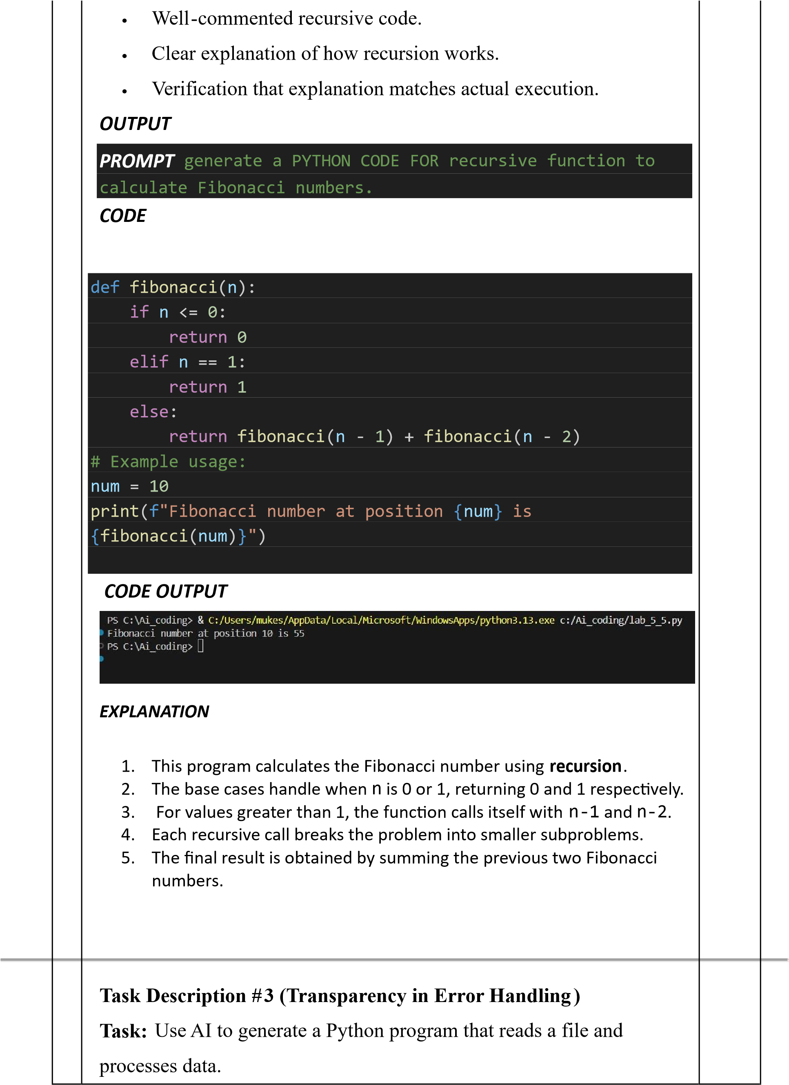
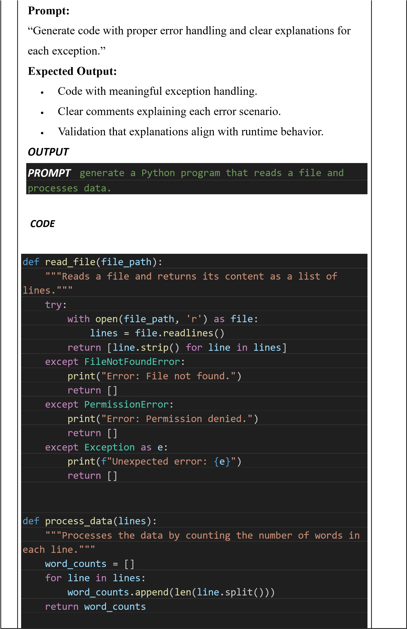

def main():
file_path = 'data.txt' lines = read_file(file_path)

if lines:
word_counts = process_data(lines) for i, count in enumerate(word_counts):
print(f"Line {i + 1}: {count} words")

if __name__ == "__main__":
main()

EXPLANATION
- This program reads data from a text file using safe file-handling practices.
- Exception handling is used to manage file not found and permission errors.
- Each line of the file is processed to count the number of words.
- The logic is divided into functions for better clarity and reuse.
- This ensures reliable, transparent, and error-free program execution.
Task Description #4 (Security in User Authentication)
Task: Use an AI tool to generate a Python-based login system.
Analyze: Check whether the AI uses secure password handling practices.
Expected Output:
  - Identification of security flaws (plain-text passwords, weak validation).
  - Revised version using password hashing and input validation.
  - Short note on best practices for secure authentication.
OUTPUT
PROMPT

# generate a Python-based login system Check whether the AI uses secure password handling practices.

