Assignment 9.3
2303A51246
KOPPU SHIVA
Batch – 18
Task Description #1: Basic Docstring Generation
Scenario
You are developing a utility function that processes numerical lists and must be properly
documented for future maintenance.
Requirements
- Write a Python function to return the sum of even numbers and sum of odd numbers in a
given list
- Manually add a Google Style docstring to the function
- Use an AI-assisted tool (Copilot / Cursor AI) to generate a function-level docstring
- Compare the AI-generated docstring with the manually written docstring
- Analyze clarity, correctness, and completeness
Expected Output
- Python function with manual Google-style docstring
- AI-generated docstring for the same function
- Comparison explaining differences between manual and AI-generated documentation
- Improved understanding of AI-generated function-level documentation Prompt :
#1.Task 1: Basic Docstring Generation
#Generate a Google-style function-level docstring for the following Python function that calculates the sum of even and odd numbers in a list.
#The docstring should describe parameters, return values, and any possible errors.
#Compare the AI-generated docstring with the manually written docstring provided below.
# Manually written docstring for comparison
#printing the docstrings for comparison
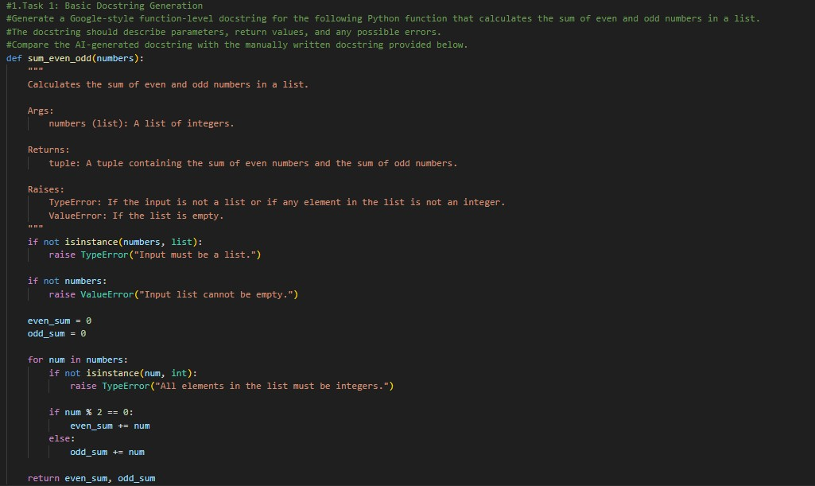
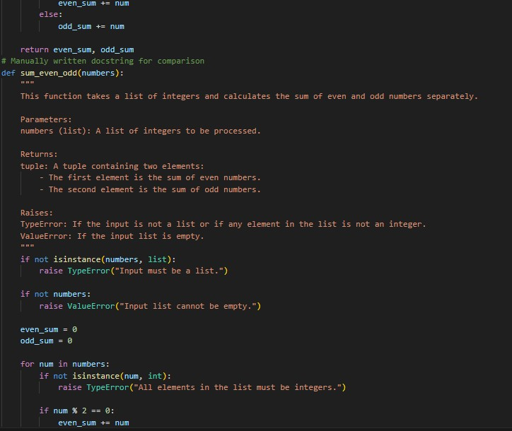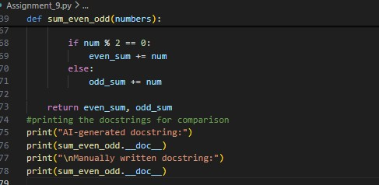

Output
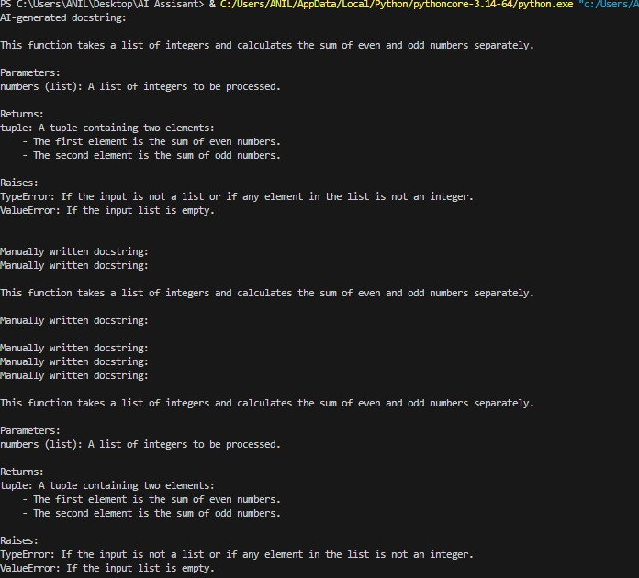

Analysis :

The manual docstring is more detailed and complete. It clearly describes the input type, return type, possible errors, and provides an example. This makes the function easier to understand and maintain.

This task helped me understand that AI can assist in generating documentation quickly, but manual refinement improves clarity and completeness.

Task Description #2 :
utomatic Inline Comments
Scenario
You are developing a student management module that must be easy to understand for new
developers.
Requirements
• Write a Python program for an sru_student class with the following:
- Attributes: name, roll_no, hostel_status
- Methods: fee_update() and display_details()
- Manually write inline comments for each line or logical block
- Use an AI-assisted tool to automatically add inline comments
- Compare manual comments with AI-generated comments
- Identify missing, redundant, or incorrect AI comments
Expected Output
- Python class with manually written inline comments
- AI-generated inline comments added to the same code
- Comparative analysis of manual vs AI comments
- Critical discussion on strengths and limitations of AI-generated comments Prompt :
##task2.automatic inline comment generation
#Add meaningful inline comments to the following Python class.
#The comments should explain each attribute, method, and logical block clearly so that new developers can easily understand the code.
# Constructor to initialize student details
# Method to update student fee
# Method to display student details

Code:
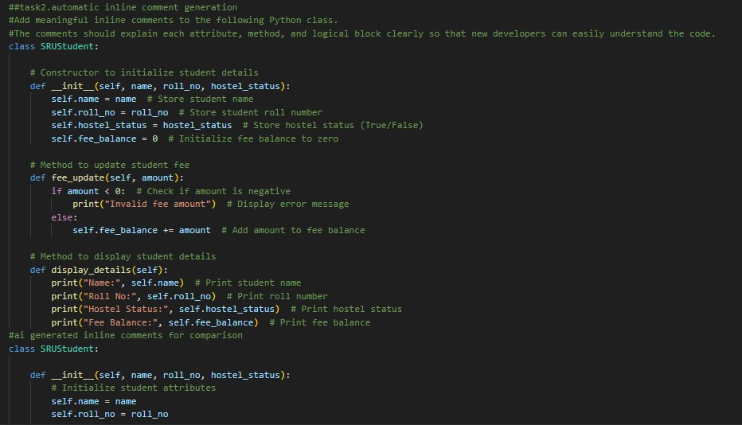
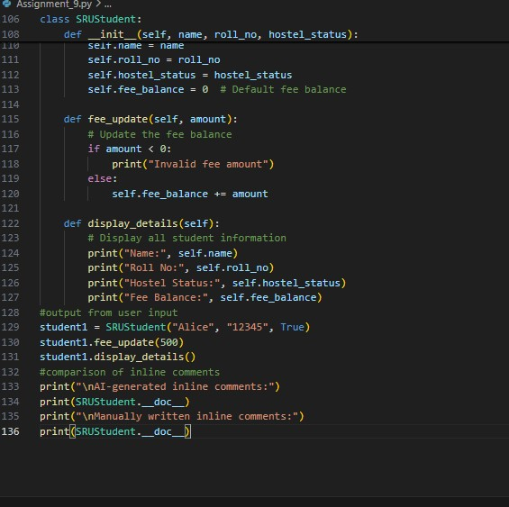
Output:
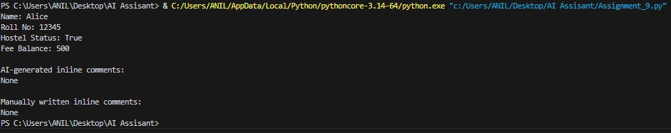

Analysis:
1.Manual comments provide deeper understanding.
2.AI comments are useful but sometimes lack detail.
3.Combining AI-generated comments with manual refinement gives the best result.
4.This task improved understanding of code documentation quality.

Task Description #3
Module-Level and Function-Level Documentation
Scenario
You are building a small calculator module that will be shared across multiple projects and
requires structured documentation.
Requirements
- Write a Python script containing 3–4 functions (e.g., add, subtract, multiply, divide)
- Manually write NumPy Style docstrings for each function
- Use AI assistance to generate:
- A module-level docstring
- Individual function-level docstrings
- Compare AI-generated docstrings with manually written ones
- Evaluate documentation structure, accuracy, and readability
Expected Output
- Python script with manual NumPy-style docstrings
- AI-generated module-level and function-level documentation
- Comparison between AI-generated and manual documentation
- Clear understanding of structured documentation for multi-function scripts
Additional Requirement
- Push the complete project documentation as a .md file to a GitHub repository
- Ensure documentation covers module overview and function descriptions Prompt :
##task3.Module-Level and Function-Level Documentation
##write a python program to build a small calculator module that will be shared across multiple projects.
#it should have the following functions: add(), subtract(), multiply(), divide() #Manually write NumPy Style docstrings for each function.

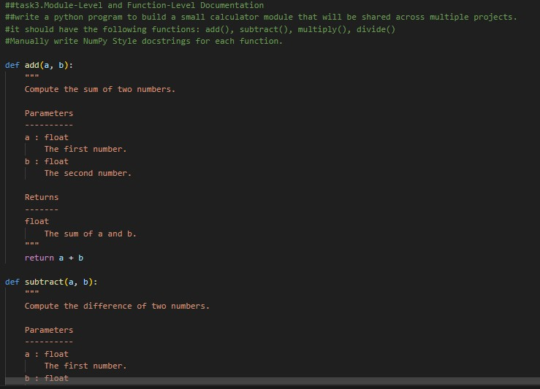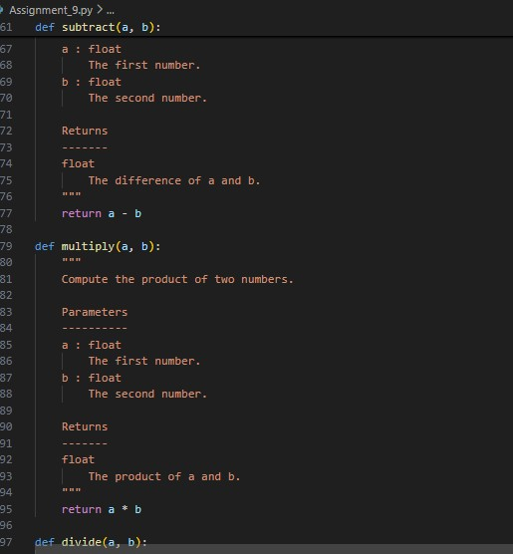

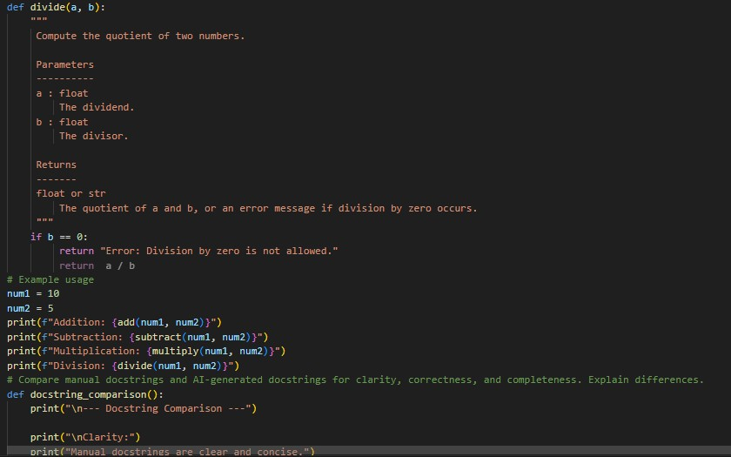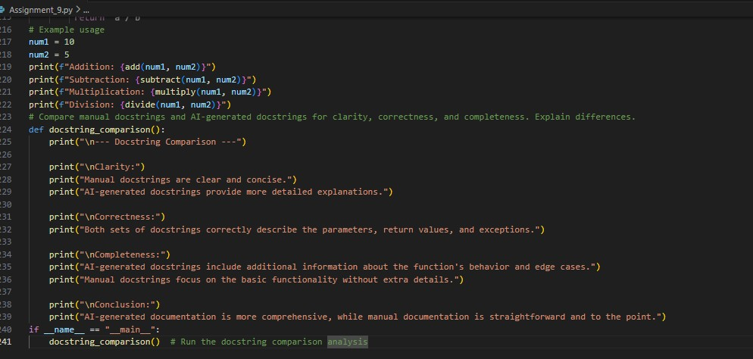

Output:
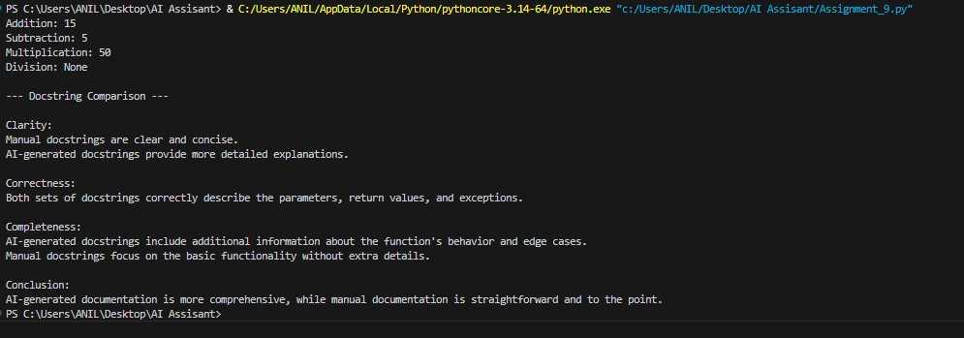

Analysis:
1.Difference between module-level and function-level documentation
2. AI-generated vs manual documentation comparison
3.Professional documentation for reusable modules

