ASSIGNMENT – 3.1

SHIVA KOPPU
2303A51246

Question 1: Zero-Shot Prompting (Palindrome Number Program)
Write a zero-shot prompt (without providing any examples) to generate
a Python function that checks whether a given number is a palindrome.
Task:
• Record the AI-generated code.
• Test the code with multiple inputs.
• Identify any logical errors or missing edge-case handling.

PROMPTING:
# write a python program for checking whether a given number is a palindrome or not
# and return if it is palindrome as true or false
CODE:
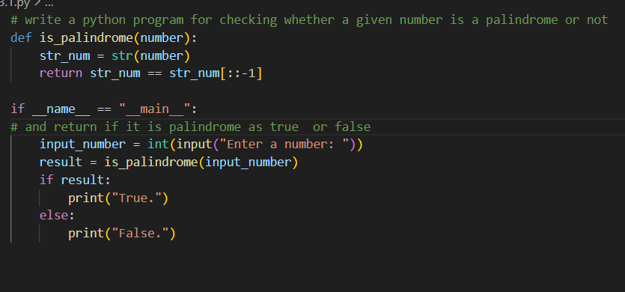
# write a python program for checking whether a given number is a palindrome or not
def is_palindrome(number):
str_num = str(number)
return str_num == str_num[::-1]

if __name__ == "__main__":
# and return if it is palindrome as true or false
input_number = int(input("Enter a number: "))
result = is_palindrome(input_number)
if result:
print("True.")
else:
print("False.")

OUTPUT:
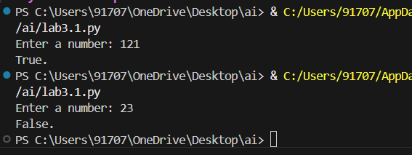
Question 2: One-Shot Prompting (Factorial Calculation)
Write a one-shot prompt by providing one input-output example and
ask the AI to generate a Python function to compute the factorial of a
given number.
Example:
Input: 5 → Output: 120
Task:
• Compare the generated code with a zero-shot solution.
• Examine improvements in clarity and correctness.
PROMPTING:
#write a program on factorial calculation
CODE:
#write a program on factorial calculation
def factorial(number):
if number < 0:
return "Factorial is not defined for negative numbers."
elif number == 0 or number == 1:
return 1
else:
result = 1
for i in range(2, number + 1):
result *= i
return result
if __name__ == "__main__":
input_number = int(input("Enter a number: "))
result = factorial(input_number)
print(f"The factorial of {input_number} is: {result}")
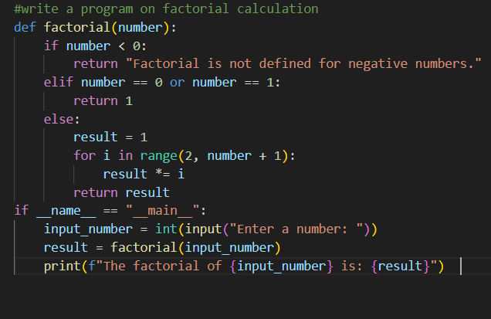
OUTPUT:
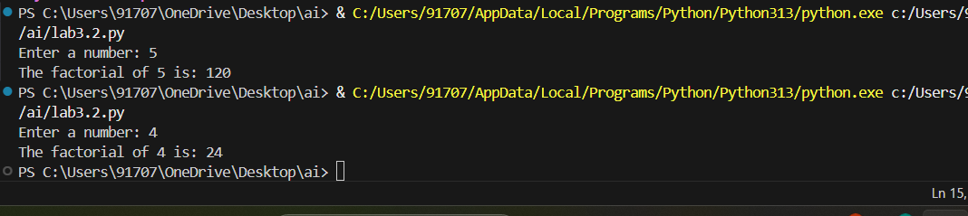
Question 3: Few-Shot Prompting (Armstrong Number Check)
Write a few-shot prompt by providing multiple input-output examples
to guide the AI in generating a Python function to check whether a
given number is an Armstrong number.
Examples:
• Input: 153 → Output: Armstrong Number
• Input: 370 → Output: Armstrong Number
• Input: 123 → Output: Not an Armstrong Number
Task:
• Analyze how multiple examples influence code structure and
accuracy.
• Test the function with boundary values and invalid inputs.

PROMPTING:
#write a progarm for amstrong number
CODE:
#write a progarm for amstrong number
def is_armstrong_number(number):
num_str = str(number)
num_digits = len(num_str)
sum_of_powers = sum(int(digit) ** num_digits for digit in num_str)
return sum_of_powers == number
if __name__ == "__main__":
input_number = int(input("Enter a number: "))
if is_armstrong_number(input_number):
print(f"{input_number} is an Armstrong number.")
else:
print(f"{input_number} is not an Armstrong number.")
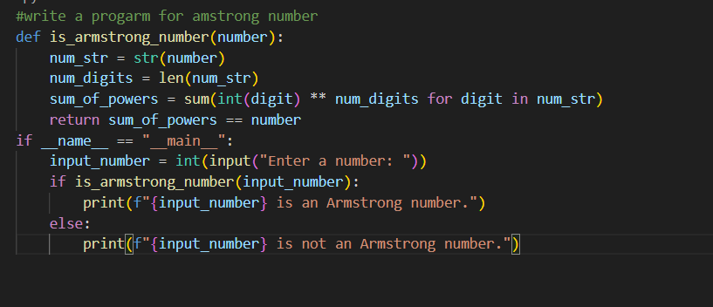
OUTPUT:
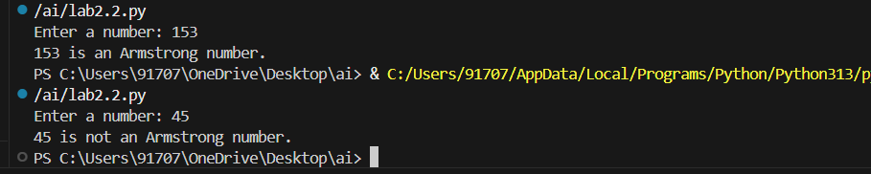

Question 5: Zero-Shot Prompting (Perfect Number Check)
Write a zero-shot prompt (without providing any examples) to
generate a Python function that checks whether a given number is a
perfect number.
Task:
• Record the AI-generated code.
• Test the program with multiple inputs.
• Identify any missing conditions or inefficiencies in the logic.
PROMPTING:
#write a program perfect number or not
CODE:
#write a program perfect number or not
def is_perfect_number(number):
if number < 1:
return False
sum_of_divisors = sum(i for i in range(1, number) if number % i == 0)
return sum_of_divisors == number
if __name__ == "__main__":
input_number = int(input("Enter a number: "))
result = is_perfect_number(input_number)
if result:
print(f"{input_number} is a perfect number.")
else:
print(f"{input_number} is not a perfect number.")

OUTPUT:
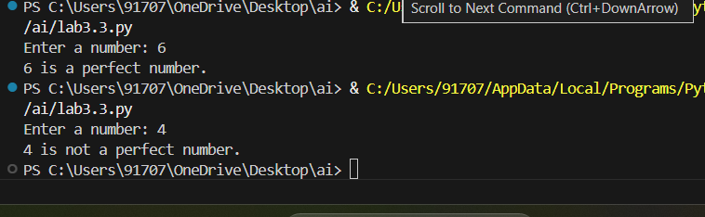
Question 6: Few-Shot Prompting (Even or Odd Classification with
Validation)
Write a few-shot prompt by providing multiple input-output
examples to guide the AI in generating a Python program that
determines whether a given number is even or odd, including proper
input validation.
Examples:
• Input: 8 → Output: Even
• Input: 15 → Output: Odd
• Input: 0 → Output: Even
Task:
• Analyze how examples improve input handling and output

PROMPTING:
#write a program for even or odd number
CODE:
#write a program for even or odd number
def is_even_or_odd(number):
if number % 2 == 0:
return "Even"
else:
return "Odd"

if __name__ == "__main__":

input_number = int(input("Enter a number: "))
result = is_even_or_odd(input_number)
print(f"{input_number} is an {result} number.")
OUTPUT:
