ASSIGNMENT – 4.3

2303a51246
shiva

Task 1:
Zero-Shot Prompting – Leap Year Check
Scenario
Zero-shot prompting involves giving instructions without providing examples.
Task Description
Use zero-shot prompting to instruct an AI tool to generate a Python function that:
• Accepts a year as input
• Checks whether the given year is a leap year
• Returns an appropriate result
Note: No input-output examples should be provided in the prompt.
Expected Output
• AI-generated leap year checking function
• Correct logical conditions
• Sample input and output
• Screenshot of AI-generated response (if required)

PROMPT:
#write a program to validate a leap year or not
CODE:
#write a program to validate a leap year or not
def is_leap_year(year):
if (year % 4 == 0 and year % 100 != 0) or (year % 400 == 0):
return True
else:
return False
if __name__ == "__main__":
input_year = int(input("Enter a year: "))
if is_leap_year(input_year):
print(f"{input_year} is a leap year.")
else:
print(f"{input_year} is not a leap year.")
OUTPUT:
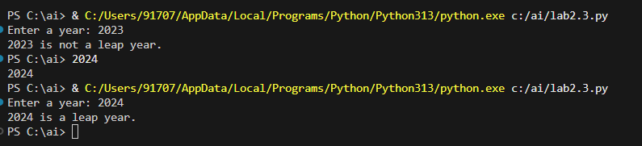

Task 2:
One-Shot Prompting – Centimeters to Inches Conversion
Scenario
One-shot prompting guides AI using a single example.
Task Description
Use one-shot prompting by providing one input-output example to generate a Python
function that:
• Converts centimeters to inches
• Uses the correct mathematical formula
Example provided in prompt:
Input: 10 cm → Output: 3.94 inches
Expected Output
• Python function with correct conversion logic
• Accurate calculation
• Sample test cases and outputs
PROMPT:
#write a program to convert centimeters to inches

CODE:
#write a program to convert centimeters to inches
def cm_to_inches(cm):
inches = cm / 2.54
return inches
if __name__ == "__main__":
input_cm = float(input("Enter length in centimeters: "))
result_inches = cm_to_inches(input_cm)
print(f"{input_cm} cm is equal to {result_inches} inches.")

OUTPUT:
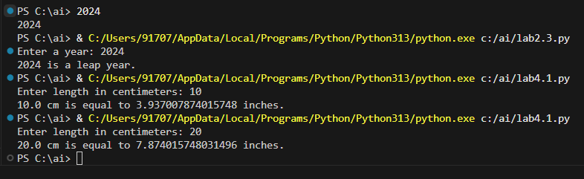

Task 3:
Few-Shot Prompting – Name Formatting
Scenario
Few-shot prompting improves accuracy by providing multiple examples.
Task Description
Use few-shot prompting with 2–3 examples to generate a Python function that:
• Accepts a full name as input
• Formats it as “Last, First”
Example formats:
• "John Smith" → "Smith, John"
• "Anita Rao" → "Rao, Anita"
Expected Output
• Well-structured Python function
• Output strictly following example patterns
• Correct handling of names
• Sample inputs and outputs

PROMPT:
#write a program Accepts a full name as input and Returns the name formatted as "Last, First"
CODE:
#write a program Accepts a full name as input and Returns the name formatted as "Last, First"
def format_name(full_name):
names = full_name.split()
if len(names) >= 2:
last_name = names[-1]
first_name = " ".join(names[:-1])
return f"{last_name}, {first_name}"
return full_name

if __name__ == "__main__":
full_name = input("Enter your full name: ")
formatted_name = format_name(full_name)
print(f"Formatted name: {formatted_name}")
OUTPUT:
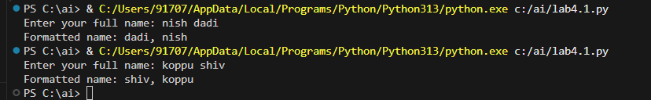

Task 4:
Comparative Analysis – Zero-Shot vs Few-Shot
Scenario
Different prompt strategies may produce different code quality.
Task Description
• Use zero-shot prompting to generate a function that counts vowels in a string
• Use few-shot prompting for the same problem
• Compare both outputs based on:
o Accuracy
o Readability
o Logical clarity
Expected Output
• Two vowel-counting functions
• Comparison table or short reflection paragraph
ZERO-SHOT CODE:
#Write a Python function to count the number of vowels in a given string.
def count_vowels(input_string):
vowels = "aeiouAEIOU"
count = 0
for char in input_string:
if char in vowels:
count += 1
return count
if __name__ == "__main__":
user_string = input("Enter a string: ")
vowel_count = count_vowels(user_string)
print(f"Number of vowels in the given string: {vowel_count}")

FEW-SHOT CODE:
# write a Python function to count the number of vowels in a given string.
# vouels = a, e, i, o, u
def count_vowels(input_string):
vowels = "aeiouAEIOU"
count = 0
for char in input_string:
if char in vowels:
count += 1
return count
if __name__ == "__main__":
user_string = input("Enter a string: ")
vowel_count = count_vowels(user_string)
print(f"Number of vowels in the given string: {vowel_count}")

OUTPUT:
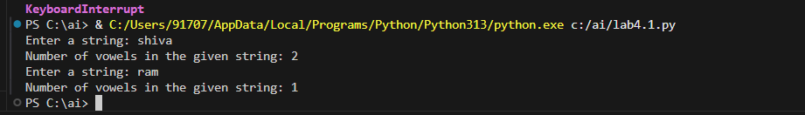

Task 5:
Few-Shot Prompting – File Handling
Scenario
File processing requires clear logical understanding.
Task Description
Use few-shot prompting to generate a Python function that:
• Reads a .txt file
• Counts the number of lines in the file
• Returns the line count
Expected Output
• Working Python file-processing function
• Correct line count
• Sample .txt input and output
• AI-assisted logic explanation

PROMPT:
#Act as a Python assistant.
#Write a Python program.
#The function should read a .txt file.
# The function should count the number of lines in the file
CODE:
#Act as a Python assistant.
#Write a Python program.
#The function should read a .txt file.
# The function should count the number of lines in the file
def count_lines_in_file(file_path):
try:
with open(file_path, 'r') as file:
lines = file.readlines()
return len(lines)
except FileNotFoundError:
print("The specified file was not found.")
return 0
if __name__ == "__main__":
file_path = input("Enter the path to the .txt file: ")
line_count = count_lines_in_file(file_path)
print(f"Number of lines in the file: {line_count}")
OUTPUT:
