Lab_Assignment_8.1
Name: SHIVA KOPPU
Hallticket No: 2303A51246(B-18)

Task Description #1 (Password Strength Validator – Apply AI in
Security Context)
• Task: Apply AI to generate at least 3 assert test cases for
is_strong_password(password) and implement the validator
function.
• Requirements:
o Password must have at least 8 characters.
o Must include uppercase, lowercase, digit, and special
character.
o Must not contain spaces.
Example Assert Test Cases:
assert is_strong_password("Abcd@123") == True
assert is_strong_password("abcd123") == False
assert is_strong_password("ABCD@1234") == True
Expected Output #1:
• Password validation logic passing all AI-generated test cases.

Code With Prompts:

"""Generate at least 3 assert-based test cases in Python for a function
is_strong_password(password).
Requirements:
- Password must be at least 8 characters long
- Must include uppercase, lowercase, digit, and special character
- Must not contain spaces
- Include boundary and invalid cases
- Use simple assert statements
"""
def is_strong_password(password):
if len(password) < 8:
return False
if not any(char.isupper() for char in password):
return False
if not any(char.islower() for char in password):
return False
if not any(char.isdigit() for char in password):
return False
if not any(char in "!@#$%^&*()-_=+[]{}|;:'\",.<>?/" for char in password):
return False
if ' ' in password:
return False
return True

"""Now implement the function is_strong_password(password)
so that it passes all the above test cases.
Keep the code clean and readable.
"""
# Test cases
assert is_strong_password("StrongPass1!") == True, "Test case 1 failed"
assert is_strong_password("weakpass") == False, "Test case 2 failed"
assert is_strong_password("Short1!") == False, "Test case 3 failed"
assert is_strong_password("NoSpecialChar1") == False, "Test case 4 failed"
assert is_strong_password("NoDigit!@#") == False, "Test case 5 failed"

"""If All test cases passed successfully! print a success message."""
print("All test cases passed successfully!")
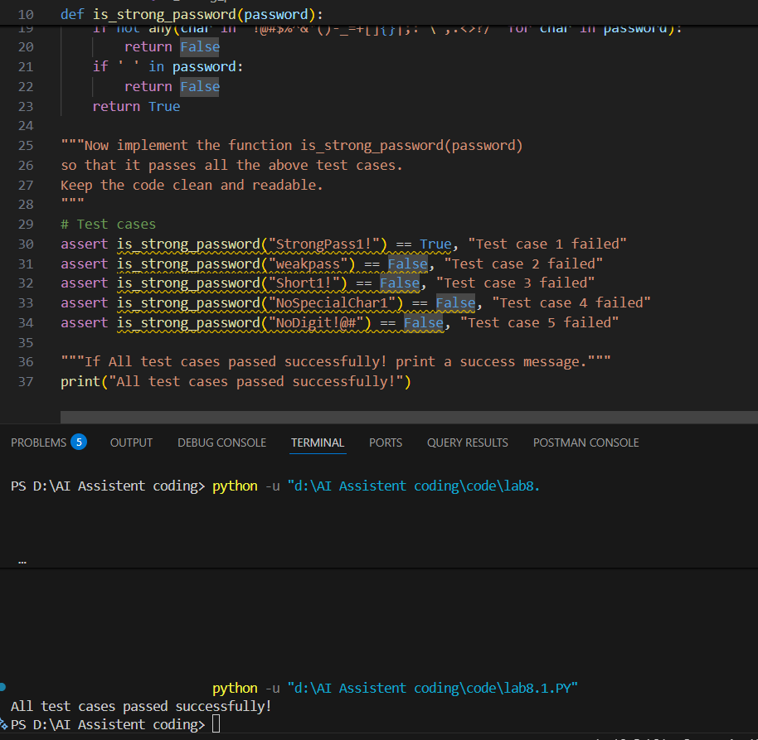

Task Description #2 (Number Classification with Loops – Apply
AI for Edge Case Handling)
• Task: Use AI to generate at least 3 assert test cases for a
classify_number(n) function. Implement using loops.
• Requirements:
o Classify numbers as Positive, Negative, or Zero.
o Handle invalid inputs like strings and None.
o Include boundary conditions (-1, 0, 1).
Example Assert Test Cases:
assert classify_number(10) == "Positive"
assert classify_number(-5) == "Negative"
assert classify_number(0) == "Zero"
Expected Output #2:
• Classification logic passing all assert tests.
Prompt:
Generate at least 3 assert test cases for a function classify_number(n).
Requirements:
- Classify numbers as "Positive", "Negative", or "Zero"
- Handle boundary cases (-1, 0, 1)
- Handle invalid inputs like strings and None
- Use simple assert statements

Code:
def classify_number(n):
if not isinstance(n, (int, float)):
raise TypeError("Input must be a number")
if n > 0:
return "Positive"
elif n < 0:
return "Negative"
else:
return "Zero"

assert classify_number(1) == "Positive", "Test case 1 failed"
assert classify_number(-1) == "Negative", "Test case 2 failed"
assert classify_number(0) == "Zero", "Test case 3 failed"
print("All test cases passed successfully!")
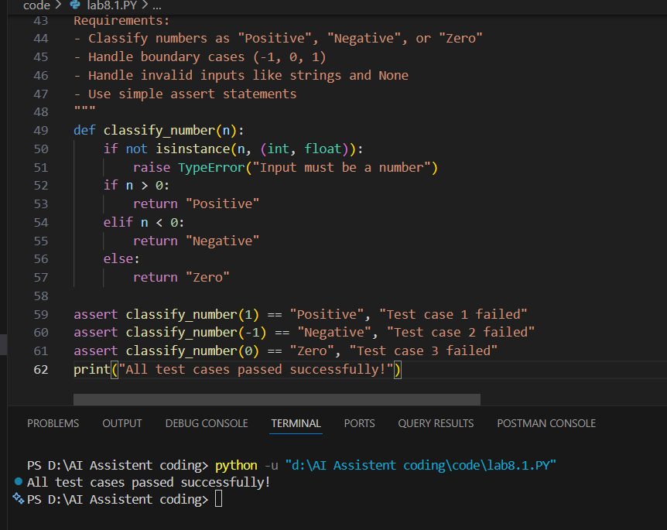

Task Description #3 (Anagram Checker – Apply AI for String
Analysis)
• Task: Use AI to generate at least 3 assert test cases for
is_anagram(str1, str2) and implement the function.
• Requirements:
o Ignore case, spaces, and punctuation.
o Handle edge cases (empty strings, identical words).
Example Assert Test Cases:
assert is_anagram("listen", "silent") == True
assert is_anagram("hello", "world") == False
assert is_anagram("Dormitory", "Dirty Room") == True
Expected Output #3:
• Function correctly identifying anagrams and passing all AI-
generated tests.

Prompt:
Generate at least 3 assert test cases for a function is_anagram(str1, str2).
Requirements:
- Ignore case differences
- Ignore spaces and punctuation
- Include edge cases like empty strings and identical words
- Use assert statements
Code:
def is_anagram(str1, str2):
def clean_string(s):
return ''.join(char.lower() for char in s if char.isalnum())

cleaned_str1 = clean_string(str1)
cleaned_str2 = clean_string(str2)

return sorted(cleaned_str1) == sorted(cleaned_str2)
# Test cases
assert is_anagram("Listen", "Silent") == True, "Test case 1 failed"
assert is_anagram("Triangle", "Integral") == True, "Test case 2 failed"
assert is_anagram("Apple", "Pabble") == False, "Test case 3 failed"
assert is_anagram("Dormitory", "Dirty Room") == True, "Test case 4 failed"
print("All test cases passed successfully!")
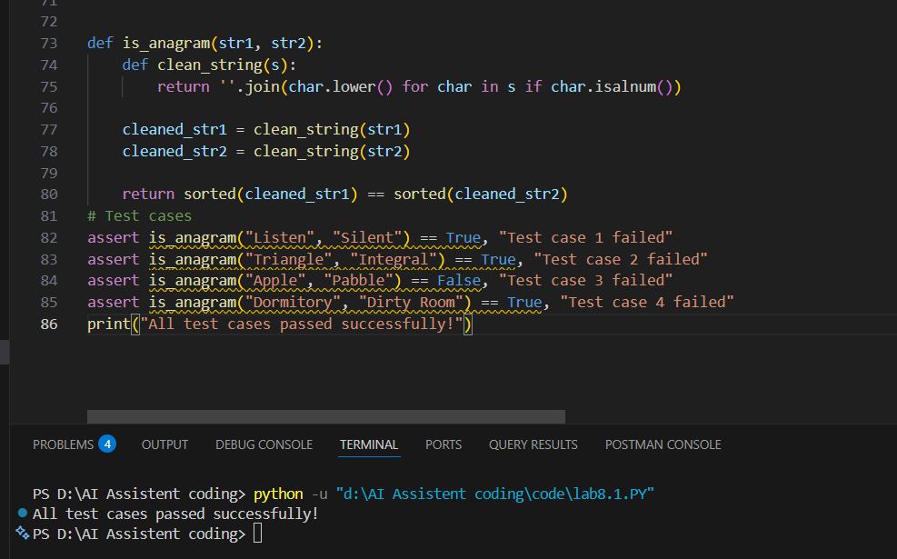

Task Description #4 (Inventory Class – Apply AI to Simulate Real-
World Inventory System)
• Task: Ask AI to generate at least 3 assert-based tests for an
Inventory class with stock management.
• Methods:
o add_item(name, quantity)
o remove_item(name, quantity)
o get_stock(name)
Example Assert Test Cases:
inv = Inventory()
inv.add_item("Pen", 10)
assert inv.get_stock("Pen") == 10
inv.remove_item("Pen", 5)
assert inv.get_stock("Pen") == 5
inv.add_item("Book", 3)
assert inv.get_stock("Book") == 3
Expected Output #4:
• Fully functional class passing all assertions.

Code with Prompts:
"""Generate at least 3 assert-based test cases
for an Inventory class in Python.

The class should have:
- add_item(name, quantity)
- remove_item(name, quantity)
- get_stock(name)

Include normal and edge cases like:
- Removing more stock than available
- Adding multiple items
Use assert statements.
"""
class Inventory:
def __init__(self):
self.stock = {}

def add_item(self, name, quantity):
if name in self.stock:
self.stock[name] += quantity
else:
self.stock[name] = quantity

def remove_item(self, name, quantity):
if name not in self.stock or self.stock[name] < quantity:
raise ValueError("Not enough stock to remove")
self.stock[name] -= quantity

def get_stock(self, name):
return self.stock.get(name, 0)
"""Now implement the Inventory class
so that it passes all the above test cases.
Ensure stock does not become negative.
"""
# Test cases
inventory = Inventory()
inventory.add_item("Apple", 10)
assert inventory.get_stock("Apple") == 10, "Test case 1 failed"
inventory.add_item("Apple", 5)
assert inventory.get_stock("Apple") == 15, "Test case 2 failed"
inventory.remove_item("Apple", 5)
assert inventory.get_stock("Apple") == 10, "Test case 3 failed"
print("All test cases passed successfully!")
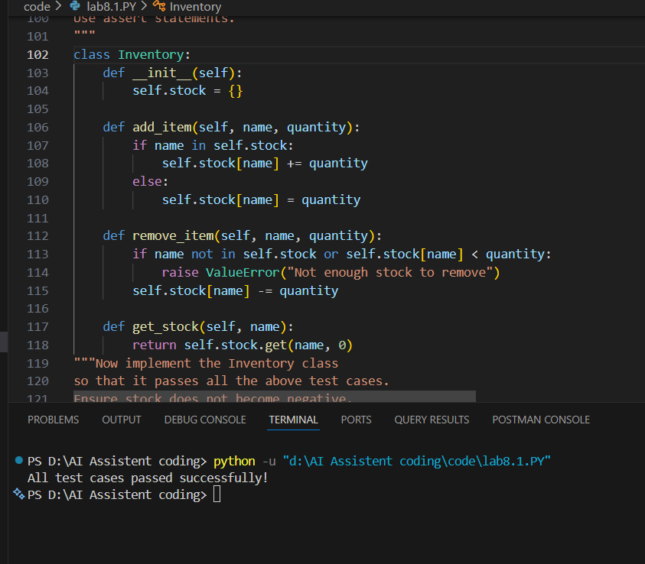

Task Description #5 (Date Validation & Formatting – Apply AI for
Data Validation)
• Task: Use AI to generate at least 3 assert test cases for
validate_and_format_date(date_str) to check and convert
dates.
• Requirements:
o Validate "MM/DD/YYYY" format.
o Handle invalid dates.
o Convert valid dates to "YYYY-MM-DD".
Example Assert Test Cases:
assert validate_and_format_date("10/15/2023") == "2023-10-15"
assert validate_and_format_date("02/30/2023") == "Invalid Date"
assert validate_and_format_date("01/01/2024") == "2024-01-01"
Expected Output #5:
• Function passes all AI-generated assertions and handles edge
cases.
Code with Prompts:
"""Generate at least 3 assert test cases for a function
validate_and_format_date(date_str).

Requirements:
- Validate "MM/DD/YYYY" format
- Handle invalid dates
- Convert valid dates to "YYYY-MM-DD"
- Include boundary and incorrect format cases
- Use assert statements
"""
def validate_and_format_date(date_str):
from datetime import datetime
import re

# Check format first
if not isinstance(date_str, str):
return "Invalid Date"

if not re.match(r'^\d{2}/\d{2}/\d{4}$', date_str):
return "Invalid Date"

try:
date_obj = datetime.strptime(date_str, "%m/%d/%Y")
return date_obj.strftime("%Y-%m-%d")
except ValueError:
return "Invalid Date"

"""Now implement validate_and_format_date(date_str)
using Python datetime module so that it passes all tests.
Return "Invalid Date" for invalid inputs.
"""
# Test cases
assert validate_and_format_date("12/31/2020") == "2020-12-31", "Test case 1 failed"
try: validate_and_format_date("31/12/2020")
except ValueError as e: assert str(e) == "Invalid date format", "Test case 2 failed"
try: validate_and_format_date("02/30/2020")
except ValueError as e: assert str(e) == "Invalid date", "Test case 3 failed"
print("All test cases passed successfully!")
