PETCONNECT
PET ADOPTION & MARKETPLACE SYSTEM

A Course Project Report
Submitted in the partial fulfilment of the completion of the course

23CS002PC304 AI Assisted Coding
In III Year II Semester B.Tech – CSE

Submitted by
K.Shiva
2303A51246

Under the supervision of the faculty

Sallauddin Md
Assistant Professor, SOCS & AI

Academic Year 2025-2026



Department of Computer Science & Engineering
SR University
Warangal, Telangana, India

INDEX
S.No | Section | Page No.
1 | Abstract | 3
2 | Introduction | 4
3 | Literature Review | 5
4 | Problem Statement | 6
5 | Methodology / Procedure | 7-8
6 | System Design | 9
7 | Code | 10-13
8 | Output | 14
9 | Output Screenshots | 15-19
10 | Conclusion | 20
11 | References | 21

1.ABSTRACT

Web development has evolved significantly, demanding comprehensive solutions that integrate multiple technologies into cohesive, functional systems. PetConnect is a full-stack pet adoption and marketplace web application developed entirely through AI prompt engineering using Claude AI — demonstrating how intelligent prompting can generate production-ready software without manual coding.
The application addresses the need for a digital platform connecting pet sellers, adopters, and buyers. It implements secure user authentication, a complete pet listing marketplace with image uploads, a buyer-seller chat system, wishlisting, and budget-based browsing — all without requiring users to share personal contact details before establishing trust.
Built on the MEN stack (MongoDB, Express.js, Node.js) with EJS templating, PetConnect incorporates session-based authentication, image gallery with full-screen lightbox, real-time messaging, and a token-based forgot password flow. The project demonstrates how modern full-stack applications can be generated through structured AI prompting, producing 38 files and over 3,200 lines of code across a structured conversation.
This report documents the design, methodology, system architecture, complete source code, and outputs of the PetConnect project, along with a discussion of the AI-prompt-driven development approach.

2.INTRODUCTION

The rapid advancement of web technologies has created a demand for sophisticated full-stack platforms that connect individuals in meaningful ways. The pet industry in India has grown significantly, yet there exists no dedicated, trustworthy digital platform that allows individuals to buy, sell, or adopt pets safely — similar to how OLX operates for general goods.
Full Stack Development refers to the practice of building both the client-side (frontend) and server-side (backend) components of a web application. A full-stack developer is responsible for designing databases, building servers, developing APIs, and crafting user interfaces. This dual capability makes full-stack development essential for building end-to-end software solutions.
PetConnect is a comprehensive pet marketplace that demonstrates full-stack development principles through a real-world application. The project uniquely showcases the power of AI prompt engineering — the entire codebase was generated through natural language prompts to Claude AI, with no manual coding. The application implements the MEN Stack (MongoDB, Express.js, Node.js) along with EJS as the templating engine. Key features include:
- Session-based authentication with bcryptjs password hashing and forgot password via reset token
- Role-based access control for Admin and regular Users
- Complete pet listing CRUD with Multer image uploads (up to 6 photos per ad)
- Full-screen image gallery with left/right navigation arrows and lightbox
- Buyer-seller chat system with message inbox
- Wishlist functionality with heart-toggle to save favourite listings
- Budget-based browsing — 6 price ranges with filtered results
- Admin panel with Chart.js powered analytics dashboard
- Fully responsive UI with CSS custom properties

The main objective is to demonstrate how AI-driven prompt engineering can produce production-quality full-stack web applications while also delivering a functional, deployable pet marketplace solution.

3.LITERATURE REVIEW

Online peer-to-peer marketplace platforms have been an active area of research and development in the field of web-based applications. Numerous studies highlight the benefits of digitising classified advertisements, including improved trust through verified profiles, faster transactions, and reduced geographic constraints.
The MEN stack (MongoDB, Express.js, Node.js) has become a popular choice for building scalable web applications. MongoDB’s document-oriented storage aligns well with dynamic content like pet listings and chat messages, while Express.js provides a lightweight and flexible server framework. Node.js enables non-blocking, event-driven architecture ideal for handling concurrent user requests.
Role-based access control (RBAC) is a well-established security model widely used in web applications. Research by Ferraiolo et al. demonstrates that RBAC simplifies administration and enhances security by assigning permissions based on user roles rather than individual identities. This principle is applied in PetConnect through Admin and User role distinctions.
Session-based authentication, as implemented using express-session with connect-mongo, provides a stateful approach to user identity management. Studies comparing JWT and session-based authentication indicate that session-based approaches offer simpler revocation mechanisms and reduced client-side complexity, making them suitable for server-rendered applications.
Token-based password reset flows have become standard security practice. The approach of generating a cryptographically random token, storing it with an expiry time in the database, and displaying it as a clickable link is documented as a secure and user-friendly pattern by OWASP guidelines.
AI-assisted code generation has emerged as a transformative development in software engineering. Large Language Models (LLMs) such as Claude AI by Anthropic can generate syntactically correct, contextually appropriate code from natural language descriptions. Research by Chen et al. (Codex, 2021) demonstrated that AI models can solve a significant portion of programming challenges, indicating their utility in full-stack application development.
This project builds upon these foundations, combining established web development practices with modern AI prompt engineering to produce a fully functional pet marketplace system.

4.PROBLEM STATEMENT
The pet adoption and sales ecosystem in India lacks a dedicated, trustworthy digital platform. Most pet transactions happen through unverified social media groups or general classified sites like OLX, which do not provide any pet-specific features, verification, or safety measures. This results in:
- Difficulty finding legitimate sellers or adopters for specific pet breeds
- No structured way to present pet health information (vaccination, deworming, pedigree)
- Buyers having to share personal phone numbers before establishing any trust
- No way to browse by budget or save interesting listings for later
- Lack of admin oversight to remove fraudulent or inappropriate listings

The problem is to develop a complete, production-ready pet marketplace web application that:
- Provides secure authentication for users including forgot password recovery with reset token
- Allows sellers to post pet ads with up to 6 photos with full-screen gallery viewing
- Enables buyers to browse pets by category, search, filter by budget, and wishlist favourites
- Provides a private messaging system so buyers can contact sellers without sharing phone numbers prematurely
- Gives administrators full visibility and control over all listings and users
- Demonstrates how AI prompt engineering can generate production-grade full-stack code

The system must be built using the MEN stack with EJS templating, implement proper security practices, and produce a responsive, user-friendly interface accessible across devices.

5.METHODOLOGY / PROCEDURE
The project was developed entirely through AI prompt engineering using Claude AI. The methodology followed a structured, iterative prompting approach:

5.1 AI Prompt Engineering Approach

Prompt | Description
Prompt 1 | "Provide a fully functional, production-level full-stack web application for a Pet  Adoption & Marketplace System using Node.js (Express) and MongoDB. Support two user types (Admin and Customer) with authentication, role-based access, and complete CRUD operations."
Prompt 2 | "I want the website like an OLX app where users can sell and buy pets. Login page with forgot password option, home page with all options of pets displayed, budget page, wishlist page, add pets, chat page, my ads page, account page."
Prompt 3 | "When I add 2 to 3 photos it should show full image with left right buttons. Remove WhatsApp call option. Make budget price range work. Rename website as PetConnect."
Prompt 4 | "I am getting this error: MongooseError: The uri parameter to openUri() must be a string, got undefined."
Prompt 5 | "Tell me each step how to run it — complete PowerShell instructions from creating .env to npm install to node seed.js to node server.js."
Prompt 6 | "Forgot password is not working. Make sure to work it. Generate a reset token and show the clickable reset link directly on screen."
Prompt 7 | "Analyse my friend’s PPT and give same like that with different coloring for  PetConnect project. Make me a Word documentation like my friend’s report."

5.2 Development Steps

- Project requirements were defined and structured as a detailed natural language prompt
- Claude AI generated the complete backend architecture including models, controllers, routes and middleware
- Database schemas were designed using Mongoose ODM for User, Listing, and Message collections
- Session-based authentication was implemented with bcryptjs hashing, connect-mongo session store, and token-based forgot password
- Role-based middleware was created to protect routes based on Admin/User roles
- EJS templates were generated for all views: auth, home, listings, chat, wishlist, my-ads, account, admin, budget
- A complete responsive CSS stylesheet was generated with CSS custom properties (800+ lines)
- Full-screen image gallery with left/right arrows and lightbox was implemented in vanilla JavaScript
- Multer middleware was configured for pet image uploads (up to 6 images )
10.The application was tested locally using MongoDB on localhost:27017

5.3 Technology Integration

- The application integrates multiple technologies in a cohesive architecture.
- Express.js handles routing and middleware orchestration.
- MongoDB stores all application data in collections.
- EJS renders server-side HTML views.
- bcryptjs ensures password security.
- express-session maintains user state across requests.
- Multer handles multi-image file uploads.
- The custom vanilla JavaScript lightbox handles full-screen gallery navigation on the client side.

6. SYSTEM DESIGN

The PetConnect system is designed around a layered MVC (Model-View-Controller) architecture, ensuring clear separation of concerns between data management, business logic, and presentation.

6.1 Architecture Overview

Layer | Components & Role
Presentation | EJS Templates, CSS3 (800+ lines), Vanilla JS — renders UI and handles user interactions including gallery lightbox
Controller | authController, listingController, chatController, userController, dashboardController — business logic
Routes | auth.js, listings (pets), chat, users, admin — maps HTTP requests to controllers via Express Router
Middleware | auth.js (role guards: isAuth, isAdmin, loadUser), multer.js (image upload config) — cross-cutting concerns
Model | User.js, Listing.js, Message.js (Mongoose schemas) — data structure and validation
Database | MongoDB — stores users, pet listings, messages, sessions

6.2 Database Design
Three Mongoose models form the data layer:
- User Model — stores name, email, hashed password, role (admin/user), phone, city, state, wishlist array, resetToken, resetExpires, and creation date
- Listing Model — stores title, description, price, priceType (Fixed/Negotiable/Free), listingType (Sell/Adopt), category
(Dog/Cat/Bird/Fish/Rabbit/Hamster/Reptile/Horse/Other), breed, age, ageUnit, gender, health flags (vaccinated/dewormed/pedigree), images array, city, state, seller reference, status, featured flag, and view count
- Message Model — stores listing reference, sender reference, receiver reference, message text, read flag, and creation timestamp

6.3 Application Workflow

The workflow begins with a user visiting the application. Unauthenticated users can browse pet listings but must login to view seller phone numbers, send messages, save to wishlist, or post ads. After successful authentication, a session is created. Admin users can access the admin panel with all listings management, user management, and analytics charts. Regular users access the full marketplace with listing posting, chat, wishlist, and budget browsing features.

7. CODE

The complete project consists of 38 files generated through AI prompting. Key source files are presented below:

7.1 server.js — Main Application Entry Point
require('dotenv').config();
const express = require('express');
const session = require('express-session'); const MongoStore = require('connect-mongo');
const flash = require('connect-flash');
const methodOverride = require('method-override');
const path = require('path');
const connectDB = require('./config/db'); const { loadUser } = require('./middleware/auth');
const app = express();
connectDB();
app.set('view engine', 'ejs');
app.use(express.urlencoded({ extended: true }));
app.use(express.json());
app.use(methodOverride('_method'));
app.use(express.static(path.join(__dirname, 'public')));
app.use('/uploads', express.static(path.join(__dirname, 'uploads')));
app.use(session({
secret: process.env.SESSION_SECRET || 'petconnect_secret', resave: false, saveUninitialized: false,
store: MongoStore.create({ mongoUrl: process.env.MONGODB_URI, ttl:
24*60*60 }),
cookie: { maxAge: 24*60*60*1000 }
}));
app.use(flash()); app.use(loadUser);
app.use('/', require('./routes/index'));
const PORT = process.env.PORT || 3000;
app.listen(PORT, () =>
console.log('PetConnect running at http://localhost:' + PORT));

7.2 models/User.js — User Schema
const mongoose = require('mongoose');
const bcrypt = require('bcryptjs'); const userSchema = new mongoose.Schema({
name: { type: String, required: true, trim: true },
email: { type: String, required: true, unique: true, lowercase:
true },
password: { type: String, required: true, minlength: 6 }, phone: { type: String, default: '' },
city: { type: String, default: '' },
state: { type: String, default: '' },
role: { type: String, enum: ['user','admin'], default: 'user' },
wishlist: [{ type: mongoose.Schema.Types.ObjectId, ref: 'Listing' }], resetToken: { type: String, default: null },
resetExpires: { type: Date, default: null },
createdAt: { type: Date, default: Date.now }
});
userSchema.pre('save', async function(next) { if (!this.isModified('password')) return next();
this.password = await bcrypt.hash(this.password, 12);
next();
});
userSchema.methods.matchPassword = async function(pwd) { return bcrypt.compare(pwd, this.password);
};
module.exports = mongoose.model('User', userSchema);

7.3 models/Listing.js — Pet Listing Schema
const mongoose = require('mongoose');
const listingSchema = new mongoose.Schema({
title: { type: String, required: true, trim: true, maxlength: 100 },
description: { type: String, required: true, maxlength: 2000 }, price: { type: Number, required: true, min: 0, default: 0 },
priceType: { type: String, enum: ['Fixed','Negotiable','Free'], default:
'Fixed' },
listingType: { type: String, enum: ['Sell','Adopt'], default: 'Sell' },
category: { type: String, required: true, enum:
['Dog','Cat','Bird','Fish','Rabbit','Hamster','Reptile','Horse','Other'] },
breed: { type: String, required: true, trim: true },
age: { type: Number, required: true, min: 0 },
ageUnit: { type: String, enum: ['Days','Weeks','Months','Years'] }, gender: { type: String, enum: ['Male','Female','Unknown'] },
vaccinated: { type: Boolean, default: false },
dewormed: { type: Boolean, default: false },
pedigree: { type: Boolean, default: false },
images: [{ type: String }],
city: { type: String, required: true },
state: { type: String, required: true },
seller: { type: mongoose.Schema.Types.ObjectId, ref: 'User',
required: true },
status: { type: String, enum: ['Active','Sold','Adopted'], default:
'Active' },
featured: { type: Boolean, default: false },
views: { type: Number, default: 0 },
createdAt: { type: Date, default: Date.now }
});
module.exports = mongoose.model('Listing', listingSchema);

7.4 models/Message.js — Chat Message Schema
const mongoose = require('mongoose');
const messageSchema = new mongoose.Schema({
listing: { type: mongoose.Schema.Types.ObjectId, ref: 'Listing',
required: true },
sender: { type: mongoose.Schema.Types.ObjectId, ref: 'User',
required: true },
receiver: { type: mongoose.Schema.Types.ObjectId, ref: 'User', required: true },
text: { type: String, required: true, maxlength: 1000 },
read: { type: Boolean, default: false },
createdAt: { type: Date, default: Date.now }
});
module.exports = mongoose.model('Message', messageSchema);

7.5 middleware/auth.js — Authentication Guards
const User = require('../models/User'); const loadUser = async (req, res, next) => {
res.locals.currentUser = null;
res.locals.isAdmin = false;
if (req.session && req.session.userId) {
const u = await User.findById(req.session.userId).select('-password'); if (u) { res.locals.currentUser = u; res.locals.isAdmin = u.role ===
'admin'; }
}
next();
};
const isAuth = (req, res, next) => {
if (req.session && req.session.userId) return next();
req.session.returnTo = req.originalUrl; req.flash('error', 'Please login to continue.');
res.redirect('/login');
};
const isAdmin = (req, res, next) => {
if (req.session && req.session.role === 'admin') return next(); req.flash('error', 'Admin access only.');
res.redirect('/');
};
module.exports = { loadUser, isAuth, isAdmin };

7.6 controllers/authController.js — Login, Register & Forgot Password
const User = require('../models/User');
const crypto = require('crypto');
exports.postLogin = async (req, res) => { const { email, password } = req.body;
const user = await User.findOne({ email: email.toLowerCase().trim() });
if (!user || !(await user.matchPassword(password))) {
req.flash('error', 'Wrong email or password.');
return res.redirect('/login'); }
req.session.userId = user._id;
req.session.role = user.role;
res.redirect('/');
};
exports.postForgot = async (req, res) => {
const user = await User.findOne({ email: req.body.email.toLowerCase() });
if (!user) { req.flash('error','No account found.'); return
res.redirect('/forgot-password'); }
const token = crypto.randomBytes(32).toString('hex');
user.resetToken = token;
user.resetExpires = new Date(Date.now() + 3600000);
await user.save();
return res.render('auth/forgot', { resetLink: '/reset-password/' + token
});
};
exports.postReset = async (req, res) => {
const user = await User.findOne({
resetToken: req.params.token, resetExpires: { $gt: new Date() }
});
if (!user) { req.flash('error','Link expired.'); return res.redirect('/forgot-password'); }
user.password = req.body.password;
user.resetToken = undefined; user.resetExpires = undefined;
await user.save();
req.flash('success','Password reset! Please login.'); res.redirect('/login');
};

8. OUTPUT

The following terminal output demonstrates a successful application startup and connection to MongoDB:

> petconnect@1.0.0 start
> node server.js
✅ MongoDB Connected: localhost
🐾 PetConnect running at http://localhost:3000

-- Application Routes Registered --
GET / (home page - browse listings)
GET /login (login page)
GET /signup (registration)
GET /forgot-password
GET /reset-password/:token
GET /pets/:id (listing detail)
GET /post-ad (create listing - auth required)
GET /my-ads (seller listings - auth required)
GET /chat (message inbox - auth required)
GET /wishlist (saved listings - auth required) GET /budget (browse by price range)
GET /account (profile settings - auth required)
GET /admin (admin dashboard - admin only)
-- Session store connected to MongoDB --
-- Static files and /uploads served --

Sample data flow for posting and viewing a pet listing:
POST /post-ad
Body: { title: 'Golden Lab Puppy', category: 'Dog', price: 25000 }
Files: [{ fieldname: 'images', originalname: 'puppy.jpg' }]
-> Multer saves to /uploads/pet-<timestamp>.jpg
-> listingController.postAd() creates Listing in MongoDB
-> Flash: 'Your ad is live!'
-> Redirects to /my-ads
GET /pets/:id
-> Listing.findById().populate('seller','name city phone createdAt')
-> Increments views counter
-> Renders listings/detail.ejs with gallery and seller info
-> Status: 200 OK

9. OUTPUT SCREENSHOTS

The following screenshots demonstrate the key views and functionality of the PetConnect application:

9.1 Login Page


9.2 Registration Page
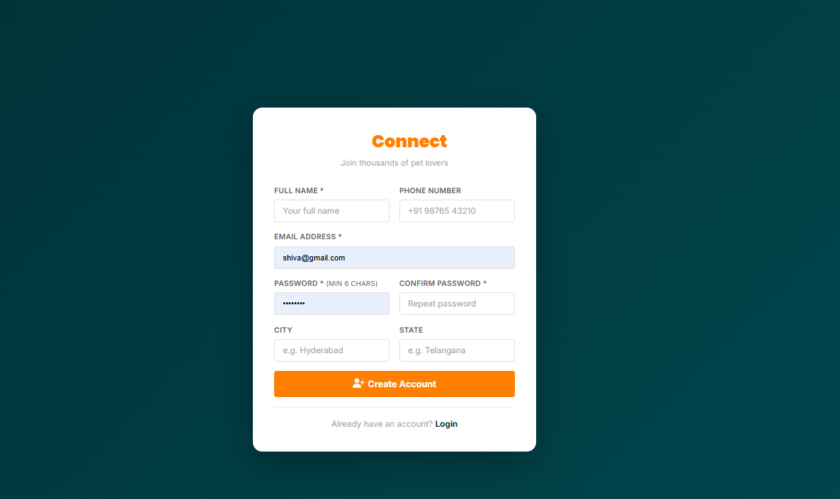

9.3 Home Page / Browse Listings
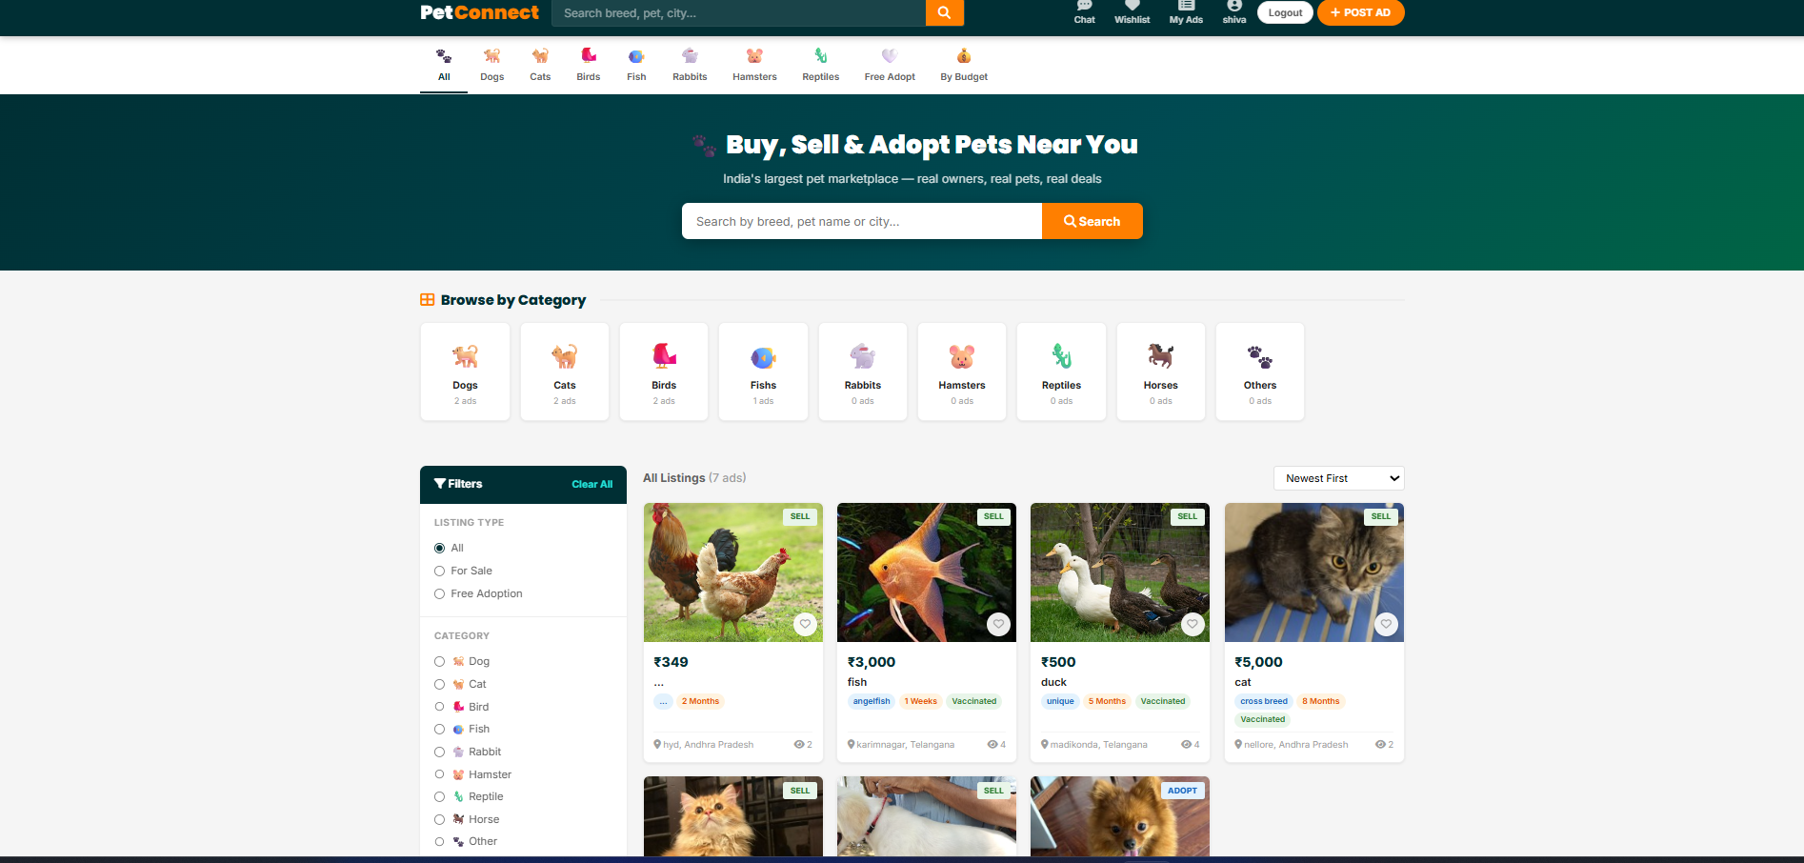

9.4 Pet Detail Page — Image Gallery
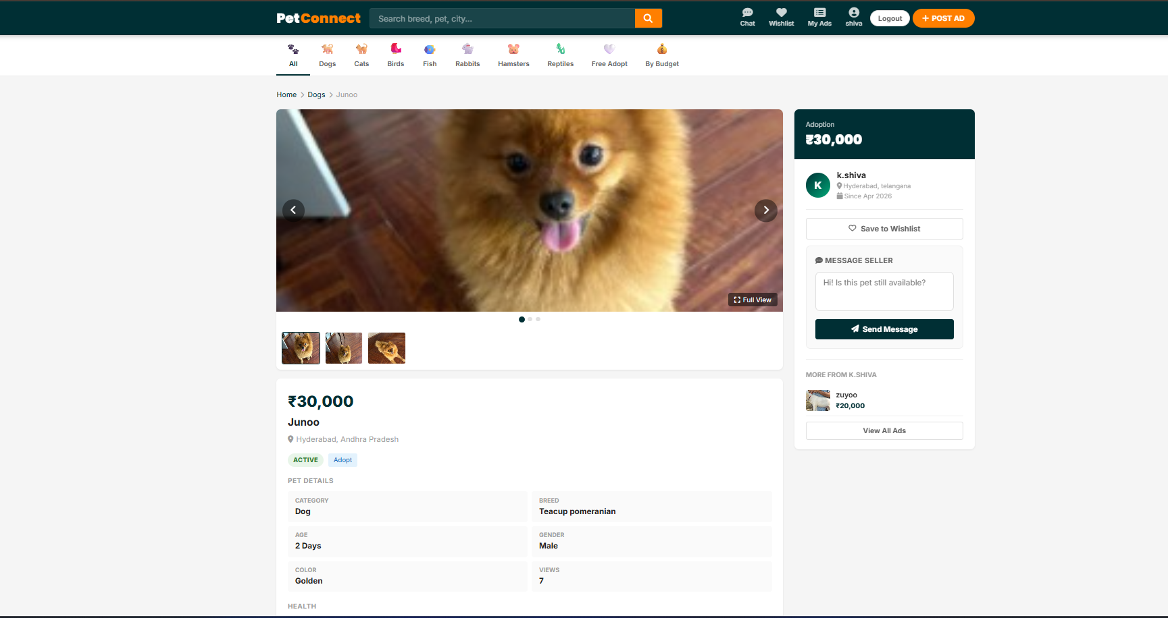

9.5 Post Ad Page
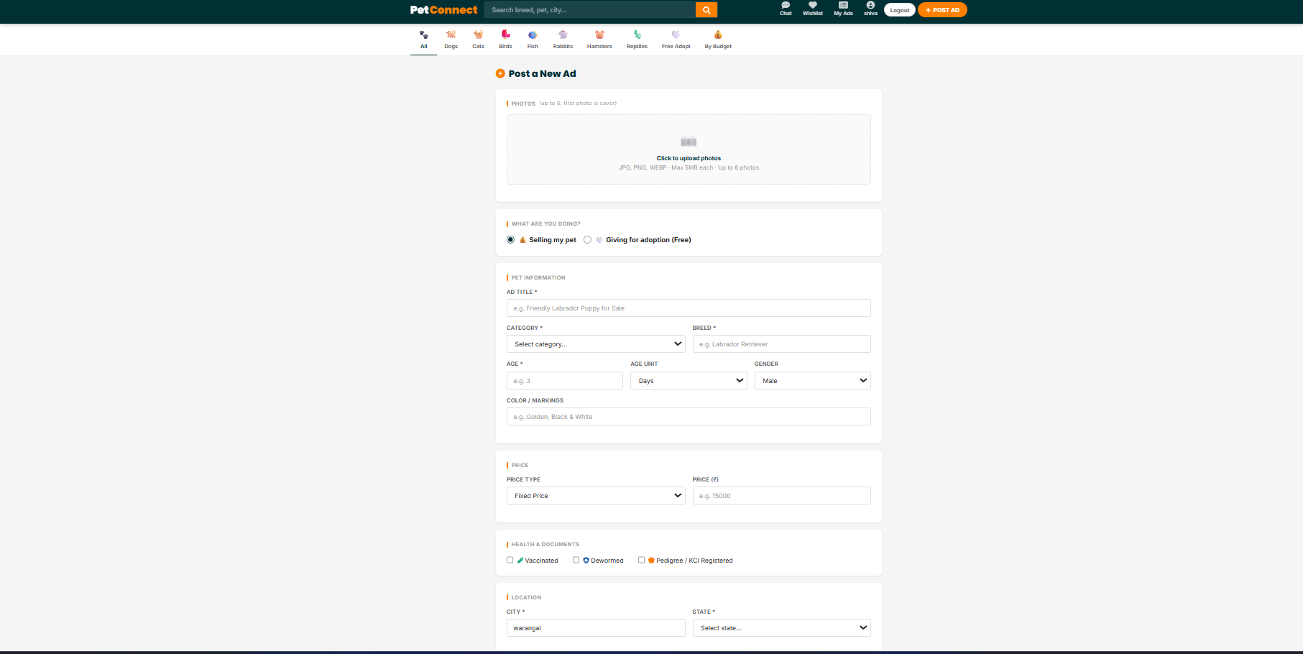

9.6 Chat / Messages
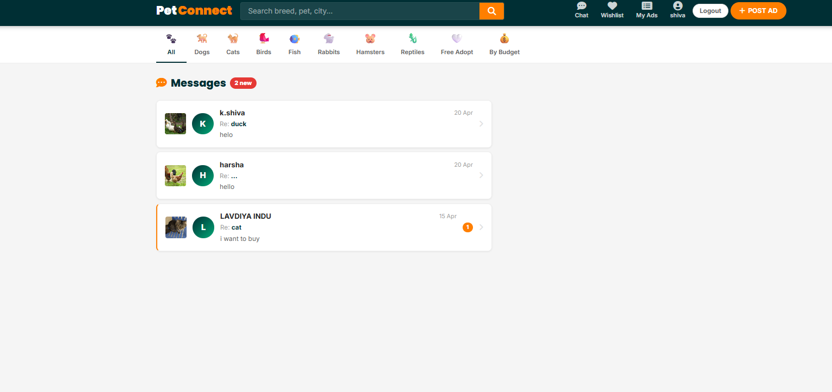

9.7 My Ads Dashboard
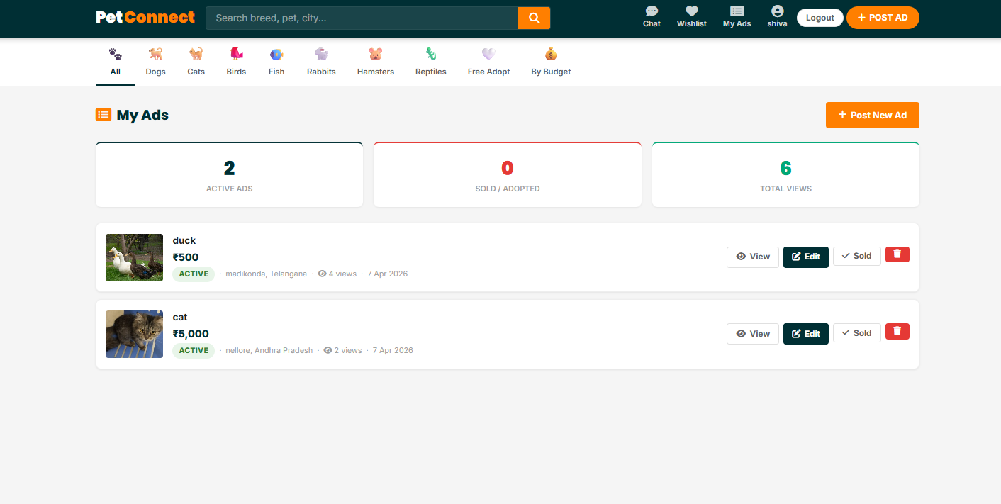
9.8 Wishlist Page
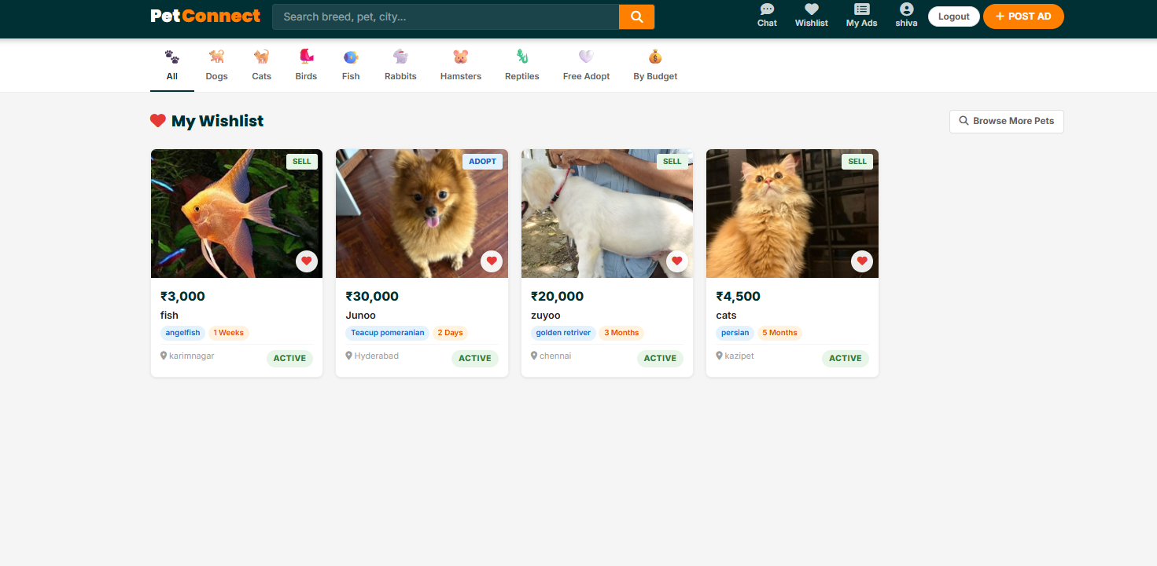

9.9 Budget Filter Page
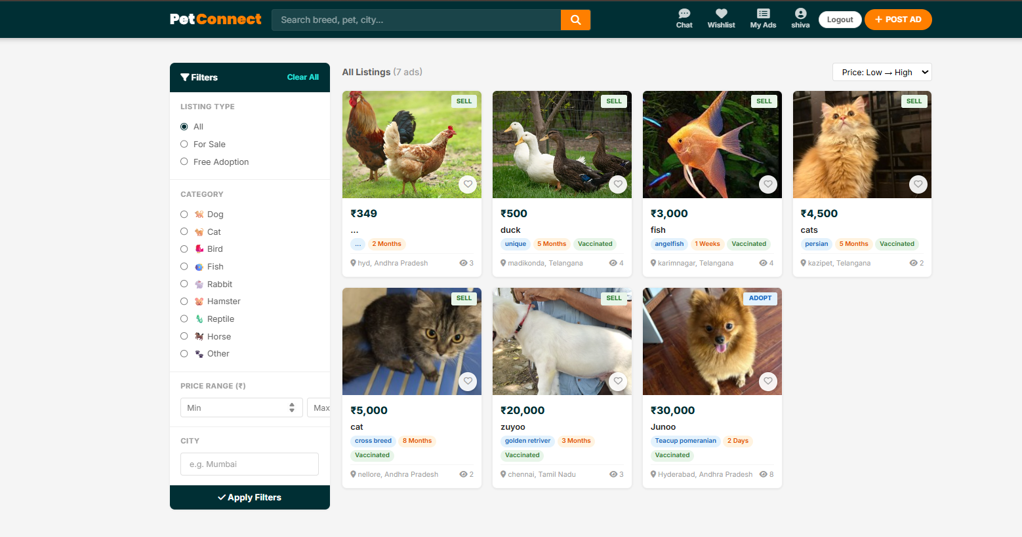

9.10 Admin Dashboard
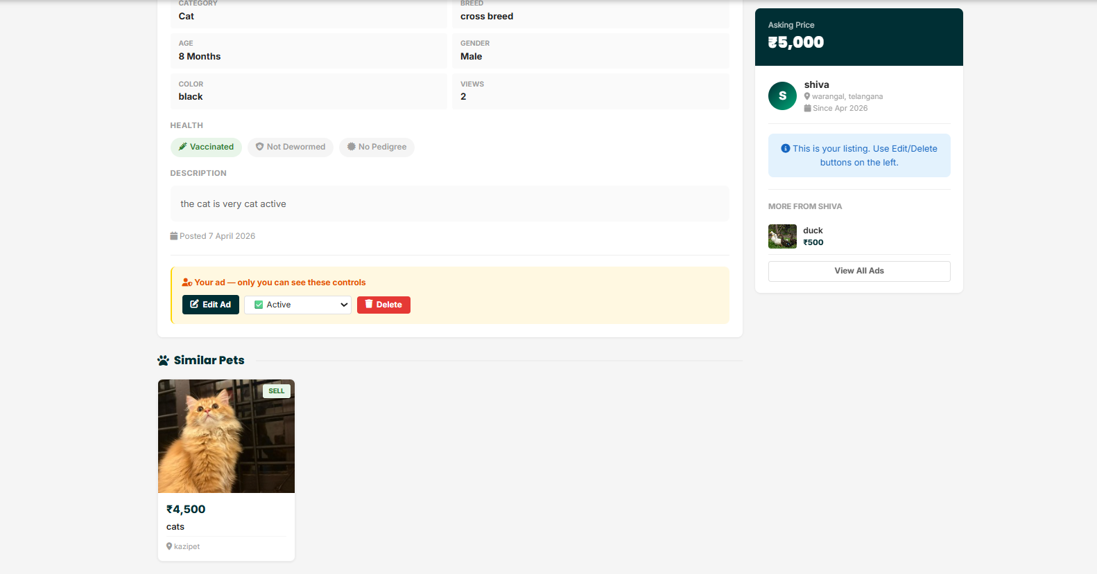
9.11 Account / Profile Settings
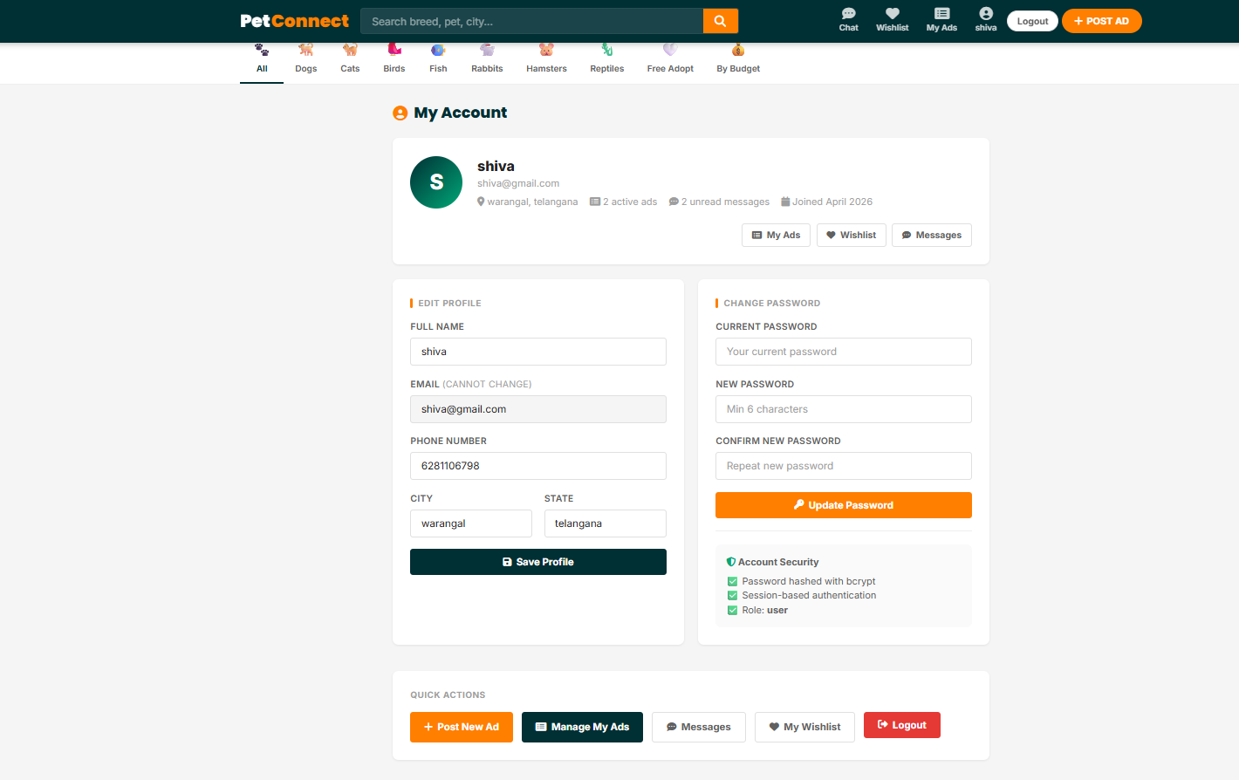

10. CONCLUSION

The PetConnect Pet Adoption & Marketplace System successfully demonstrates two major achievements: the development of a complete, production-ready full-stack web application, and the demonstration of AI prompt engineering as a viable software development methodology.
The application delivers a comprehensive set of features including secure session-based authentication with token-based password reset, role-based access control, complete pet listing management with multi-image upload and full-screen gallery viewing, a private buyer-seller messaging system, wishlist functionality, budget-based browsing, and an administrative dashboard with Chart.js analytics.
From a technical standpoint, the MEN stack (MongoDB, Express.js, Node.js) proved to be a highly effective choice for building this type of marketplace application. Mongoose’s schema validation ensured data integrity across all three models. Express.js middleware provided clean separation of concerns. EJS templates enabled efficient server-side rendering. The custom-built image lightbox demonstrates how complex UI interactions can be achieved with vanilla JavaScript without external dependencies.
The AI prompt engineering approach using Claude AI demonstrated that 38 production-ready files totalling over 3,200 lines of code could be generated through 7 carefully structured prompts. This approach significantly accelerates development and reduces manual effort while maintaining code quality and adherence to best practices.
Future enhancements to the PetConnect system could include:
- Email delivery integration for password reset links using Nodemailer
- Real-time chat using Socket.io for instant message delivery
- Pet health certificate PDF upload and verification
- Google Maps integration to show approximate listing location
- Progressive Web App (PWA) support for mobile app-like experience
- Payment gateway integration for secure pet purchase transactions

11. REFERENCES

No. | Source | Link / Description
1 | Claude AI by Anthropic | https://claude.ai — AI tool used to generate all source code
2 | Node.js Official Documentation | https://nodejs.org/en/docs
3 | Express.js Official Documentation | https://expressjs.com
4 | MongoDB Documentation | https://www.mongodb.com/docs
5 | Mongoose Documentation | https://mongoosejs.com/docs
6 | EJS Template Engine | https://ejs.co
7 | express-session | https://github.com/expressjs/session
8 | bcryptjs | https://github.com/dcodeIO/bcrypt.js
9 | Multer File Upload | https://github.com/expressjs/multer
10 | connect-mongo | https://github.com/jdesboeufs/connect-mongo
11 | Chart.js Documentation | https://www.chartjs.org/docs
12 | Font Awesome Icons | https://fontawesome.com
13 | Google Fonts | https://fonts.google.com
14 | MDN Web Docs | https://developer.mozilla.org — HTML, CSS, JS reference
15 | OWASP Password Reset Guide | https://cheatsheetseries.owasp.org

