ASSIGNMENT-8.3
2303A51295
BATCH-10
Task 1: Email Validation using TDD
PROMPT:
write a python program to develop a user registration system that requires reliable email input validation
CODE:
import re
class UserRegistration:
def __init__(self, name, email):
self.name = name
self.email = email
def validate_email(self):
pattern = r'^[a-zA-Z0-9._%+-]+@[a-zA-Z0-9.-]+\.[a-zA-Z]{2,}$'
if re.match(pattern, self.email):
return True
else:
return False
def display(self):
print(f"Name: {self.name}")
print(f"Email: {self.email}")
if self.validate_email():
print("Email is valid.")
else:
print("Email is invalid.")
# Test Cases
user1 = UserRegistration("Alice", "alice@example.com")
user2 = UserRegistration("Bob", "bob@example")
user1.display()
user2.display()
OUTPUT:
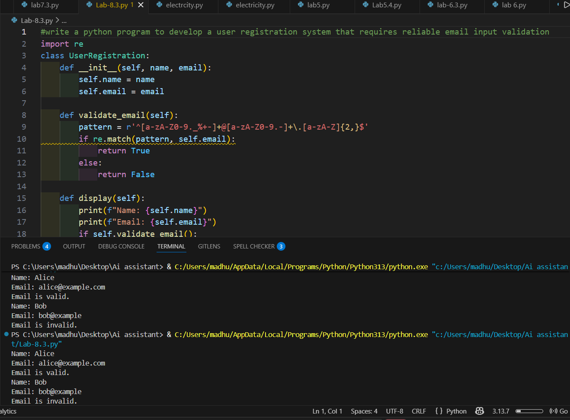
CODE ANAYLSIS:
· This program stores a user’s name and email and checks if the email is written correctly.
· It uses a pattern rule to see if the email looks like name@gmail.com.
· This helps avoid wrong email entries and keeps user details correct.

TASK-2: Grade Assignment using Loops
PROMPT: write a python program to bulid an automated grading system for an online examination platform using loops and aslo include invalid input like -5,eighty
CODE:
def calculate_grade(score):
if score < 0 or score > 100:
return "Invalid input"
elif score >= 90:
return "Grade: A"
elif score >= 80:
return "Grade: B"
elif score >= 70:
return "Grade: C"
elif score >= 60:
return "Grade: D"
else:
return "Grade: F"
# Test Cases
scores = [95, 85, 75, 65, 55, -5
, "eighty"]
for s in scores:
if isinstance(s, int):
print(f"Score: {s} - {calculate_grade(s)}")
else:
print(f"Score: {s} - Invalid input")
OUTPUT:
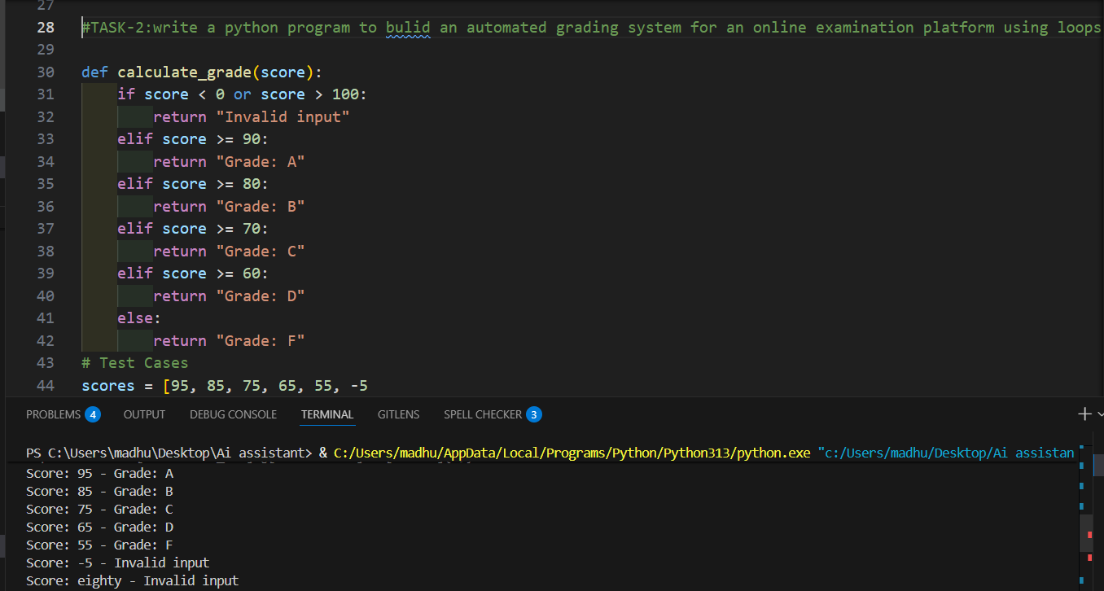
CODE ANAYLSIS:
· This program gives grades based on marks and finds invalid inputs.
· It checks score ranges and also handles wrong values like negative numbers or text.
· This saves time and ensures marks are correct before grading.

TASK-3: Sentence Palindrome Checker
PROMPT:
write a python program to check sentence palindrome checker to develop a text-processing utility to analyze sentences
CODE:
def is_palindrome(sentence):
cleaned = ''.join(sentence.lower().split())
return cleaned == cleaned[::-1]
# Test Cases
sentences = ["Madam In Eden Im Adam",
"Hello World","A man a plan a canal Panama"]
for s in sentences:
if is_palindrome(s):
print(f'"{s}" is a palindrome.')
else:
print(f'"{s}" is not a palindrome.')
OUTPUT:
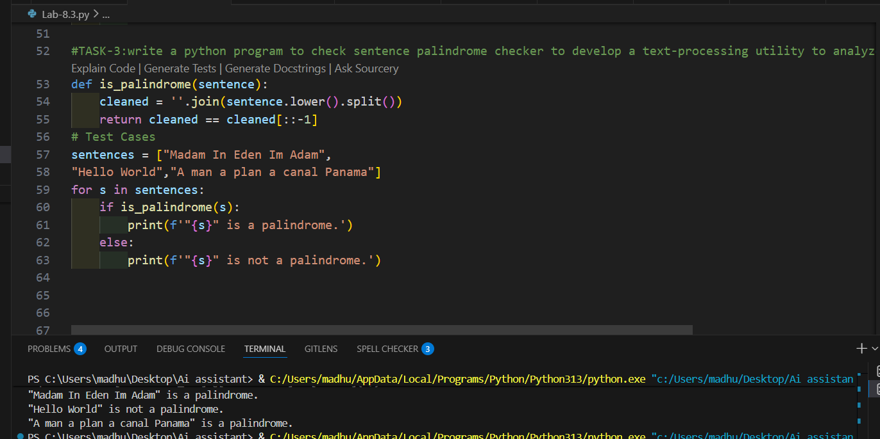
CODE ANAYLSIS:
· This program checks if a sentence reads the same forward and backward.
· It removes spaces, converts to lowercase, and compares the sentence with its reverse.
· This helps in text checking and improves string handling skills.

TASK-4: ShoppingCart Class
PROMPT: Write a python program to design a basic shopping cart module for an e-commerce application.add item and remove item and total cost
CODE:
class ShoppingCart:
def __init__(self):
self.cart = {}
def add_item(self, item, price):
self.cart[item] = price
print(f"Added {item} to cart at ₹{price}")

def remove_item(self, item):
if item in self.cart:
del self.cart[item]
print(f"Removed {item} from cart")
else:
print(f"{item} not found in cart")

def total_cost(self):
return sum(self.cart.values())
# Test Cases
cart = ShoppingCart()
cart.add_item("Laptop", 50000)
cart.add_item("Headphones", 2000)
cart.add_item("Mouse", 500)
print("Total Cost: ₹", cart.total_cost())
cart.remove_item("Headphones")
print("Total Cost after removal: ₹", cart.total_cost())
OUTPUT:
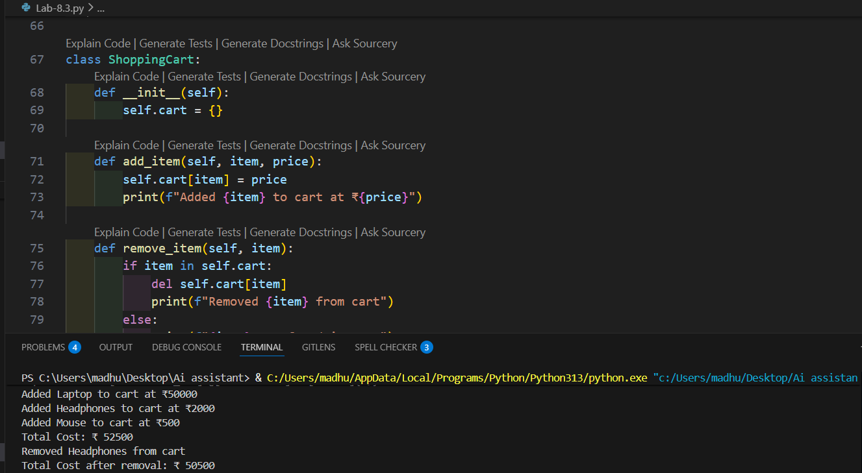
CODE ANAYLSIS:
· This program works like a shopping cart where items can be added or removed.
· It stores items with prices and adds them to calculate the total cost.
· This shows how online shopping systems manage items and billing.

TASK-5: Date Format Conversion
PROMPT: write a python program to create a utility function to convert date formats for reports
CODE:
from datetime import datetime
def convert_date_format(date_str, current_format, desired_format):
try:
date_obj = datetime.strptime(date_str, current_format)
return date_obj.strftime(desired_format)
except ValueError:
return "Invalid date format"
# Test Cases
dates = [("2024-06-15", "%Y-%m-%d", "%d/%m/%Y"),
("15/06/2024", "%d/%m/%Y", "%Y-%m-%d"),
("06-15-2024", "%m-%d-%Y", "%Y/%m/%d"),
("invalid-date", "%Y-%m-%d", "%d/%m/%Y")]
for date_str, current_fmt, desired_fmt in dates:
print(f"Original: {date_str} - Converted: {convert_date_format(date_str, current_fmt, desired_fmt)}")
OUTPUT:
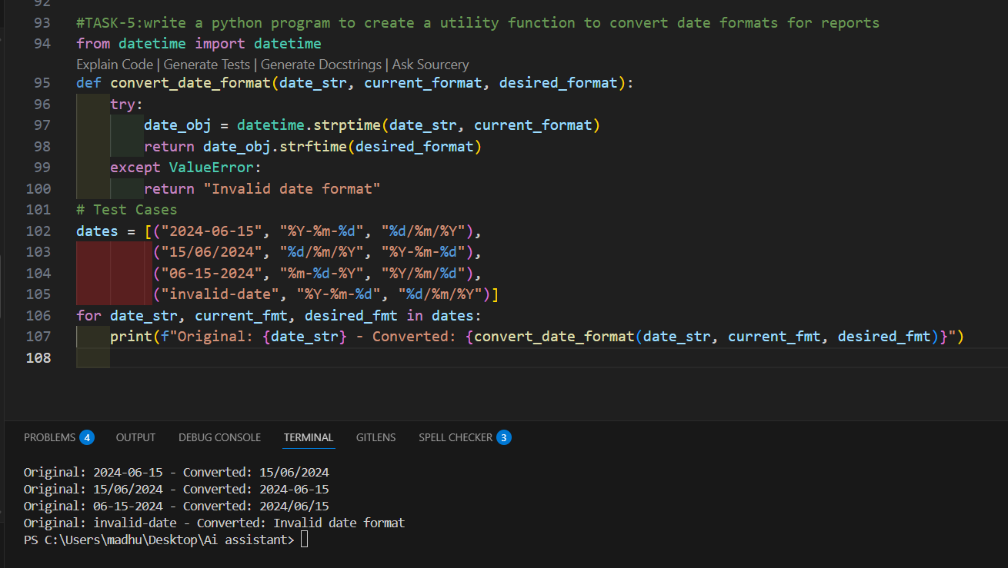
CODE ANAYLSIS:
- This program changes dates from one format to another.
- It reads the given date and converts it into the required format.
- This avoids confusion when different systems use different date styles

