ASSIGNMENT-1.4
2303A51295 BATCH-10
TASK-1:

PROMPT:
Prime number check without using function.

CODE:
num = int(input("Enter a number: ")) if num > 1:
for i in range(2, int(num**0.5) + 1): if (num % i) == 0:
print(f"{num} is not a prime number") break
else:
print(f"{num} is a prime number") else:
print(f"{num} is not a prime number")

OUTPUT:
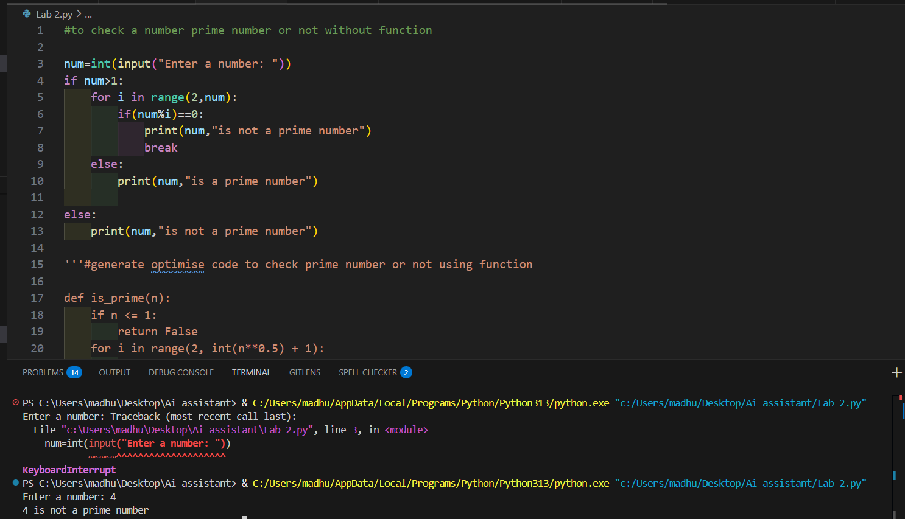

EXPLANATION:
- This program checks whether a number is prime by testing if it has any divisors from 2 to √n.
- If it is divisible by any number, it is not prime.
- If no divisor is found, it is prime.
- Numbers less than or equal to 1 are not prime..
TASK-2
PROMPT:
optimized the above code using function.

CODE:
def is_prime(n):
if n <= 1:
return False
for i in range(2, int(n**0.5) + 1): if n % i == 0:
return False return True
if name == " main ":
number = int(input("Enter a number: ")) if is_prime(number):
print(f"{number} is a prime number") else:
print(f"{number} is not a prime number")

OUTPUT:
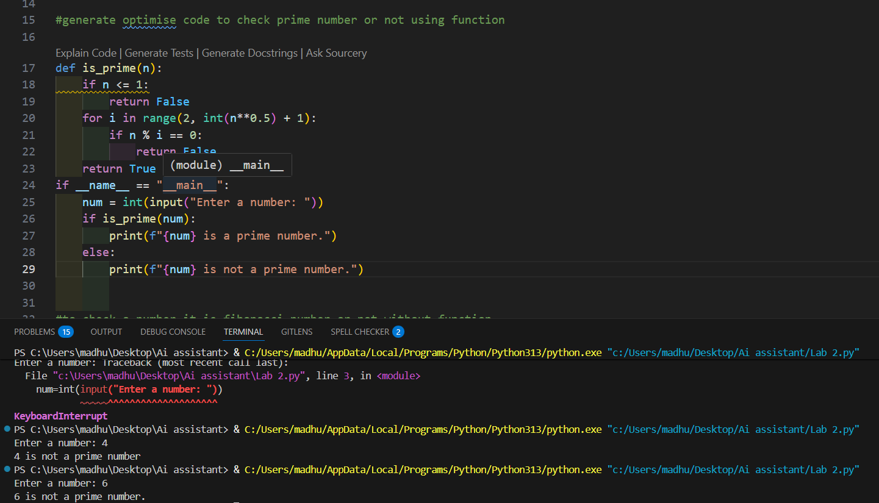
EXPLANATION:
- This program defines a function is_prime() that checks whether a number is prime by trying to divide it by all numbers from 2 up to the square root of the number.
- If any division gives remainder 0, the function returns False (not prime). If no divisor is found, it returns True (prime).
- The main part of the program takes a number from the user, calls the function, and prints whether the number is prime or not.

TASK-3:

PROMPT:
Fibonacci series without using function.

CODE:
n_terms = int(input("How many terms? ")) n1, n2 = 0, 1
count = 0
if n_terms <= 0:
print("Please enter a positive integer") elif n_terms == 1:

print("Fibonacci sequence upto", n_terms, ":") print(n1)
else:
print("Fibonacci sequence:") while count < n_terms:
print(n1)
nth = n1 + n2 n1 = n2
n2 = nth count += 1

OUTPUT:
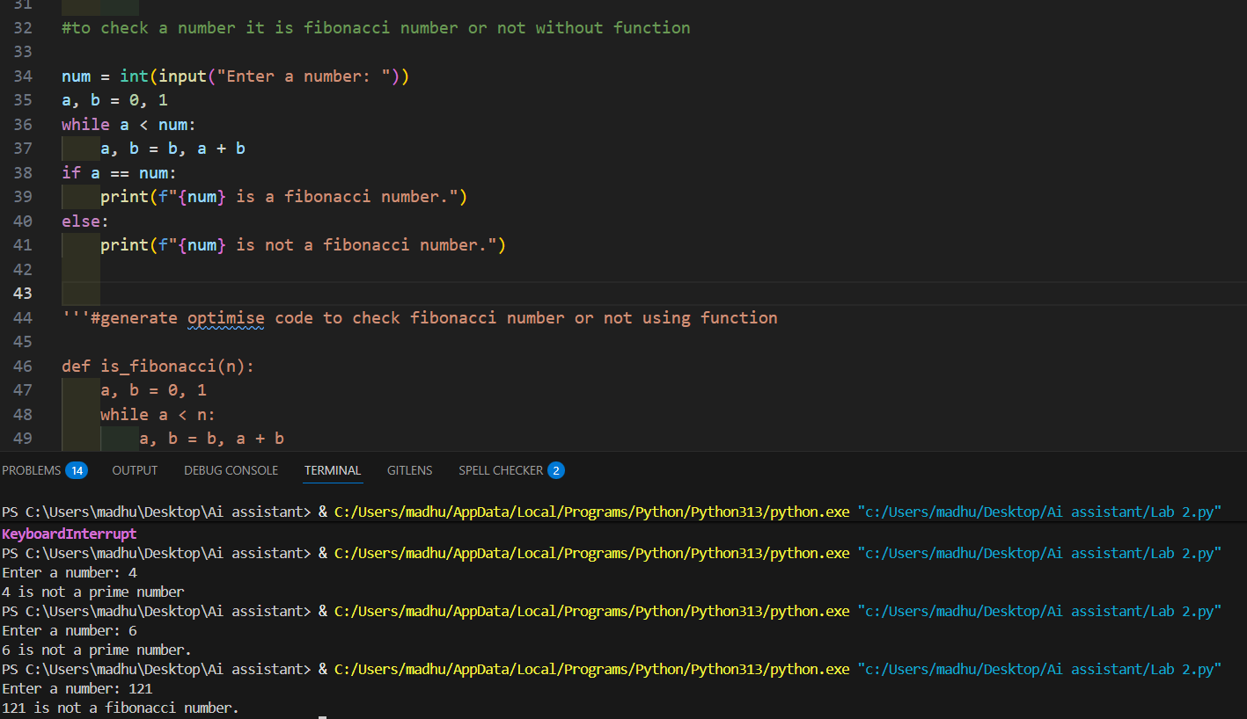
EXPLANATION:
- This program prints the Fibonacci sequence up to the number of terms entered by the user.
It starts with 0 and 1, then each next number is formed by adding the previous two numbers.
- If the user enters 0 or a negative number, it shows an error message. If the user enters 1, it prints only the first term (0).
Otherwise, it uses a loop to generate and print the required Fibonacci numbers.

TASK-4:

PROMPT:
optimized the above code using function.

CODE:
def fibonacci(n):
sequence = [] a, b = 0, 1
for _ in range(n): sequence.append(a) a, b = b, a + b
return sequence
if name == " main ":
terms = int(input("How many terms")) if terms <= 0:
print("Please enter a positive integer") else:
print("Fibonacci sequence:") for num in fibonacci(terms):
print(num)

OUTPUT:
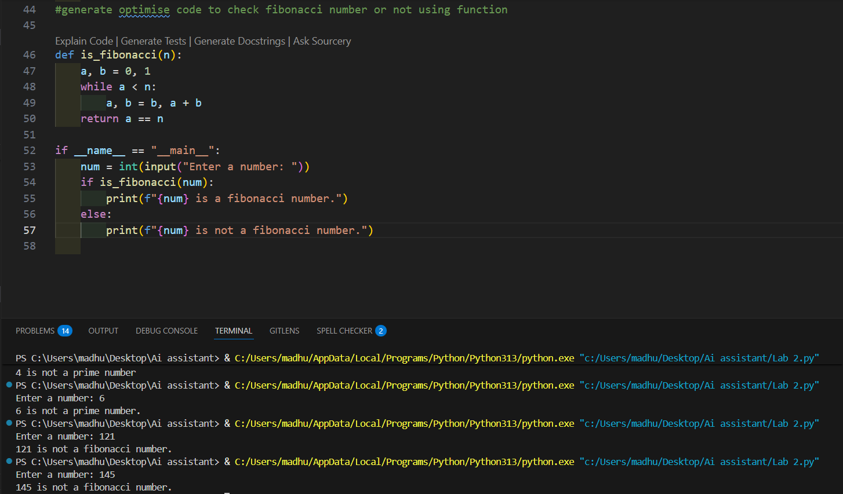

EXPLANATION:
- The function fibonacci(n) creates a list and fills it with Fibonacci numbers starting from 0 and 1. Each new number is formed by adding the previous two numbers. It returns the list of generated numbers.
- In the main part of the program, the user enters how many terms they want. If the number is 0 or negative, the program asks for a positive integer.
- Otherwise, it calls the fibonacci() function and prints the Fibonacci sequence.

PROMPT:

TASK-5:

#Write a function to find the longest common prefix string amongst an array of strings. #If there is no common prefix, return an empty string "".

CODE:
def longest_common_prefix(strs): if not strs:
return ""

prefix = strs[0] for s in strs[1:]:
while s[:len(prefix)] != prefix and prefix:
prefix = prefix[:-1] return prefix
if name == " main ":
string_list = ["flower", "flow", "flight"]
result = longest_common_prefix(string_list) print(f"The longest common prefix is: '{result}'")

OUTPUT:
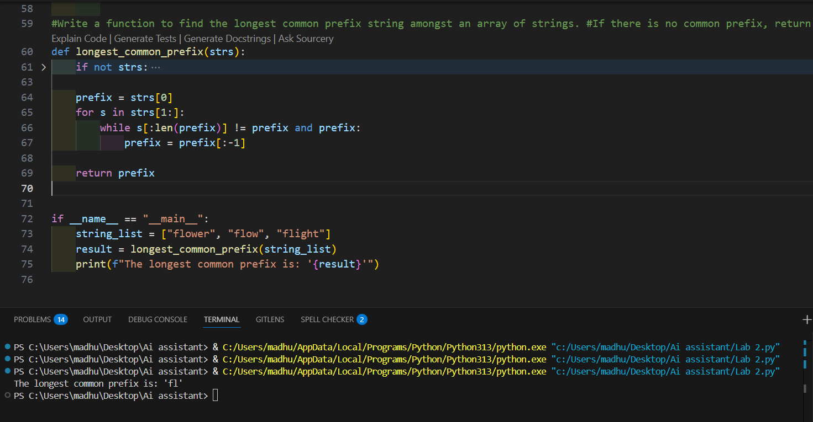
EXPLANATION:
- This program finds the longest common prefix (starting part) shared by all strings in a list.
- It begins by assuming the first string is the prefix. Then it compares this prefix with each remaining string. If the current prefix does not match the beginning of a string, it shortens the prefix by removing the last character and checks again.
- This continues until a match is found or the prefix becomes empty.
- After checking all strings, the remaining prefix is the longest common prefix, and it is printed as the result.

