ASSIGNMENT-6.3
2303A51295 BATCH-10
TASK-1:

You are developing a simple student information management module.

PROMPT:
generate a python code using class and python constructor and display _details() to develop a student information management include
attributes name,roll number and branch

CODE:

class Student:
def __init__(self, name, roll_number, branch):
self.name = name
self.roll_number = roll_number
self.branch = branch

def _details(self):
print(f"Name: {self.name}")
print(f"Roll Number: {self.roll_number}")
print(f"Branch: {self.branch}")

# Example usage:
student1 = Student("Alice", "12345", "Computer Science")
student1._details()
OUTPUT:
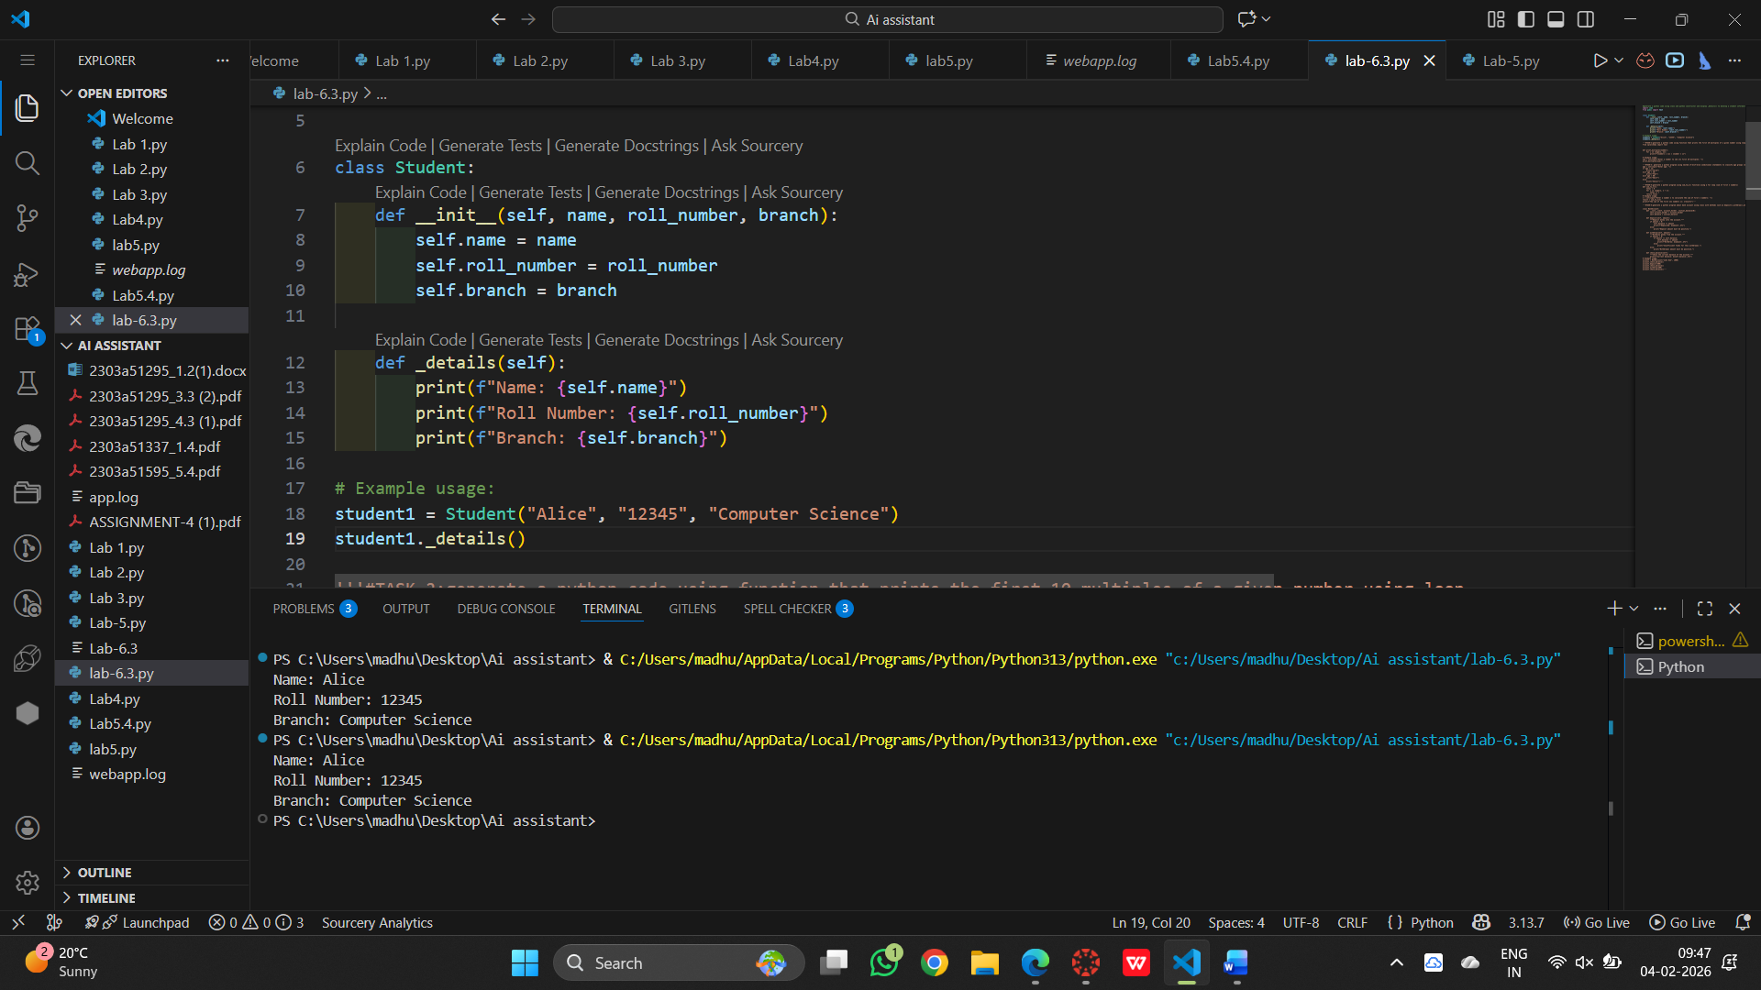

EXPLANATION:

The Student class acts like a template to store student information such as name, roll number, and branch.The function applies standard leap year rules and returns True or False.

The __init__ constructor automatically saves the values given while creating a student object.The result is printed as either a leap year or not.

The _details() function is used to print the stored details of the student when it is called.

TASK-2
You are writing a utility function to display multiples of a given number
PROMPT:
generate a python code using function that prints the first 10 multiples of a given number using loop

CODE:
def print_multiples(number):
for i in range(1, 11):
print(f"{number} x {i} = {number * i}")

# Example usage:
num = int(input("Enter a number to see its first 10 multiples: "))
print_multiples(num)

OUTPUT:

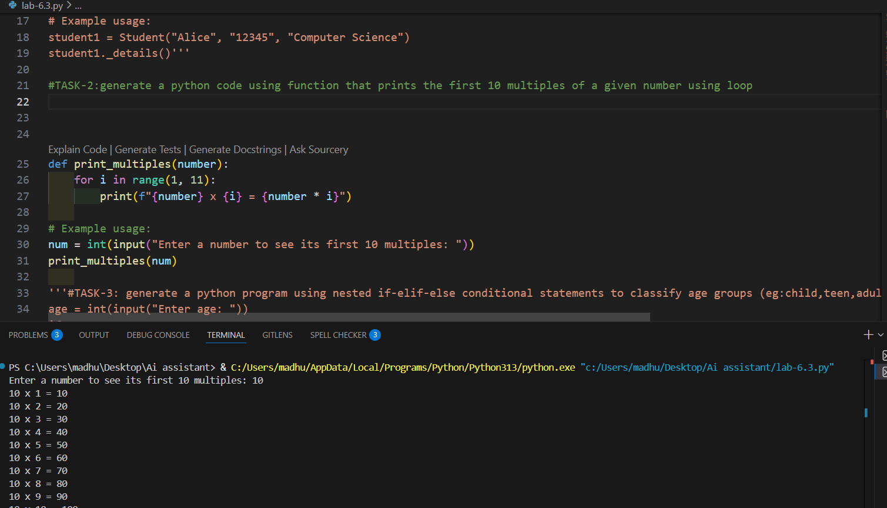

EXPLANATION:

A function named print_multiples is created to accept a number as input.

Inside the function, a loop runs from 1 to 10 and prints the multiples of that number.

The user enters a number, and the function is called to display its first 10 multiples.

TASK-3:

Ask the AI tool to generate nested if-elif-else conditional statements to classify age groups (e.g., child, teenager, adult, senior).

PROMPT:

generate a python program using nested if-elif-else conditional statements to classify age groups (eg:child,teen,adult,senior)

CODE:

age = int(input("Enter age: "))

if age < 13:

print("Child")

elif age < 20:

print("Teen")

elif age < 60:

print("Adult")

else:

print("Senior")

OUTPUT:

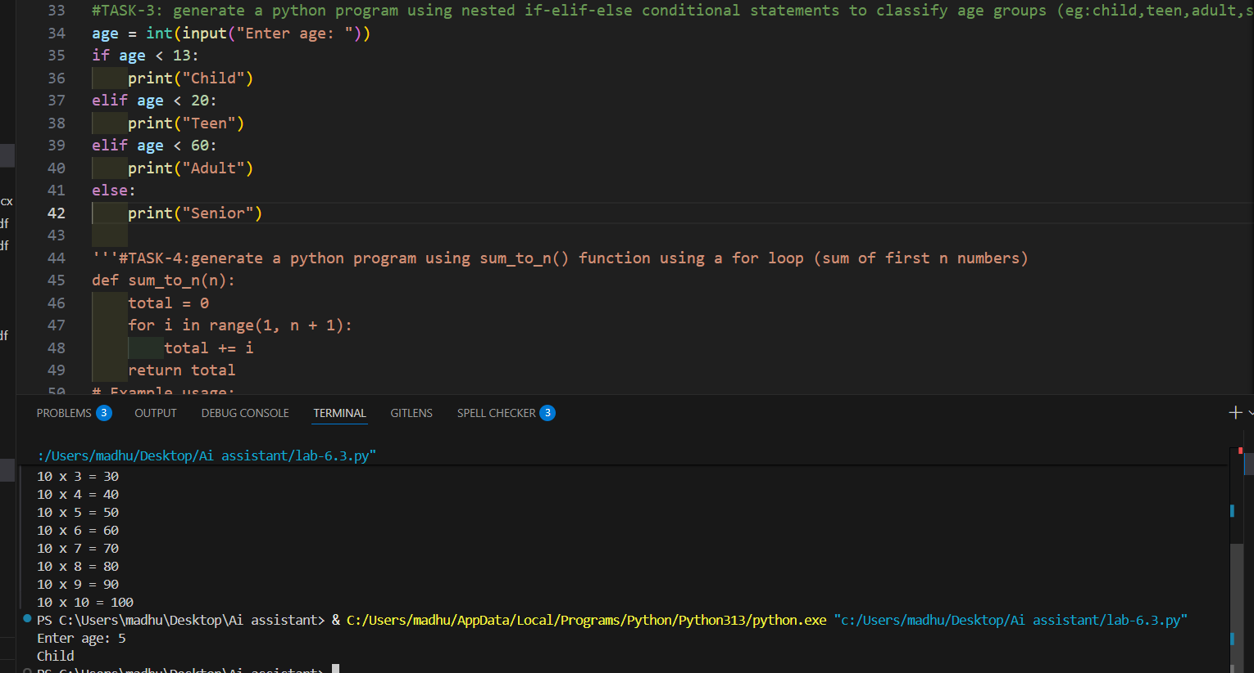

EXPLANATION:

- The program asks the user to enter an age. It then uses conditional statements to decide which age group the person belongs to.
- If the age is below 13, it shows “Child”.
- If the age is between 13 and 19, it shows “Teen”.
- If the age is between 20 and 59, it shows “Adult”.
- For any age 60 or above, it shows “Senior”.

TASK-4:

PROMPT:

generate a python program using sum_to_n() function using a for loop (sum of first n numbers)

CODE:

def sum_to_n(n):

total = 0

for i in range(1, n + 1):

total += i

return total

# Example usage:

n = int(input("Enter a number n to calculate the sum of first n numbers: "))

result = sum_to_n(n)

print(f"The sum of the first {n} numbers is: {result}")

OUTPUT:

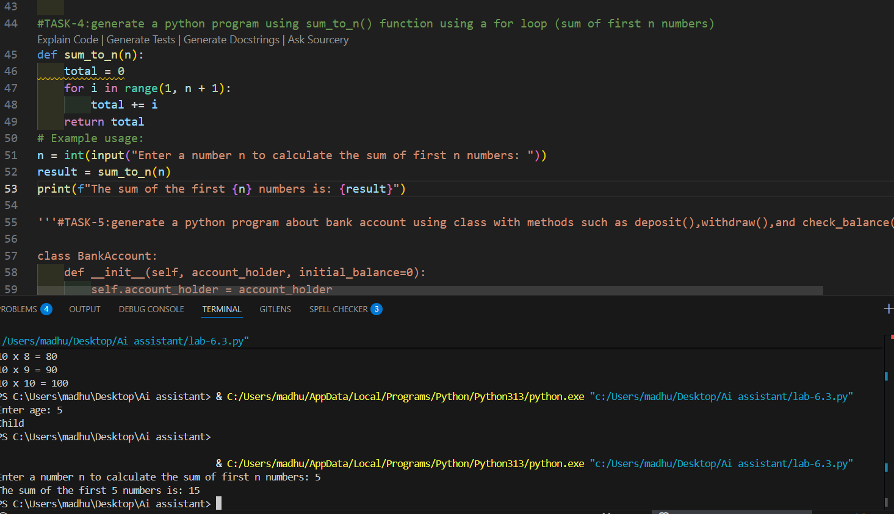
EXPLANATION:

The function sum_to_n(n) is created to calculate the sum of the first n natural numbers.

A loop runs from 1 to n and adds each number to the variable total.

The user enters a value for n, the function is called, and the final sum is printed as output.

TASK-5:
Use AI tools to generate a Bank Account class with methods such as deposit(), withdraw(),and check_balance().

PROMPT:
generate a python program about bank account using class with methods such as deposit(),withdraw(),and check_balance()
CODE:

class BankAccount:

def __init__(self, account_holder, initial_balance=0):

self.account_holder = account_holder

self.balance = initial_balance

def deposit(self, amount):

"""Deposit money into the account."""

if amount > 0:

self.balance += amount

print(f"Deposited: ${amount:.2f}")

else:

print("Deposit amount must be positive.")

def withdraw(self, amount):

"""Withdraw money from the account."""

if amount > 0:

if amount <= self.balance:

self.balance -= amount

print(f"Withdrew: ${amount:.2f}")

else:

print("Insufficient funds for this withdrawal.")

else:

print("Withdrawal amount must be positive.")

def check_balance(self):

"""Check the current balance of the account."""

print(f"Current balance: ${self.balance:.2f}")

# Example usage:

account = BankAccount("John Doe", 1000)

account.check_balance()

account.deposit(500)

account.check_balance()

account.withdraw(200)

account.check_balance()

OUTPUT:

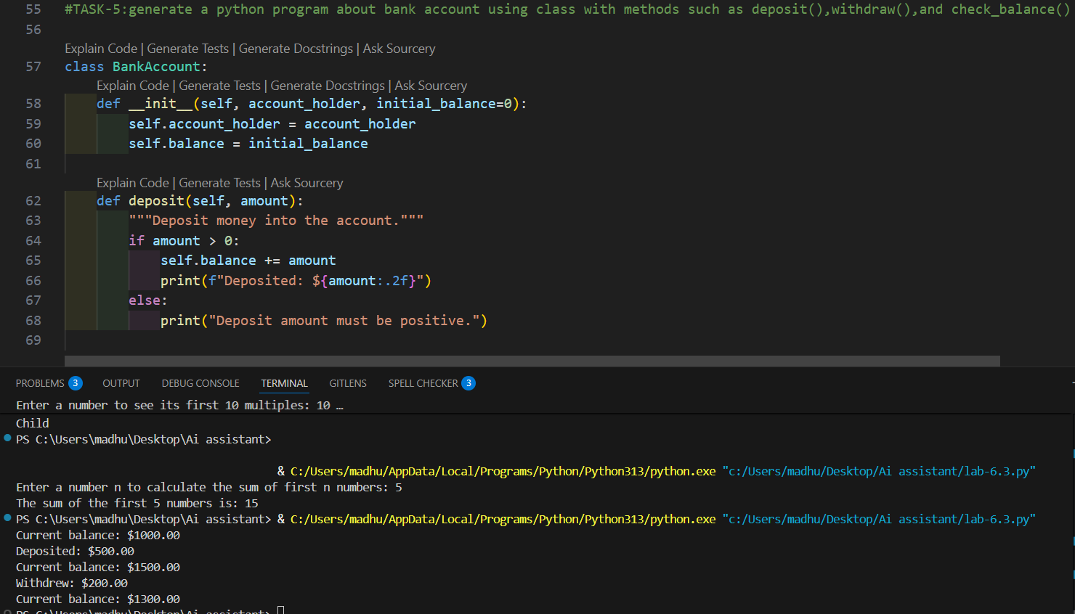
EXPLANATION:

The program creates a BankAccount class with a constructor to store the account holder name and initial balance.

It includes three methods:

deposit() to add money to the account,

withdraw() to remove money if sufficient balance is available,

check_balance() to display the current balance.

An object of the class is created, and these methods are called to perform banking operations like deposit, withdrawal, and balance checking.

