ASSIGNMENT-7.3
2303A51295
BATCH-10
Task 1: Fixing Syntax Errors
PROMPT:
I have a Python function with a syntax error. Detect the issue and correct it.
def add(a, b)
return a + b
CODE:
def add(a, b):
return a + b
print(add(5, 3))
OUTPUT:
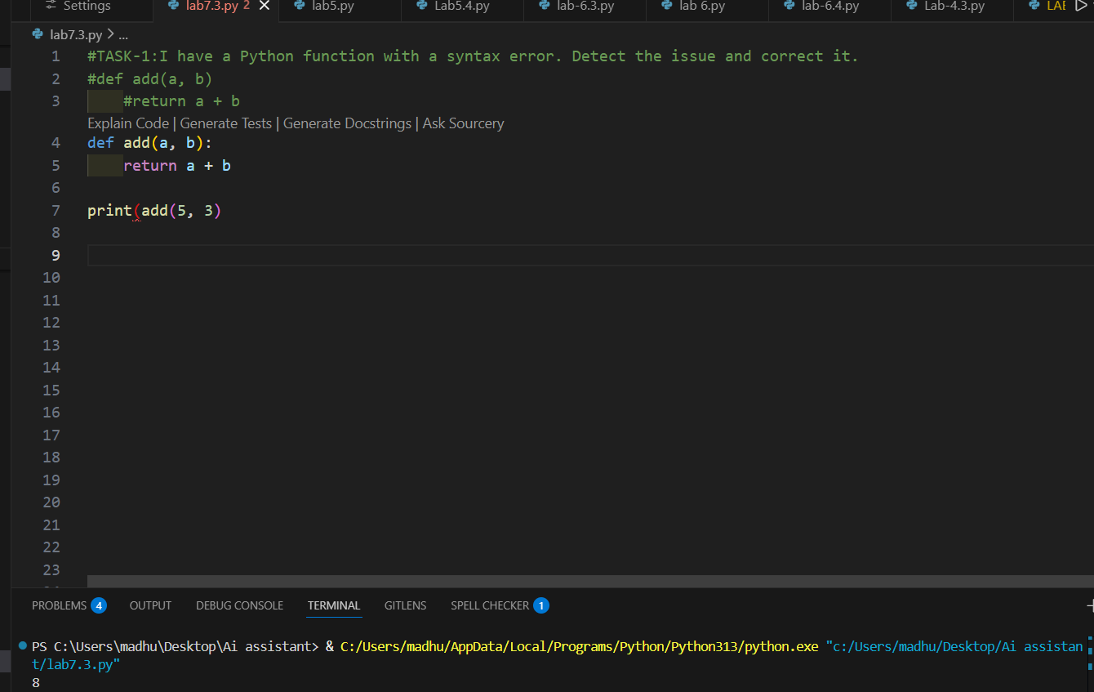
CODE ANAYLSIS:
- This code defines a function named add.
- It takes two numbers as input.
- It returns their sum.
- The missing colon error was fixed.
- Now the function runs correctly.

TASK-2: Debugging Logic Errors in Loops
PROMPT: This loop runs infinitely. Identify the logical mistake and fix it.
def count_down(n):
while n>=0:
print(n)
n+=1
CODE:
def count_down(n):
while n >= 0:
print(n)
n -= 1
count_down(5)
OUTPUT:
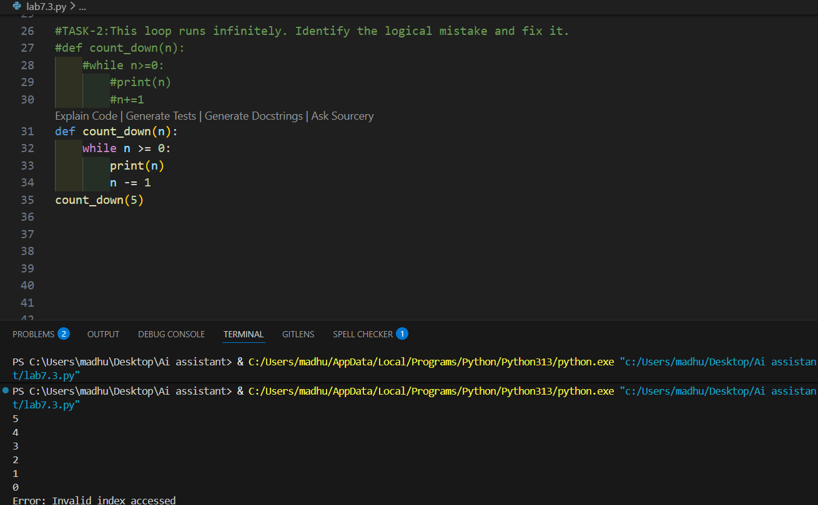
CODE ANAYLSIS:
- Original code had logical error
- n += 1 caused infinite loop
- Changing it to n -= 1 fixes the problem

TASK-3: Handling Runtime Errors (Division by Zero)
PROMPT:
This Python function crashes with a runtime error. Identify the issue and add proper error handling.
def divide(a, b):
return a / b
CODE:
def divide(a, b):
try:
return a / b
except ZeroDivisionError:
return "Error: Division by zero is not allowed"
print(divide(10, 0))
print(divide(10, 2))
OUTPUT:
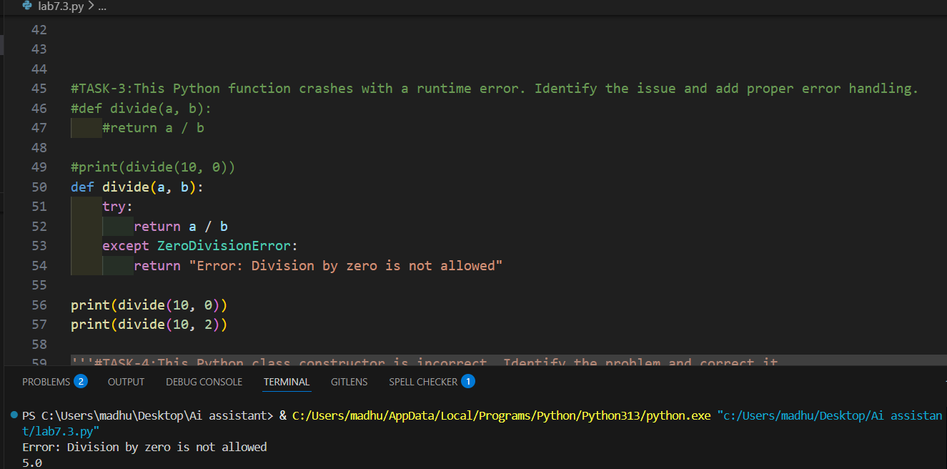
CODE ANAYLSIS:
- This function performs division.
- If the second number is zero, program may crash.
- try-except is used to handle that error.
- Now the function runs safely without crashing.

TASK-4: Debugging Class Definition Errors
PROMPT: This Python class constructor is incorrect. Identify the problem and correct it.
class Rectangle:
def__init__(length,width):
self.length=length
self.width=width
CODE:
class Rectangle:
def __init__(self, length, width):
self.length = length
self.width = width
r = Rectangle(10, 5)
print(r.length)
print(r.width)
OUTPUT:
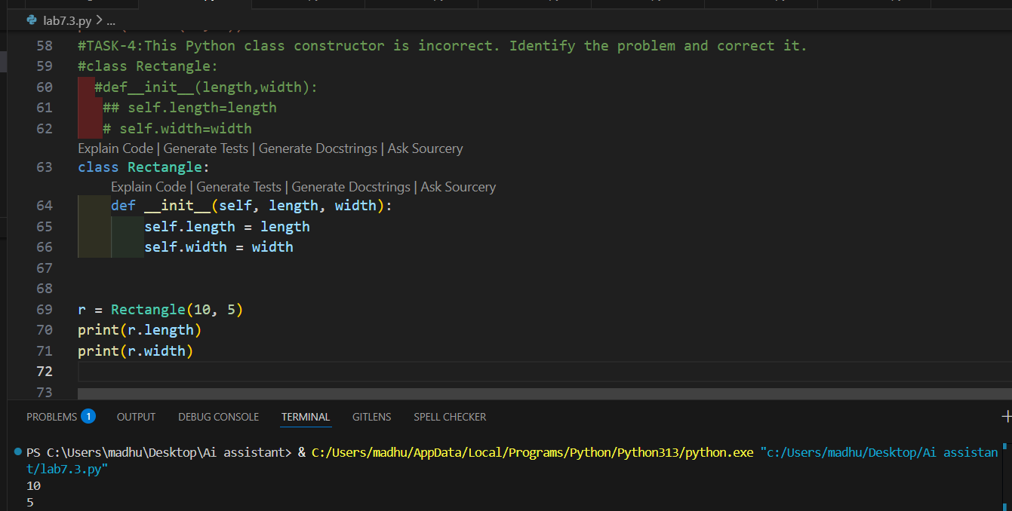
CODE ANAYLSIS:
- Object creation must be outside class.
- Indented lines inside class are treated as class code.
- Creating object inside class causes error.
- Moving it outside fixes the problem.
TASK-5: Resolving Index Errors in Lists
PROMPT: This code throws an IndexError. Identify the problem and suggest a safe way to access list elements
numbers = [10, 20, 30]
print(numbers[5])
CODE:
numbers = [10, 20, 30]
try:
print(numbers[5])
except IndexError:
print("Error: Invalid index accessed")
OUTPUT:
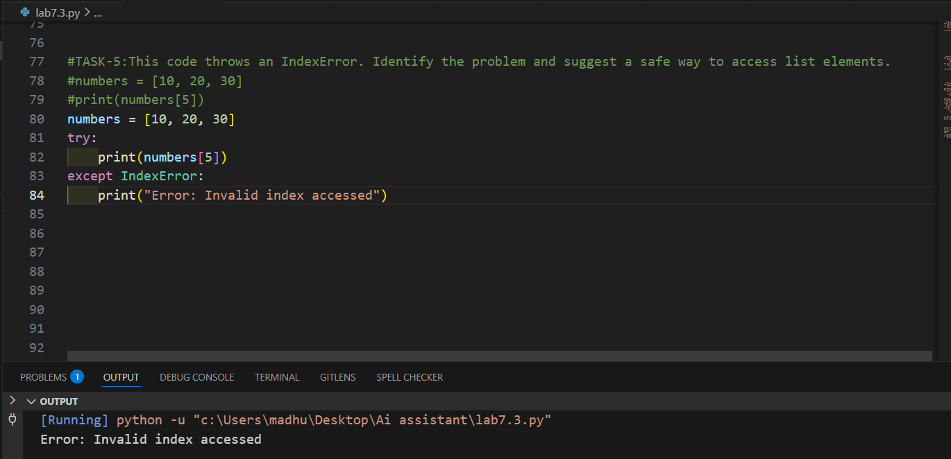
CODE ANAYLSIS:
- The list has only 3 elements.
- Accessing index 5 is invalid.
- This causes IndexError.
- try-except handles the error safely.
- Program no longer crashes.

