ASSIGNMENT-11.3
2303A51295
BATCH-10
Task 1: Smart Contact Manager (Arrays & Linked Lists)
PROMPT:
write a Python program for a contact manager using arrays (Python lists).The program should support adding, searching, and deleting contacts.Each contact should contain a name and phone number.
CODE:
class ContactManager:
def __init__(self):
self.contacts = []

def add_contact(self, name, phone_number):
contact = {"name": name, "phone_number": phone_number}
self.contacts.append(contact)
print(f"Contact {name} added successfully.")

def search_contact(self, name):
for contact in self.contacts:
if contact["name"] == name:
return contact
return None

def delete_contact(self, name):
for contact in self.contacts:
if contact["name"] == name:
self.contacts.remove(contact)
print(f"Contact {name} deleted successfully.")
return
print(f"Contact {name} not found.")
# Example usage
if __name__ == "__main__":
manager = ContactManager()
manager.add_contact("Alice", "123-456-7890")
manager.add_contact("Bob", "987-654-3210")

contact = manager.search_contact("Alice")
if contact:
print(f"Contact found: {contact}")
else:
print("Contact not found.")

manager.delete_contact("Bob")
manager.delete_contact("Charlie")
OUTPUT:
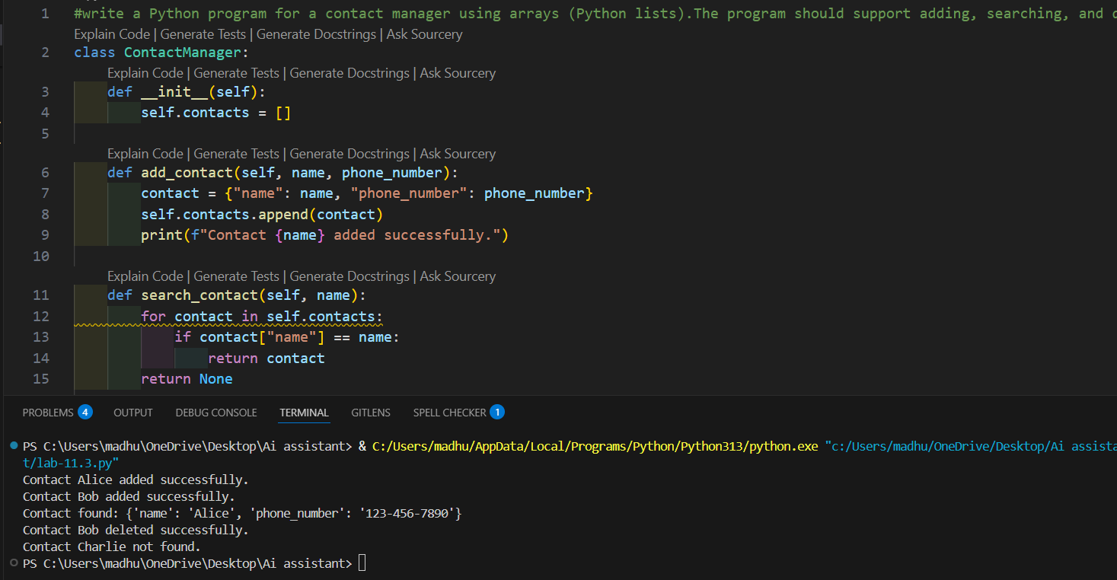
Implementation 2: Linked List Contact Manager
PROMPT:
Generate a Python implementation of a Contact Manager using Linked List.Include add, search and delete operations.
CODE:
class ContactNode:
def __init__(self, name, phone_number):
self.name = name
self.phone_number = phone_number
self.next = None
class ContactManager:
def __init__(self):
self.head = None

def add_contact(self, name, phone_number):
new_contact = ContactNode(name, phone_number)
if not self.head:
self.head = new_contact
print(f"Contact {name} added successfully.")
return
current = self.head
while current.next:
current = current.next
current.next = new_contact
print(f"Contact {name} added successfully.")

def search_contact(self, name):
current = self.head
while current:
if current.name == name:
return {"name": current.name, "phone_number": current.phone_number}
current = current.next
return None

def delete_contact(self, name):
current = self.head
previous = None
while current:
if current.name == name:
if previous:
previous.next = current.next
else:
self.head = current.next
print(f"Contact {name} deleted successfully.")
return
previous = current
current = current.next
print(f"Contact {name} not found.")
# Example usage
if __name__ == "__main__":
manager = ContactManager()
manager.add_contact("Alice", "123-456-7890")
manager.add_contact("Bob", "987-654-3210")

contact = manager.search_contact("Alice")
if contact:
print(f"Contact found: {contact}")
else:
print("Contact not found.")

manager.delete_contact("Bob")
manager.delete_contact("Charlie")
OUTPUT:
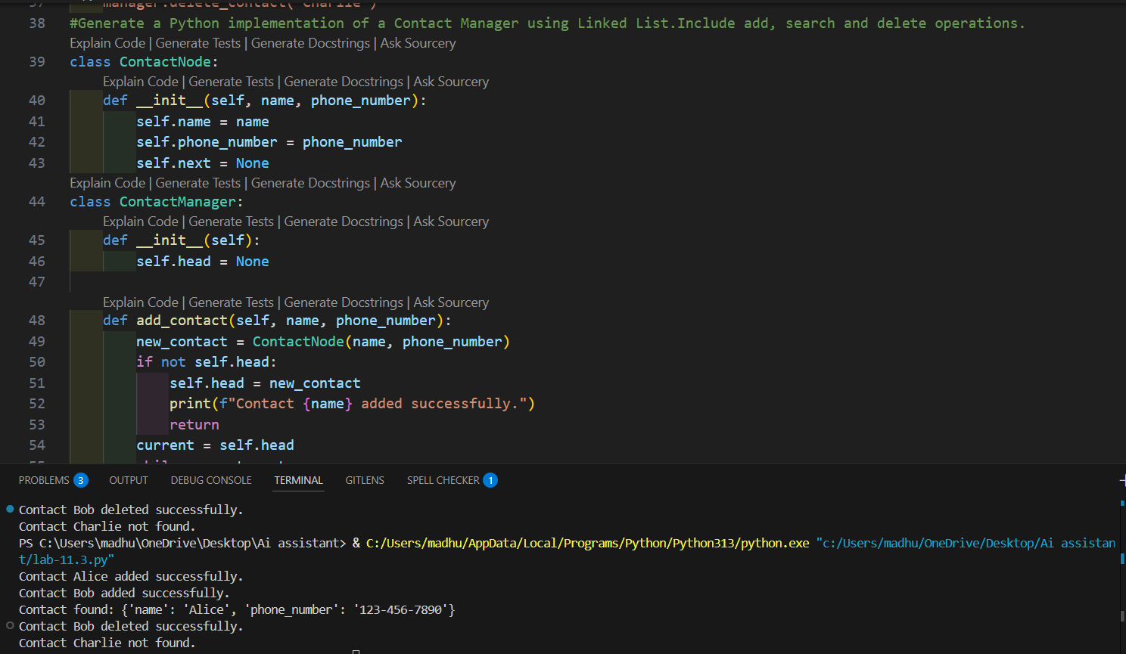
CODE ANAYLSIS:
- The program implements a Contact Manager using Array (list) and Linked List to store contacts with name and phone number.
- Both implementations allow adding, searching, and deleting contacts from the contact list.
- In the array, contacts are stored in a list, while in the linked list, contacts are stored as nodes connected to each other.

TASK-2: Library Book Search System (Queues & Priority Queues)
PROMPT: Create a Python queue program for managing library book requests.Include enqueue and dequeue methods and extend it to priority queue where faculty have higher priority.
CODE:
class LibraryQueue:
def __init__(self):
self.queue = []

def enqueue(self, book_request):
self.queue.append(book_request)
print(f"Book request for '{book_request['title']}' added to the queue.")

def dequeue(self):
if not self.queue:
print("No book requests in the queue.")
return None
book_request = self.queue.pop(0)
print(f"Book request for '{book_request['title']}' processed.")
return book_request
class PriorityLibraryQueue(LibraryQueue):
def enqueue(self, book_request):
if book_request['priority'] == 'faculty':
self.queue.insert(0, book_request)
else:
self.queue.append(book_request)
print(f"Book request for '{book_request['title']}' added to the queue with priority '{book_request['priority']}'.")

# Example usage
if __name__ == "__main__":

priority_queue = PriorityLibraryQueue()
priority_queue.enqueue({'title': 'Introduction to Algorithms', 'priority': 'student'})
priority_queue.enqueue({'title': 'Advanced Python Programming', 'priority': 'faculty'})
priority_queue.enqueue({'title': 'Data Structures and Algorithm Analysis', 'priority': 'student'})

priority_queue.dequeue()
priority_queue.dequeue()
priority_queue.dequeue()
priority_queue.dequeue()
OUTPUT:
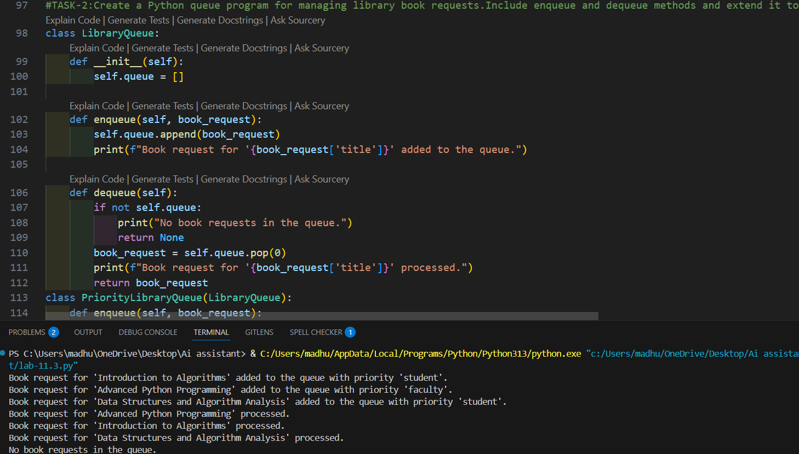
CODE ANAYLSIS:
- The program uses a Queue data structure to manage book requests in FIFO order.
- A Priority Queue is used to give faculty requests higher priority than student requests.
- The system processes requests using enqueue() to add requests and dequeue() to remove them.
TASK-3: Emergency Help Desk (Stack Implementation)
PROMPT:
Write a Python program for stack implementation for IT support tickets with push, pop, peek and check if empty.
CODE:
class HelpDeskStack:
def __init__(self):
self.stack = []

def push(self, ticket):
self.stack.append(ticket)

def pop(self):
if self.stack:
return self.stack.pop()
return "No tickets"

def peek(self):
if self.stack:
return self.stack[-1]
return "Empty"

def is_empty(self):
return len(self.stack) == 0
stack = HelpDeskStack()
stack.push("WiFi issue")
stack.push("Printer issue")
stack.push("Login problem")
print(stack.peek())
print(stack.pop())
print(stack.pop())
OUTPUT:
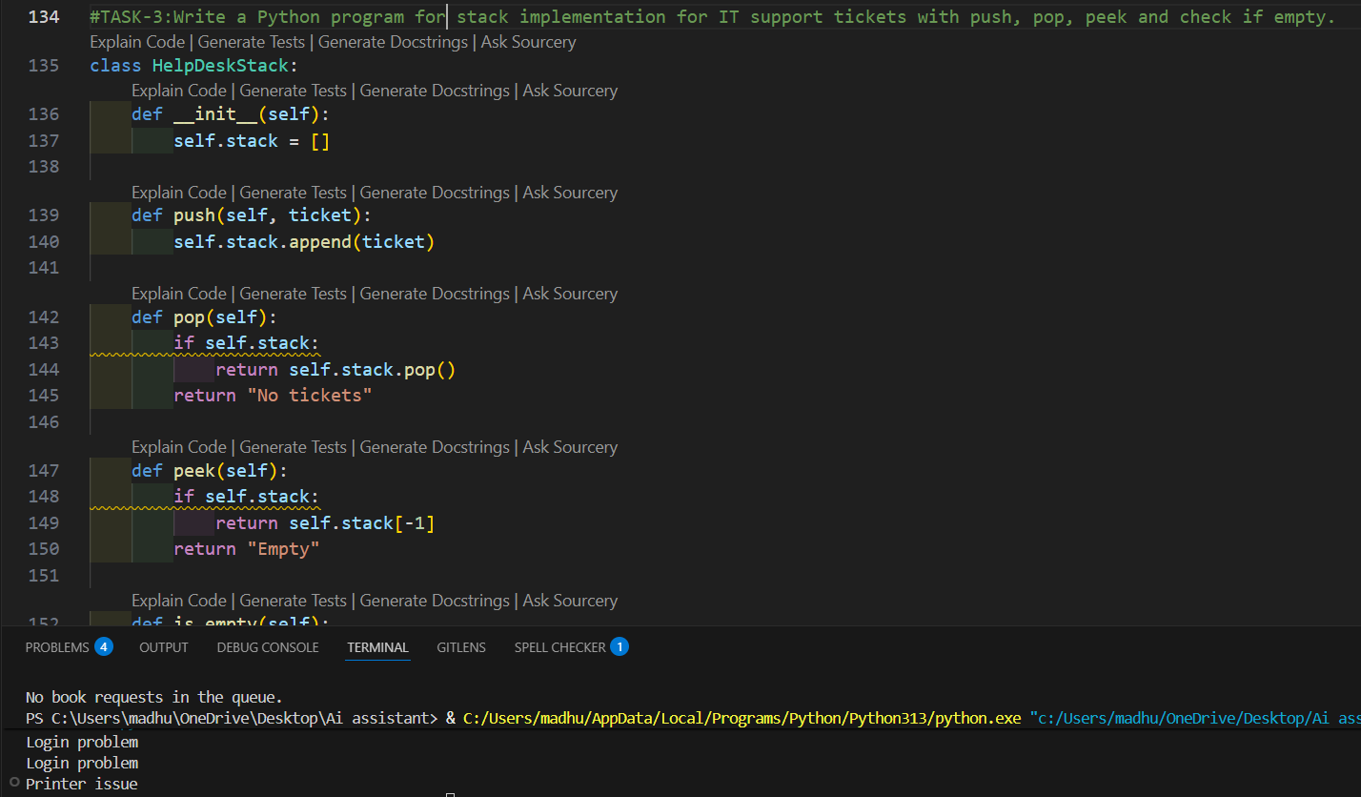
CODE ANAYLSIS:
• The program implements a Stack data structure to manage IT help desk tickets.
• It supports operations push(), pop(), and peek() to add, remove, and view the latest ticket.
• The system follows LIFO (Last-In, First-Out) where the most recent ticket is resolved first.

TASK-4: Hash Table
PROMPT: write a Python hash table with insert, search and delete methods using chaining collision handling.
CODE:
class HashTable:
def __init__(self, size=10):
self.size = size
self.table = [[] for _ in range(size)]

def _hash(self, key):
return hash(key) % self.size

def insert(self, key, value):
index = self._hash(key)
for i, (k, v) in enumerate(self.table[index]):
if k == key:
self.table[index][i] = (key, value)
return
self.table[index].append((key, value))

def search(self, key):
index = self._hash(key)
for k, v in self.table[index]:
if k == key:
return v
return None

def delete(self, key):
index = self._hash(key)
for i, (k, v) in enumerate(self.table[index]):
if k == key:
del self.table[index][i]
return True
return False
hash_table = HashTable()
hash_table.insert("name", "Alice")
hash_table.insert("age", 30)
print(hash_table.search("name"))
print(hash_table.search("age"))
hash_table.delete("name")
print(hash_table.search("name"))
OUTPUT:
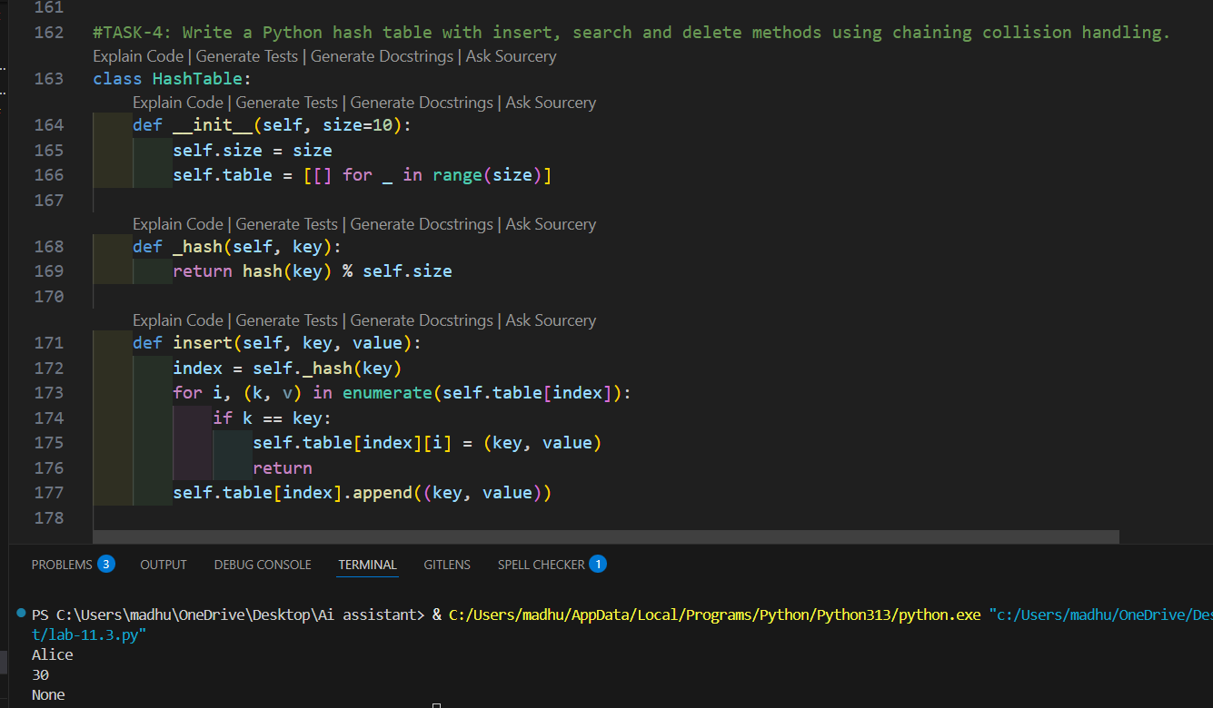
CODE ANAYLSIS:
•The program implements a Hash Table to store and retrieve data using a hash function.
• It supports insert, search, and delete operations for managing key-value pairs.
• Collision handling is done using chaining, where multiple elements are stored in the same bucket.

TASK-5: Real-Time Application Challenge
PROMPT: write a Python program to simulate a cafeteria order queue using Queue data structure.
CODE:
from collections import deque
class CafeteriaQueue:
def __init__(self):
self.queue = deque()

def enqueue(self, order):
self.queue.append(order)
print(f"Order '{order}' added to the queue.")

def dequeue(self):
if not self.queue:
print("No orders in the queue.")
return None
order = self.queue.popleft()
print(f"Order '{order}' processed.")
return order
# Example usage
if __name__ == "__main__":
cafeteria_queue = CafeteriaQueue()
cafeteria_queue.enqueue("Coffee")
cafeteria_queue.enqueue("Sandwich")
cafeteria_queue.enqueue("Salad")

cafeteria_queue.dequeue()
cafeteria_queue.dequeue()
cafeteria_queue.dequeue()
cafeteria_queue.dequeue()

OUTPUT:
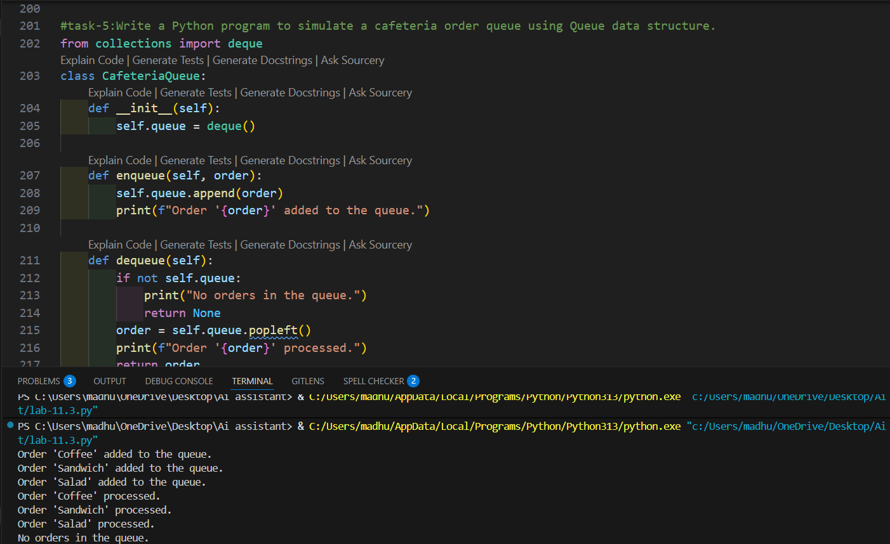
CODE ANAYLSIS:
• Different data structures are selected for campus systems like attendance, events, library, bus scheduling, and cafeteria orders.
• Each feature uses a structure that improves efficiency and data management.
• One feature (such as cafeteria order queue) is implemented using Python to demonstrate the system.

