Assignment - 1
Name : N . Deepthi
H.T. NO : 2303A51354
Batch : 06

Task - 0 :
Install and configure GitHub Copilot in VS Code. Take screenshots of
each step.
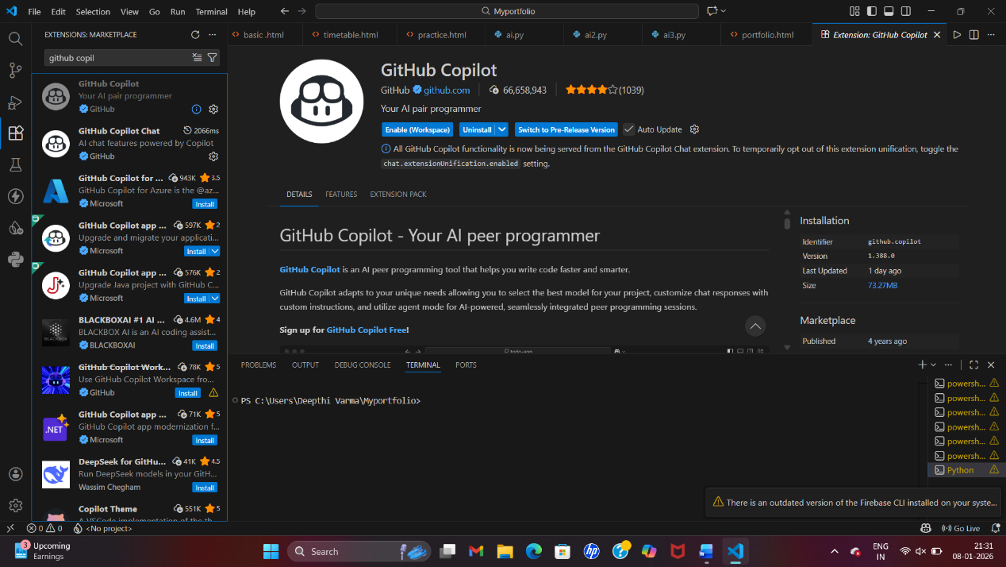

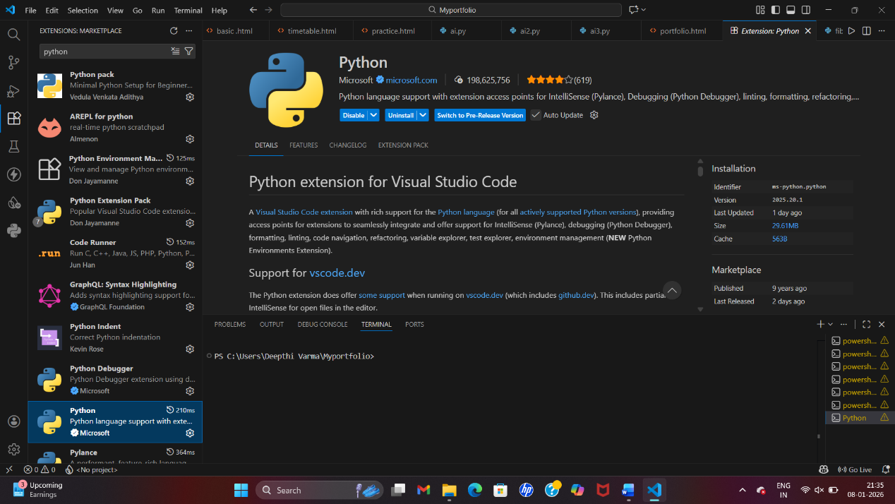

Task - 1 :
Prompt : Write a Python program that prints the Fibonacci series for a given number of terms.
Take input n from the user, use looping statements to produce the series, and avoid defining any functions.

Code :
n = int(input("Enter the number of terms: "))

a, b = 0, 1

print("Fibonacci series:")
for i in range(n):
print(a, end=" ")
c = a + b
a = b
b = c

Output:
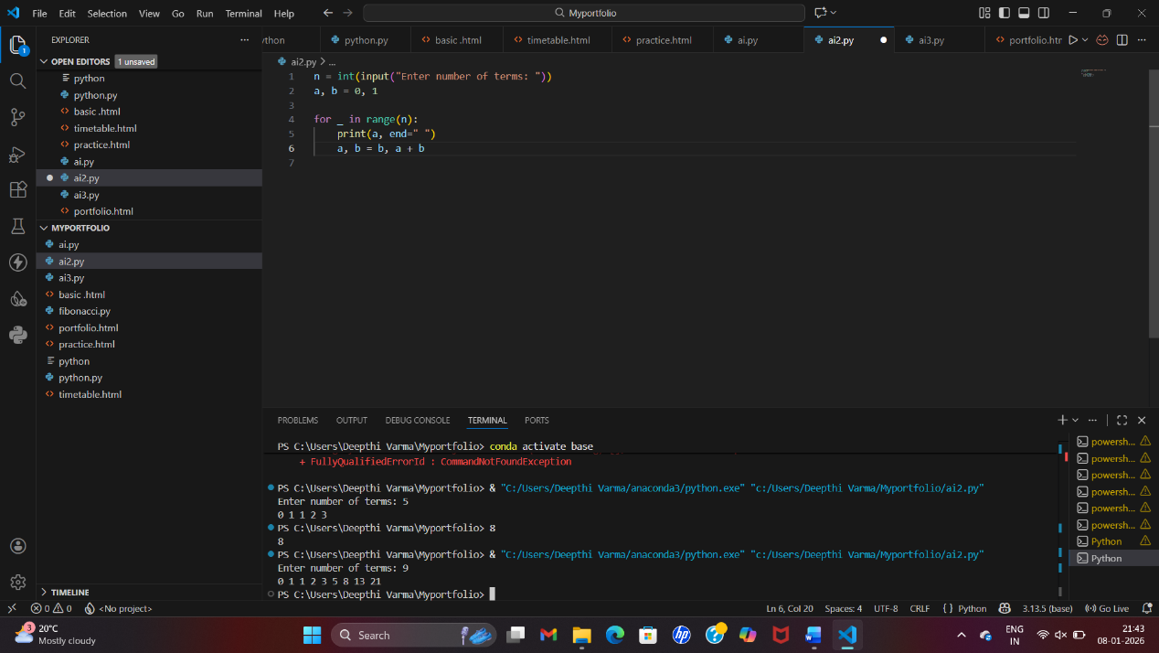

Explanation:

n = int(input("Enter the number of terms: "))
• This line asks the user to enter how many terms of the Fibonacci series we want.
• The value is stored in the variable n.
a, b = 0, 1
• The Fibonacci series starts with 0 and 1.
• a stores the first number (0).
• b stores the second number (1).
for i in range(n):
• This loop runs n times, based on the user input.
• Each loop iteration prints one Fibonacci number.
print(a, end=””)
• Prints the value of a (current Fibonacci number).
- end=" " ensures all numbers are printed on the same line, separated by spaces.
c = a + b
a = b
b = c
• Adds the previous two numbers (a and b).
• Stores the result in variable c.
• a is updated to the value of b.
• b is updated to the new Fibonacci number c.
• This shift prepares the variables for the next loop cycle.
Task - 2 :
Prompt : Simplify this Fibonacci Python code by optimizing variable usage while keeping the same result.
Code :
n = int(input("Enter the number of terms: "))

a, b = 0, 1

print("Fibonacci series:")
for i in range(n):
print(a, end=" ")
a, b = b, a + b
Output :
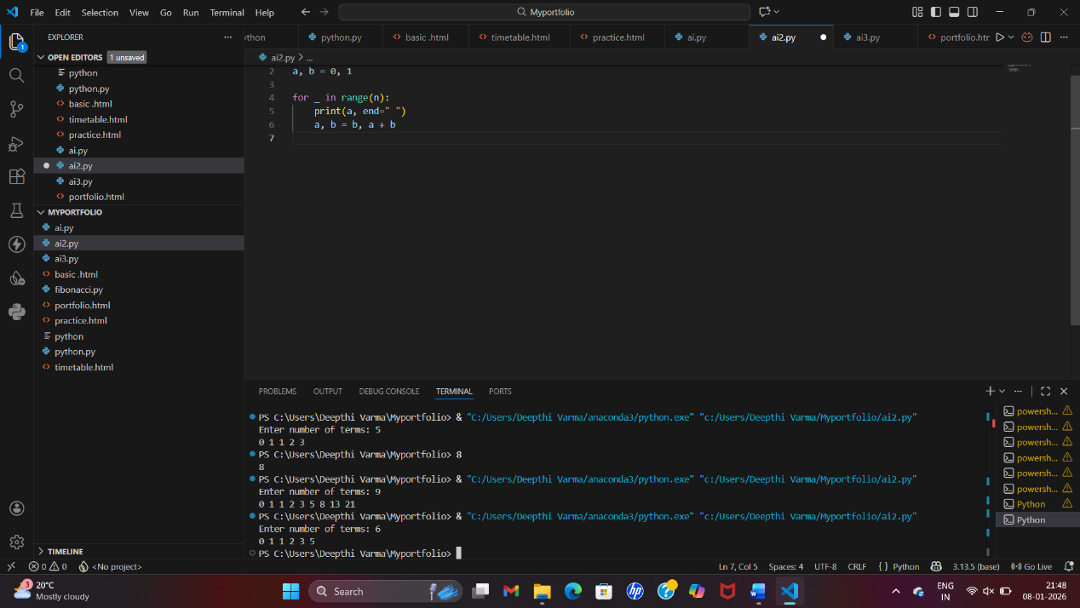
Explanation :
a, b = b, a + b
This is tuple assignment, which updates both variables in a single line:
a becomes the previous value of b
b becomes the sum of previous a and b
Task - 3 :
Prompt : Write a Python program that uses a user-defined function to print the Fibonacci series for n terms.
Read the value of n from the user, invoke the function from the main program, and include AI-generated comments to clearly explain the logic.
.
Code :
# Function to generate and display the Fibonacci series up to n terms
def fibonacci(n):
"""
Generate and print the Fibonacci series for n terms.

Args:
n (int): The number of terms in the Fibonacci series to generate
"""
# Initialize the first two Fibonacci numbers
a, b = 0, 1

print("Fibonacci series:")
# Iterate n times to generate n terms of the Fibonacci series
for i in range(n):
# Print the current Fibonacci number
print(a, end=" ")
# Update a and b to the next two consecutive Fibonacci numbers
a, b = b, a + b

# Print a newline at the end for better formatting
print()

# Main program
if __name__ == "__main__":
# Take the number of terms from the user
n = int(input("Enter the number of terms: "))

# Call the fibonacci function to generate and display the series
fibonacci(n)

Output :
Explanation :
• The program defines a user-defined function fibonacci(n) to generate the Fibonacci series.
• It initializes the first two numbers (0 and 1) and uses a loop to produce n terms.
• In each iteration, the current number is printed and the next Fibonacci numbers are calculated.
• The main program takes input from the user and calls the function.
• This approach improves code reusability, clarity, and modularity.
Task - 4:
Prompt : Compare function-based and non-function-based Fibonacci programs in Python, focusing on clarity, reusability, debugging, and scalability.
Aspect | Without Functions (Task 1) | With Functions (Task 3)
Code Clarity | Logic is written directly in the main program, which is easy to understand for very small scripts but becomes cluttered as code grows. | Code is well-structured with a separate fibonacci() function, making it cleaner and easier to read.
Reusability | Cannot be reused easily; the Fibonacci logic must be rewritten if needed elsewhere. | Highly reusable; the fibonacci() function can be called multiple times or used in other programs.
Debugging Ease | Harder to debug in larger code since all logic is in one place. | Easier to debug because the logic is isolated inside a function.
Scalability / Suitability for Larger Systems | Not suitable for large systems; adding features makes the code complex and messy. | Suitable for larger systems; modular design supports expansion and maintenance.
Task - 5 :
Prompt : Write a Python program that demonstrates both iterative and recursive methods for generating the Fibonacci series.
Take input from the user and add proper comments for each approach.
Code :
# ===== ITERATIVE METHOD =====
# Function to generate Fibonacci series iteratively up to n terms
def fibonacci_iterative(n):
"""
Generate and print the Fibonacci series using iterative approach.

Args:
n (int): The number of terms in the Fibonacci series to generate
"""
# Initialize the first two Fibonacci numbers
a, b = 0, 1

print("Fibonacci series (Iterative):")

# Iterate n times to generate n terms of the Fibonacci series
for i in range(n):
# Print the current Fibonacci number
print(a, end=" ")
# Update a and b to the next two consecutive Fibonacci numbers
a, b = b, a + b

# Print a newline at the end for better formatting
print()

# ===== RECURSIVE METHOD =====
# Function to generate Fibonacci series recursively
def fibonacci_recursive(n):
"""
Generate and print the Fibonacci series using recursive approach.

Args:
n (int): The number of terms in the Fibonacci series to generate
"""
# Base case: if n is 0 or negative, return empty list
if n <= 0:
return []

# Helper function to calculate the nth Fibonacci number
def fib_helper(num):
# Base cases for recursion
if num == 0:
return 0
elif num == 1:
return 1
# Recursive case: sum of previous two Fibonacci numbers
else:
return fib_helper(num - 1) + fib_helper(num - 2)

print("Fibonacci series (Recursive):")

# Generate and print n Fibonacci numbers using recursion
for i in range(n):
# Call the helper function to get the ith Fibonacci number and print it
print(fib_helper(i), end=" ")

# Print a newline at the end for better formatting
print()

# Main program
if __name__ == "__main__":
# Take the number of terms from the user
n = int(input("Enter the number of terms: "))

# Display both iterative and recursive approaches
print()

# Call the iterative Fibonacci function
fibonacci_iterative(n)

print()

# Call the recursive Fibonacci function
fibonacci_recursive(n)

Output :
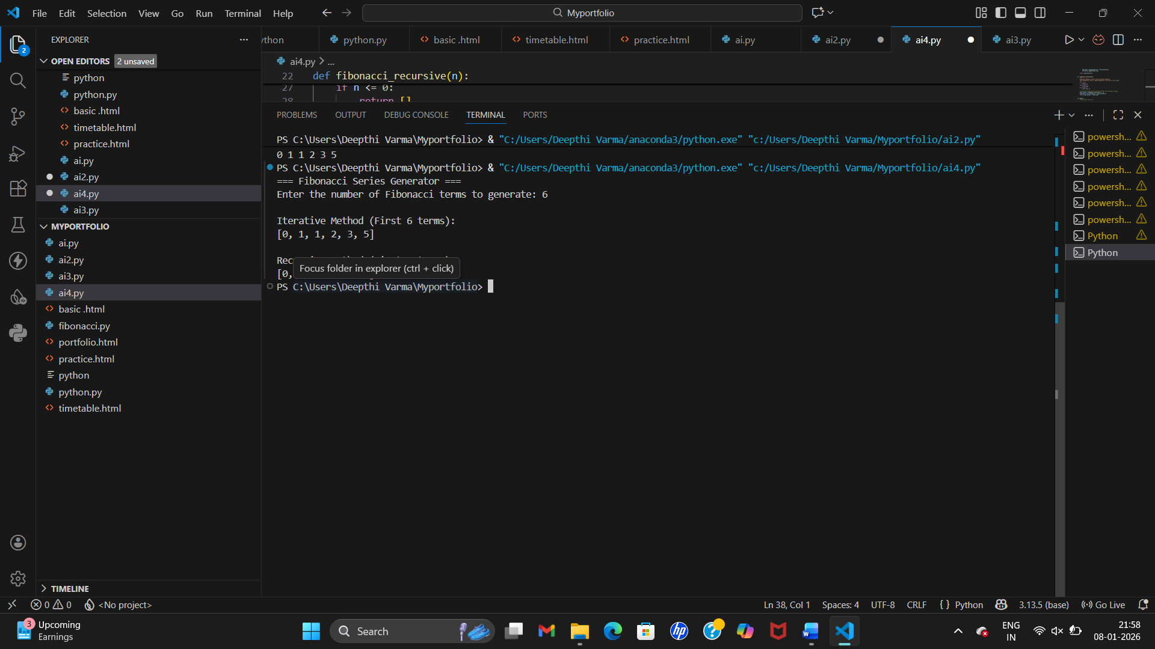

Explanation :

Iterative Method Execution Flow
The program starts from the main block and takes input n.
fibonacci_iterative(n) is called.
Variables a = 0 and b = 1 are initialized.
A for loop runs n times:
Prints the current value of a.
Updates values using a, b = b, a + b.
The loop ends after printing n Fibonacci numbers.
Control returns to the main program.

Recursive Method Execution Flow
The program starts from the main block and takes input n.
fibonacci_recursive(n) is called.
A nested helper function fib_helper(num) is defined.
For each value i from 0 to n-1:
fib_helper(i) is called.
fib_helper() works as follows:
If num is 0 or 1, return base values.
Otherwise, recursively calls itself twice:
fib_helper(n-1) + fib_helper(n-2)
This creates many repeated function calls.
The result is printed and control returns to the main program.
Time and space complexity :
Aspect | Iterative Approach | Recursive Approach
Time Complexity | O(n) | O(2ⁿ) (Exponential)
Space Complexity | O(1) | O(n)
Performance for Large n | Very efficient, fast execution | Very slow and inefficient

When recursion should be avoided :
Recursion should be avoided when:
n is large (e.g., n > 30)
Performance and speed are important
Memory usage must be minimal
The problem has overlapping subproblems without memoization
There is a risk of stack overflow

