ASSIGNMENT - 3.4
2303A51355
Batch-10

Task-1
Prompt: generate a Python program to print the first n Fibonacci numbers using a function without giving an example Code:
def fibonacci_sequence(n):
sequence = [] a, b = 0, 1
for _ in range(n): sequence.append(a) a, b = b, a + b return sequence # Example usage n = int(input("Enter the number of Fibonacci numbers to generate: ")) fib_sequence = fibonacci_sequence(n) print(f"The first {n} Fibonacci numbers are: {fib_sequence}")

Output :
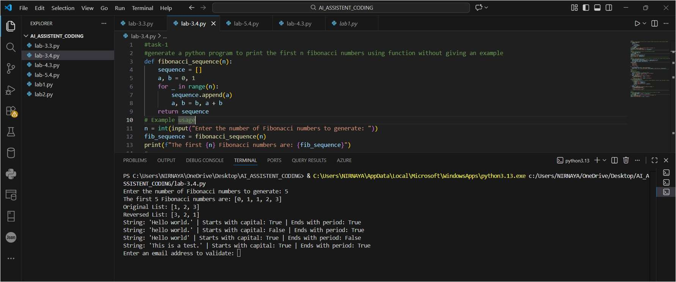
Code Analysis :
- The function fibonacci_sequence(n) generates Fibonacci numbers iteratively.
- Variables a and b store the previous two Fibonacci values.
- A for loop runs n times to generate required numbers.
- Each generated number is stored in a list for easy return.
- Function-based approach improves reusability and clarity.

Task-2
Prompt: generate a Python program to reverse a list and provide one example
Code:
def reverse_list(input_list): return input_list[::-1]
# Example usage sample_list = [1, 2, 3] reversed_list = reverse_list(sample_list) print(f"Original List: {sample_list}") print(f"Reversed List: {reversed_list}")

Output :
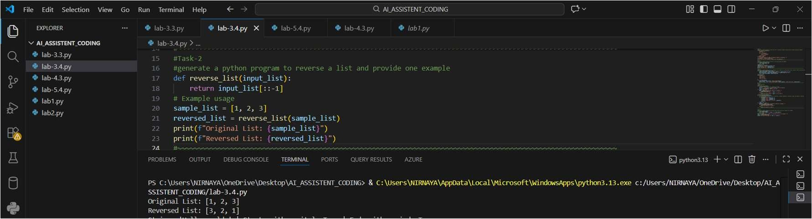
Code Analysis :
- The function reverse_list() accepts a list as input.
- Python slicing [::-1] is used for efficient reversal.
- No additional loop or memory-intensive operations are required.
- Original list remains unchanged, ensuring data safety.
- Function allows reuse for any list input.

Task-3
Prompt : generate a Python program with 2-3 examples of how to check if a string starts with a capital letter and ends with a period using a function.
Code :
def check_string_format(input_string):
starts_with_capital = input_string[0].isupper() if input_string else False ends_with_period = input_string.endswith('.') if input_string else False return starts_with_capital, ends_with_period
# Example usage
test_strings = [
"Hello world.",
"hello world.",
"Hello world",
"This is a test."
] for s in test_strings:
starts_capital, ends_period = check_string_format(s)
print(f"String: '{s}' | Starts with capital: {starts_capital} | Ends with period: {ends_period}")

Output :
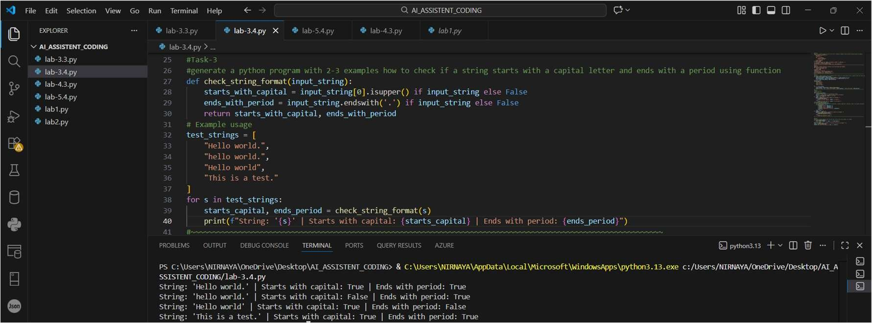
Code Analysis :
- The function checks both starting and ending conditions of a string.
- isupper() verifies whether the first character is capitalized.
- endswith('.') confirms proper sentence termination.
- Handles empty strings safely using conditional checks.
- Returns multiple Boolean values for detailed validation.

Task-4
Prompt: Email Validator
Code: import re def is_valid_email(email):
# Define a regex pattern for validating an Email pattern = r'^[a-zA-Z0-9._%+-]+@[a-zA-Z0-9.-]+\.[a-zA-Z]{2,}$' return re.match(pattern, email) is not None if __name__ == "__main__": email = input("Enter an email address to validate: ") if is_valid_email(email):
print(f"The email address '{email}' is valid.") else:
print(f"The email address '{email}' is not valid.")
# Password Strength Checker def is_strong_password(password):
# A strong password has at least 8 characters, contains uppercase, lowercase, digit, and special character if (len(password) >= 8 and re.search(r'[A-Z]', password) and re.search(r'[a-z]', password) and re.search(r'[0-9]', password) and re.search(r'[!@#$%^&*(),.?":{}|<>]', password)):
return True return False if __name__ == "__main__":
password = input("EnteQr a password to check its strength: ") if is_strong_password(password): print("The password is strong.") else:
print("The password is weak.")

Output :
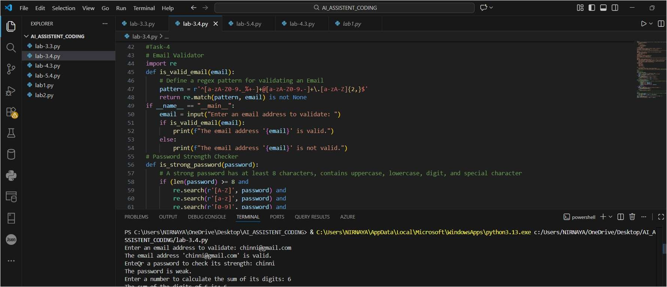
Code Analysis :
- Regular expressions (re) are used for pattern matching.
- Email validation ensures correct structure using a defined regex.
- Password checker verifies length, case, digits, and special characters.
- Separate functions improve modularity and readability.
- Enhances security by validating user credentials effectively.
Task 5
Prompt: generate a Python program with a function that returns the sum of the digits of a
number
Code:
def sum_of_digits(number):
return sum(int(digit) for digit in str(abs(number)))
# Example usage num = int(input("Enter a number to calculate the sum of its digits: ")) result = sum_of_digits(num) print(f"The sum of the digits of {num} is: {result}")

Output :
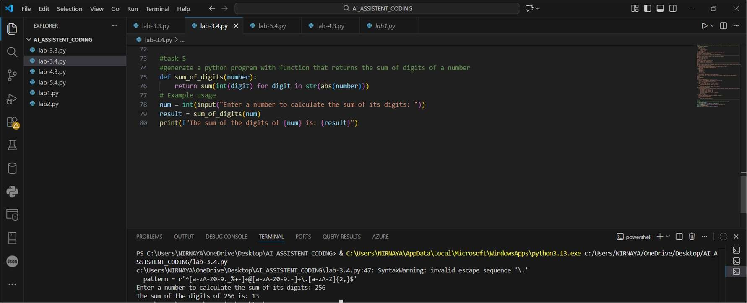
Code Analysis :
- The function converts the number into a string for easy digit access.
- abs() ensures correct handling of negative numbers.
- int() converts each character back to a digit.
- sum() efficiently adds all digits in one line.
- Function returns the result, supporting reuse in other programs.

