ASSIGNMENT – 3.3
2303A51355
Batch-10

Task-1
Prompt: I want an application for the TGNPDCL electricity bill payment system generation that must collect accurate consumer data, that needs previous units, current units, and the type of customer, code in python langauage.

Code :
def calculate_bill(previous_units, current_units, customer_type):
units_consumed = current_units - previous_units if customer_type.lower() == 'residential': if units_consumed <= 100:
bill_amount = units_consumed * 1.5 elif units_consumed <= 300:
bill_amount = (100 * 1.5) + (units_consumed - 100) * 2.5
else:
bill_amount = (100 * 1.5) + (200 * 2.5) + (units_consumed - 300) * 4.0 elif customer_type.lower() == 'commercial': if units_consumed <= 100:
bill_amount = units_consumed * 2.0 elif units_consumed <= 300:
bill_amount = (100 * 2.0) + (units_consumed - 100) * 3.5
else:
bill_amount = (100 * 2.0) + (200 * 3.5) + (units_consumed - 300) * 5.0
else:
raise ValueError("Invalid customer type. Please enter 'residential' or 'commercial'.") return bill_amount # Collecting user input consumer_id = input("Enter Consumer ID: ") previous_units = int(input("Enter Previous Units: ")) current_units = int(input("Enter Current Units: ")) customer_type = input("Enter Customer Type (residential/commercial): ")
# Calculating bill
try:
bill_amount = calculate_bill(previous_units, current_units, customer_type) print(f"Consumer ID: {consumer_id}") print(f"Units Consumed: {current_units - previous_units}") print(f"Bill Amount: ₹{bill_amount:.2f}") except ValueError as e:
print(e)

Output :
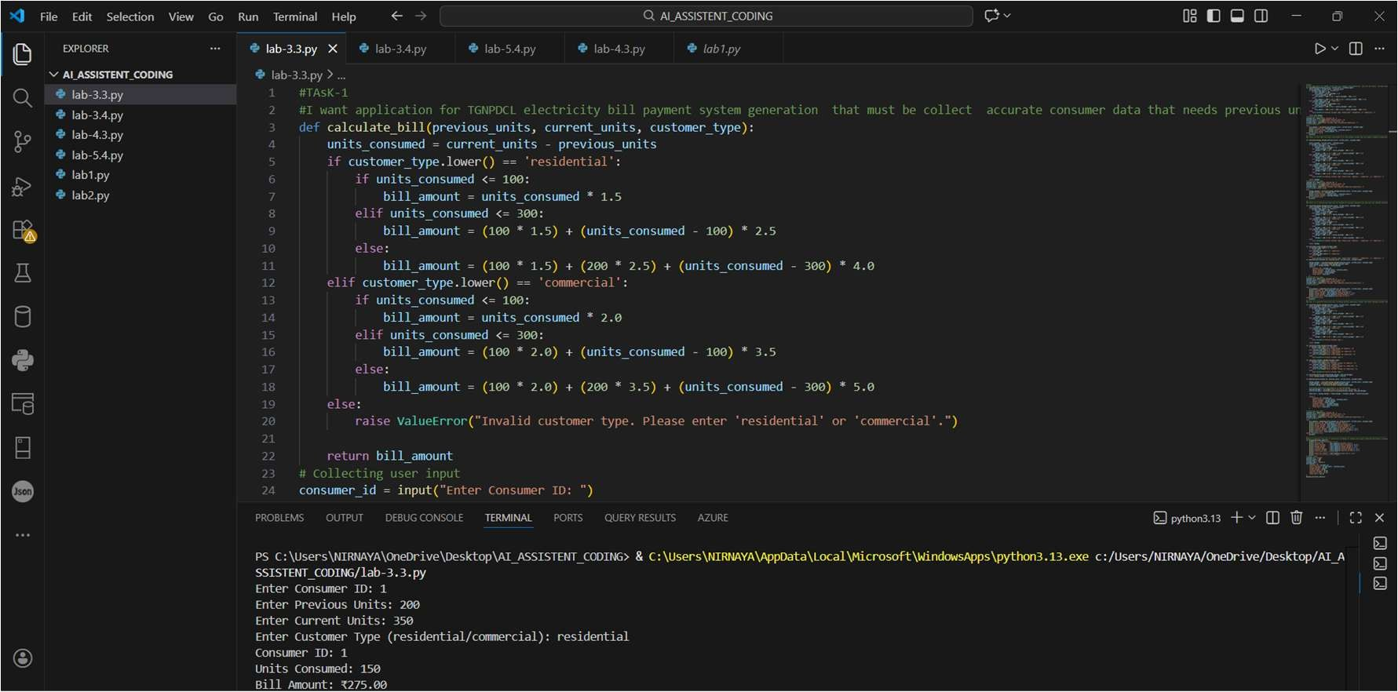
Code Analysis :
- The program uses a function calculate_bill() to separate billing logic from user input.
- Units consumed are calculated by subtracting previous units from current units.
- Nested if–elif conditions apply slab-based tariff rates.
- Customer type is normalized using .lower() to avoid case mismatch errors.
- Exception handling ensures invalid customer types are handled safely.

Task-2
Prompt: find code from Task-1 and extend it to find energy charges that were based on domestic, commercial, and industrial consumers in optimised condition statements in Python language.

Code :
def calculate_energy_charges(previous_units, current_units, consumer_type):

units_consumed = current_units - previous_units if consumer_type.lower() == 'domestic': if units_consumed <= 100:
charges = units_consumed * 1.2
elif units_consumed <= 300:
charges = (100 * 1.2) + (units_consumed - 100) * 2.0
else:
charges = (100 * 1.2) + (200 * 2.0) + (units_consumed - 300) * 3.5
elif consumer_type.lower() == 'commercial':
if units_consumed <= 100:
charges = units_consumed * 2.5 elif units_consumed <= 300:
charges = (100 * 2.5) + (units_consumed - 100) * 4.0
else:
charges = (100 * 2.5) + (200 * 4.0) + (units_consumed - 300) * 6.0
elif consumer_type.lower() == 'industrial': if units_consumed <= 100:
charges = units_consumed * 3.0 elif units_consumed <= 300:
charges = (100 * 3.0) + (units_consumed - 100) * 5.0
else:
charges = (100 * 3.0) + (200 * 5.0) + (units_consumed - 300) * 7.5
else:
raise ValueError("Invalid consumer type. Please enter 'domestic', 'commercial', or 'industrial'.")

return charges # Collecting user input consumer_id = input("Enter Consumer ID: ") previous_units = int(input("Enter Previous Units: ")) current_units = int(input("Enter Current Units: ")) consumer_type = input("Enter Consumer Type (domestic/commercial/industrial): ")
# Calculating energy charges
try:
energy_charges = calculate_energy_charges(previous_units, current_units,
consumer_type) print(f"Consumer ID: {consumer_id}") print(f"Units Consumed: {current_units - previous_units}") print(f"Energy Charges: ₹{energy_charges:.2f}") except ValueError as e:
print(e)

Output :
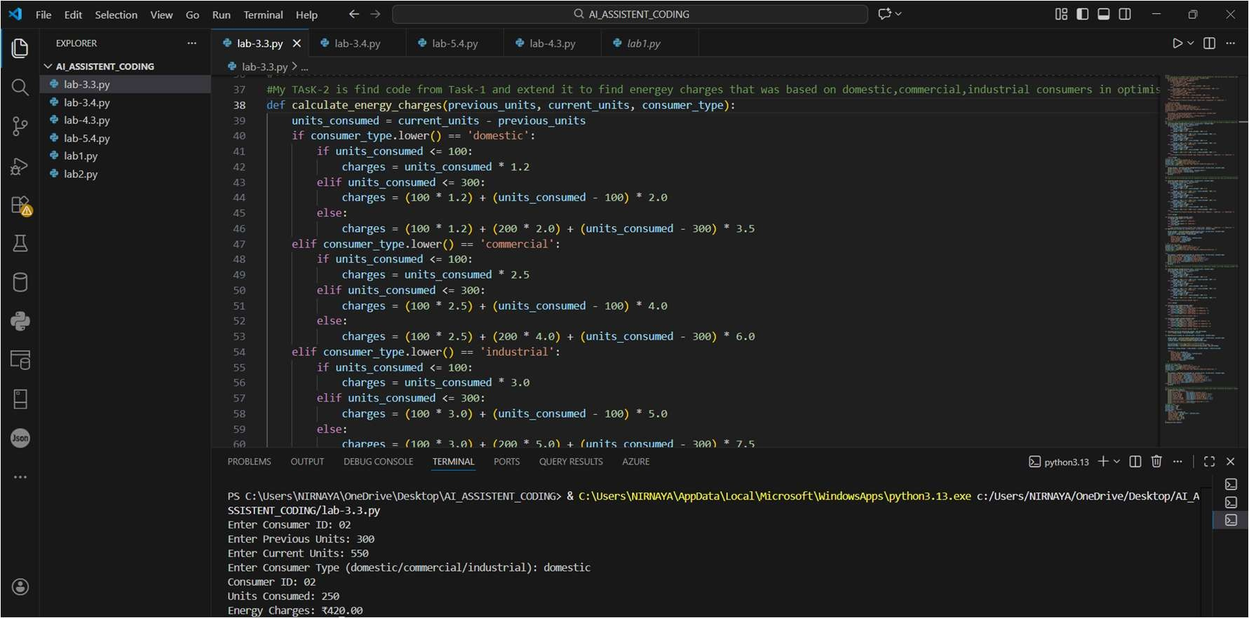
Code Analysis :
- A single function, calculate_energy_charges() handles all consumer categories.
- Slab-based billing is implemented using structured conditional blocks.
- Logical grouping avoids redundant calculations.
- Function returns computed charges for further processing.
- Error handling improves robustness against invalid inputs.

Task-3
Prompt: find billing logic that must be reusable for multiple consumers, and that uses user-defined functions to calculate energy charges, fixed charges, and that should return values including meaningful comments in Python.
Code :

def calculate_energy_charges(previous_units, current_units, consumer_type):
units_consumed = current_units - previous_units if consumer_type.lower() == 'domestic': if units_consumed <= 100:
charges = units_consumed * 1.2

elif units_consumed <= 300: charges = (100 * 1.2) + (units_consumed - 100) * 2.0 else:

charges = (100 * 1.2) + (200 * 2.0) + (units_consumed - 300) * 3.5
elif consumer_type.lower() == 'commercial':

if units_consumed <= 100:
charges = units_consumed * 2.5

elif units_consumed <= 300: charges = (100 * 2.5) + (units_consumed - 100) * 4.0 else: charges = (100 * 2.5) + (200 * 4.0) + (units_consumed - 300) * 6.0 elif consumer_type.lower() == 'industrial': if units_consumed <= 100:

charges = units_consumed * 3.0 elif units_consumed <= 300:
charges = (100 * 3.0) + (units_consumed - 100) * 5.0
else:
charges = (100 * 3.0) + (200 * 5.0) + (units_consumed - 300) * 7.5
else:
raise ValueError("Invalid consumer type. Please enter 'domestic', 'commercial', or 'industrial'.")

return charges

def calculate_fixed_charges(consumer_type): if consumer_type.lower() == 'domestic':
return 50.0 elif consumer_type.lower() == 'commercial': return 100.0 elif consumer_type.lower() == 'industrial':
return 150.0 else:
raise ValueError("Invalid consumer type. Please enter 'domestic', 'commercial', or
'industrial'.") def generate_bill(consumer_id, previous_units, current_units, consumer_type):

energy_charges = calculate_energy_charges(previous_units, current_units,
consumer_type) fixed_charges = calculate_fixed_charges(consumer_type) total_bill = energy_charges + fixed_charges return {
"Consumer ID": consumer_id,
"Units Consumed": current_units - previous_units,
"Energy Charges": energy_charges,
"Fixed Charges": fixed_charges,
"Total Bill": total_bill
}
# Collecting user input consumer_id = input("Enter Consumer ID: ") previous_units = int(input("Enter Previous Units: ")) current_units = int(input("Enter Current Units: ")) consumer_type = input("Enter Consumer Type (domestic/commercial/industrial): ") # Generating bill
try:
bill_details = generate_bill(consumer_id, previous_units, current_units,
consumer_type) print(f"Consumer ID: {bill_details['Consumer ID']}") print(f"Units Consumed: {bill_details['Units Consumed']}") print(f"Energy Charges: ₹{bill_details['Energy Charges']:.2f}") print(f"Fixed Charges: ₹{bill_details['Fixed Charges']:.2f}") print(f"Total Bill: ₹{bill_details['Total Bill']:.2f}") except ValueError as e:
print(e)

Output :
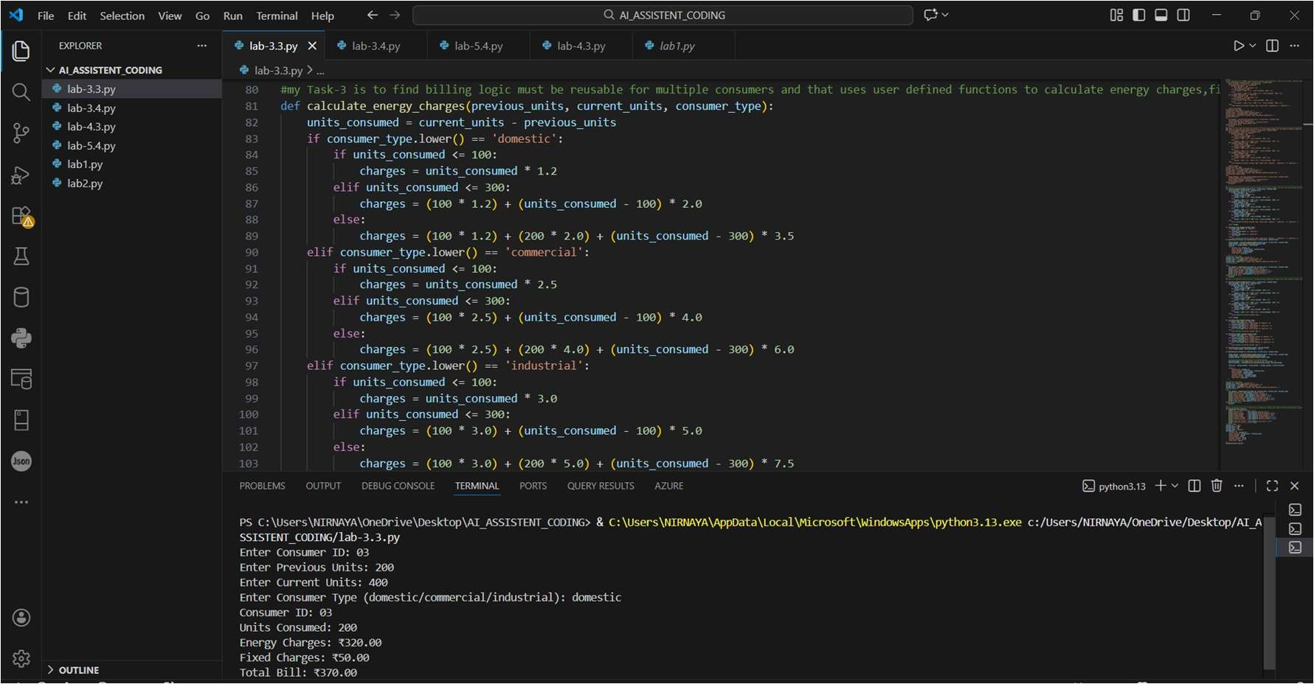
Code Analysis :
- Code is modularised using multiple user-defined functions.
- Energy charges and fixed charges are calculated independently.
- generate_bill() integrates all charge components into one structure.
- Dictionary return type improves readability and structured output.
- Design supports reuse for multiple consumers efficiently.

Task-4
Prompt: generate an electricity bill including multiple additional charges like fixed charges, customer charges, percentage of electricity duty, and duty calculation by improving accuracy.

Code :
def calculate_energy_charges(previous_units, current_units, consumer_type):
units_consumed = current_units - previous_units if consumer_type.lower() == 'domestic': if units_consumed <= 100:
charges = units_consumed * 1.2 elif units_consumed <= 300:
charges = (100 * 1.2) + (units_consumed - 100) * 2.0
else:
charges = (100 * 1.2) + (200 * 2.0) + (units_consumed - 300) * 3.5 elif consumer_type.lower() == 'commercial': if units_consumed <= 100:
charges = units_consumed * 2.5 elif units_consumed <= 300:
charges = (100 * 2.5) + (units_consumed - 100) * 4.0
else:
charges = (100 * 2.5) + (200 * 4.0) + (units_consumed - 300) * 6.0 elif consumer_type.lower() == 'industrial': if units_consumed <= 100:
charges = units_consumed * 3.5 elif units_consumed <= 300:
charges = (100 * 3.5) + (units_consumed - 100) * 5.5
else:
charges = (100 * 3.5) + (200 * 5.5) + (units_consumed - 300) * 7.5
else:
raise ValueError("Invalid consumer type.")

return charges

def calculate_fixed_charges(consumer_type):
if consumer_type.lower() == 'domestic':
return float(input("Enter Fixed Charges for Domestic: ")) elif consumer_type.lower() == 'commercial':
return float(input("Enter Fixed Charges for Commercial: ")) elif consumer_type.lower() == 'industrial':
return float(input("Enter Fixed Charges for Industrial: ")) else:
raise ValueError("Invalid consumer type.")

def calculate_customer_charges(consumer_type): if consumer_type.lower() == 'domestic':
return float(input("Enter Customer Charges for Domestic: ")) elif consumer_type.lower() == 'commercial':
return float(input("Enter Customer Charges for Commercial: ")) elif consumer_type.lower() == 'industrial':
return float(input("Enter Customer Charges for Industrial: "))
else:
raise ValueError("Invalid consumer type.")

def calculate_electricity_duty(energy_charges, duty_percentage):
return energy_charges * duty_percentage / float(1)

def generate_bill(consumer_id, previous_units, current_units, consumer_type):

energy_charges = calculate_energy_charges(previous_units, current_units, consumer_type) fixed_charges = calculate_fixed_charges(consumer_type) customer_charges = calculate_customer_charges(consumer_type)

# Calculate electricity duty based on a fixed percentage duty_percentage = float(input("Enter Electricity Duty Percentage: ")) electricity_duty = calculate_electricity_duty(energy_charges, duty_percentage)

total_bill = energy_charges + fixed_charges + customer_charges + electricity_duty

return {
"Consumer ID": consumer_id,
"Units Consumed": current_units - previous_units,
"Energy Charges": energy_charges,
"Fixed Charges": fixed_charges,
"Customer Charges": customer_charges,
"Electricity Duty": electricity_duty,
"Total Bill": total_bill
}

# Collecting user input consumer_id = input("Enter Consumer ID: ") previous_units = int(input("Enter Previous Units: ")) current_units = int(input("Enter Current Units: ")) consumer_type = input("Enter Consumer Type (domestic/commercial/industrial): ")
# Generating bill
try:
bill_details = generate_bill(consumer_id, previous_units, current_units, consumer_type) print(f"Consumer ID: {bill_details['Consumer ID']}") print(f"Units Consumed: {bill_details['Units Consumed']}") print(f"Energy Charges: ₹{bill_details['Energy Charges']:.2f}") print(f"Fixed Charges: ₹{bill_details['Fixed Charges']:.2f}") print(f"Customer Charges: ₹{bill_details['Customer Charges']:.2f}")
print(f"Electricity Duty: ₹{bill_details['Electricity Duty']:.2f}") print(f"Total Bill: ₹{bill_details['Total Bill']:.2f}") except ValueError as e:
print(e)
Output :
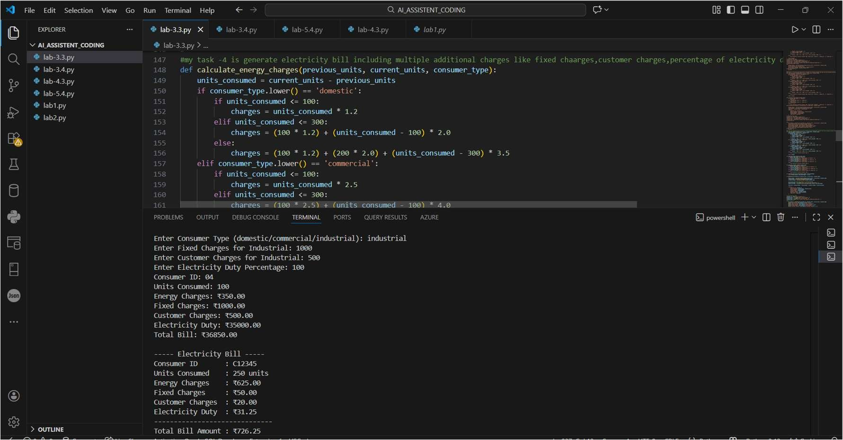
Code Analysis :
- Additional charge components are added through dedicated functions.
- Electricity duty is computed as a percentage of energy charges.
- Dynamic user input improves billing accuracy and flexibility.
- Functions maintain separation of concerns for clarity.
- The total bill aggregates all computed components systematically.

Task 5
Prompt: generate the final bill of electricity, including all charges, with proper formatting and display in Python language.

code : ef display_bill(bill_details):
print("\n----- Electricity Bill -----") print(f"Consumer ID : {bill_details['Consumer ID']}") print(f"Units Consumed : {bill_details['Units Consumed']} units") print(f"Energy Charges : ₹{bill_details['Energy Charges']:.2f}") print(f"Fixed Charges : ₹{bill_details['Fixed Charges']:.2f}") print(f"Customer Charges : ₹{bill_details['Customer Charges']:.2f}") print(f"Electricity Duty : ₹{bill_details['Electricity Duty']:.2f}") print("------------------------------") print(f"Total Bill Amount : ₹{bill_details['Total Bill']:.2f}")
print("------------------------------\n")
# Example usage consumer_id = "C12345" previous_units = 500 current_units = 750 consumer_type = "domestic"
bill_details = {
"Consumer ID": consumer_id,
"Units Consumed": current_units - previous_units,
"Energy Charges": 625.00,
"Fixed Charges": 50.00,
"Customer Charges": 20.00,
"Electricity Duty": 31.25,
"Total Bill": 726.25
} display_bill(bill_details)

Output :
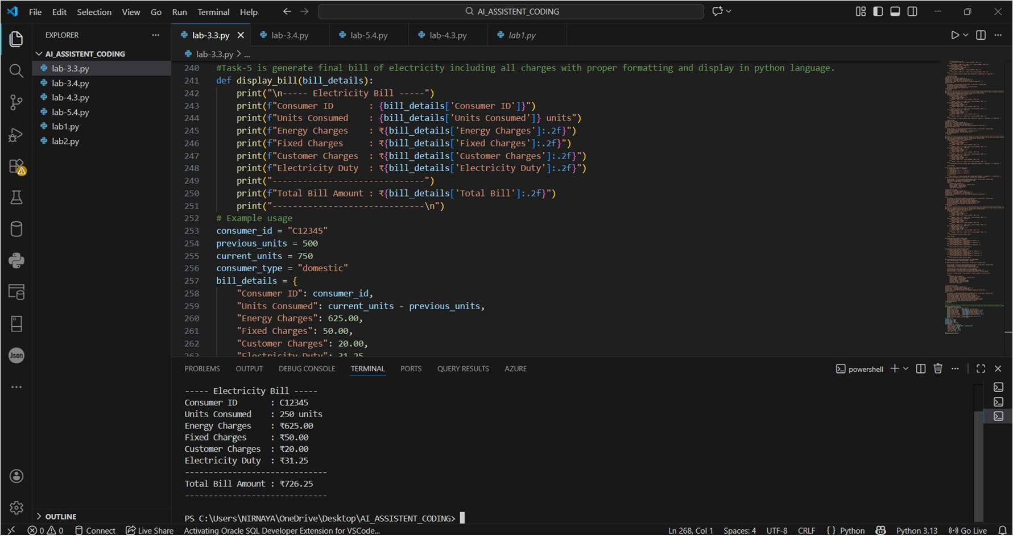
Code Analysis :
- Display logic is isolated in the display_bill() function.
- Formatted printing ensures professional bill presentation.
- Uses dictionary keys to access bill components safely.
- Separation of calculation and presentation improves maintainability.
- Supports easy modification for real-world billing systems.

