ASSIGNMENT - 4.3
2303A51355
Batch-10

Task-1
Prompt: Give me a program to zero-short promp ng to check a leap year, and give instructions without providing examples
code :
def is_leap_year(year): if (year % 4 == 0 and year % 100 != 0) or (year % 400 == 0):
return True return False year = int(input("Enter a year to check if it's a leap year: ")) if is_leap_year(year):
print(f"{year} is a leap year.")
else:
print(f"{year} is not a leap year.") Output
:
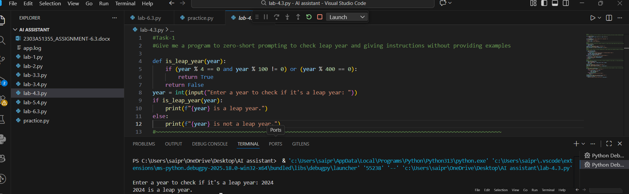
Code Analysis:
- This program determines whether a given year is a leap year using a function.
- The function applies standard leap year rules and returns True or False.
- The user inputs a year, which is checked by the function.
- The result is printed as either a leap year or not.

Task-2
Prompt: generate a one-short prompt that changes centimetres to inches with one input and output using the correct mathematical formula
Code :
def cm_to_inches(cm): inches = cm / 2.54
return inches cm_value = float(input("Enter length in cen meters: ")) inches_value = cm_to_inches(cm_value) print(f"{cm_value} cm is equal to {inches_value:.2f} inches.") Output :
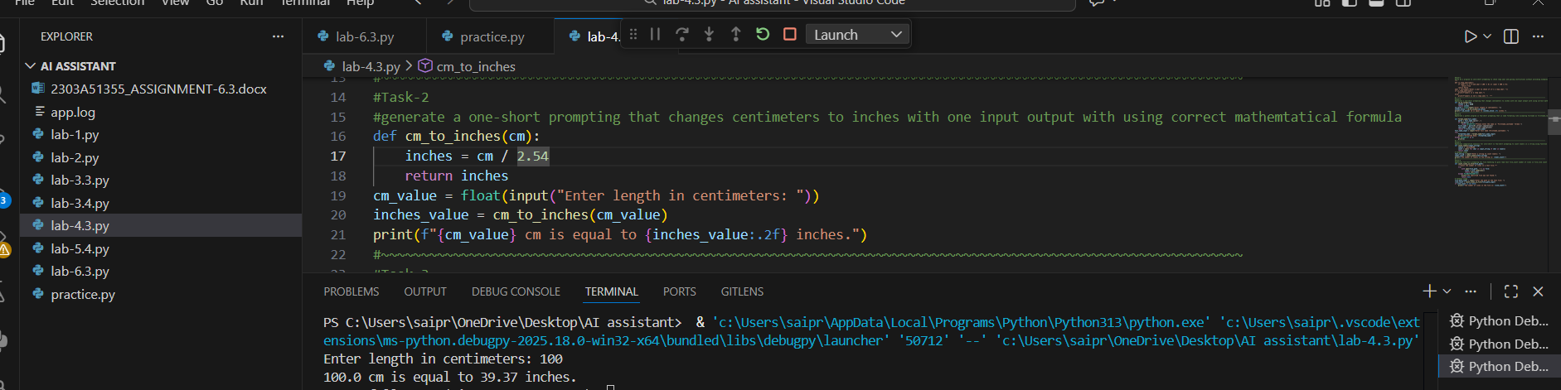
Code Analysis:
- This program converts a length from centimetres to inches using the correct mathematical formula.
- A function performs the conversion by dividing the value by 2.54.
- The user enters a value in centimetres, which is passed to the function.
- The converted result is displayed in inches.
Task-3
Prompt: generate a python program is few-short promp ng that is name forma ng like accep ng fullname as firstname,lastname.
Code :
def format_name(full_name): parts = full_name.split(',') if len(parts) != 2:
raise ValueError("Please enter the name in 'Firstname,Lastname' format.") first_name = parts[0].strip().capitalize()
last_name = parts[1].strip().capitalize() return f"{first_name}
{last_name}" full_name_input = input("Enter full name
(Firstname,Lastname): ")
try:
forma ed_name = format_name(full_name_input) print(f"Forma ed Name: {forma ed_name}")
except ValueError as e:
print(e) Output:
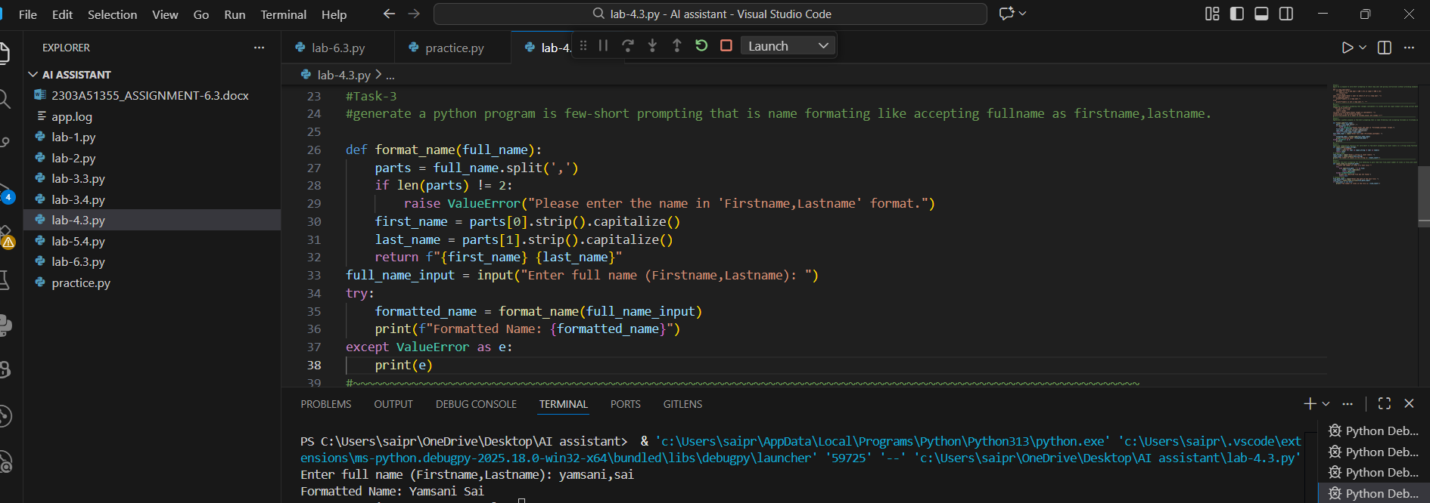
Code Analysis :
- This program formats a full name entered as first name and last name.
- The input is split and validated to ensure the correct format.
- Each part of the name is cleaned and capitalised. ➢ The forma ed full name is then displayed.

Task-4
Prompt: generate a compara ve analysis for zero-short vs few-short promp ng to count vowels in a string using a function:
Code :
def count_vowels(input_string):
vowels = 'aeiouAEIOU' count = sum(1 for char in input_string if char in vowels) return count
# Example usage
test_string = input("Enter a string to count vowels: ") vowel_count = count_vowels(test_string) print(f"The number of vowels in the string is: {vowel_count}") Output:
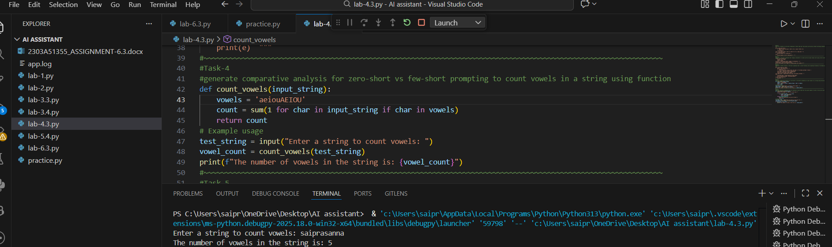
Code Analysis :
- The function counts vowels in a given string using a direct logic approach.
- Zero-shot prompting applies the logic without examples.
- Few-shot prompting helps by showing patterns before execution.
- The function returns the total number of vowels in the input string.

Task-5
Prompt: generate a few short prompts for file handling to give a read text file, count the number of lines in the file, and line count by function def count_lines_in_file(file_path):
try:
with open(file_path, 'r') as file:
lines = file.readlines() return len(lines) except FileNotFoundError:
print("The specified file was not found.") return None
# Example usage file_path_input = input("Enter the path of the text file: ") line_count = count_lines_in_file(file_path_input) if line_count is not None:
print(f"The number of lines in the file is: {line_count}")
Output :
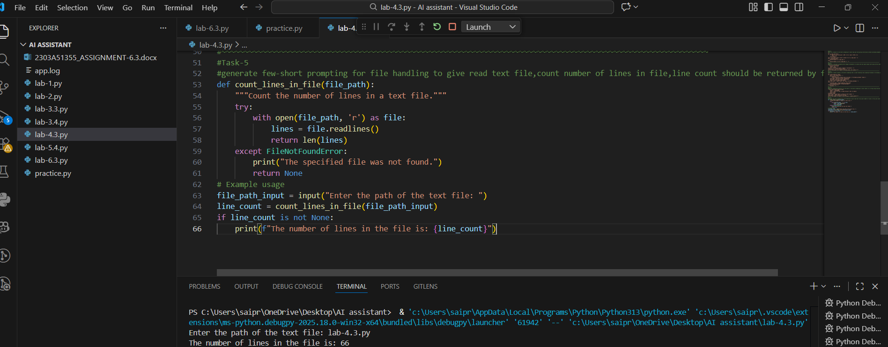

Code Analysis :
- This program reads a text file and counts the number of lines.
- A function opens the file safely and calculates the line count.
- Error handling is used if the file does not exist.
- The final line count is returned and displayed.

