Assignment-3.2
Name:R.sai kundan Ht.no:2303A51413
Batch.No:21

TaskDescription-1
- ProgressivePromptingforCalculatorDesign:AsktheAItodesignasimple calculator program by initially providing only the function name. Gradually enhance the prompt by adding comments and usage examples.
Promptused-1:
writeapythonfunctionnamedcalculatorthattakesthreeparameters:two numbers and an operator (as a string: '+', '-', '*', '/').
Code-1:

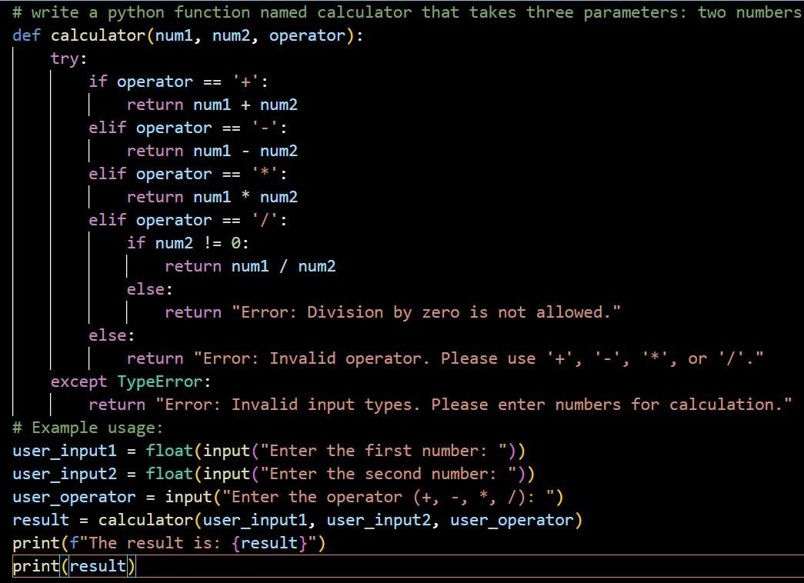
Output-1:
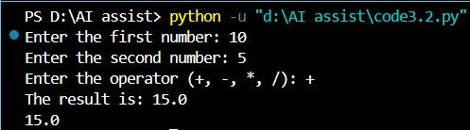
Promptused-2:
writeapythonfunctionnamedcalculatorthattakesthreeparameters:two numbers and an operator (as a string: '+', '-', '*', '/').
requirements:

Take2numbersandoperatorasinput Handle division by zero
Handleinvalidoperatorinputs

exampleinput:10,5,"+"output:15

Code-2:
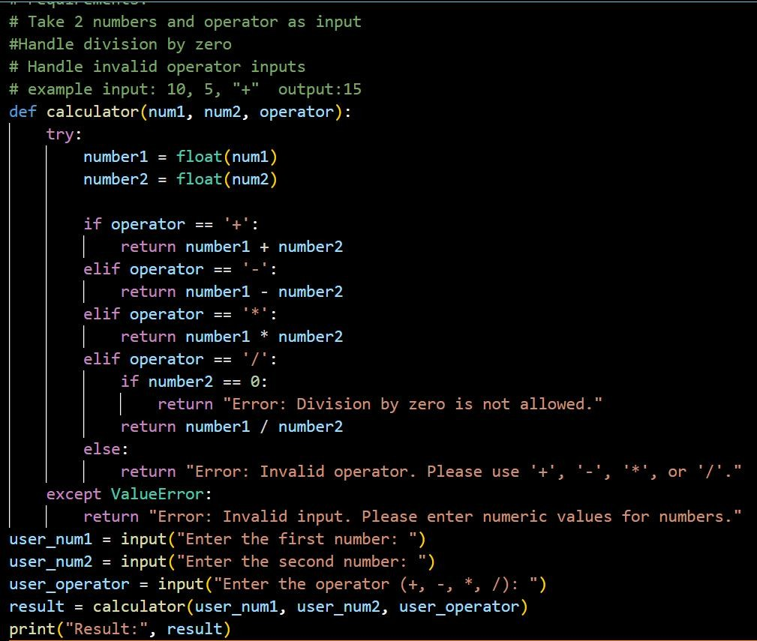
Output-2:
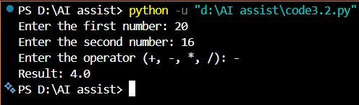

Comparisonof2codes:

Aspect Initial CalculatorVersion ImprovedCalculatorVersion

Input Handling
Assumesnumericinputsare already valid
Convertsinputstofloatand validates them

Error Handling
Handlesdivisionbyzero and invalid operator
Handlesinvalidnumbers,division by zero, and invalid operators

Code Structure
Basicconditionallogic inside function
Cleanerstructurewithexplicit input validation

Readability

Understandablebutless descriptive
Improved readability with commentsandclearvariable names

Robustness
Mayfailfornon-numeric inputs

Morerobustanduser-friendly

User Feedback

Limitederrormessages
Clearandinformativeerror messages

Suitability
Suitableforsimple calculations
Suitableforreal-worldanduser- facing programs

TaskDescription-2
- RefiningPromptsforSortingLogic:Startwithavaguepromptforsorting studentmarks,thenrefineittoclearlyspecifysortingorderandconstraints.
Code-1:

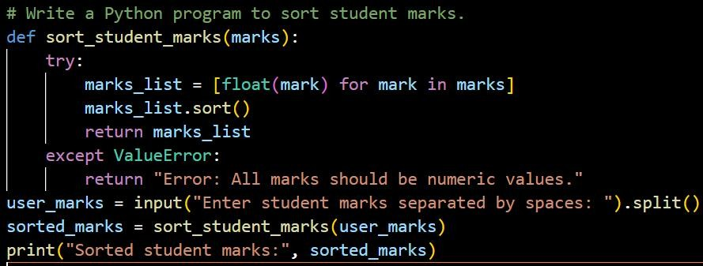
Output-1:
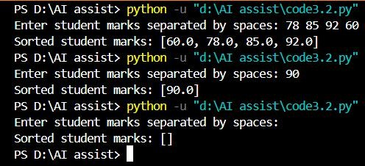
Code-2:
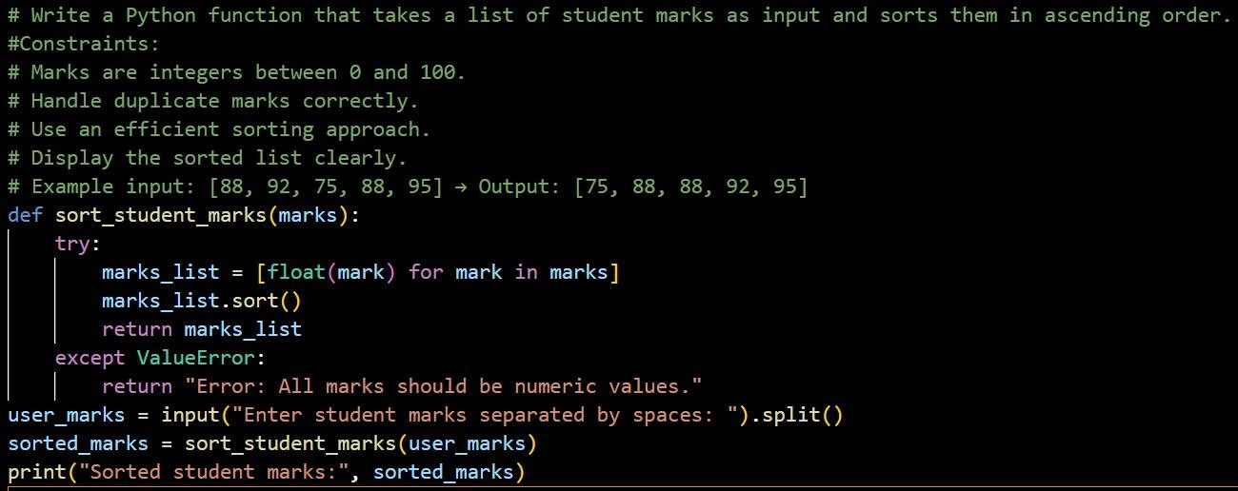

Output-2:

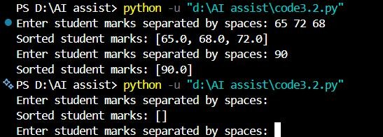
Justification:
Refiningthepromptbyspecifyingsortingorderandinputconstraintsimproved the accuracy and structure of the AI-generated sorting logic.
TherefinedpromptguidedtheAItohandlenumericconversion,duplicates,and empty inputs more reliably.
ThisshowsthatclearerpromptsleadtomoreefficientandpredictableAI- generated programs.

TaskDescription-3
- Few-Shot Prompting for Prime Number Validation: Provide multiple input- outputexamplesforafunctionthatcheckswhetheranumberisprime.Observe how few-shot prompting improves correctness.
Promptused:
Writeapythonfunctionthatcheckswhetheragivennumberisprimeorprime. example input: 2 output: prime number
input:7 output: prime number input:1output:notaprimenumber Code:

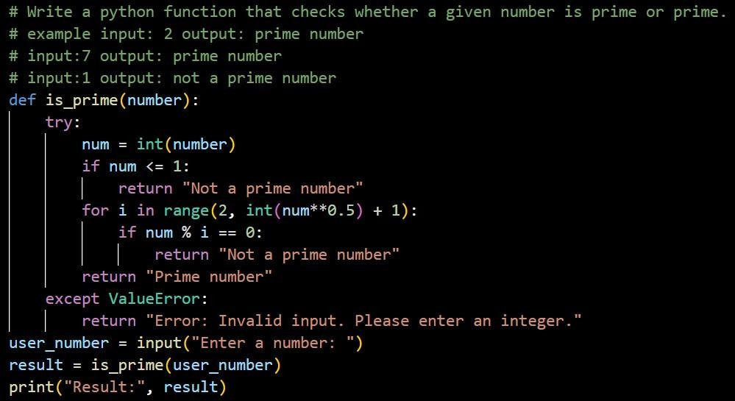

Output:
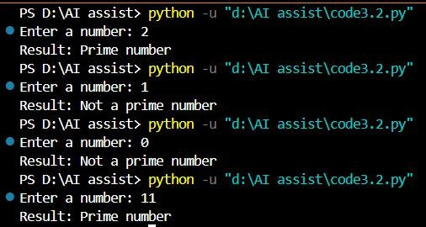
Justification:
Few-shotpromptingimprovestheprime-checkinglogicbyshowingtheAIclear examples of both prime and non-prime numbers.
TheseexamplesguidetheAItocorrectlyhandleedgecasessuchas0,1,and negative numbers, which are often missed in zero-shot prompting.
Asaresult,thegeneratedfunctionismoreaccurate,efficient,andreliablein validating prime numbers.

TaskDescription-4
- Prompt-GuidedUIDesignforStudentGradingSystem:Createauserinterface for a student grading system that calculates total marks, percentage, and grade based on user input.
PromptUsed:
Designasimpleanduser-friendlystudentgradingsystemUI Requirements:
- Createinputfieldstoentermarksformultiplesubjects.
- Calculatetotalmarksandpercentagebasedontheenteredvalues.
- Assigngradesbasedonpercentage(e.g.,A,B,C,Fail).
- Displaytotalmarks,percentage,andgradeclearlyonthescreen.
- Useacleanandwell-structuredlayout.
- Validateinputstoensureonlynumericvaluesareaccepted.
- UseHTMLandCSSfortheuserinterfaceandJavaScriptfor calculations. create all files in one file

Code:

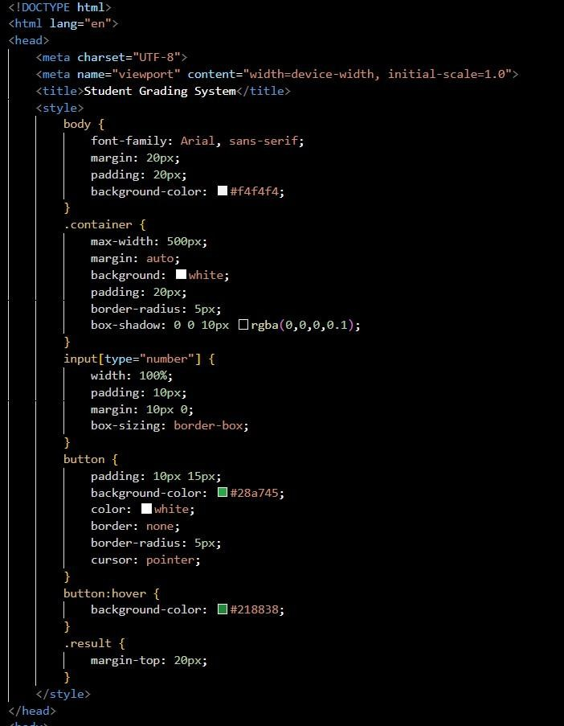

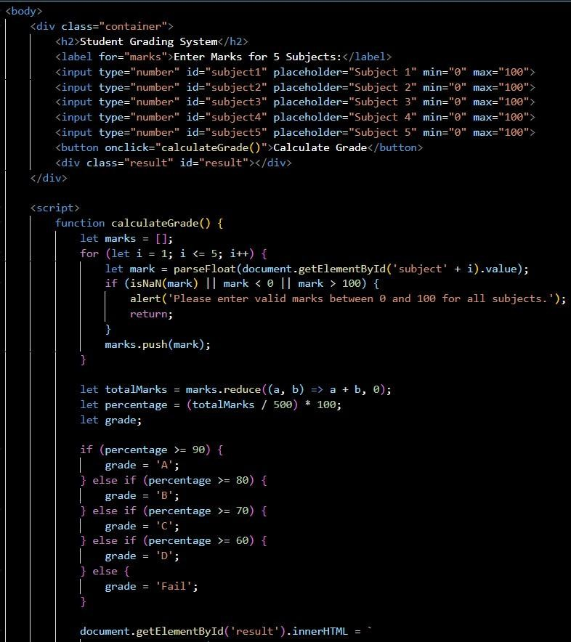
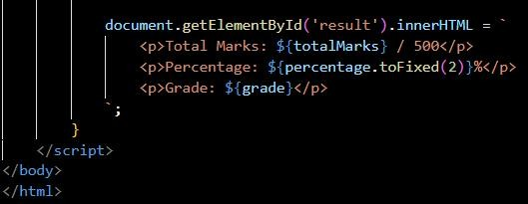

Output:
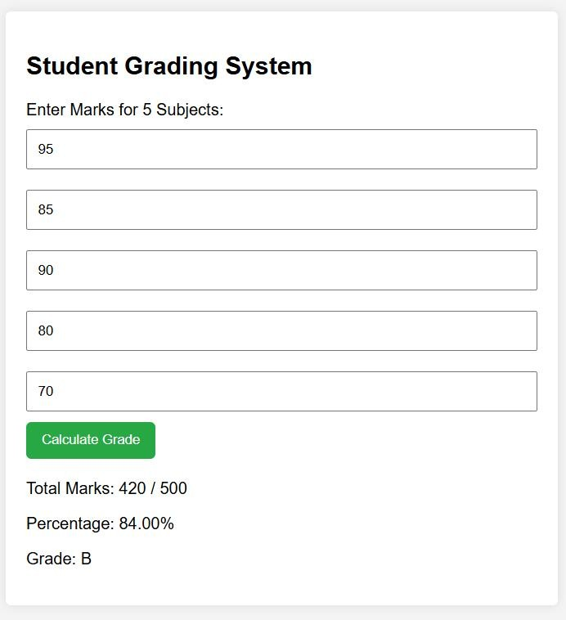

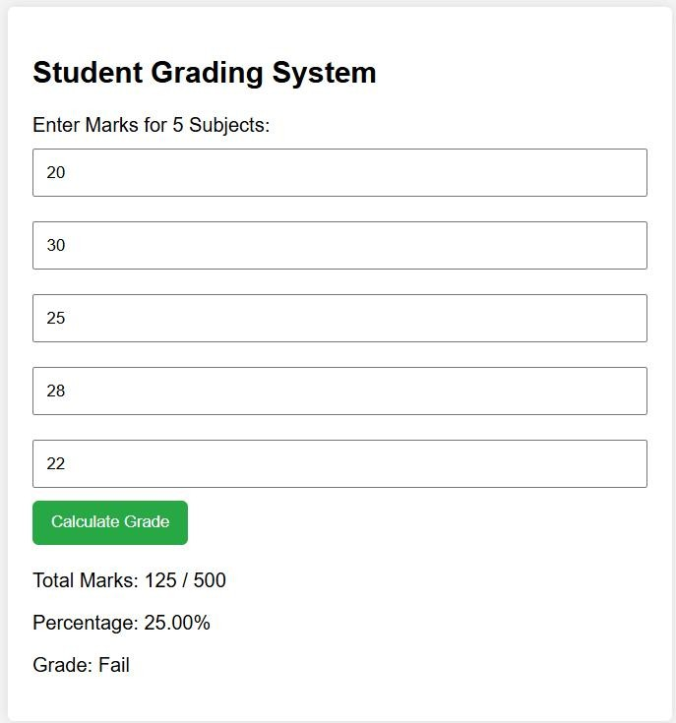
Justification:
Theprompt-guidedUIdesignensuresaccuratecalculationoftotalmarks, percentage, and grade based on user input.
Clearinputvalidationimprovesreliabilitybyhandlinginvalidandmissing values effectively.
AstructuredUIlayoutenhancesreadabilityandprovidesclearoutputfor students and evaluators.

TaskDescription-5
- AnalyzingPromptSpecificityinUnitConversionFunctions:ImprovingaUnit
ConversionFunction(KilometerstoMilesandMilestoKilometers)Using Clear
Instructions.

Promptused-1:
WriteaPythonfunctiontoconvertkilometerstomilesandmilestokilometers. Take input from the user and display the result.
Code-1:
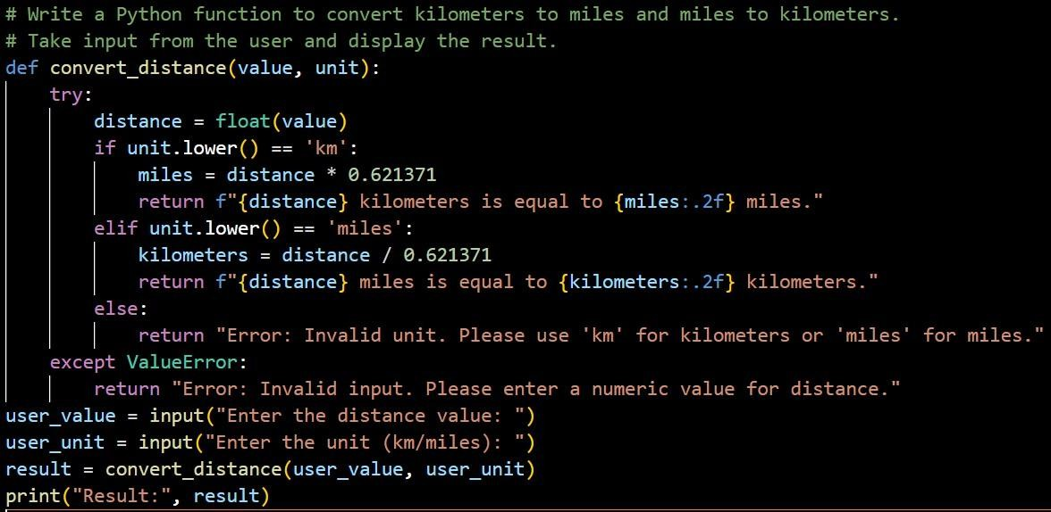

Output-1:

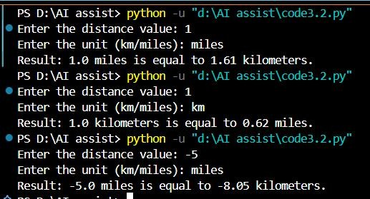

Promptused-2:
WriteaPythonprogramusingfunctionstoconvert:
- Kilometerstomiles
- Milestokilometers Requirements:
- Takenumericinputfromtheuser.

- Allowtheusertochoosetheconversiontype.
- Usecorrectconversionformulas.
- Validateinputandhandleinvalidvalues.
- Displayclearandformattedoutput.

Code-2:

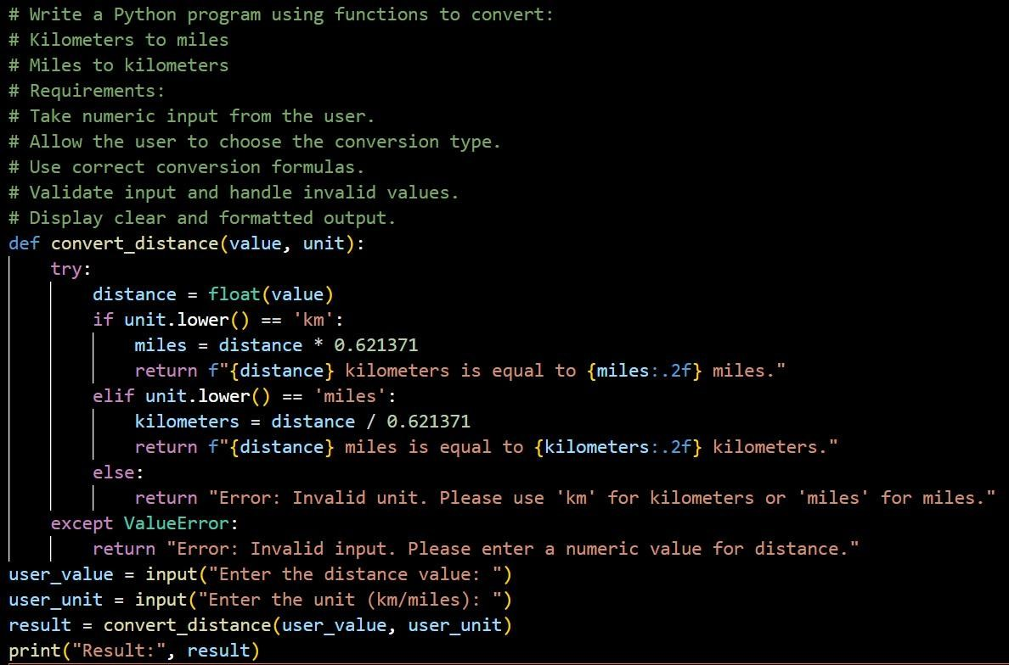
Output-2:
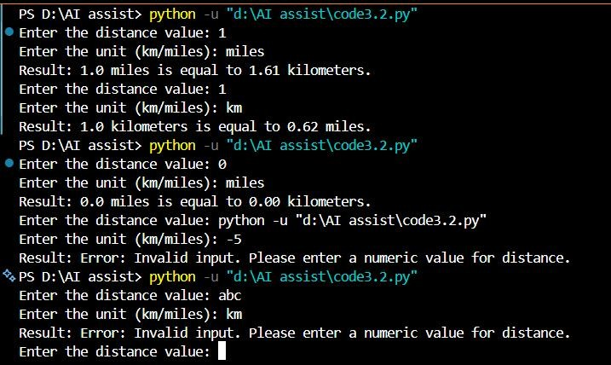

Justification:

Inthefirstprompt,theunitconversionlogicproducescorrectresultsbutlacks strict validation, allowing negative distance values.
Witha moredetailedprompt,theprogramimprovesbyaddingcleareroutput formatting and better handling of invalid inputs.
Overall,increasedpromptspecificityleadstomoreaccurate,robust,anduser- friendly unit conversion code.

