ASSIGNMENT-2.3 ID-2303A51510
BATCH-25 AI FOR CODING
AKHILESH VELURU

SCHOOL OF COMPUTER SCIENCE AND ARTIFICIAL INTELLIGENCE |  |  |  |  | DEPARTMENT OF COMPUTER SCIENCE ENGINEERING
Program Name: B. Tech |  |  |  | Assignment Type: Lab |  |  | Academic Year:2025-2026
Course Coordinator Name |  |  |  | Dr. Rishabh Mittal
Instructor(s) Name |  |  |  | Mr. S Naresh Kumar  Ms. B. Swathi  Dr. Sasanko Shekhar Gantayat  Mr. Md Sallauddin  Dr. Mathivanan  Mr. Y Srikanth  Ms. N Shilpa  Dr. Rishabh Mittal (Coordinator)  Dr. R. Prashant Kumar  Mr. Ankushavali MD  Mr. B Viswanath  Ms. Sujitha Reddy  Ms. A. Anitha  Ms. M.Madhuri  Ms. Katherashala Swetha  Ms. Velpula sumalatha  Mr. Bingi Raju
CourseCode |  |  | 23CS002PC304 | Course Title |  | AI Assisted Coding
Year/Sem |  |  | III/II | Regulation |  | R23
Date and Day  of Assignment |  |  | Week1 – Wednesday | Time(s) |  | 23CSBTB01 To 23CSBTB52
Duration |  |  | 2 Hours | Applicable to  Batches |  | All batches
Assignment Number:1.3(Present assignment number)/24(Total number of assignments)
 | Q.No. | Question |  |  |  |  |  | Expected Time  to complete
 | 1 | Lab 2: Exploring Additional AI Coding Tools beyond Copilot – Gemini (Colab) and Cursor AI  Lab Objectives:  - To explore and evaluate the functionality of Google Gemini for AI-assisted coding within Google Colab.  - To understand and use Cursor AI for code generation, explanation, and refactoring.  - To compare outputs and usability between Gemini, GitHub Copilot, and Cursor AI.  - To perform code optimization and documentation using AI tools.  Lab Outcomes (LOs):  After completing this lab, students will be able to:  - Generate Python code using Google Gemini in Google Colab.  - Analyze the effectiveness of code explanations and suggestions by Gemini.  - Set up and use Cursor AI for AI-powered coding assistance.  - Evaluate and refactor code using Cursor AI features.  - Compare AI tool behavior and code quality across different platforms.  Task 1: Word Frequency from Text File  - Scenario:  You are analyzing log files for keyword frequency.  - Task:  Use Gemini to generate Python code that reads a text file and counts word frequency, then explains the code.  - Expected Output:  - Working code  - Explanation  - Screenshot  - 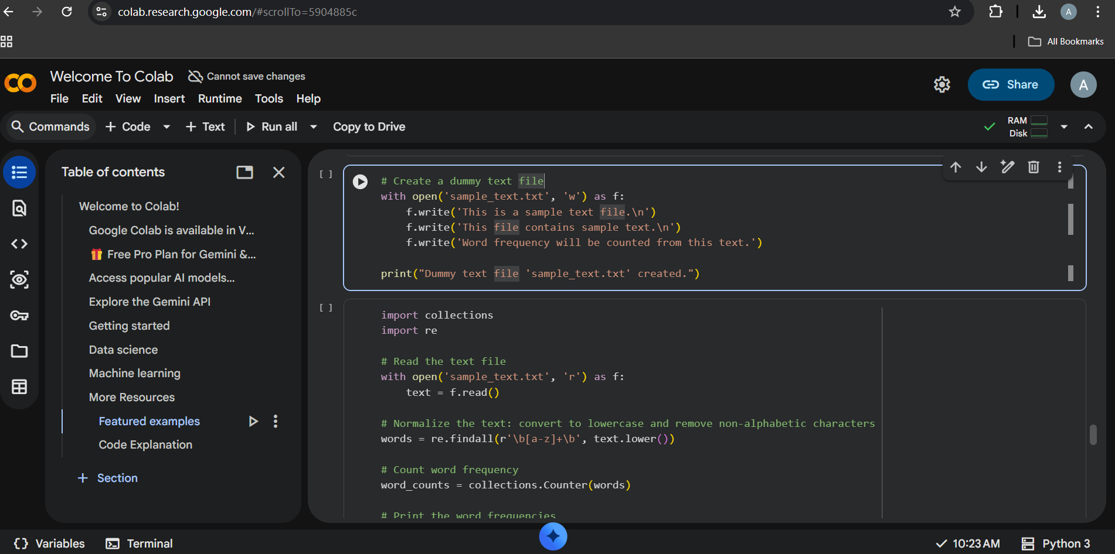  Task 2: File Operations Using Cursor AI  - Scenario:  You are automating basic file operations.  - Task:  Use Cursor AI to generate a program that:  - Creates a text file  - Writes sample text  - Reads and displays the content  - Expected Output:  - Functional code  - Cursor AI screenshots  - 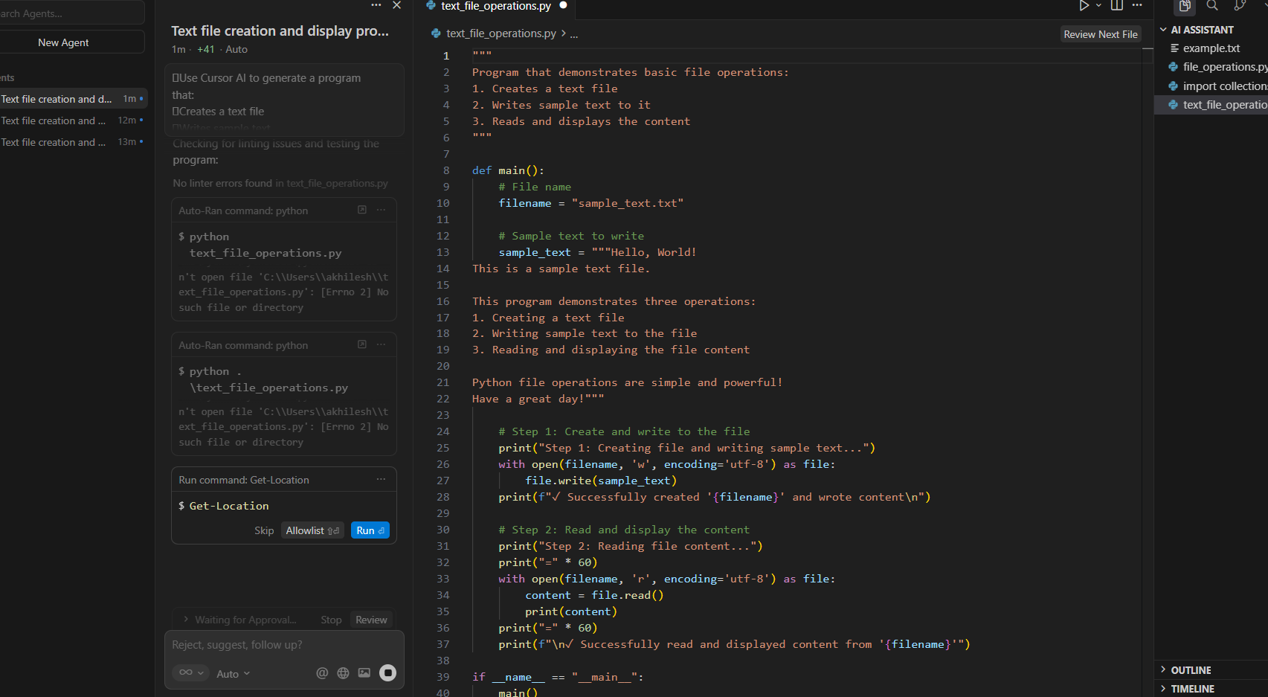  Task 3: CSV Data Analysis  - Scenario:  You are processing structured data from a CSV file.  - Task:  Use Gemini in Colab to read a CSV file and calculate mean, min, and max.  - Expected Output:  - Correct output  - Screenshot  - 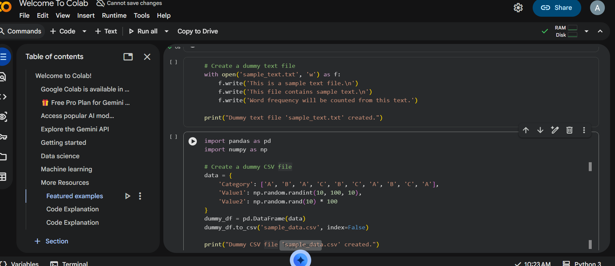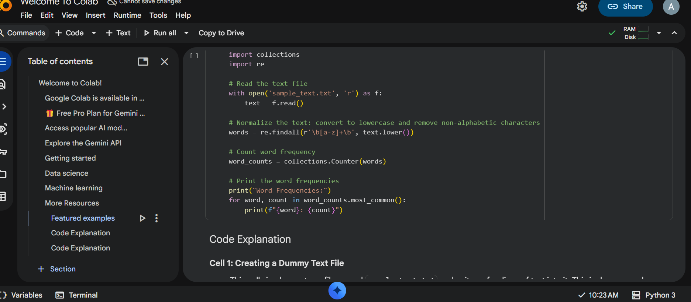  Task 4: Sorting Lists – Manual vs Built-in  - Scenario:  You are reviewing algorithm choices for efficiency.  - Task:  Use Gemini to generate:  - Bubble sort  - Python’s built-in sort()  - Compare both implementations.  - Expected Output:  - Two versions of code  - Short comparison  - 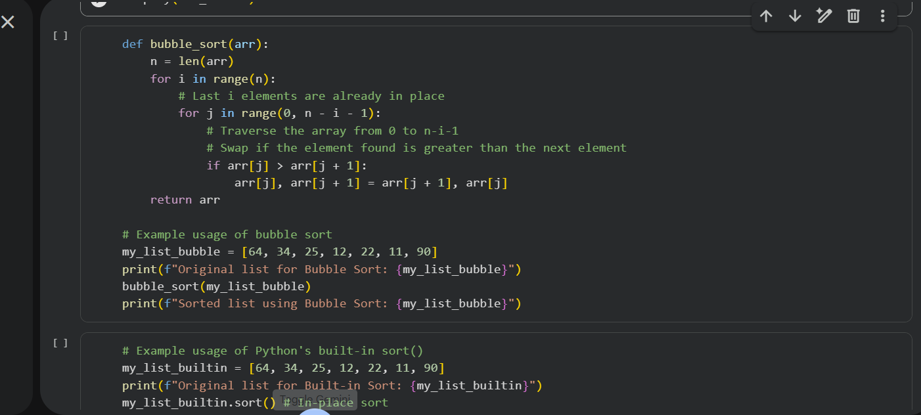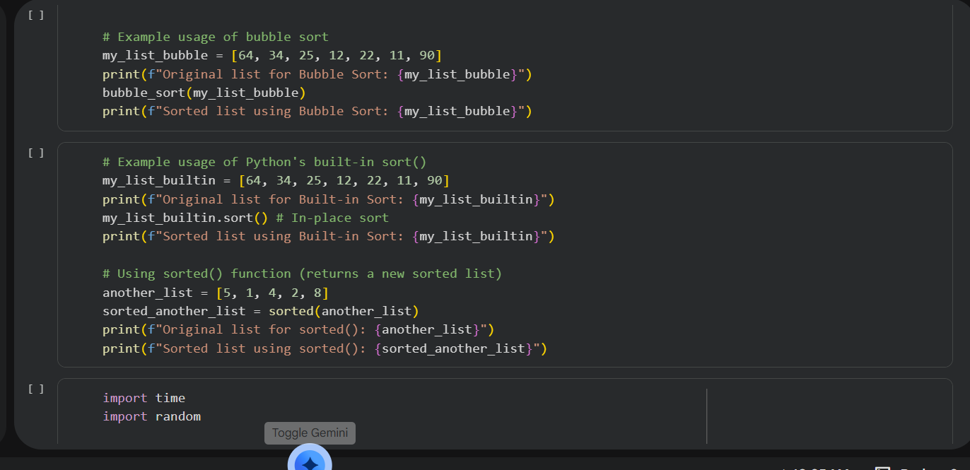  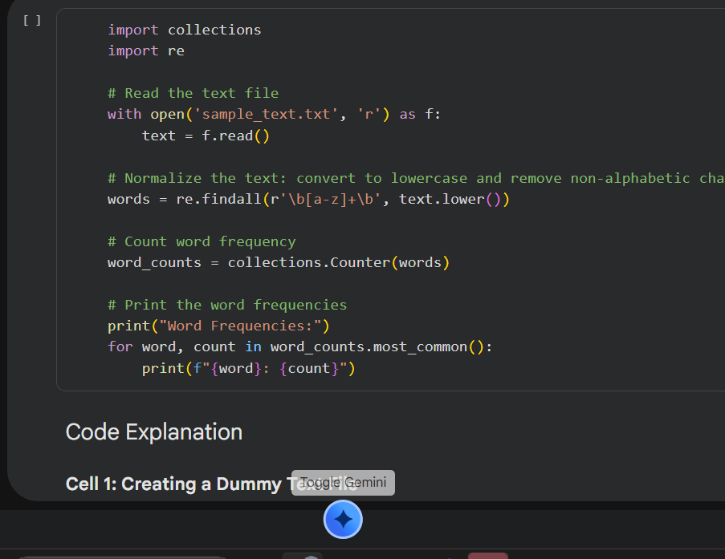  Note: Report should be submitted as a word document for all tasks in a single document with prompts, comments & code explanation, and output and if required, screenshots. |  |  |  |  |  | Week1 - Monday

