Week-6.3
Name:P.Naga Soumya
Hallticket:2303a51604
Batch:17

Task Description #1: Classes (Student Class)
Scenario
You are developing a simple student information management module.
Task
• Use an AI tool (GitHub Copilot / Cursor AI / Gemini) to complete a Student class.
• The class should include attributes such as name, roll number, and branch.
• Add a method display_details() to print student information.
• Execute the code and verify the output.
• Analyze the code generated by the AI tool for correctness and clarity.
Expected Output #1
• A Python class with a constructor (__init__) and a display_details() method.
• Sample object creation and output displayed on the console.
• Brief analysis of AI-generated code.
Code:
class Student:
def __init__(self, name, roll_number, branch):
self.name = name
self.roll_number = roll_number
self.branch = branch

def display_details(self):
print(f"Student Name: {self.name}")
print(f"Roll Number: {self.roll_number}")
print(f"Branch: {self.branch}")
# Example usage
if __name__ == "__main__":
name = input("Enter student name: ")
roll_number = input("Enter roll number: ")
branch = input("Enter branch: ")

student = Student(name, roll_number, branch)
student.display_details()
Output:
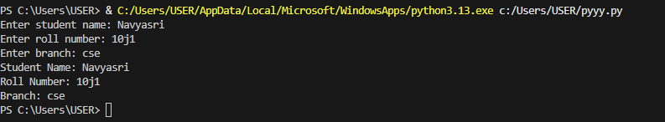
Analysis: This program defines a Student class to store basic student information like name, roll number, and branch.It takes input from the user, creates a Student object, and stores the entered details.Finally, it displays the student’s details using the display_details() method.
Task Description #2: Loops (Multiples of a Number)
Scenario
You are writing a utility function to display multiples of a given number.
Task
• Prompt the AI tool to generate a function that prints the first 10 multiples of a given number
using a loop.
• Analyze the generated loop logic.
• Ask the AI to generate the same functionality using another controlled looping structure (e.g.,
while instead of for).
Expected Output #2
• Correct loop-based Python implementation.
• Output showing the first 10 multiples of a number.
• Comparison and analysis of different looping approaches.
Code:
def display_multiples(number):
count = 1
while count <= 10:
multiple = number * count
print(f"{number} x {count} = {multiple}")
count += 1
# Example usage
display_multiples(5)

output:
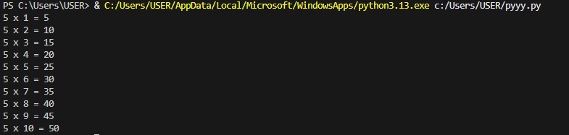
Analysis: This function prints the multiplication table of a given number up to 10.
It uses a while loop to calculate and display each multiple step by step.
Calling the function with 5 outputs the table of 5 from 1 to 10.
Task Description #3: Conditional Statements (Age Classification)
Scenario
You are building a basic classification system based on age.
Task
• Ask the AI tool to generate nested if-elif-else conditional statements to classify age groups
(e.g., child, teenager, adult, senior).
• Analyze the generated conditions and logic.
• Ask the AI to generate the same classification using alternative conditional structures (e.g.,
simplified conditions or dictionary-based logic).
Expected Output #3
• A Python function that classifies age into appropriate groups.
• Clear and correct conditional logic.
• Explanation of how the conditions work.
Code:
def classify_age(age):
if age < 0:
return "Invalid age"
elif age <= 12:
return "Child"
elif age <= 19:
return "Teenager"
elif age <= 64:
return "Adult"
else:
return "Senior"
# Get user input
try:
user_age = int(input("Enter your age: "))
age_group = classify_age(user_age)
print(f"You are classified as: {age_group}")
except ValueError:
print("Please enter a valid integer for age.")

output:
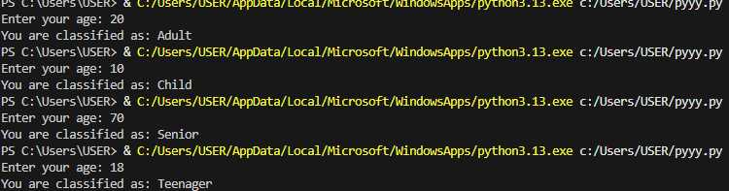
Analysis: This program classifies a person into an age group based on the entered age.
It uses conditional statements to handle different age ranges and invalid input.
User input is validated to ensure a proper integer is provided.
ask Description #4: For and While Loops (Sum of First n Numbers)
Scenario
You need to calculate the sum of the first n natural numbers.
Task
• Use AI assistance to generate a sum_to_n() function using a for loop.
• Analyze the generated code.
• Ask the AI to suggest an alternative implementation using a while loop or a mathematical
formula.
Expected Output #4
• Python function to compute the sum of first n numbers.
• Correct output for sample inputs.
• Explanation and comparison of different approaches.
Code:
Analysis: This program calculates the sum of the first n natural numbers using a for loop.It repeatedly adds each number from 1 to n to a running total.
Finally, it displays the computed sum based on the user’s input.
Task Description #5: Classes (Bank Account Class)
Scenario
You are designing a basic banking application.
Task
• Use AI tools to generate a Bank Account class with methods such as deposit(), withdraw(),
and check_balance().
• Analyze the AI-generated class structure and logic.
• Add meaningful comments and explain the working of the code.
Expected Output #5
• Complete Python Bank Account class.
• Demonstration of deposit and withdrawal operations with updated balance.
• Well-commented code with a clear explanation.
Code:
class BankAccount:
def __init__(self, account_holder, initial_balance=0):
self.account_holder = account_holder
self.balance = initial_balance

def deposit(self, amount):
if amount > 0:
self.balance += amount
print(f"Deposited: ${amount:.2f}")
else:
print("Deposit amount must be positive.")

def withdraw(self, amount):
if amount > 0:
if amount <= self.balance:
self.balance -= amount
print(f"Withdrew: ${amount:.2f}")
else:
print("Insufficient funds.")
else:
print("Withdrawal amount must be positive.")

def check_balance(self):
print(f"Current balance: ${self.balance:.2f}")
def main():
print("Welcome to the Banking Application")
account_holder = input("Enter account holder name: ")
account = BankAccount(account_holder)

while True:
print("\nOptions:")
print("1. Deposit")
print("2. Withdraw")
print("3. Check Balance")
print("4. Exit")

choice = input("Choose an option (1-4): ")

if choice == '1':
amount = float(input("Enter amount to deposit: "))
account.deposit(amount)
elif choice == '2':
amount = float(input("Enter amount to withdraw: "))
account.withdraw(amount)
elif choice == '3':
account.check_balance()
elif choice == '4':
print("Thank you for using the Banking Application. Goodbye!")
break
else:
print("Invalid option. Please try again.")
if __name__ == "__main__":
main()

Output:
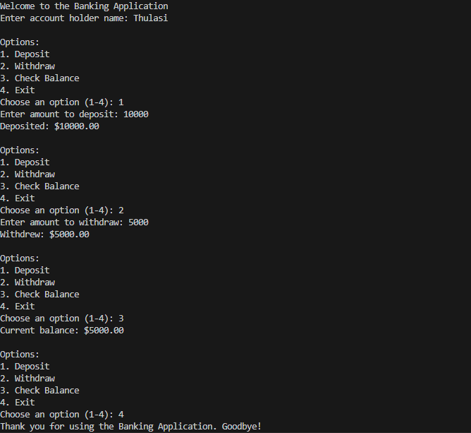

Analysis: This program simulates a simple banking system using a BankAccount class.
It allows the user to deposit money, withdraw money, and check the current balance through a menu-driven interface.The program runs continuously until the user chooses to exit.

