Week-6.1
Name:P.Naga Soumya
Hallticket:2303a51604
Batch:17

Task Description #1 (AI-Based Code Completion for Loops)
Task: Use an AI code completion tool to generate a loop-based
program.
Prompt:
“Generate Python code to print all even numbers between 1 and N
using a loop.”
Expected Output:
• AI-generated loop logic.
• Identification of loop type used (for or while).
• Validation with sample inputs.
Code:
N = int(input("Enter a number N: "))
for i in range(1, N + 1):
if i % 2 == 0:
print(i)
output:
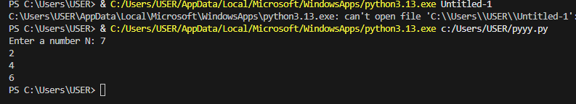
Analysis: This program efficiently uses a for loop and conditional statement to identify and print even numbers between 1 and a user-defined value N. It demonstrates basic programming concepts such as input handling, looping, and conditional checking in Python.

Task Description #2 (AI-Based Code Completion for Loop with
Conditionals)
Task: Use an AI code completion tool to combine loops and
conditionals.
Prompt:
“Generate Python code to count how many numbers in a list are even
and odd.”
Expected Output:
• AI-generated code using loop and if condition.
• Correct count validation.
• Explanation of logic flow.
Code:
numbers = [1, 2, 3, 4, 5, 6, 7, 8, 9, 10]
even_count = 0
odd_count = 0
for num in numbers:
if num % 2 == 0:
even_count += 1
else:
odd_count += 1
print(f"Even numbers: {even_count}")
print(f"Odd numbers: {odd_count}")
Output:
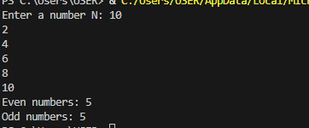
Analysis: The program counts even and odd numbers from a given list using a loop.
It uses the modulo operator to classify each number correctly.
This demonstrates the use of lists, loops, and conditional statements in Python.

Task Description #3 (AI-Based Code Completion for Class
Attributes Validation)
Task: Use an AI tool to complete a Python class that validates user
input.
Prompt:
“Generate a Python class User that validates age and email using
conditional statements.”
Expected Output:
• AI-generated class with validation logic.
• Verification of condition handling.
• Test cases for valid and invalid inputs.
Code:
class User:
def __init__(self, age, email):
self.age = age
self.email = email
def validate_age(self):
if self.age >= 18:
return "Valid age"
else:
return "Invalid age (must be 18 or above)"
def validate_email(self):
if "@" in self.email and "." in self.email:
return "Valid email"
else:
return "Invalid email format"
# User input
age = int(input("Enter your age: "))
email = input("Enter your email: ")
user = User(age, email)
print(user.validate_age())
print(user.validate_email())
output:
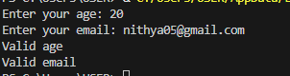
Analysis: The program successfully validates user age and email using conditional logic within a class structure.
It demonstrates effective use of object-oriented programming for input validation in Python.
Task Description #4 (AI-Based Code Completion for Classes)
Task: Use an AI code completion tool to generate a Python class for
managing student details.
Prompt:
“Generate a Python class Student with attributes (name, roll number,
marks) and methods to calculate total and average marks.”
Expected Output:
• AI-generated class code.
• Verification of correctness and completeness of class
structure.
• Minor manual improvements (if needed) with justification.
Code:
class Student:
def __init__(self, name, roll_number, marks):
self.name = name
self.roll_number = roll_number
self.marks = marks

def calculate_total(self):
return sum(self.marks)

def calculate_average(self):
if len(self.marks) == 0:
return 0
return self.calculate_total() / len(self.marks)
# Input from user
name = input("Enter student name: ")
roll_number = input("Enter roll number: ")
marks = []
num_subjects = int(input("Enter number of subjects: "))
for i in range(num_subjects):
mark = float(input(f"Enter marks for subject {i+1}: "))
marks.append(mark)
# Create Student object
student = Student(name, roll_number, marks)
# Calculate total and average marks
total_marks = student.calculate_total()
average_marks = student.calculate_average()
# Display results
print(f"Total Marks: {total_marks}")
print(f"Average Marks: {average_marks}")
Output:
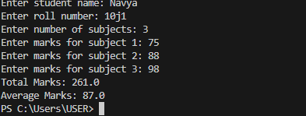
ask Description 5 (AI-Assisted Code Completion Review)
Task: Use an AI tool to generate a complete Python program using
classes, loops, and conditionals together.
Prompt:
“Generate a Python program for a simple bank account system using
class, loops, and conditional statements.”
Expected Output:
• Complete AI-generated program.
• Identification of strengths and limitations of AI suggestions.
• Reflection on how AI assisted coding productivity.
Code:
class BankAccount:
def __init__(self, account_holder, balance=0):
self.account_holder = account_holder
self.balance = balance

def deposit(self, amount):
if amount > 0:
self.balance += amount
print(f"Deposited: ${amount:.2f}")
else:
print("Deposit amount must be positive.")

def withdraw(self, amount):
if amount > 0:
if amount <= self.balance:
self.balance -= amount
print(f"Withdrew: ${amount:.2f}")
else:
print("Insufficient funds.")
else:
print("Withdrawal amount must be positive.")

def check_balance(self):
print(f"Current balance: ${self.balance:.2f}")
def main():
print("Welcome to the Simple Bank Account System")
name = input("Enter account holder's name: ")
account = BankAccount(name)

while True:
print("\nOptions:")
print("1. Deposit")
print("2. Withdraw")
print("3. Check Balance")
print("4. Exit")
choice = input("Choose an option (1-4): ")

if choice == '1':
amount = float(input("Enter amount to deposit: "))
account.deposit(amount)
elif choice == '2':
amount = float(input("Enter amount to withdraw: "))
account.withdraw(amount)
elif choice == '3':
account.check_balance()
elif choice == '4':
print("Thank you for using the bank account system. Goodbye!")
break
else:
print("Invalid option. Please try again.")
if __name__ == "__main__":
main()
Output:

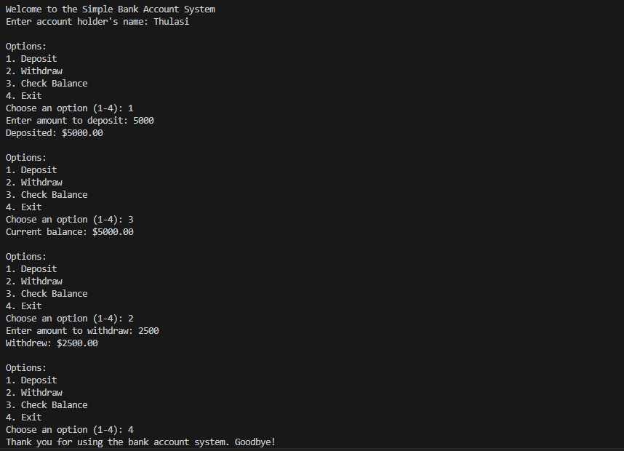
Analysis:
The program successfully simulates a simple bank account system using a class-based approach.
It allows users to deposit, withdraw, and check balance with proper validation.
This demonstrates effective use of object-oriented programming and user interaction in Python.

