Assignment - 6.3
2303a51607
Batch -18
CH.ROHITH SAI
Task1 : TO print student details includes roll no, name ,branch
Prompt :# Develop a simple student management module in Python using Object-Oriented Programming.
#The class should include attributes such as name, roll number, and branch.
#Add a method display_details() to print student information.
#Create sample student objects and display their details on the console.
#Ensure the code is clean, structured, and easy to understand.
#CODE
class Student:
def __init__(self, name, roll_number, branch):
self.name = name
self.roll_number = roll_number
self.branch = branch

def display_details(self):
print(f"Student Name: {self.name}")
print(f"Roll Number: {self.roll_number}")
print(f"Branch: {self.branch}")
# Sample object creation and output
student1 = Student("Alice", "101", "Computer Science")
student1.display_details()
student2 = Student("Bob", "102", "Mechanical Engineering")
student2.display_details()
student3 = Student("Charlie", "103", "Electrical Engineering")
student3.display_details()
student4 = Student("Diana", "104", "Civil Engineering")
student4.display_details()

output :
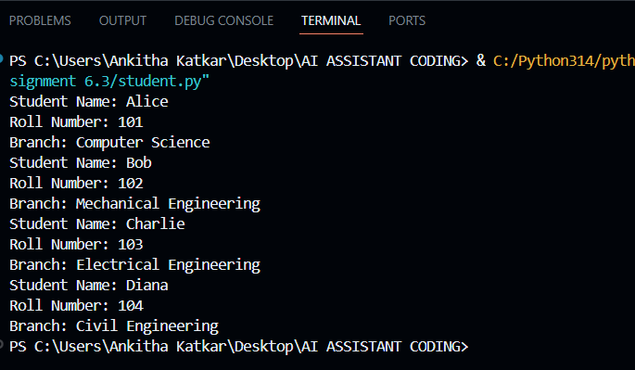

TASK – 2 To print first ten multiples of user input number
Prompt: #Write a Python function to print the first 10 multiples of a given number using a for loop.The program should be simple and easy to understand.give clean and structured code

CODE :
def print_multiples(number):
print(f"The first 10 multiples of {number} are:")
for i in range(1, 11):
multiple = number * i
print(multiple)
# using user input
num = int(input("Enter a number to find its first 10 multiples: "))
print_multiples(num)

OUTPUT :
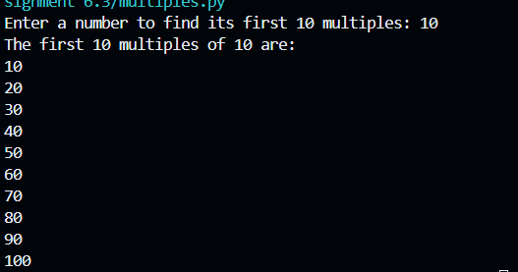

TASK – 3 : print that classifies age groups using if-elif-else conditional statements to classify age groups as chils d, teenager, adult, senior
PROMPT : #Write a Python function that classifies a person based on age using nested if-elif-else statements.The program should classify age into child, teenager, adult, and senior.Use simple conditions and clear logic.give clean and structured code

CODE
def classify_age(age):
if age < 0:
return "Invalid age"
elif age <= 12:
return "Child"
elif age <= 19:
return "Teenager"
elif age <= 59:
return "Adult"
else:
return "Senior"
# using user input
age_input = int(input("Enter the age of the person: "))
classification = classify_age(age_input)
print(f"The person is classified as: {classification}")

OUTPUT :

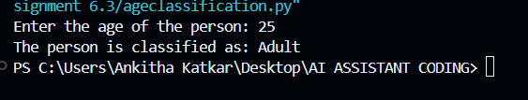

TASK- 4 : : You need to calculate the sum of the first n natural numbers. Using for loop
PROMPT #Write a Python function named sum_to_n() that calculates the sum of the first n natural numbers using a for loop.The code should be simple and easy to understand.give clean and structured code

CODE :
def sum_to_n(n):
total_sum = 0
for i in range(1, n + 1):
total_sum += i
return total_sum
# using user input
num = int(input("Enter a natural number n to calculate the sum of the first n natural numbers: "))
result = sum_to_n(num)
print(f"The sum of the first {num} natural numbers is: {result}")
OUTPUT :

TASK-5 : You are designing a basic banking application
PROMPT : #Generate a # Write a Python program to create a BankAccount class.
# The class should include methods deposit(), withdraw(), and check_balance().
# Use simple logic and beginner-friendly code. Give clean and structured code.

CODE :
class BankAccount:
def __init__(self, account_holder, initial_balance=0):
self.account_holder = account_holder
self.balance = initial_balance

def deposit(self, amount):
if amount > 0:
self.balance += amount
print(f"Deposited: ${amount:.2f}")
else:
print("Deposit amount must be positive.")

def withdraw(self, amount):
if amount > 0:
if amount <= self.balance:
self.balance -= amount
print(f"Withdraw: ${amount:.2f}")
else:
print("Insufficient balance.")
else:
print("Withdrawal amount must be positive.")

def check_balance(self):
print(f"Current balance: ${self.balance:.2f}")
ram=BankAccount("John Doe", 1000)
ram.check_balance()
ram.deposit(500)
ram.check_balance()
ram.withdraw(200)
OUTPUT ;
