ASSIGNMENT-7.4 B.ROHITH

2303A51658

Lab7:ErrorDebuggingwithAI:Systematicapproachesto findingandfixingbugs
Task1(MutableDefaultArgument–FunctionBug)
Task:Analyzegivencodewhereamutabledefaultargumentcauses unexpectedbehavior.UseAItofixit.
#Bug:Mutabledefaultargument defadd_item(item,items=[]): items.append(item)
returnitems print(add_item(1)) print(add_item(2))
ExpectedOutput:Correctedfunctionavoidssharedlistbug.
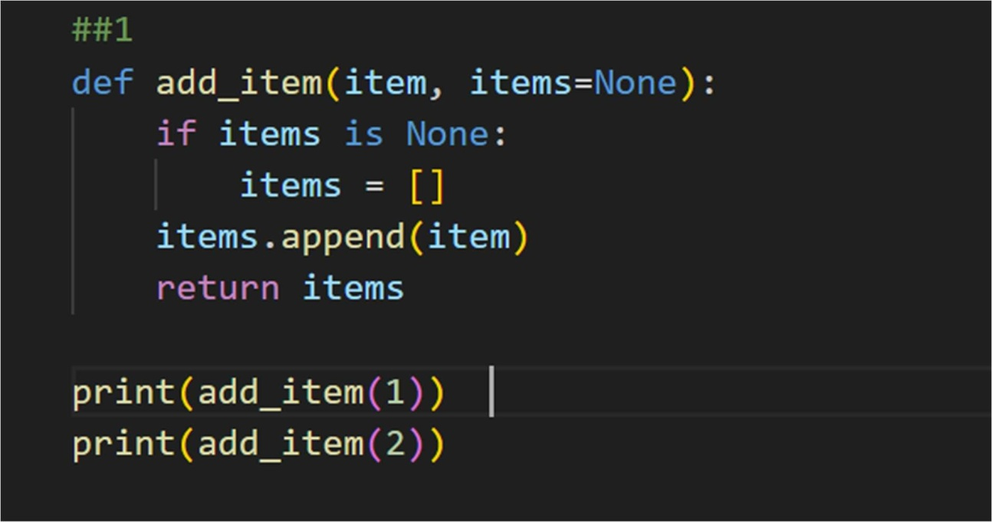

OUTPUT:
[1]
[2]

Task2(Floating-PointPrecisionError)
Task:Analyzegivencodewherefloating-pointcomparisonfails. Use AI tocorrectwithtolerance.
#Bug:Floatingpointprecisionissue defcheck_sum():
return(0.1+0.2)==0.3 print(check_sum())
ExpectedOutput:Correctedfunction
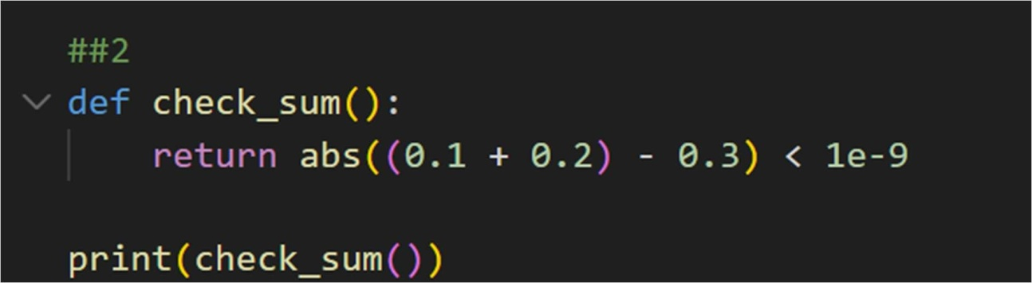

OUTPUT:
True
Task3(RecursionError–MissingBaseCase)
Task:Analyzegivencodewhererecursionrunsinfinitelydueto missing base case. Use AI to fix.
#Bug:Nobasecase defcountdown(n):
print(n)
returncountdown(n-1) countdown(5)
ExpectedOutput:Correctrecursionwithstoppingcondition.

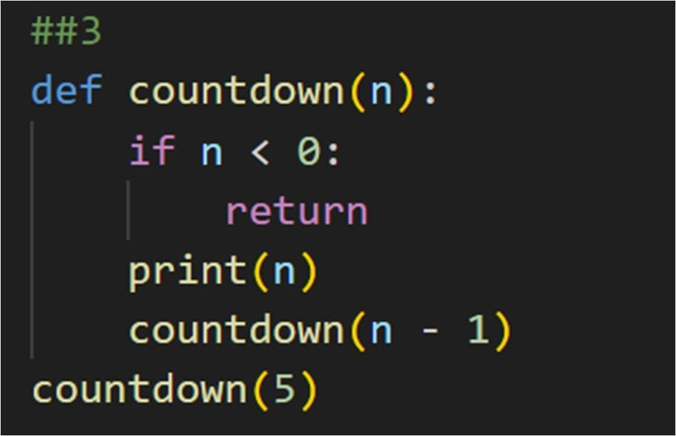

OUTPUT:
5
4
3
2
1
0
Task4(DictionaryKeyError)
Task:Analyzegivencodewhereamissingdictionarykeycauses error.UseAItofixit.
#Bug:Accessingnon-existingkey defget_value():
data={"a":1,"b":2} returndata["c"] print(get_value())
ExpectedOutput:Correctedwith.get()orerrorhandling.

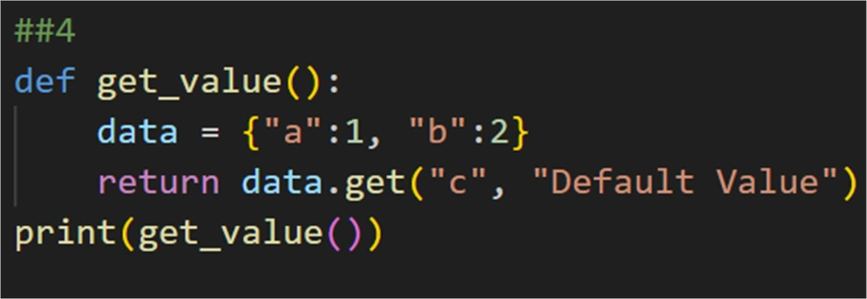

OUTPUT:
DefaultValue
Task5(InfiniteLoop–WrongCondition)
Task:Analyzegivencodewhereloopneverends.UseAItodetect and fix it.
# Bug:Infiniteloop defloop_example():
i=0
whilei<5:
print(i)
ExpectedOutput:Correctedloopincrementsi.
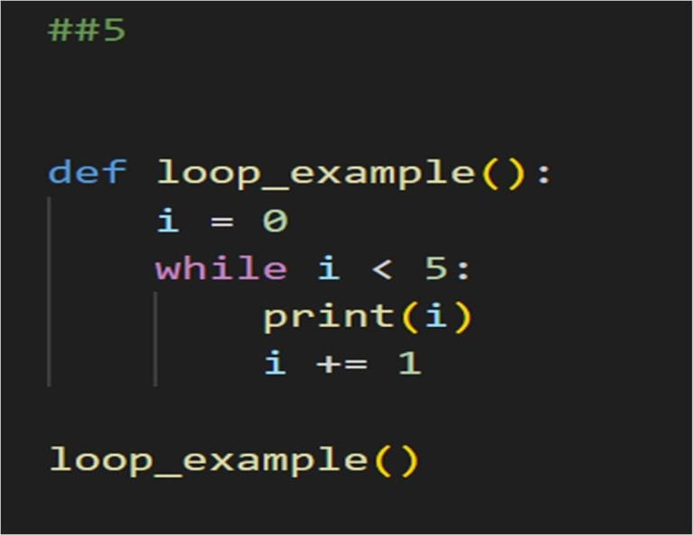

OUTPUT: 0

1
2
3
4
Task6(UnpackingError–WrongVariables)
Task:Analyzegivencodewheretupleunpackingfails.UseAIto fixit.
#Bug:Wrongunpacking a, b =(1, 2, 3)
ExpectedOutput:Correctunpackingorusing_forextravalues.
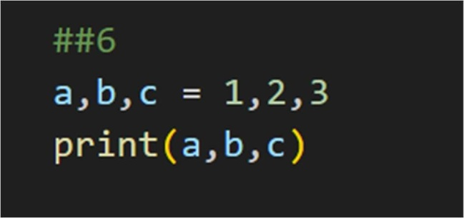

OUTPUT:
123
Task7(MixedIndentation–TabsvsSpaces)
Task:Analyzegivencodewheremixedindentationbreaks execution.UseAItofixit.
#Bug:Mixedindentation deffunc():
x=5
y=10
returnx+y
ExpectedOutput:Consistentindentationapplied.

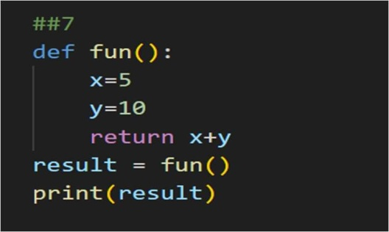

OUTPUT:
15
Task8(ImportError–WrongModuleUsage)
Task:Analyzegivencodewithincorrectimport.UseAItofix. # Bug: Wrong import
importmaths print(maths.sqrt(16))
ExpectedOutput:Correctedtoimportmath
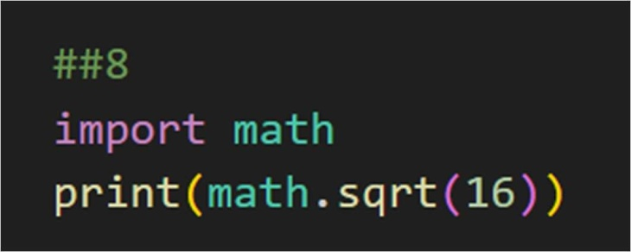

OUTPUT:
4.0
Task9(UnreachableCode–ReturnInsideLoop)
Task:Analyzegivencodewhereareturninsidealooppreventsfull iteration.UseAItofixit.
#Bug:Earlyreturninsideloop deftotal(numbers):
forninnumbers:
returnn print(total([1,2,3]))
ExpectedOutput:Correctedcodeaccumulatessumandreturns

afterloop.
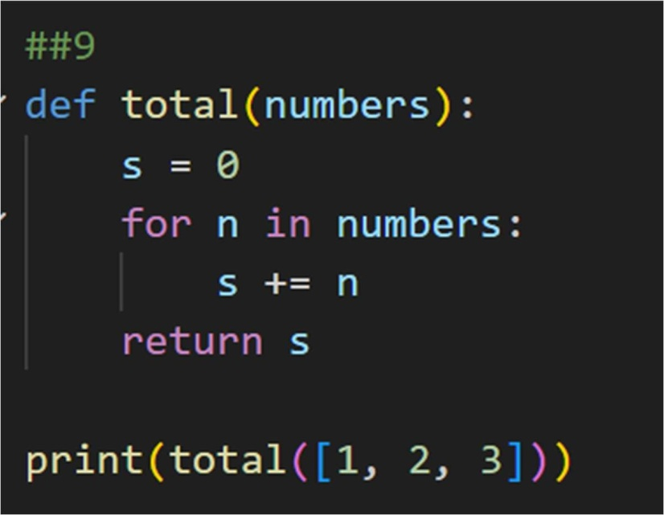

OUTPUT:
6
Task10(NameError–UndefinedVariable)
Task:Analyzegivencodewhereavariableisusedbeforebeing defined.LetAIdetectandfixtheerror.
#Bug:Usingundefinedvariable defcalculate_area():
return length * width print(calculate_area()) Requirements:
- Runthecodetoobservetheerror.
- AskAItoidentifythemissingvariabledefinition.
- Fixthebugbydefininglengthandwidthasparameters.
- Add3asserttestcasesforcorrectness. Expected Output:
- Correctedcodewithparameters.
- AI explanation of the bug. Successfulexecutionofassertions.

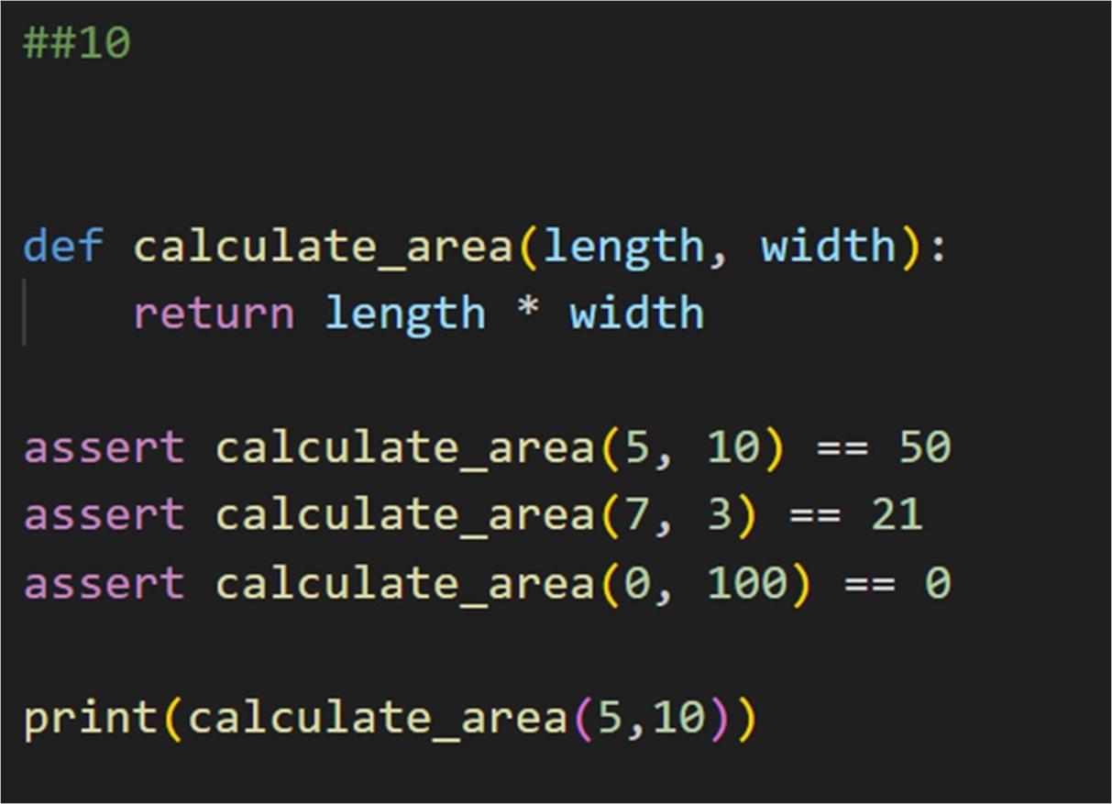

OUTPUT:
50
Task11(TypeError–MixingDataTypesIncorrectly)
Task:Analyzegivencodewhereintegersandstringsareadded incorrectly.LetAIdetectandfixtheerror.
#Bug:Addingintegerandstring defadd_values():
return 5 + "10"print(add_values()) Requirements:
- Runthecodetoobservetheerror.
- AIshouldexplainwhyint+strisinvalid.
- Fixthecodebytypeconversion(e.g.,int("10")orstr(5)).
- Verifywith3assertcases. Expected Output#6:

- Correctedcodewithtypehandling.
- AIexplanationofthefix. Successfultestvalidation.
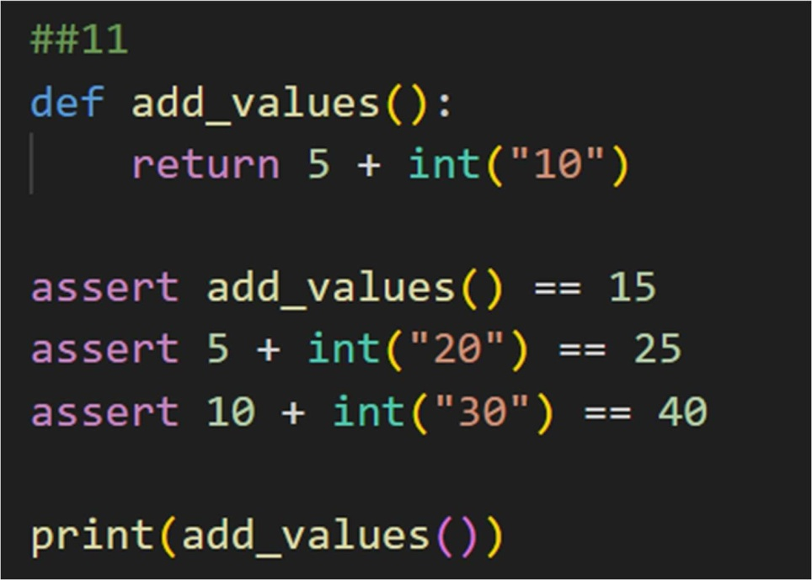

OUTPUT:
15
Task12(TypeError–String+ListConcatenation)
Task:Analyzecodewhereastringisincorrectlyaddedtoalist. # Bug: Adding string and list
defcombine():
return"Numbers:"+[1,2,3] print(combine()) Requirements:
- Runthecodetoobservetheerror.
- Explainwhystr+listisinvalid.
- Fixusingconversion(str([1,2,3])or"".join()).
- Verifywith3assertcases. ExpectedOutput:
- Correctedcode

- Explanation
- Successfultestvalidation
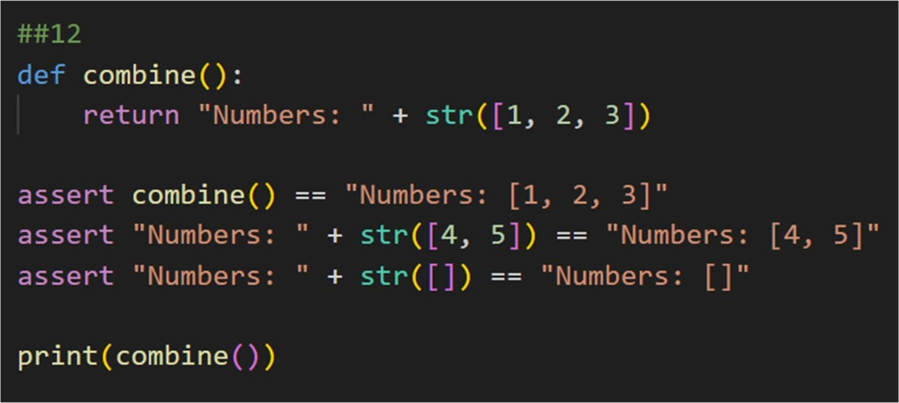

OUTPUT:
Numbers:[1,2,3]
Task13(TypeError–MultiplyingStringbyFloat)
Task:Detectandfixcodewhereastringismultipliedbyafloat. # Bug:Multiplyingstringbyfloat
defrepeat_text():
return"Hello"*2.5 print(repeat_text()) Requirements:
- Observetheerror.
- Explainwhyfloatmultiplicationisinvalidforstrings.
- Fixbyconvertingfloattoint.
- Add3asserttestcases.

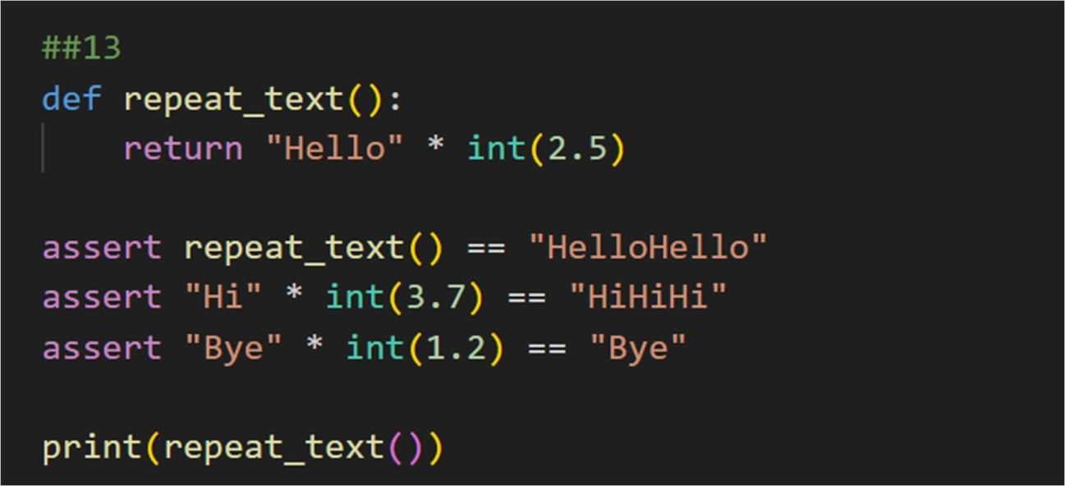

OUTPUT:
HelloHello
Task14(TypeError–AddingNonetoInteger)
Task:AnalyzecodewhereNoneisaddedtoaninteger. # Bug: Adding None and integer
defcompute():
value = None returnvalue+10 print(compute()) Requirements:
- Runandidentifytheerror.
- ExplainwhyNoneTypecannotbeadded.
- Fixbyassigningadefaultvalue.
- Validateusingasserts.

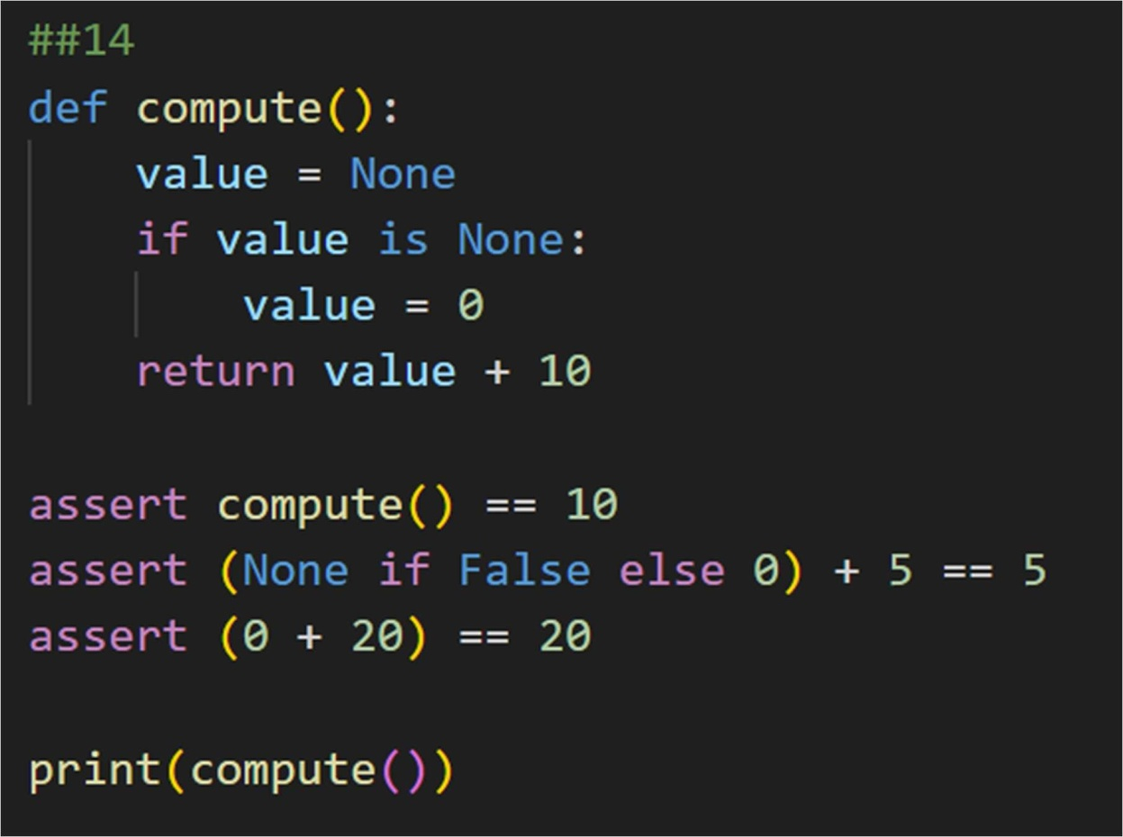

OUTPUT:
10
Task15(TypeError–InputTreatedasStringInsteadof Number)
Task:Fixcodewhereuserinputisnotconvertedproperly. # Bug: Input remains string
defsum_two_numbers():
a=input("Enterfirstnumber:")
b=input("Entersecondnumber:") return a + b print(sum_two_numbers()) Requirements:
- Explainwhyinputisalwaysstring.
- Fixusingint()conversion.

- Verifywithasserttestcases.
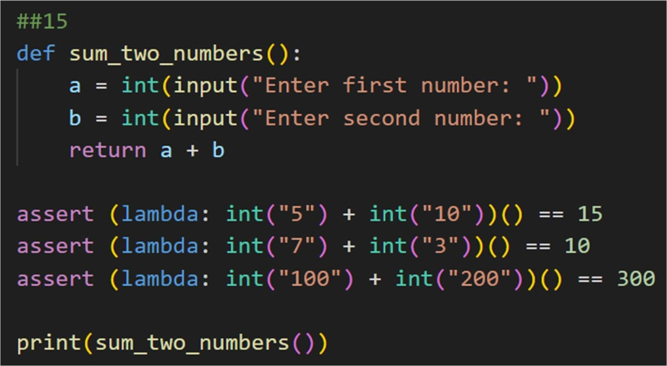

OUTPUT:
Enter first number: 11 Entersecondnumber:98 109

