Course Title : HIGH PERFORMANCE COMPUTING ASS-9
Name: S.Santhosh
Hall Ticket No:2303A51732
Batch-11

Lab: OpenMP Synchronization and Load Imbalance Analysis Objective:
To analyze synchronization overhead and load imbalance in OpenMP programs and optimize performance using proper directives.
Task 1: Synchronization Overhead (Critical vs Reduction) Step 1:
Create a file named reduction_bad.c
Implement parallel summation using:
#pragma omp critical inside the loop.
Compile:
gcc -O2 -fopenmp reduction_bad.c -o reduction_bad Run with:
export OMP_NUM_THREADS=1 export OMP_NUM_THREADS=4 Record execution time.
Step 2:
Create reduction_good.c Replace critical with:
#pragma omp parallel for reduction(+:sum) Compile and run with same thread counts.

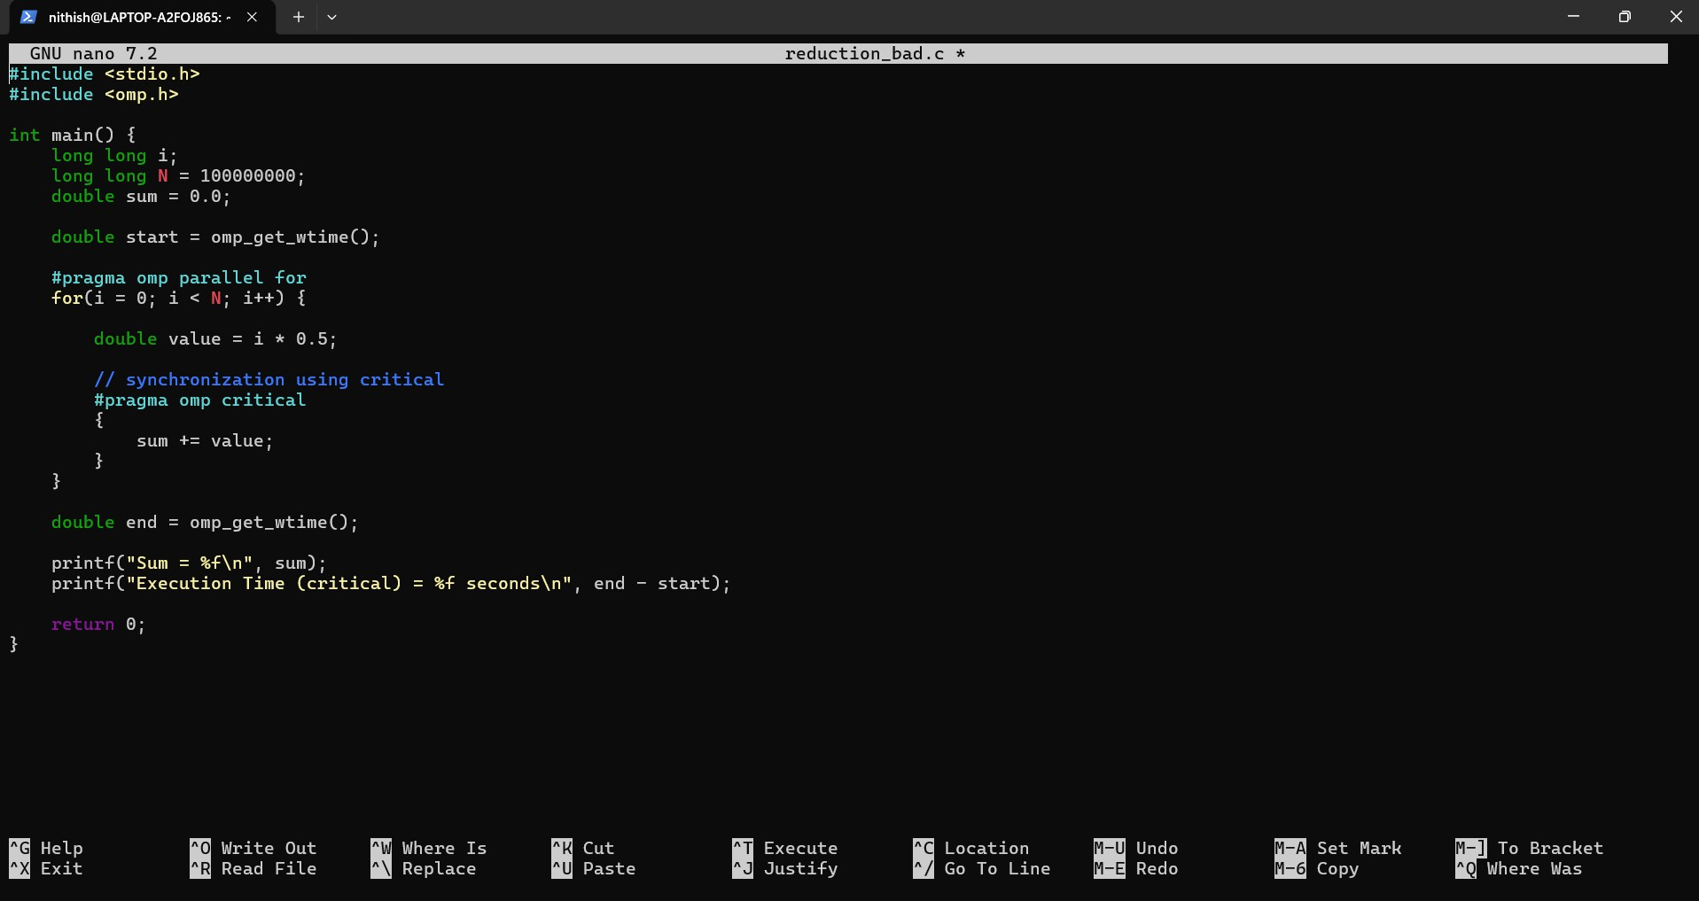
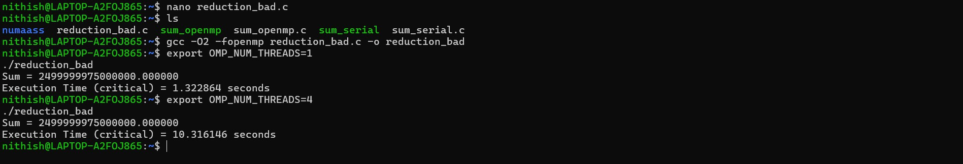

Step 2:
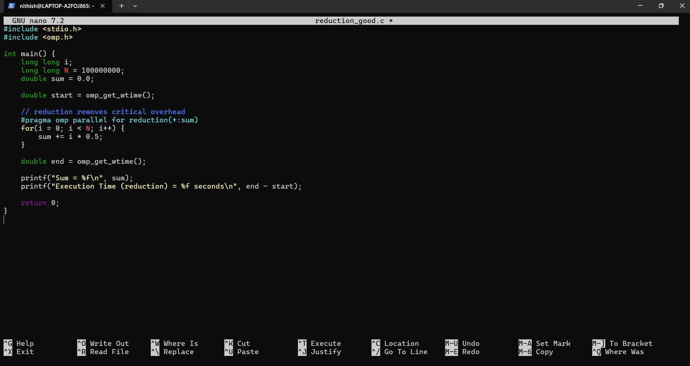

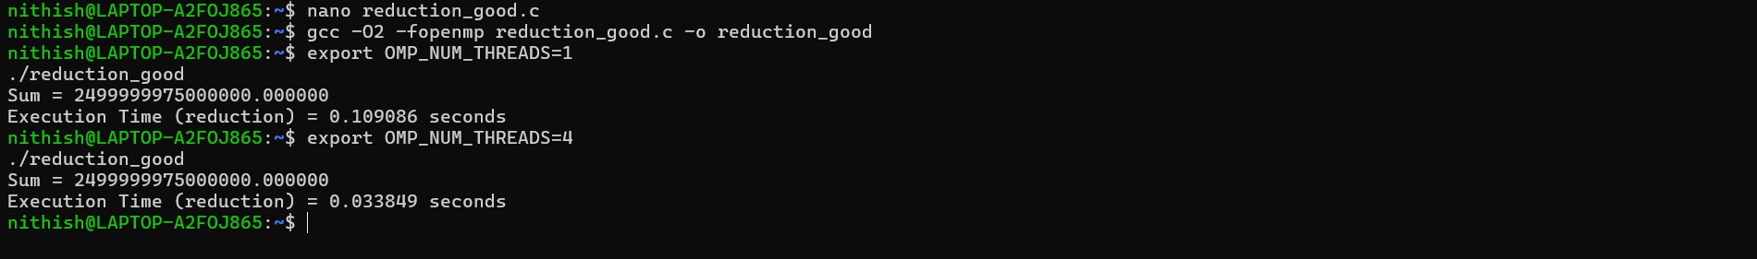

Task 2: Load Imbalance and Scheduling

Create a file named imbalance.c. Implement a loop where:
One iteration performs heavy computation Other iterations perform small computation Run with default scheduling.
Record execution time.

Now modify to:
#pragma omp parallel for schedule(dynamic) Run again and record time.
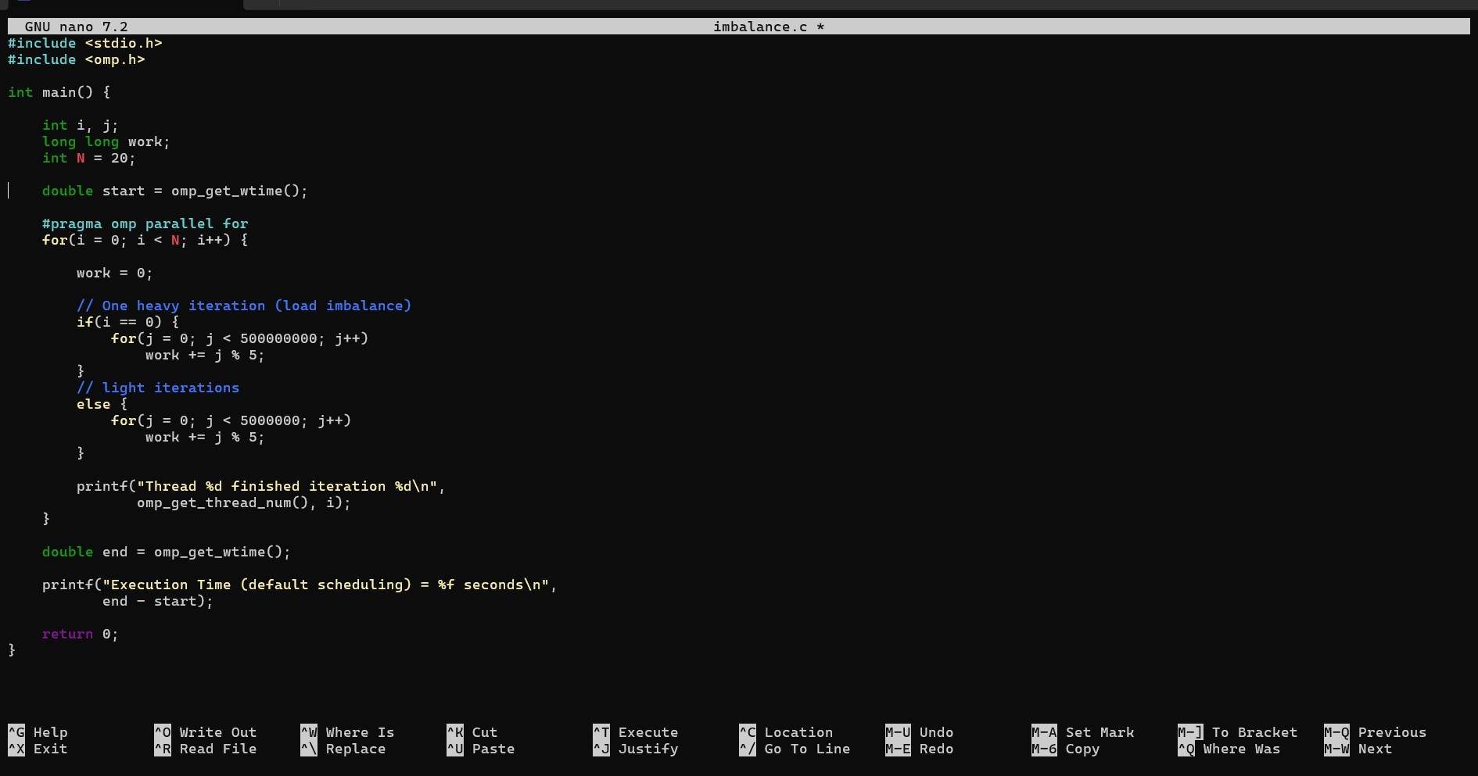

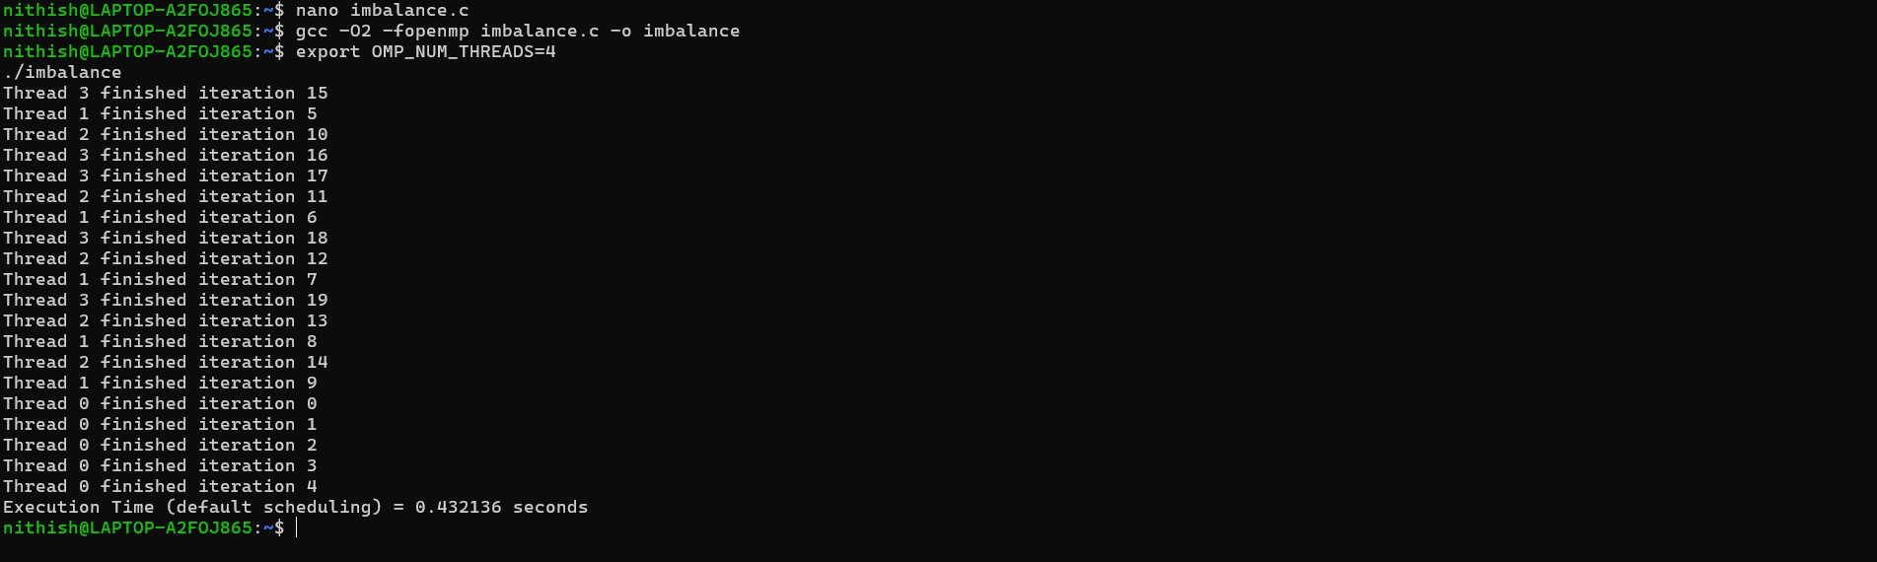
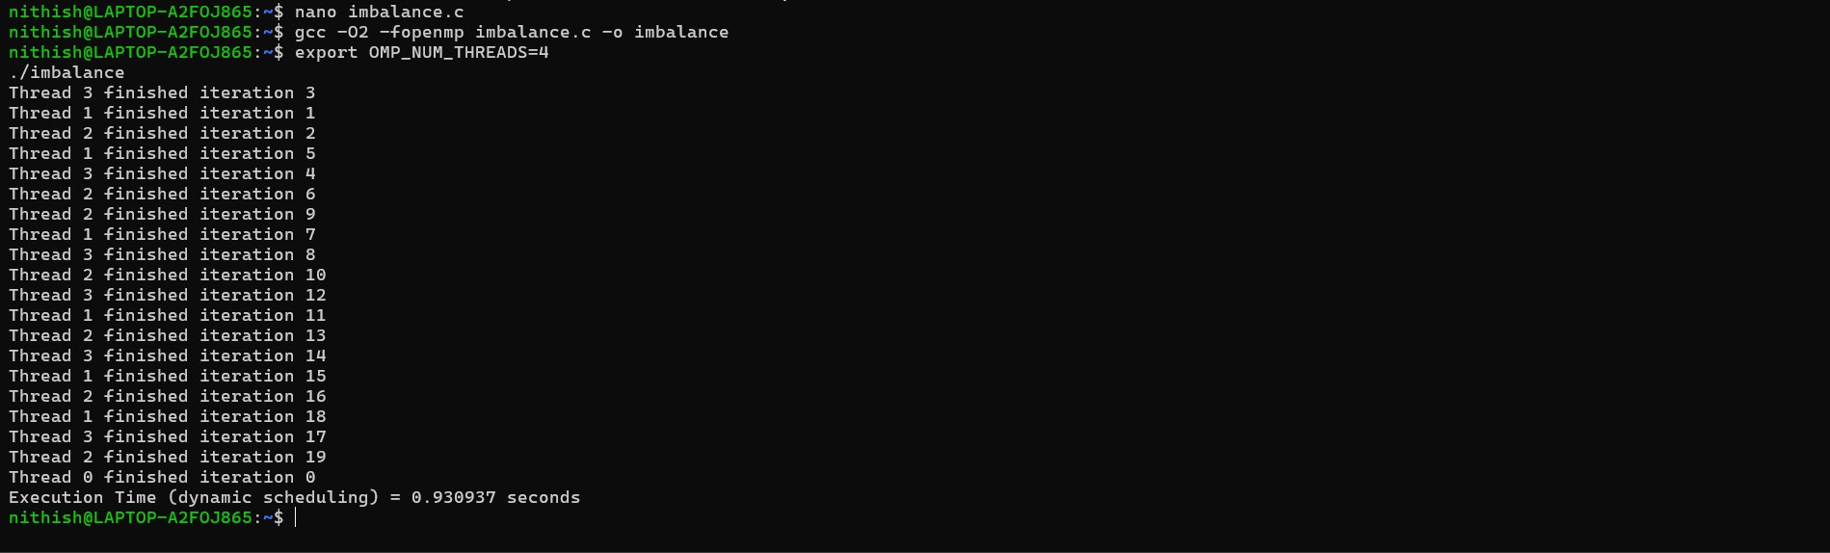

Task 3: Performance Analysis Questions Answer the following:
- Why does using critical reduce scalability?
When we use a critical section, only one thread is allowed to access that part of the code at a time. So even though multiple threads are created, they end up waiting in a queue to update the shared variable. As the number of threads increases, the waiting time also increases, which limits the benefit of parallel execution.

How does reduction improve performance?
With reduction, each thread works on its own temporary copy of the variable instead of sharing one common variable. This means threads can run independently without waiting for each other.
At the end, OpenMP combines all results automatically, which makes the program faster and more efficient.

What is load imbalance?
Load imbalance happens when some threads get more work while others get less. The threads that finish early remain idle while one or two threads are still busy. Because not all CPU
resources are used equally, the overall performance decreases.

Why does dynamic scheduling improve performance in uneven workloads?
Dynamic scheduling distributes work while the program is running instead of assigning everything at the beginning. If a thread finishes early, it immediately receives new work. This

keeps all threads busy and reduces idle time, which improves overall performance when workloads are uneven.

Identify the hotspot section in your program and justify.
The hotspot in the program is the heavy computation loop where one iteration performs much more work than the others. This part takes the longest time to execute and dominates the total runtime, making it the main performance bottleneck.

