SCHOOL OF COMPUTER SCIENCE AND ARTIFICIAL INTELLIGENCE |  |  |  |  | DEPARTMENT OF COMPUTER SCIENCE ENGINEERING
Program Name: B. Tech |  |  |  | Assignment Type: Lab |  |  | Academic Year:2025-2026
Course Coordinator Name |  |  |  | Dr. Rishabh Mittal
Instructor(s) Name
  Mr. S Naresh Kumar
  Ms. B. Swathi
  Dr. Sasanko Shekhar Gantayat
  Mr. Md Sallauddin
  Dr. Mathivanan
  Mr. Y Srikanth
  Ms. N Shilpa
  Dr. Rishabh Mittal (Coordinator)
  Dr. R. Prashant Kumar
  Mr. Ankushavali MD
  Mr. B Viswanath
  Ms. Sujitha Reddy
  Ms. A. Anitha
  Ms. M.Madhuri
  Ms. Katherashala Swetha
  Ms. Velpula sumalatha
  Mr. Bingi Raju
Course Code |  |  | 23CS002PC304 | Course Title |  | AI Assisted Coding
Year/Sem |  |  | III/I | Regulation |  | R23
Date and Day  of Assignment |  |  | Week 2 - Wednesday | Time(s) |  | 23CSBTB01 To 23CSBTB52
Duration |  |  | 2 Hours | Applicable to  Batches |  | All batches
Assignment Number: 3.3(Present assignment number)/24(Total number of assignments)
 | Q.No. | Question |  |  |  |  |  | Expected Time  to complete
 | 1 | Lab 3: Application for TGNPDCL – Electricity Bill Generation Using Python & AI Tools  Lab Objectives  - To design a real-world electricity billing application using Python  - To use AI-assisted coding tools for logic generation and optimization  - To understand conditional logic and arithmetic operations  - To generate structured billing output similar to utility bills  Lab Outcomes (LOs)  After completing this lab, students will be able to:  - Read and validate user input in Python  - Apply conditional logic for tariff-based billing  - Use AI tools to assist in program development  - Calculate and display electricity bill components  - Build a complete real-time application  Task 1: AI-Generated Logic for Reading Consumer Details  Scenario  An electricity billing system must collect accurate consumer data.  Task Description  Use an AI tool (GitHub Copilot / Gemini) to generate a Python program that:  - Reads:  - Previous Units (PU)  - Current Units (CU)  - Type of Customer  - Calculates units consumed  - Implements logic directly in the main program (no functions)  Expected Output  - Correct input reading  - Units consumed calculation  - Screenshot showing AI-generated code  - Sample input and output  - 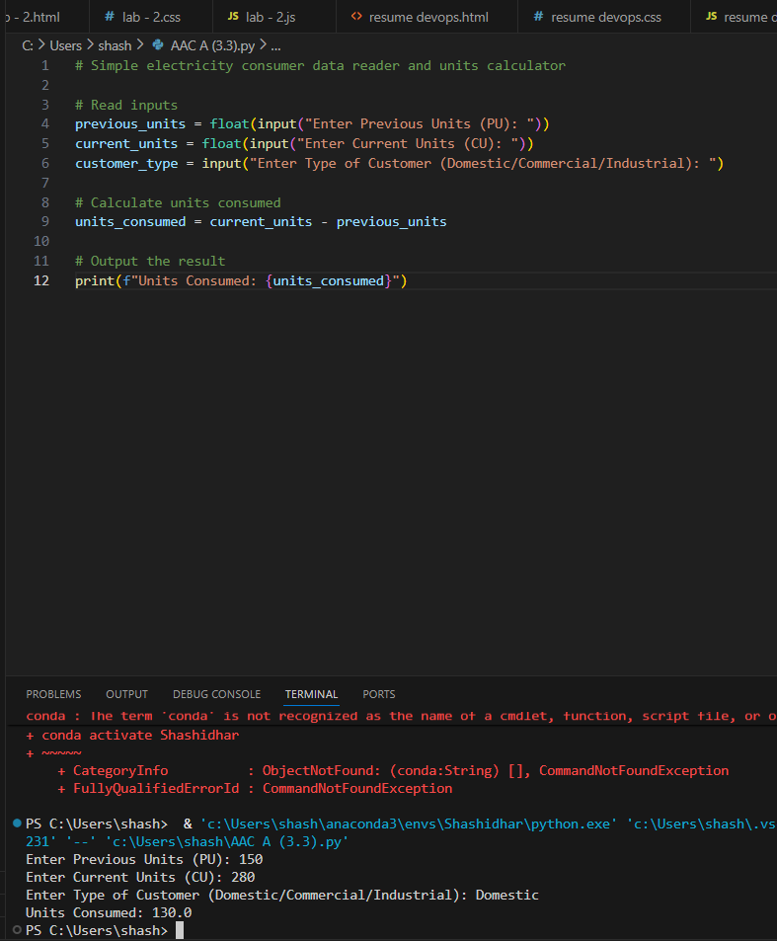  Task 2: Energy Charges Calculation Based on Units Consumed  Scenario  Energy charges depend on the number of units consumed and customer type.  Task Description  Review the AI-generated code from Task 1 and extend it to:  - Calculate Energy Charges (EC)  - Use conditional statements based on:  - Domestic  - Commercial  - Industrial consumers  - Improve readability using AI prompts such as:  - “Simplify energy charge calculation logic”  - “Optimize conditional statements”  Expected Output  - Correct EC calculation  - Clear conditional logic  - Original and improved versions (optional)  - Sample execution results  - 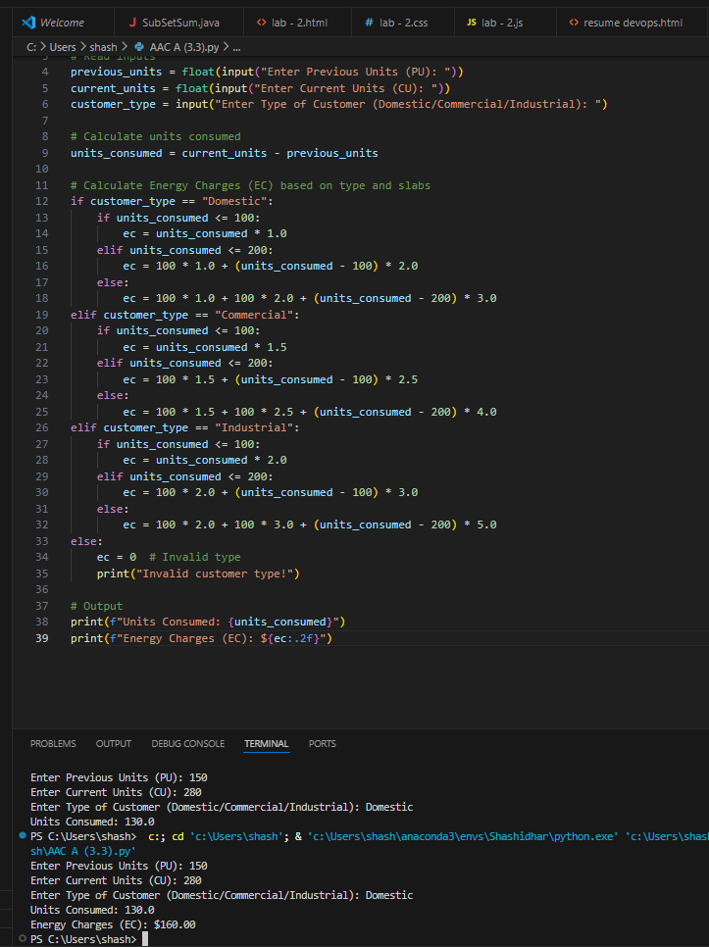  Task 3: Modular Design Using AI Assistance (Using Functions)  Scenario  Billing logic must be reusable for multiple consumers.  Task Description  Use AI assistance to generate a Python program that:  - Uses user-defined functions to:  - Calculate Energy Charges  - Calculate Fixed Charges  - Returns calculated values  - Includes meaningful comments  Expected Output  - Function-based Python program  - Correct EC and FC values  - Screenshots of AI-assisted function generation  - Test cases with outputs  - 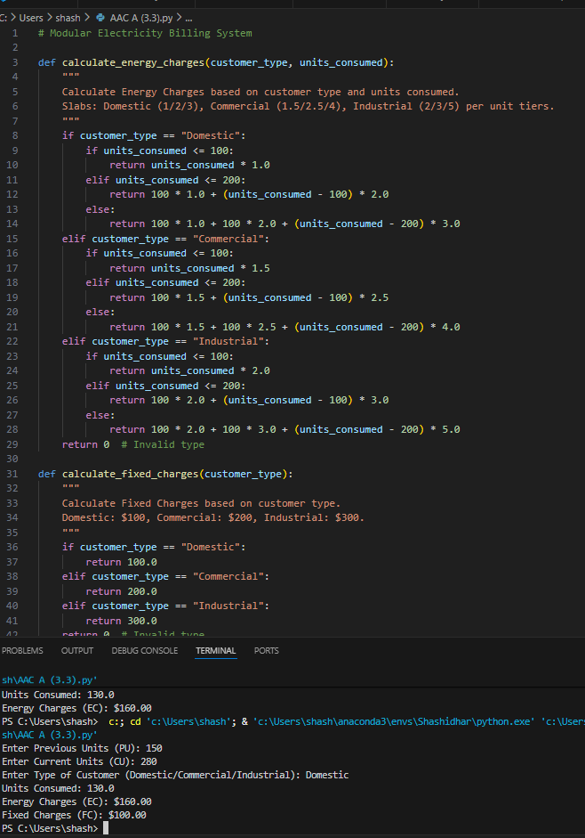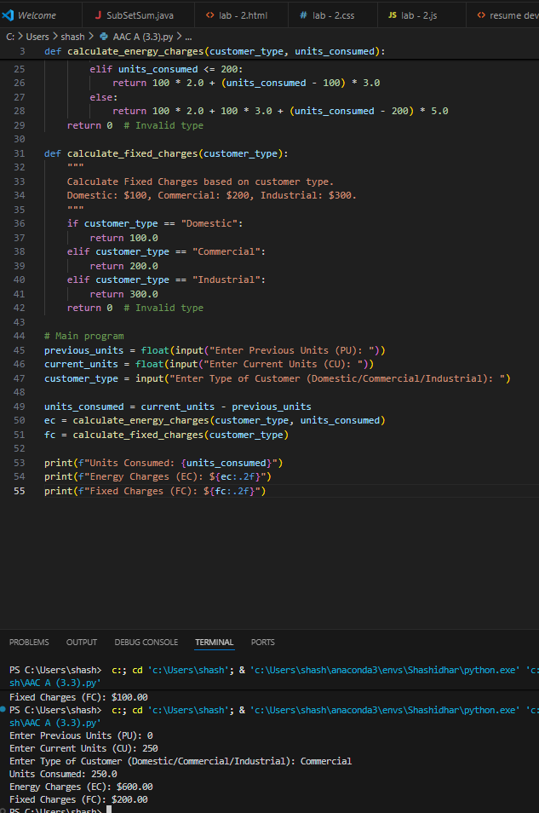  Task 4: Calculation of Additional Charges  Scenario  Electricity bills include multiple additional charges.  Task Description  Extend the program to calculate:  - FC – Fixed Charges  - CC – Customer Charges  - ED – Electricity Duty (percentage of EC)  Use AI prompts like:  - “Add electricity duty calculation”  - “Improve billing accuracy”  Expected Output  - Individual charge values printed  - Correct duty calculation  - Well-structured output  - Verified intermediate results  - 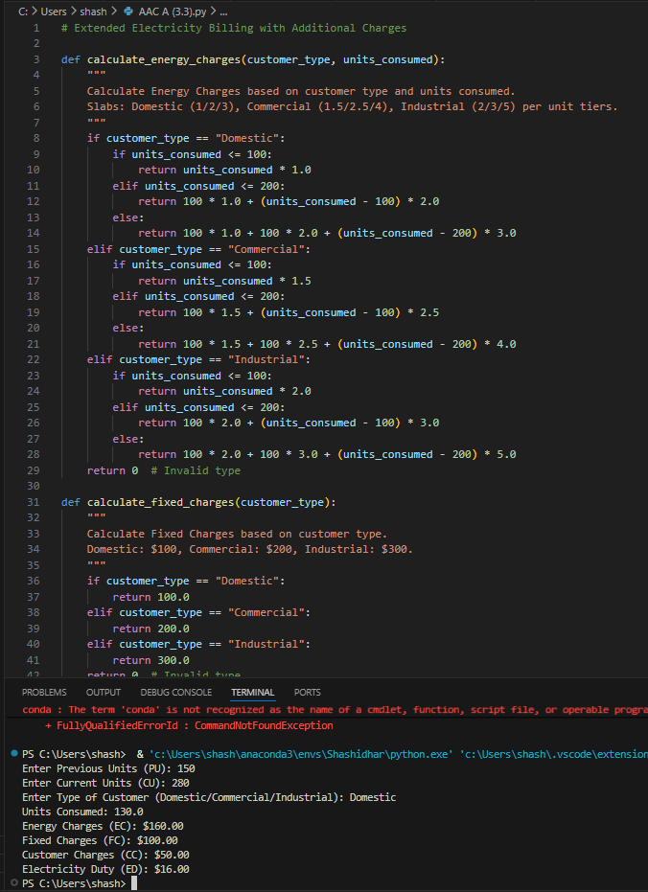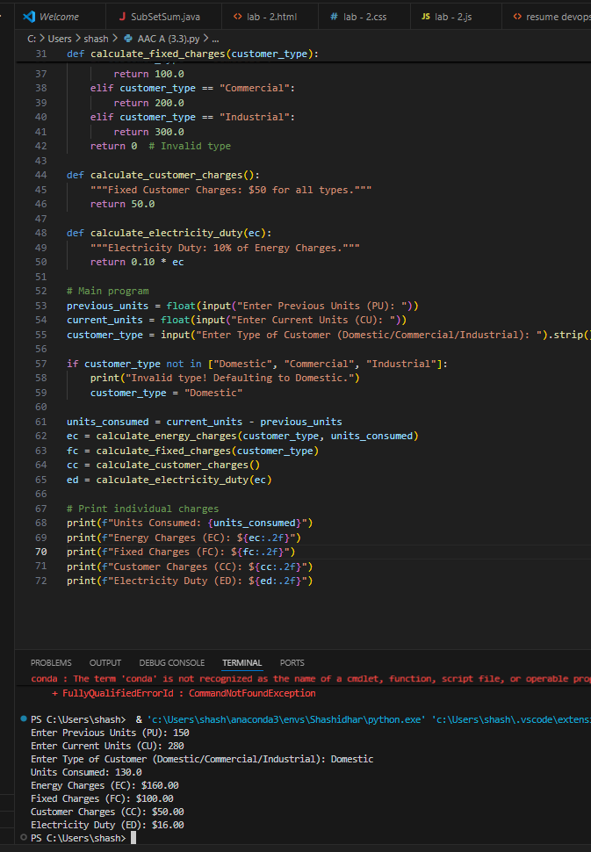  Task 5: Final Bill Generation and Output Analysis  Scenario  The final electricity bill must present all values clearly.  Task Description  Develop the final Python application to:  - Calculate total bill:  - Total Bill = EC + FC + CC + ED  - Display:  - Energy Charges (EC)  - Fixed Charges (FC)  - Customer Charges (CC)  - Electricity Duty (ED)  - Total Bill Amount  - Analyze the program based on:  - Accuracy  - Readability  - Real-world applicability  Expected Output  - Complete electricity bill output  - Neatly formatted display  - Sample input/output  - Short analysis paragraph  - 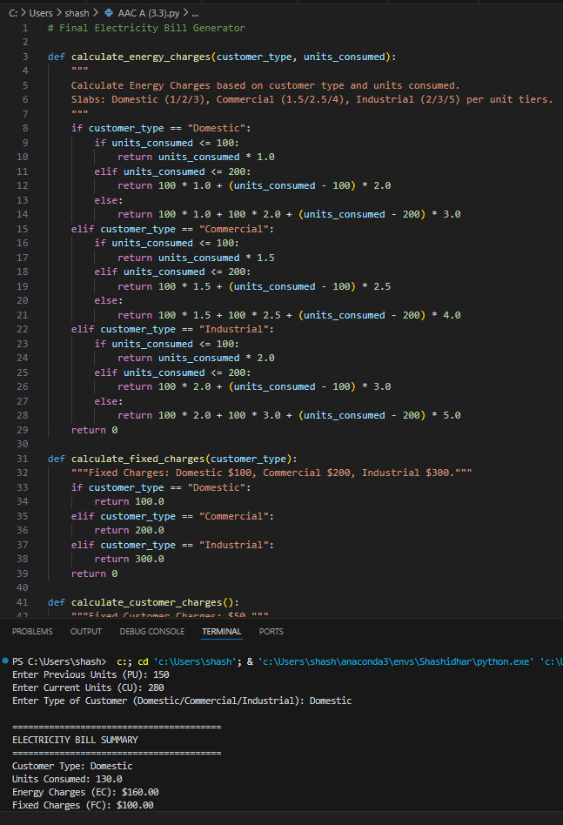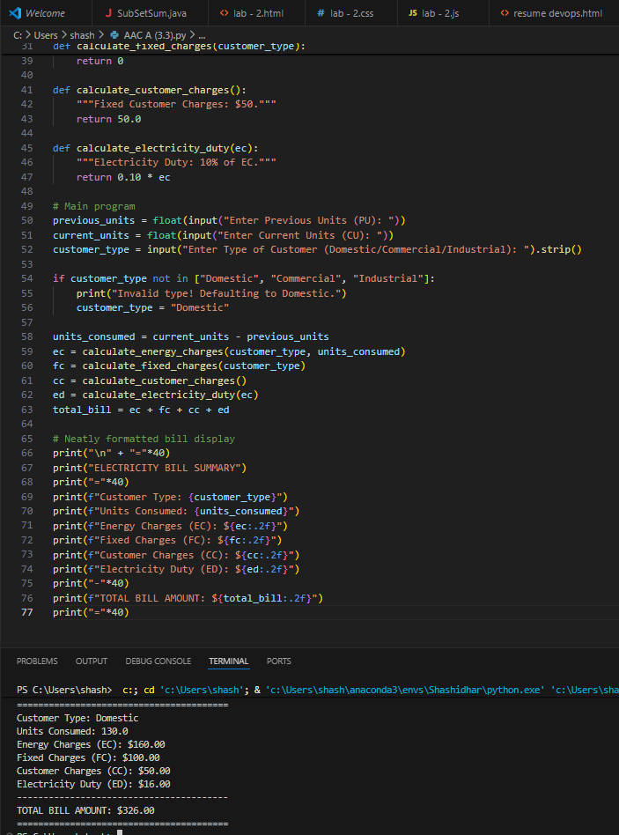  Note: Report should be submitted as a word document for all tasks in a single document with prompts, comments & code explanation, and output and if required, screenshots. |  |  |  |  |  | Week2 - Wednesday

