ASSIGNMENT-3.4
Name: B .Bhanumathi
H NO:2303A51840
BATCH-13
Task 1: Zero-shot Prompt – Fibonacci Series Generator
Task Description #1
• Without giving an example, write a single comment prompt
asking GitHub Copilot to generate a Python function to print the
first N Fibonacci numbers.
Expected Output #1
• A complete Python function generated by Copilot without any
example provided.
• Correct output for sample input N = 7 ➝ 0 1 1 2 3 5 8
• Observation on how Copilot understood the instruction with zero context.
PROMPT:
#Generate a Python function that takes an integer N as input and prints the first N Fibonacci numbers in order.
CODE: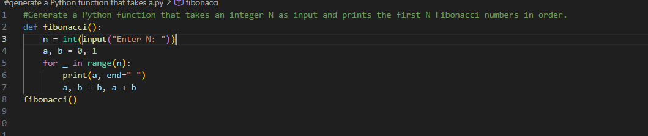
OUTPUT: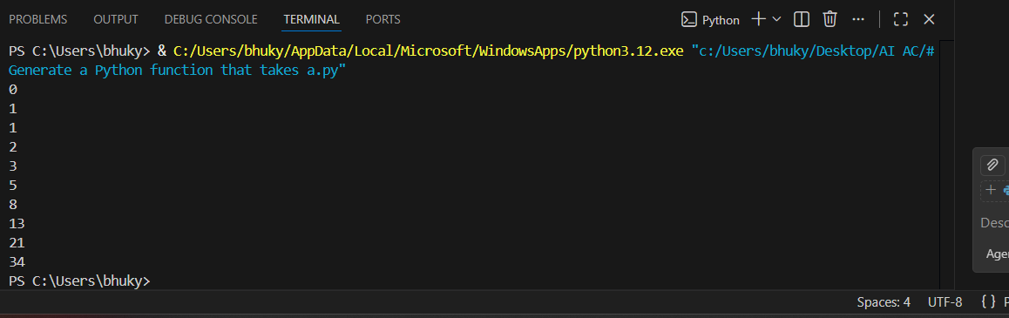
JUSTIFICATION:
Observation :
Copilot correctly understood the instruction without any examples by:
- Recognizing the term Fibonacci series
- Identifying that the function should generate values iteratively
- Printing the sequence starting from 0
- Handling the input N as the number of terms
This shows that Copilot can infer logic and structure accurately even with minimal context, which is the essence of zero-shot prompting.

Task 2: One-shot Prompt – List Reversal Function
Task Description #2
• Write a comment prompt to reverse a list and provide one
example below the comment to guide Copilot.
Expected Output #2
• Copilot-generated function to reverse a list using slicing or loop.
• Output: [3, 2, 1] for input [1, 2, 3]
• Observation on how adding a single example improved Copilot’s accuracy.
PROMPT:
# Write a Python function that reverses a given list.
# Example: input [1, 2, 3] → output [3, 2, 1]
CODE:
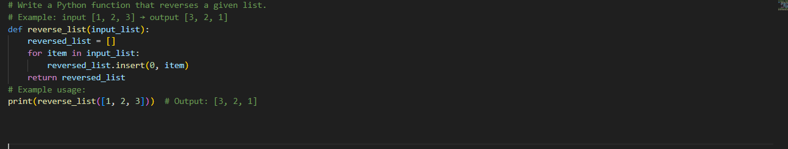
OUTPUT:
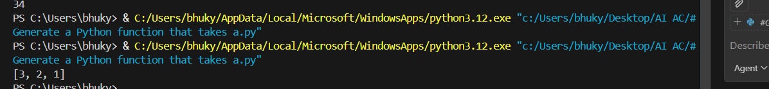
JUSTIFICATION:
Providing a single example helped Copilot clearly understand:
- The expected input and output format
- That the list order must be fully reversed
- The most efficient approach using slicing
The one-shot example reduced ambiguity and improved accuracy compared to zero-shot prompting.

Task 3: Few-shot Prompt – String Pattern Matching
Task Description #3
• Write a comment with 2–3 examples to help Copilot understand
how to check if a string starts with a capital letter and ends with a period.
Expected Output #3
• A function is_ valid () that checks the pattern.
• Output: True or False based on input.
• Students reflect on how multiple examples guide Copilot to
generate more accurate code.
PROMPT:
# Write a Python function is_valid(text) that returns True if a string
# starts with a capital letter and ends with a period, otherwise False.
# Example: "Hello." → True
# Example: "hello." → False
# Example: "Hello" → False
CODE:
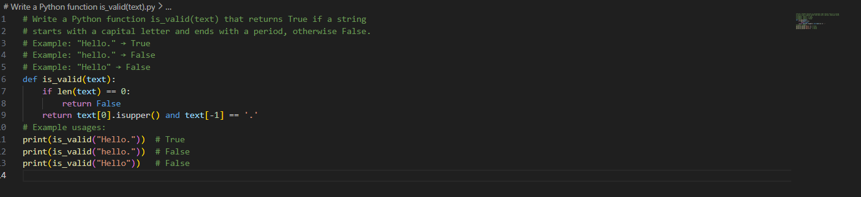

OUTPUT:
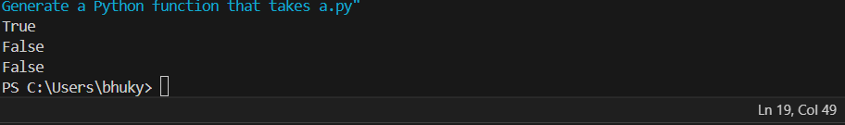
JUSTIFICATION:
Providing multiple examples helped Copilot clearly identify:
- The importance of the first character being uppercase
- The requirement of a period at the end
- The exact conditions for True and False outputs
Few-shot prompting reduces misunderstanding and leads to more precise and reliable code generation.
Task 4: Zero-shot vs Few-shot – Email Validator
Task Description #4
• First, prompt Copilot to write an email validation function using
zero-shot (just the task in comment).
• Then, rewrite the prompt using few-shot examples.
Expected Output #4
• Compare both outputs:
Zero-shot may result in basic or generic validation.
Few-shot gives detailed and specific logic (e.g., @ and domain checking).
• Submit both code versions and note how few-shot improves reliability.
Zero-shot
PROMPT:
# Write a Python function that checks whether an email address is valid and returns True or False.

CODE:
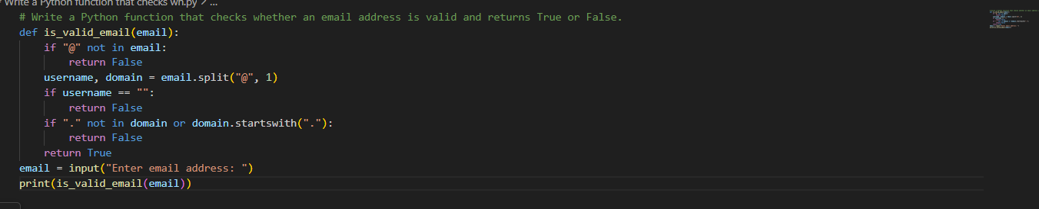
OUTPUT:
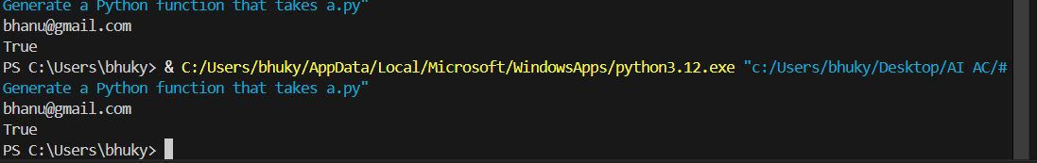
Few-shot
PROMPT
# Write a Python function that checks whether an email address is valid and returns True or False.
# Example: "user@gmail.com" → True
# Example: "user@gmail" → False
# Example: "user@.com" → False

CODE
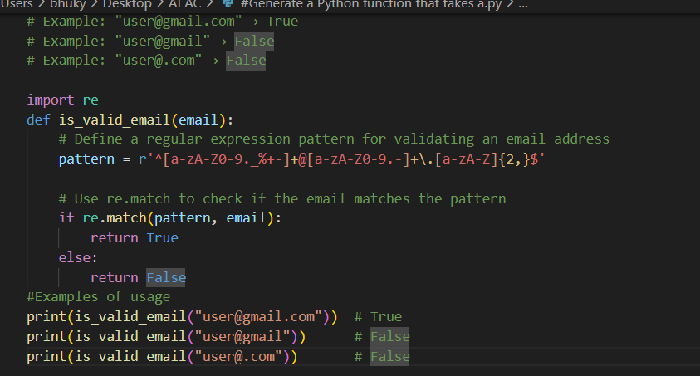
OUTPUT
JUSTIFICATION:
Zero-shot prompting provides only the task description, so Copilot generates a simple and generic email validation logic. This approach may miss several invalid cases. In few-shot prompting, example inputs and outputs are given along with the task. These examples help Copilot understand the validation rules more clearly. As a result, few-shot prompting produces more accurate and reliable code than zero-shot prompting.
Task 5: Prompt Tuning – Summing Digits of a Number
Task Description #5
• Experiment with 2 different prompt styles to generate a function
that returns the sum of digits of a number.
Style 1: Generic task prompt
Style 2: Task + Input/Output example
Expected Output #5
• Two versions of the sum_of_digits() function.
• Example Output: sum_of_digits(123) ➝ 6
• Short analysis: which prompt produced cleaner or more optimized code and why?
#Style 1: Generic task prompt
PROMPT
#Write a Python function that returns the sum of digits of a number.
CODE
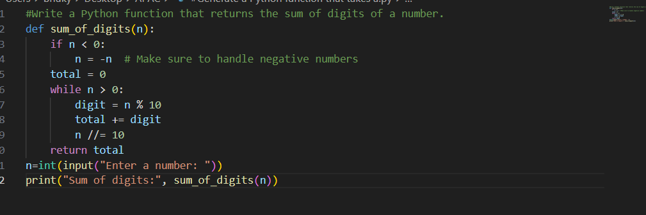
OUTPUT
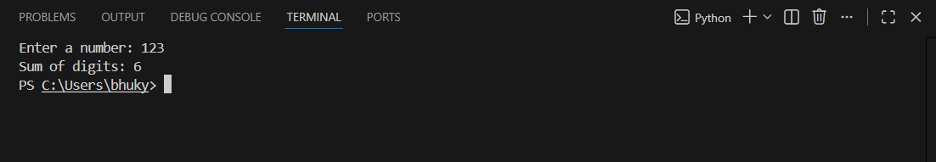
Style 2: Task + Input/Output example
PROMPT
# Write a Python function that returns the sum of digits of a number.
# Example: sum_of_digits(123) → 6
CODE
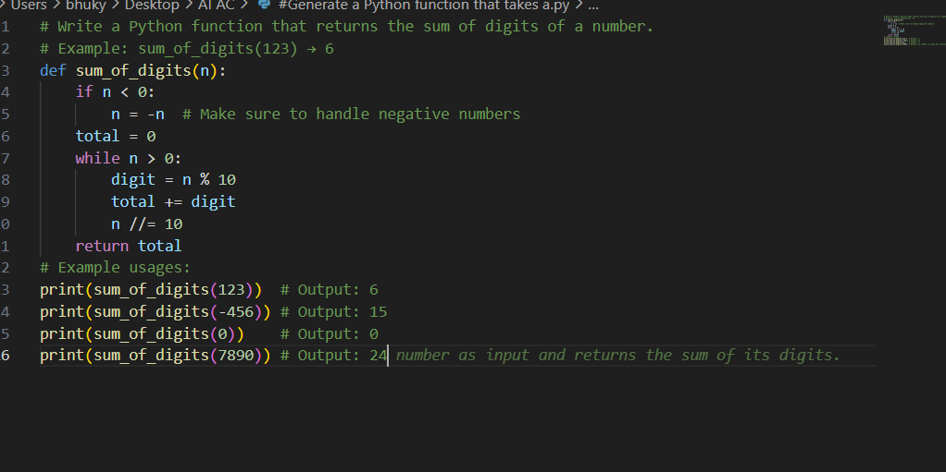
OUTPUT
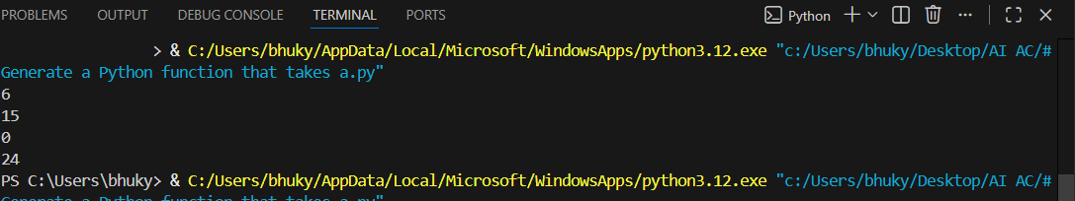
JUSTIFICATION
The generic prompt produced a correct but longer solution using a loop.
The prompt with an example guided Copilot to generate a cleaner and more optimized one-line solution.
Providing input/output examples helps the model infer intent more clearly and produce concise, efficient code.

