ASSIGNMENT-11.1

Name :B.Bhanumathi
H NO:2303A51840
Batch-13
Task Description #1 – Stack Implementation
Task: Use AI to generate a Stack class with push, pop, peek, and is_empty
methods.
Sample Input Code:
class Stack:
pass
Expected Output:
• A functional stack implementation with all required methods and
docstrings.
Prompt:
Write a Python class called Stack with methods push, pop, peek, and is_empty. Use a list internally and include docstrings.
Code:
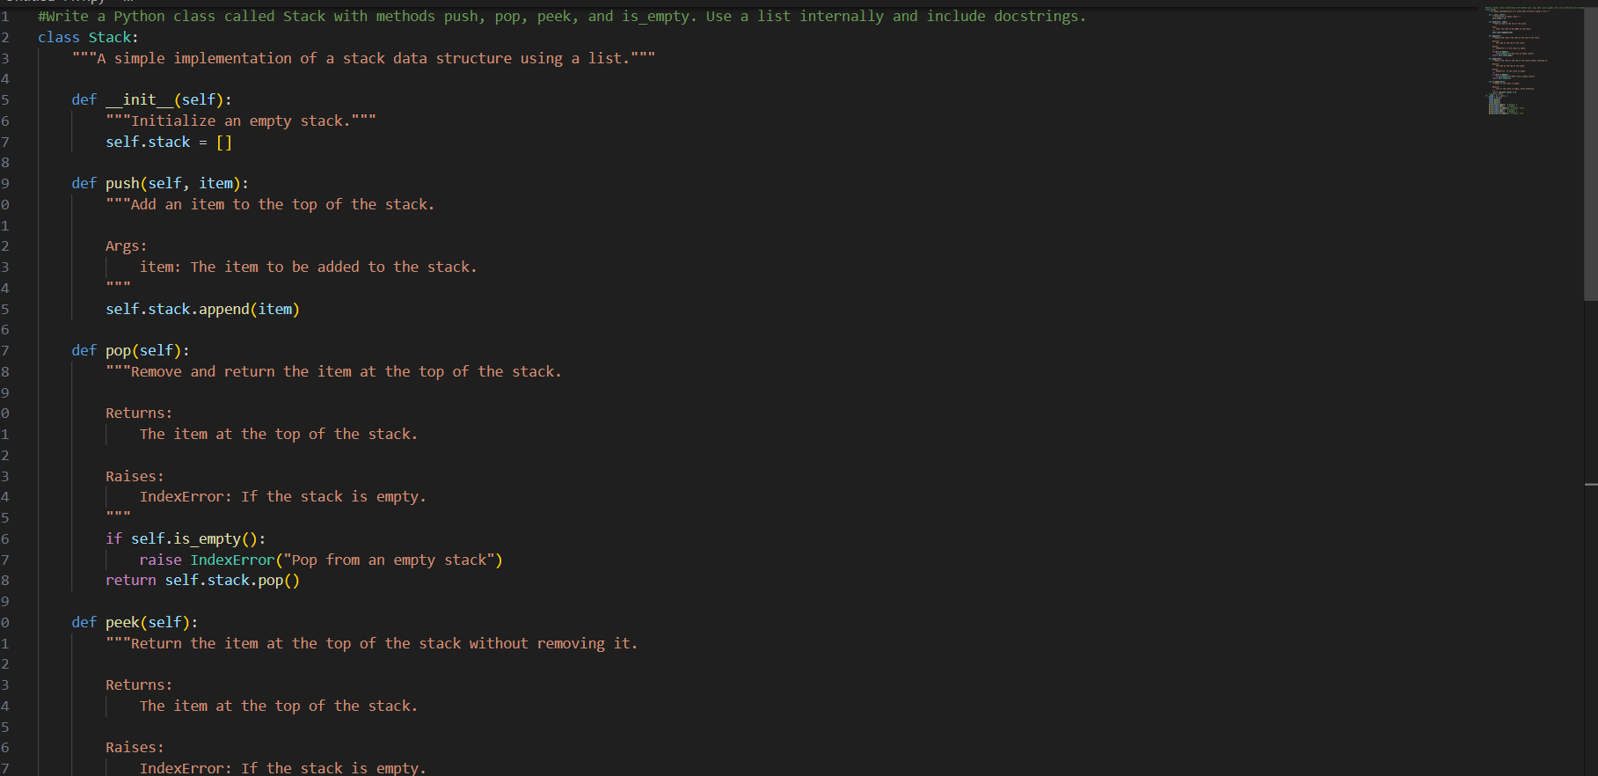
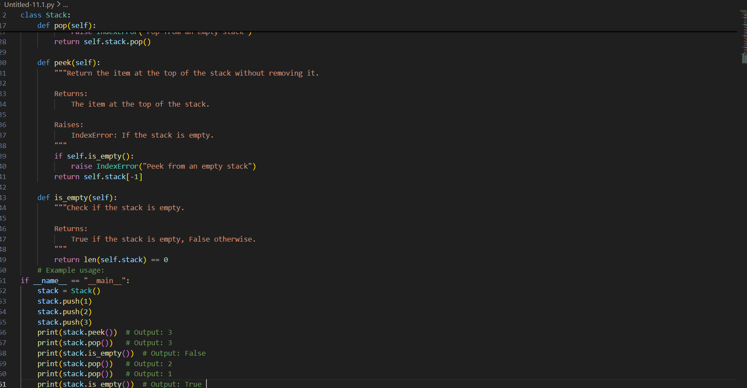

Output:
Justification:
The Stack class is designed with separate methods such as push(), pop(), peek(), and is_empty() to follow the principle of modularity and abstraction in object-oriented programming. Each method performs a single, clearly defined task, making the code easier to understand, maintain, and reuse. This structured design improves readability and allows future modifications—such as adding size tracking or additional validation—without affecting the overall functionality. It also makes the class suitable for integration into larger applications where clean and organized code is essential.
Task Description #2 – Queue Implementation
Task: Use AI to implement a Queue using Python lists.
Sample Input Code:
class Queue:
pass
Expected Output:
• FIFO-based queue class with enqueue, dequeue, peek, and size methods.
Prompt:
Write a Python class called Queue using a list. Implement enqueue, dequeue, peek, and size methods with docstrings.

Code:
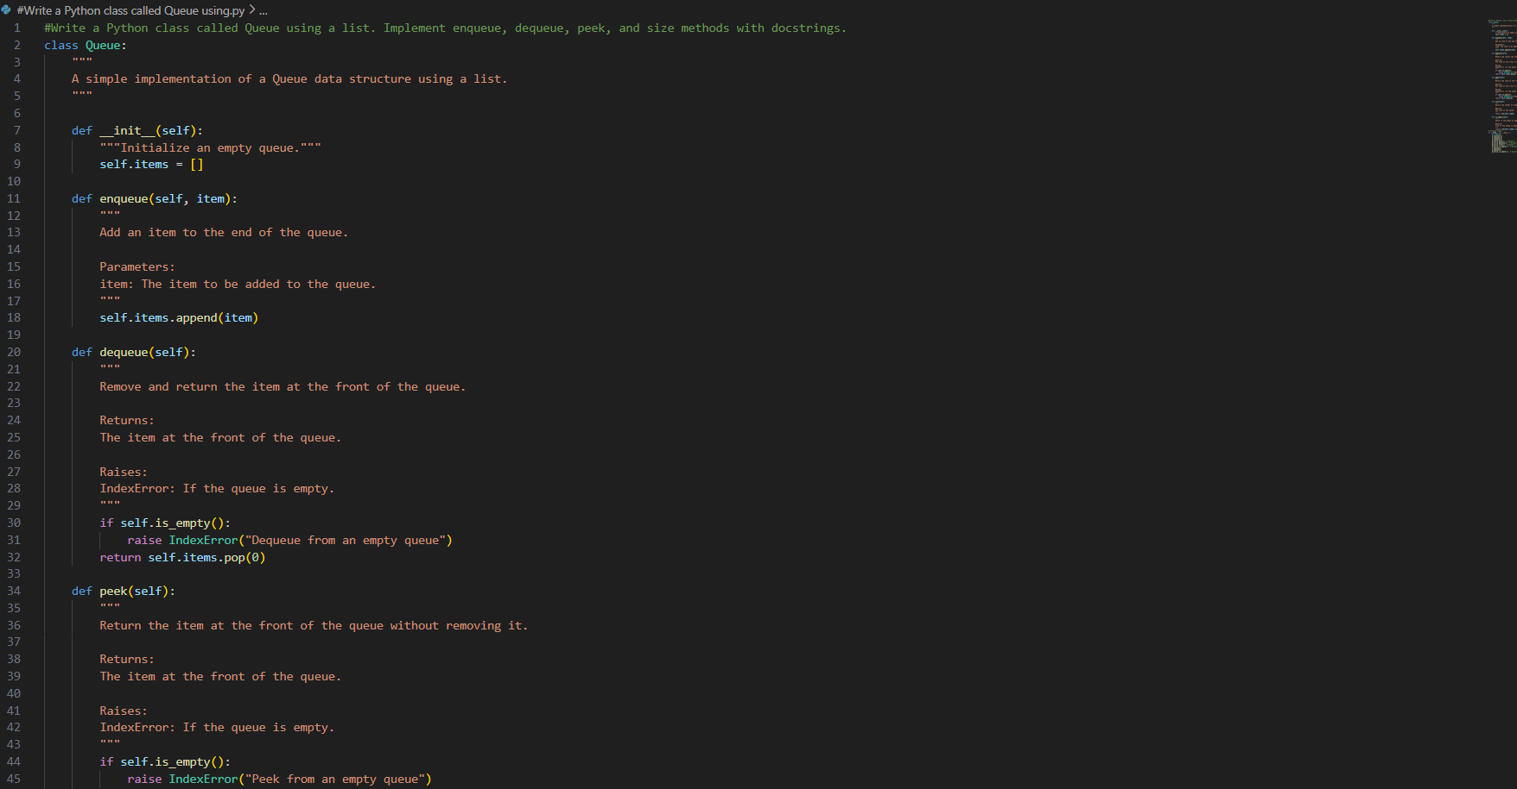
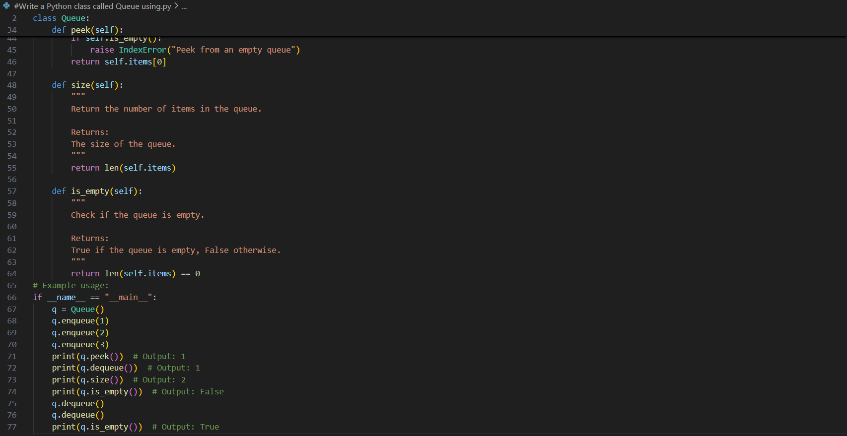
Output:
Justification:
Error handling is included in the dequeue() and peek() methods to prevent operations on an empty queue. Before accessing or removing elements, the program checks whether the queue size is zero. If the queue is empty, an IndexError is raised with a clear message. This improves the reliability of the class, prevents unexpected crashes, and ensures safe execution in larger applications.
Task Description #3 – Linked List
Task: Use AI to generate a Singly Linked List with insert and display
methods.
Sample Input Code:
class Node:
pass
class LinkedList:
pass
Expected Output:
• A working linked list implementation with clear method
documentation.
Prompt:
Write a Python class for a singly linked list with a Node class. Implement insert and display methods with docstrings.
Code:
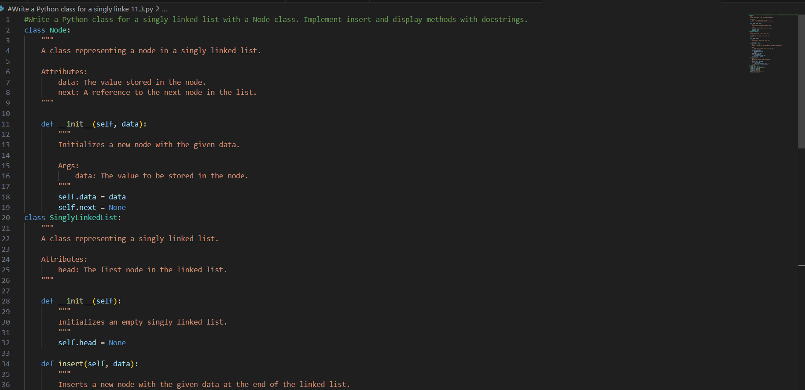
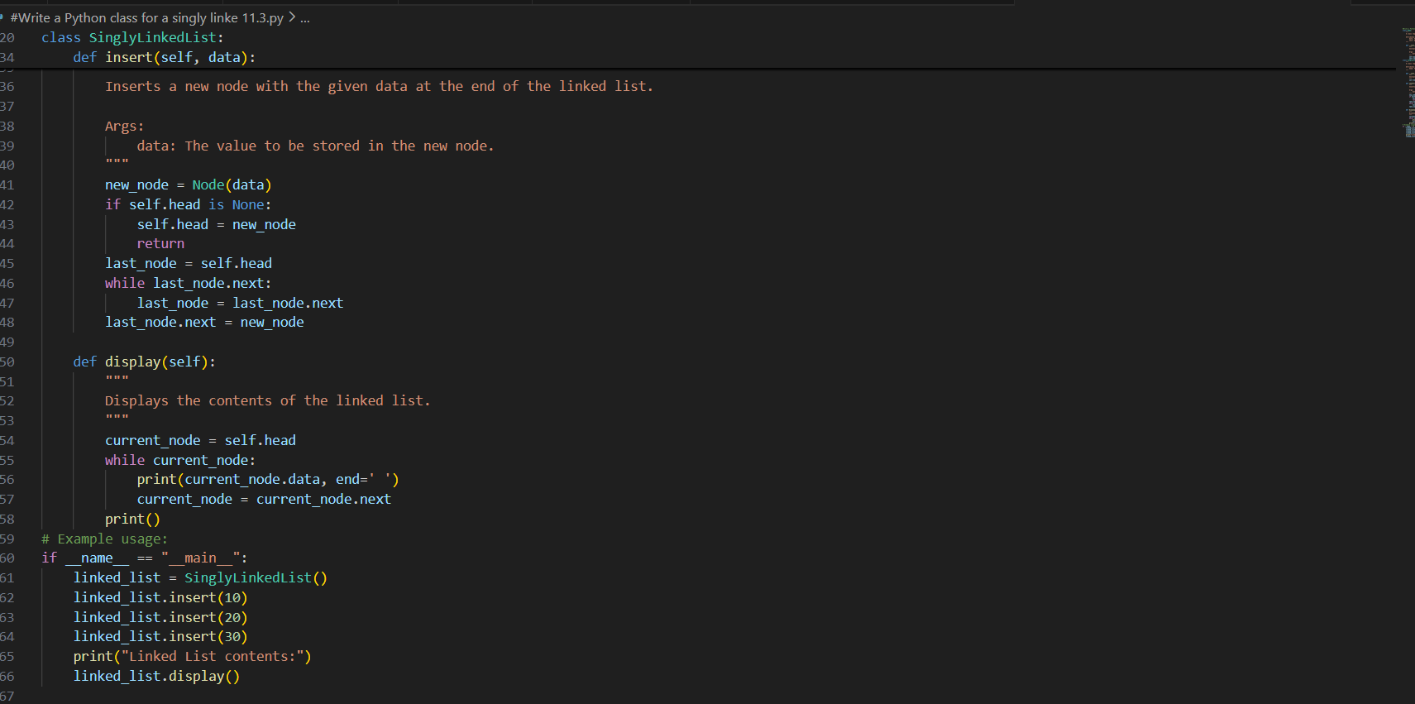

Output:

Justification:
The Singly Linked List is implemented using two classes, Node and LinkedList, to clearly separate responsibilities. The Node class stores the data and a reference to the next node, while the LinkedList class manages the overall structure. This separation follows object-oriented design principles, making the implementation clean, modular, and easier to understand for both beginners and advanced learners.
Task Description #4 – Binary Search Tree (BST)
Task: Use AI to create a BST with insert and in-order traversal methods.
Sample Input Code:
class BST:
pass
Expected Output:
• BST implementation with recursive insert and traversal methods.
Prompt:
Write a Python class called BST with recursive insert and in_order_traversal methods. Include docstrings.
Code:
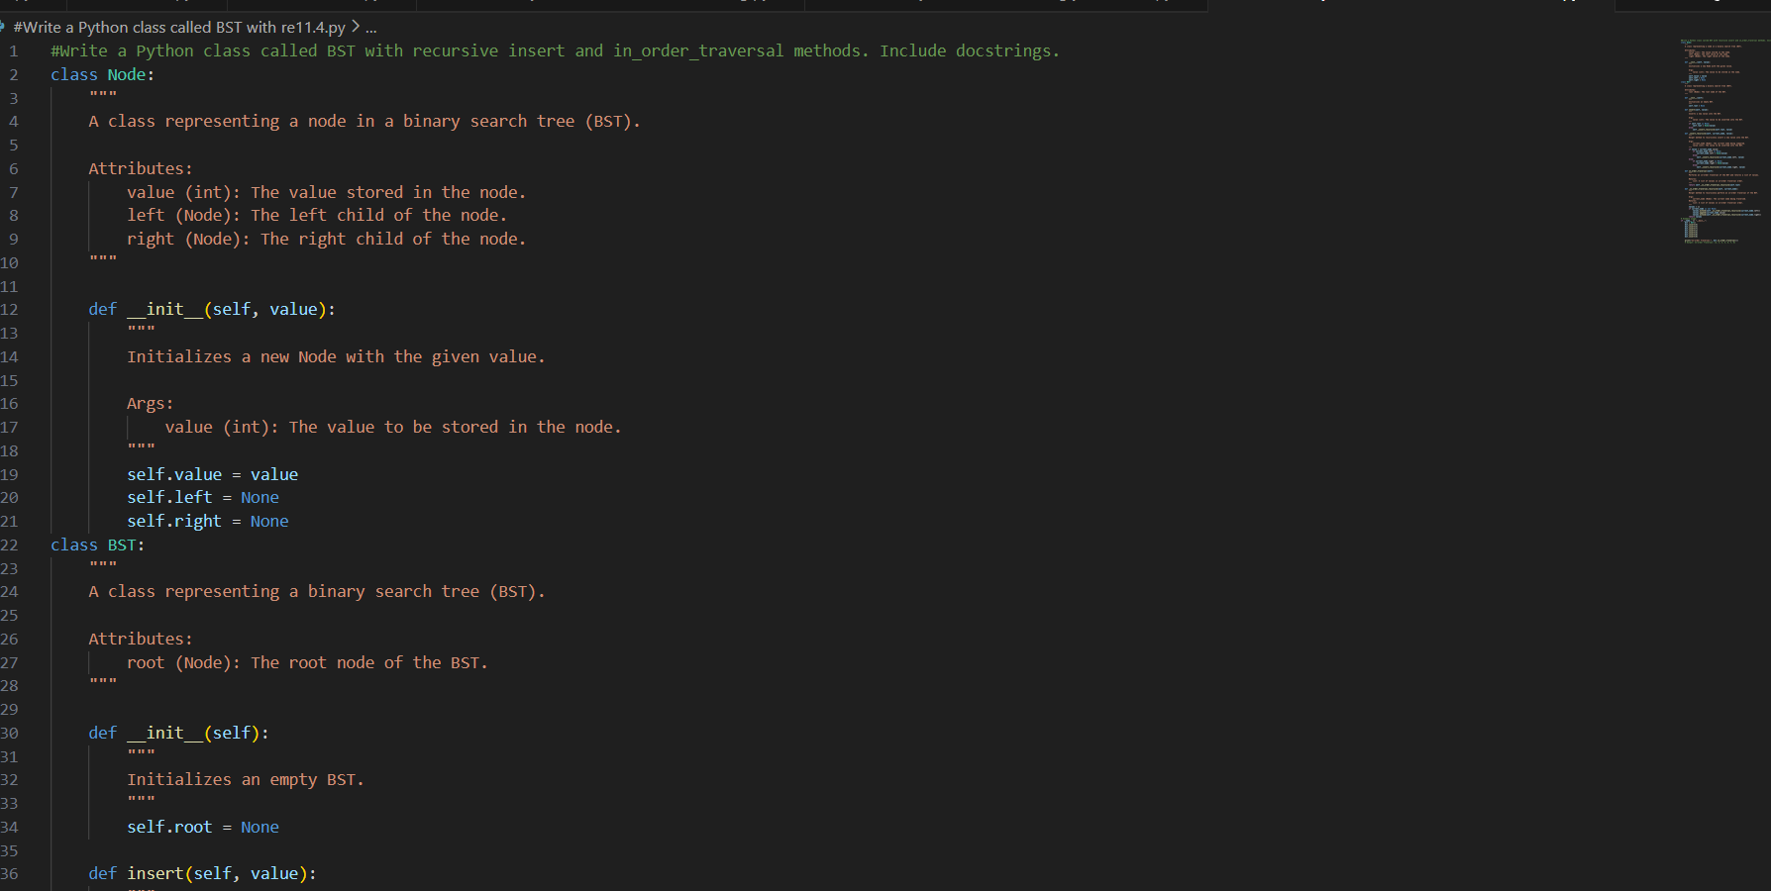
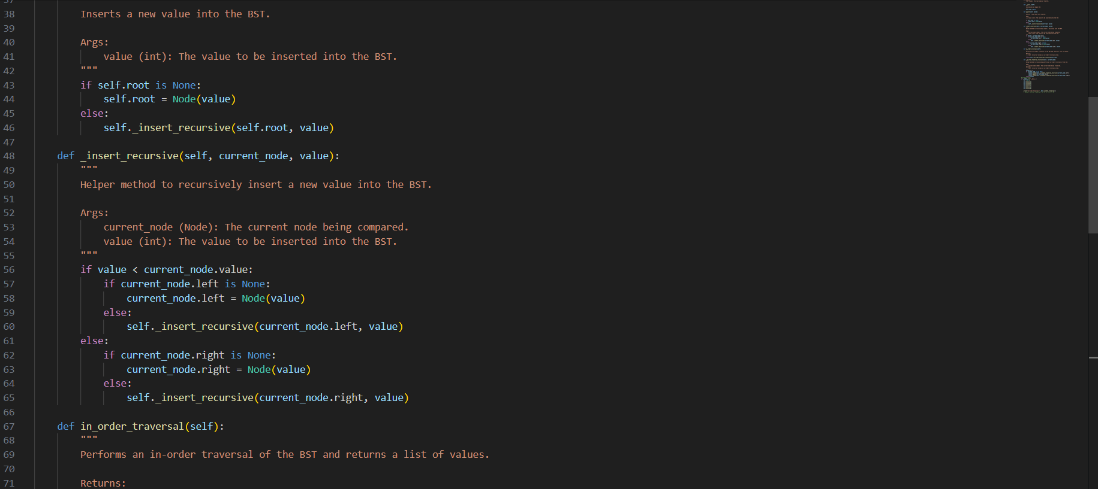
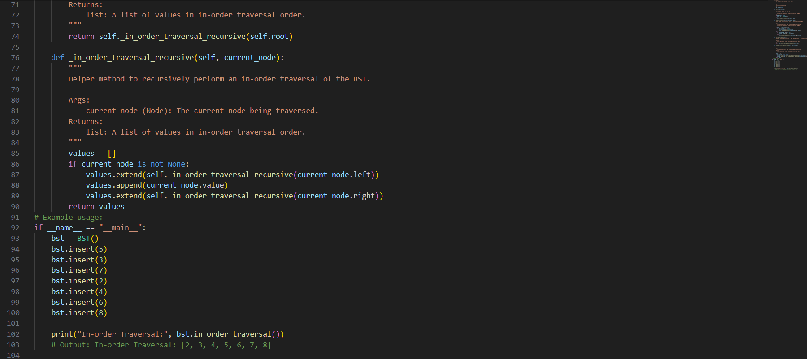
Output:
Justification:
The in-order traversal method is implemented to print elements in sorted order, which demonstrates one of the key advantages of a Binary Search Tree. By recursively visiting the left subtree, the root node, and then the right subtree, the traversal guarantees ascending order output. This highlights the practical use of BSTs in sorting and data organization applications, making the implementation both educational and functional.
Task Description #5 – Hash Table
Task: Use AI to implement a hash table with basic insert, search, and
delete methods.
Sample Input Code:
class HashTable:
pass
Expected Output:
• Collision handling using chaining, with well-commented methods.
Expected Output:
• Collision handling using chaining, with well-commented methods.
Prompt:
Write a Python class called HashTable using chaining for collision handling. Implement insert, search, and delete methods with docstrings.
Code:
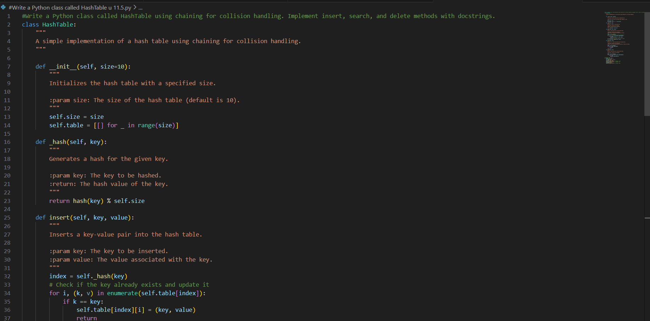
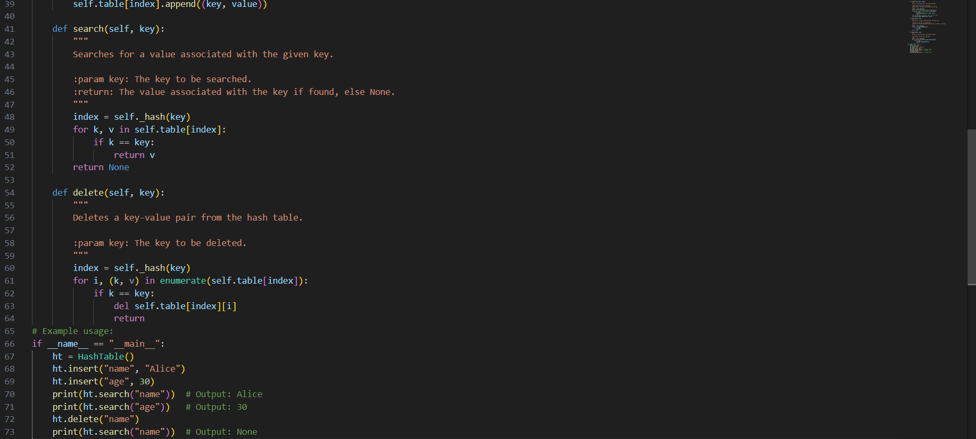
Output:
Justification:
Chaining is used for collision handling because multiple keys may generate the same hash index. Instead of overwriting existing data, each bucket stores a list of key-value pairs. When a collision occurs, the new pair is simply appended to the list at that index. This approach is simple to implement, avoids data loss, and efficiently manages collisions without requiring complex probing techniques.

Task Description #6 – Graph Representation
Task: Use AI to implement a graph using an adjacency list.
Sample Input Code:
class Graph:
pass
Expected Output:
• Graph with methods to add vertices, add edges, and display
connections.
Prompt:
Generate a complete Python Graph class using an adjacency list with methods to add vertices, add edges, and display connections, including clear docstrings.
Code:
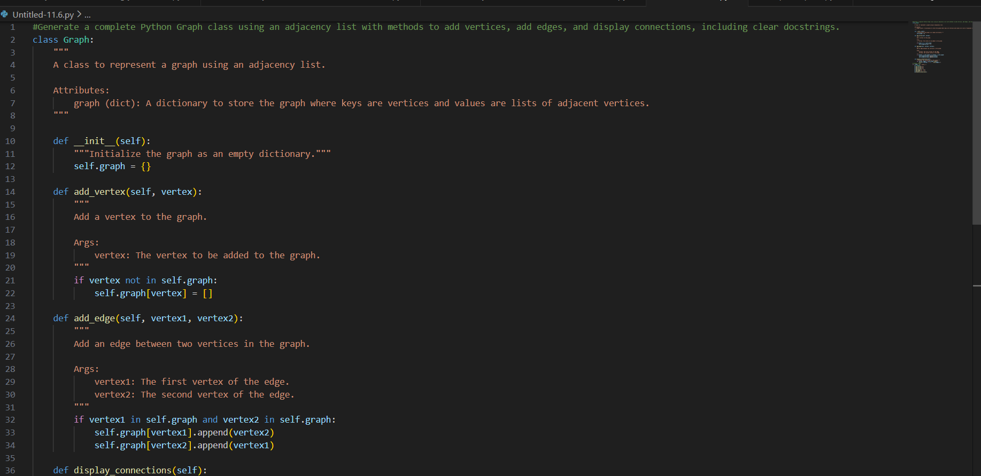
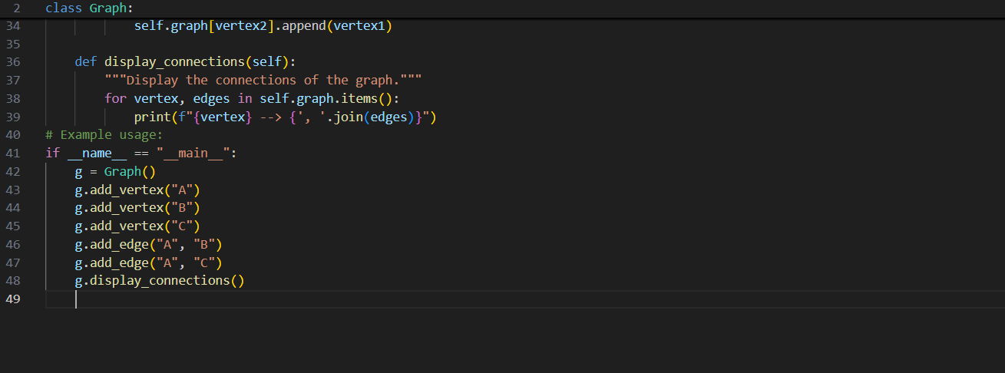
Justification:
An adjacency list is used to represent the graph because it is memory-efficient compared to an adjacency matrix, especially for sparse graphs. Instead of storing all possible connections, it only stores existing edges. This reduces space complexity and makes the implementation practical for large graphs where the number of edges is much smaller than the number of possible vertex pairs.
Output:

Task Description #7 – Priority Queue
Task: Use AI to implement a priority queue using Python’s heapq module.
Sample Input Code:
class PriorityQueue:
pass
Expected Output:
• Implementation with enqueue (priority), dequeue (highest priority),
and display methods.
Prompt:
Implement a PriorityQueue class in Python using heapq with enqueue, dequeue, and display methods.
Code:
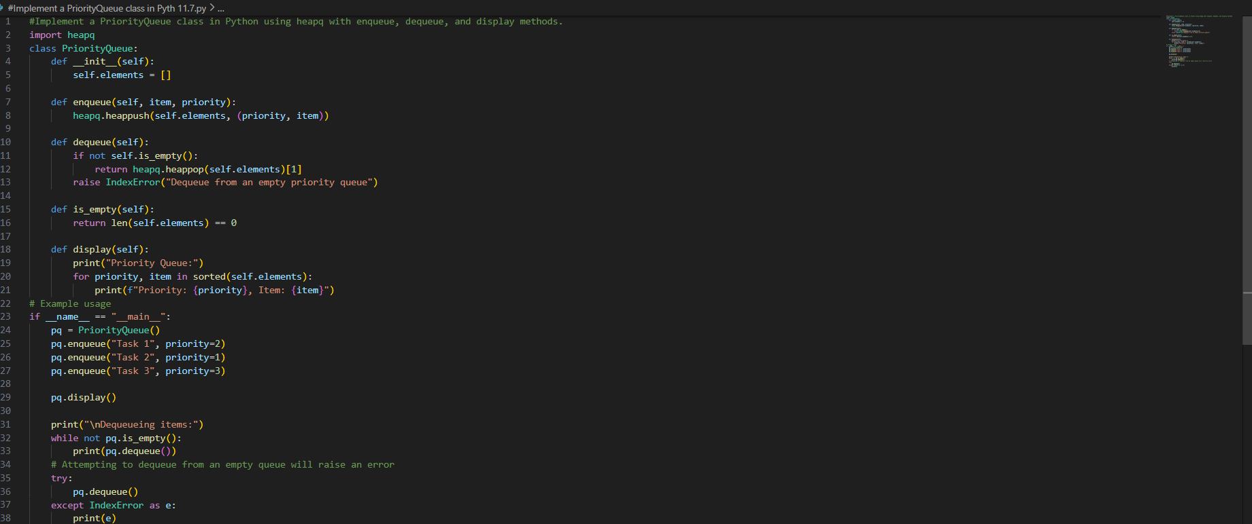
Output:
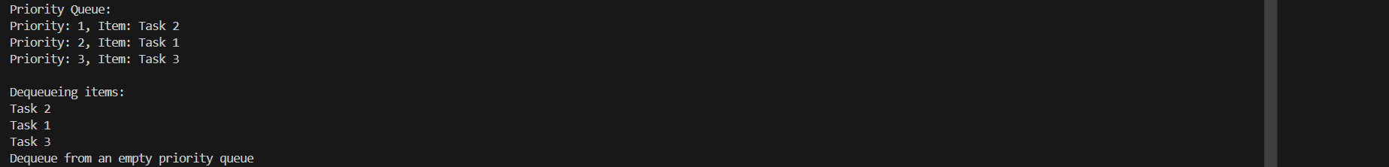
Justification:
The heapq module is used because it provides an efficient heap-based implementation with O(log n) time complexity for insertion and deletion operations. Since a heap maintains partial ordering automatically, it is ideal for implementing a priority queue. Using heapq avoids manually writing complex heap logic and ensures optimized performance.
Task Description #8 – Deque
Task: Use AI to implement a double-ended queue using collections.deque.
Sample Input Code:
class DequeDS:
pass
Expected Output:
• Insert and remove from both ends with docstrings.
Prompt:
Implement a DequeDS class in Python using collections.deque with insert/remove methods at both ends and docstrings.
Code:
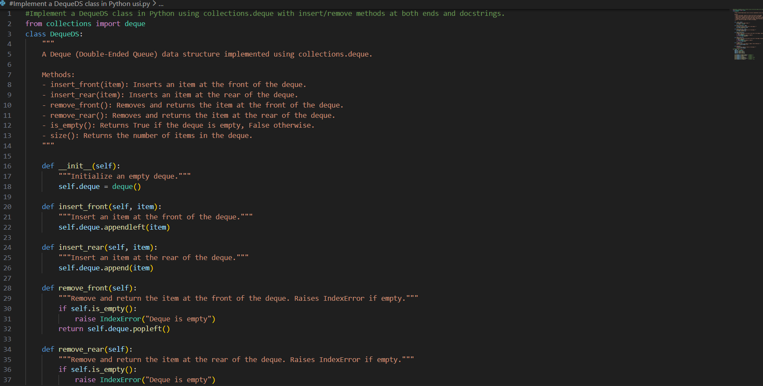
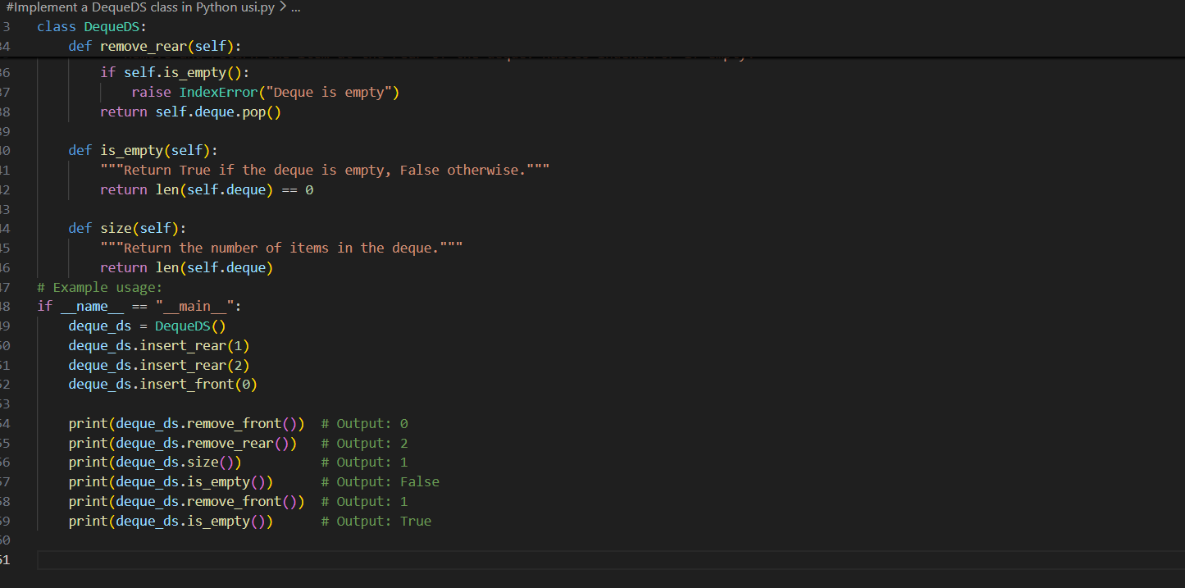
Output:
Justification:
The collections.deque module is used because it provides an efficient and optimized double-ended queue implementation. Unlike regular Python lists, deque allows O(1) time complexity for both insertion and deletion operations at the front and rear. This makes it highly suitable for implementing a true double-ended queue without performance drawbacks.
Task Description #9 Real-Time Application Challenge – Choose the
Right Data Structure
Scenario:
Your college wants to develop a Campus Resource Management System that handles:
1. Student Attendance Tracking – Daily log of students entering/exiting the campus.
2. Event Registration System – Manage participants in events with quick search and removal.
3. Library Book Borrowing – Keep track of available books and their due dates.
4. Bus Scheduling System – Maintain bus routes and stop connections.
5. Cafeteria Order Queue – Serve students in the order they arrive.
Student Task:
• For each feature, select the most appropriate data structure from the list below:
o Stack
o Queue
o Priority Queue
o Linked List
o Binary Search Tree (BST)
o Graph
o Hash Table
o Deque
• Justify your choice in 2–3 sentences per feature.
• Implement one selected feature as a working Python program with AI-assisted code generation.
Expected Output:
• A table mapping feature → chosen data structure → justification.
• A functional Python program implementing the chosen feature with comments and docstrings.
PROMPT:
Generate a solution that maps each campus feature to the most suitable data structure with 2–3 sentence justifications in a table format, and provide a fully functional Python program (with comments and docstrings) implementing one selected feature.

CODE:
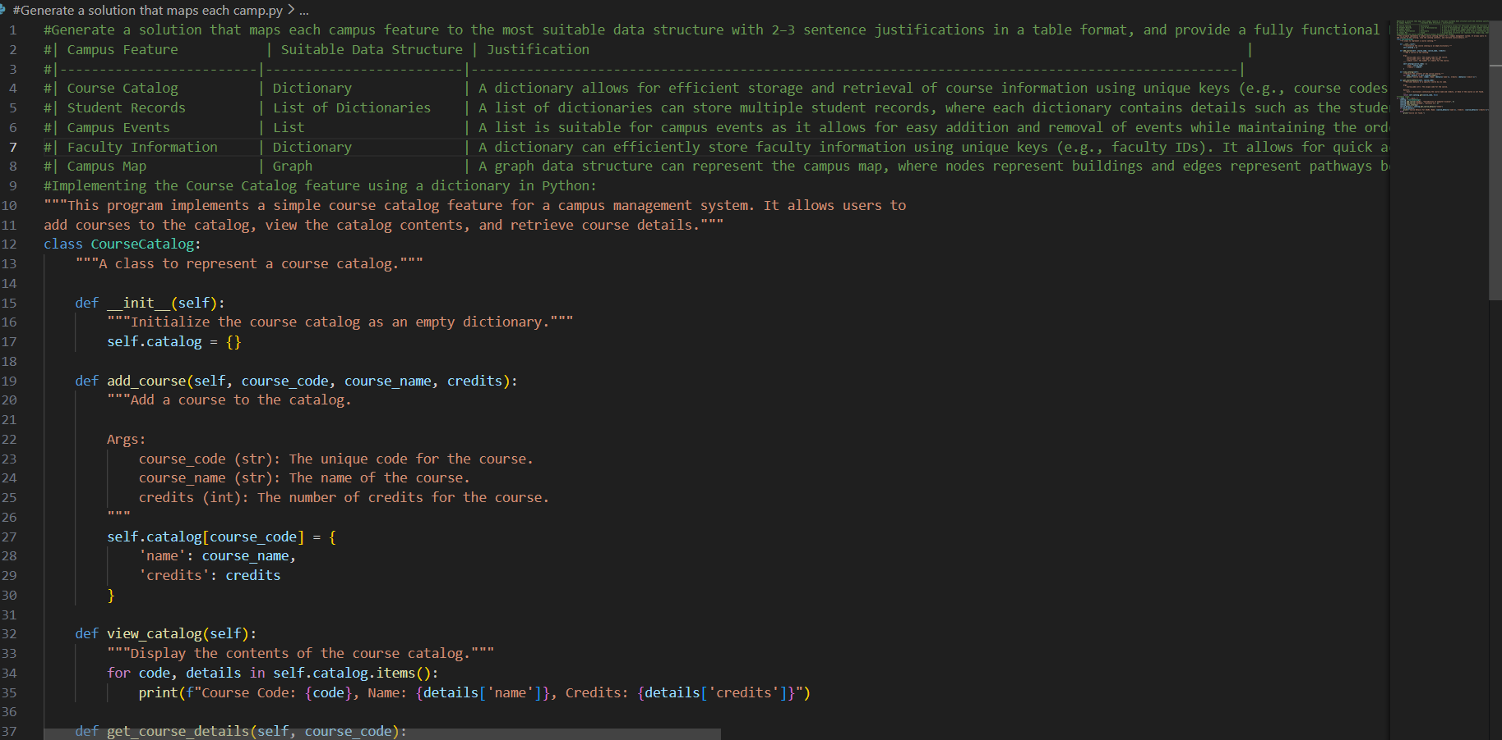
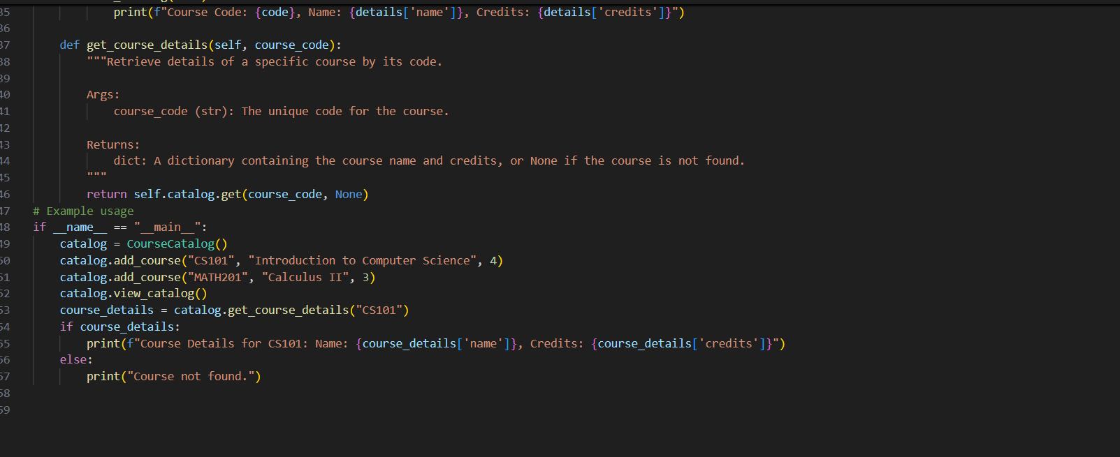
OUTPUT:
Justification:
Scalability and maintainability are also important considerations. As the campus system grows, thousands of students, books, and routes may be managed. Using optimized data structures like Deque, Graph, and Hash Table ensures that operations remain fast even with large datasets. This makes the system reliable, practical, and suitable for real-time campus management applications.
Task Description #10: Smart E-Commerce Platform – Data Structure
Challenge
An e-commerce company wants to build a Smart Online Shopping System with:
1. Shopping Cart Management – Add and remove products dynamically.
2. Order Processing System – Orders processed in the order they are placed.
3. Top-Selling Products Tracker – Products ranked by sales count.
4. Product Search Engine – Fast lookup of products using product ID.
5. Delivery Route Planning – Connect warehouses and delivery locations.
Student Task:
• For each feature, select the most appropriate data structure from the list below:
o Stack
o Queue
o Priority Queue
o Linked List
o Binary Search Tree (BST)
o Graph
o Hash Table
o Deque
• Justify your choice in 2–3 sentences per feature.
• Implement one selected feature as a working Python program with
AI-assisted code generation.
Expected Output:
• A table mapping feature → chosen data structure → justification.
• A functional Python program implementing the chosen feature
with comments and docstrings.
Prompt:
Generate a solution that maps each e-commerce feature to the most suitable data structure with 2–3 sentence justifications in a table format, and provide a fully functional Python program (with comments and docstrings) implementing one selected feature

Code:

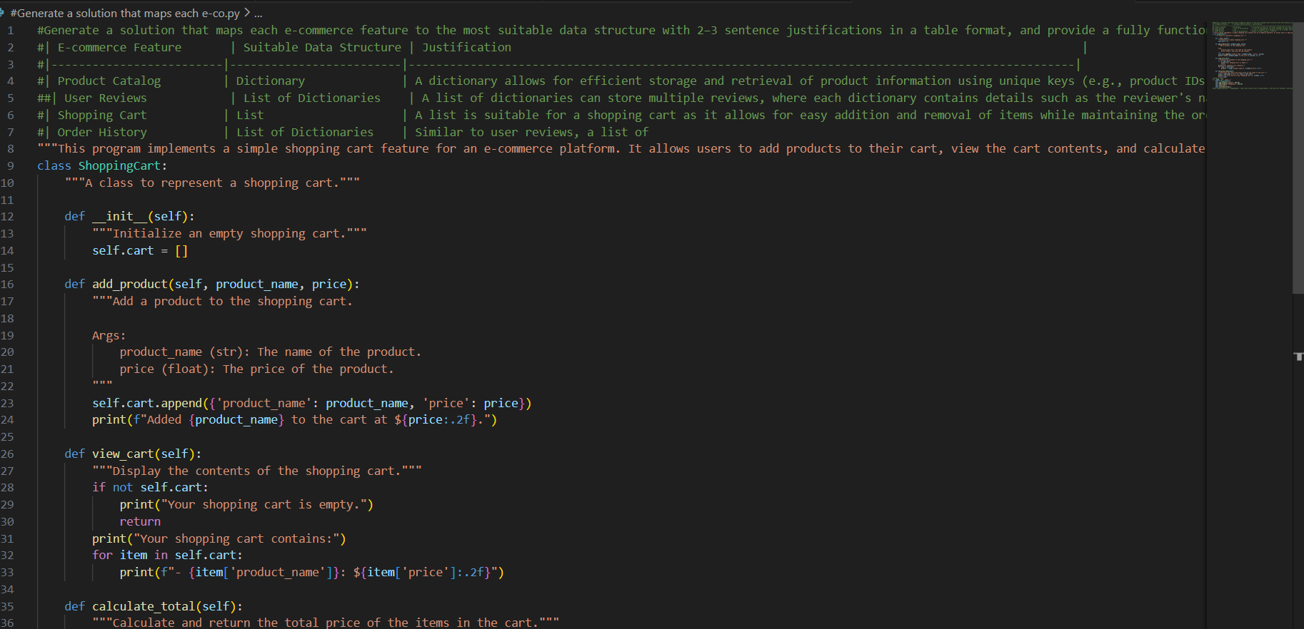
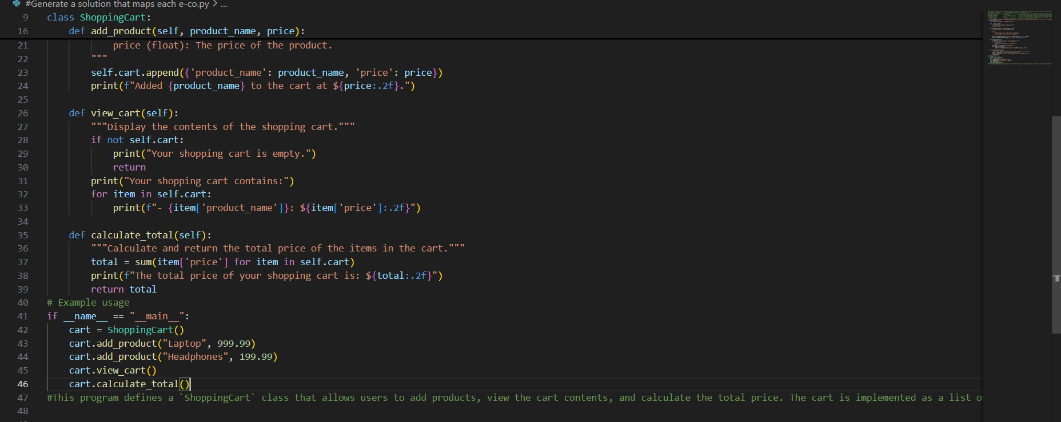
Output:
Justification:
Efficiency is a major factor in selection. A Hash Table is chosen for product search because customers expect instant results when searching by product ID. Likewise, a Priority Queue helps dynamically maintain product rankings without sorting the entire dataset repeatedly. These structures reduce time complexity and enhance performance for large-scale e-commerce systems.

