Lab_Assignment_12.4
2303A51852

Task 1: Bubble Sort for Ranking Exam
Scores
Prompt: I am building a college result system to sort student exam scores.
Write a Python program for Bubble Sort with proper comments.
Include early termination optimization.
Provide sample input/output and explain time complexity.

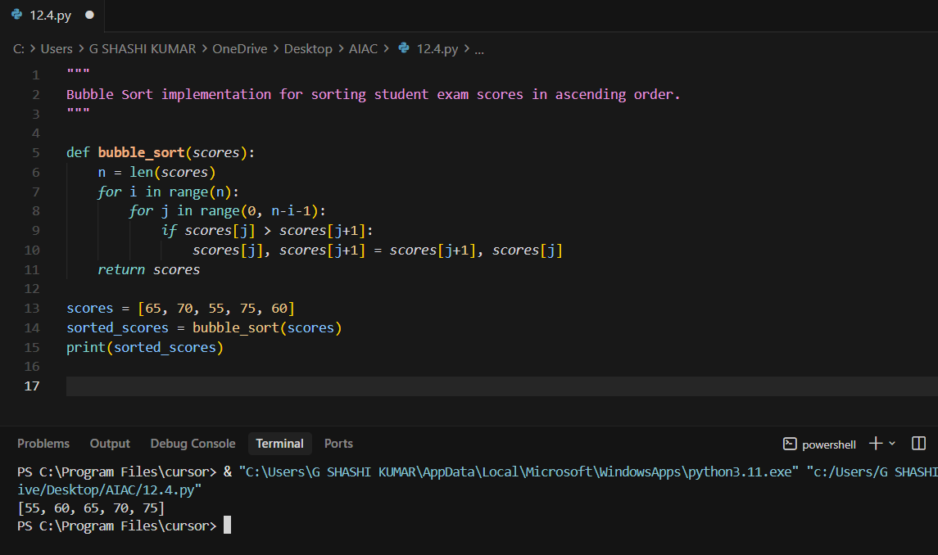
Task 2: Improving Sorting for Nearly Sorted
Attendance Records
Prompt: I have an attendance list that is almost sorted.
Suggest a better sorting algorithm than Bubble Sort.
Implement it in Python with comments.
Compare its performance and explain why it works better
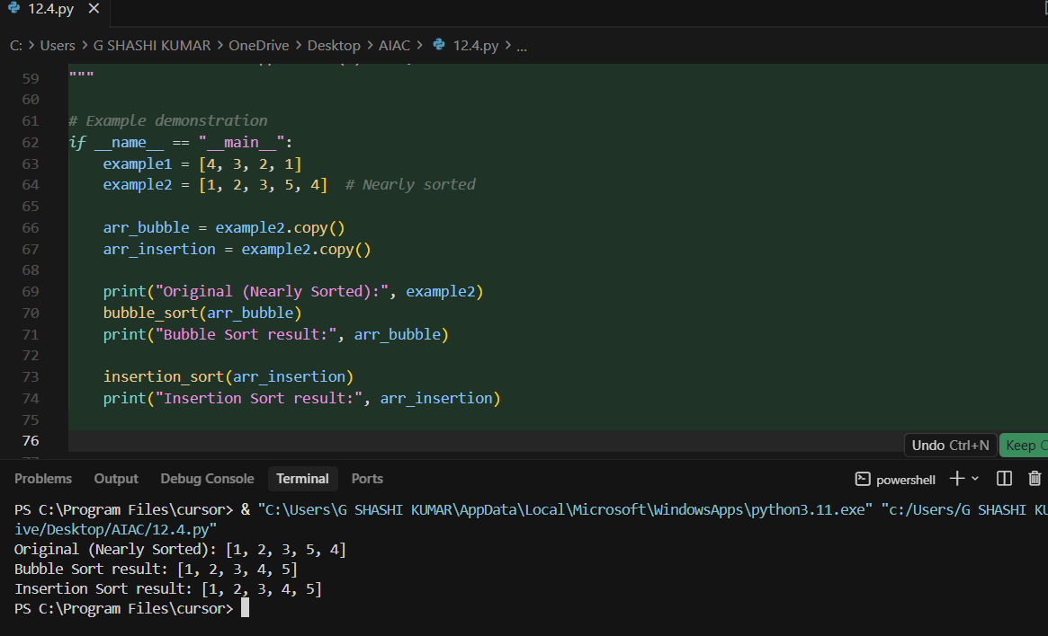
Task 3: Searching Student Records in a
Database
Prompt: I am creating a student portal to search roll numbers.
Write Python code for Linear Search and Binary Search.
Add docstrings and comments.
Compare their time complexities and use cases.
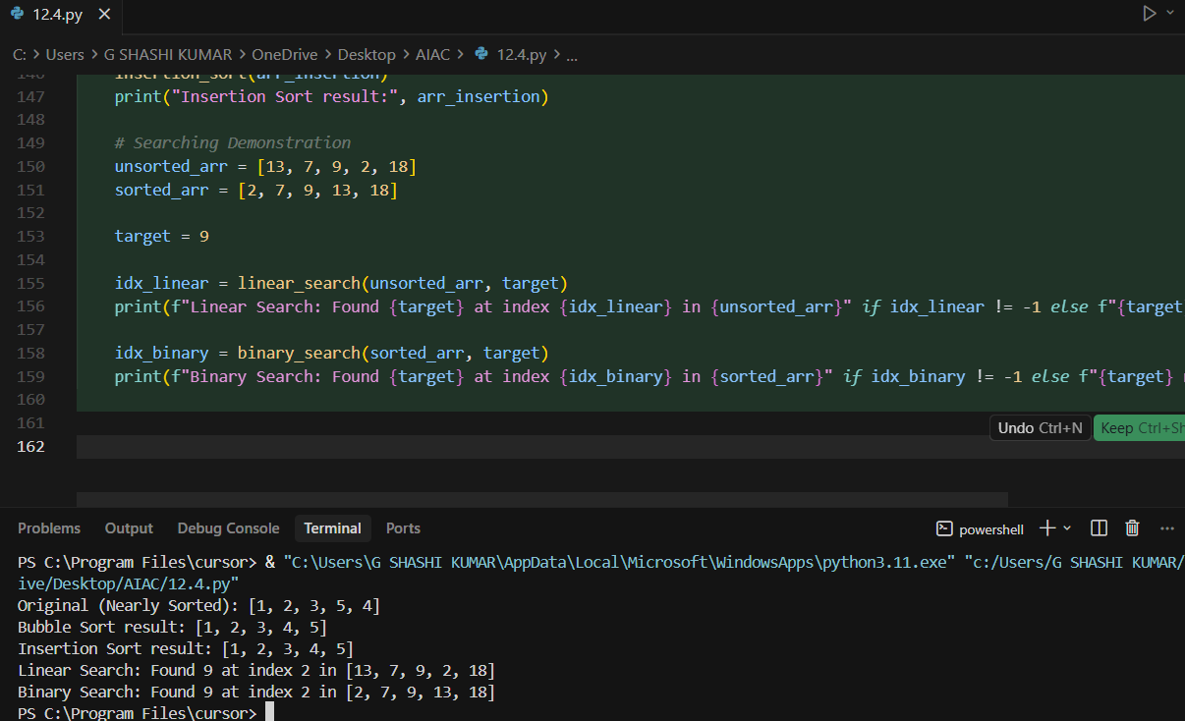
Task 4: Choosing Between Quick Sort and
Merge Sort for Data Processing
Prompt: I need to sort large datasets in different orders.
Write recursive Python programs for Quick Sort and Merge Sort.
Add comments explaining recursion.
Compare their complexities and performance.
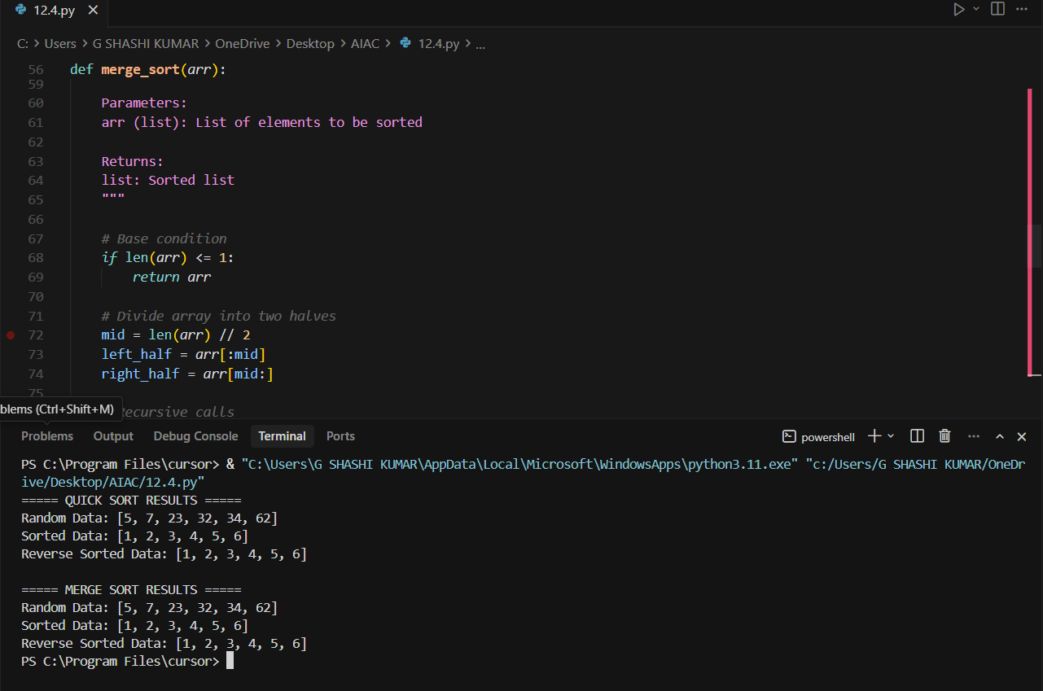
Task 5: Optimizing a Duplicate Detection
Algorithm
Prompt: I need to detect duplicate user IDs in a dataset.
First write a nested loop solution.
Then optimize it using a set.
Compare O(n²) and O(n) performance.
