ASSIGNMENT-10.4
NAME:R.SHASHIDEEPIKA
H.NO:2303A51871
B-13
Lab 9 – Code Review and Quality: Using AI to Improve Code Quality and
Readability
Task 1: AI-Assisted Syntax and Code Quality Review
Scenario
You join a development team and are asked to review a junior developer’s Python script that fails to run correctly due to basic coding mistakes. Before deployment, the code must be corrected and
standardized.
Task Description
You are given a Python script containing:
• Syntax errors
• Indentation issues
• Incorrect variable names
• Faulty function calls
Use an AI tool (GitHub Copilot / Cursor AI) to:
• Identify all syntactic and structural errors
• Correct them systematically
• Generate an explanation of each fix made
Expected Outcome
• Fully corrected and executable Python code
• AI-generated explanation describing:
o Syntax fixes
o Naming corrections
o Structural improvements
• Clean, readable version of the script

Faulty code:
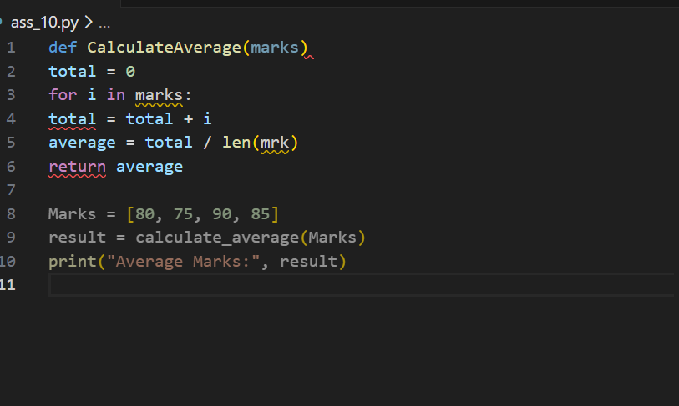
Output:
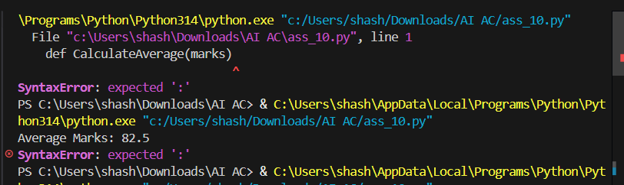

Corrected code:
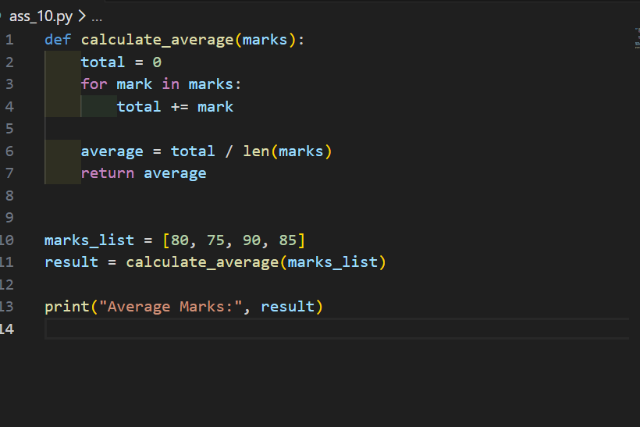
Output:
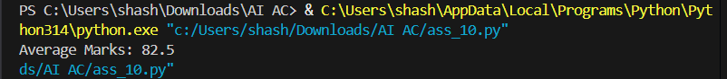

AI Review:
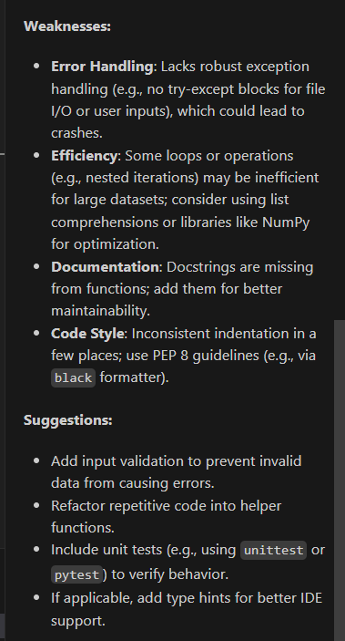
Task 2: Performance-Oriented Code Review
Scenario
A data processing function works correctly but is inefficient and slows down the system when large datasets are used.
Task Description
You are provided with a function that identifies duplicate values in a list using inefficient nested loops.
Using AI-assisted code review:
• Analyze the logic for performance bottlenecks
• Refactor the code for better time complexity
• Preserve the correctness of the output
Ask the AI to explain:
• Why the original approach was inefficient
• How the optimized version improves performance
Expected Outcome
• Optimized duplicate-detection logic (e.g., using sets or hash-
based structures)
• Improved time complexity
• AI explanation of performance improvement
• Clean, readable implementation
Inefficient code:
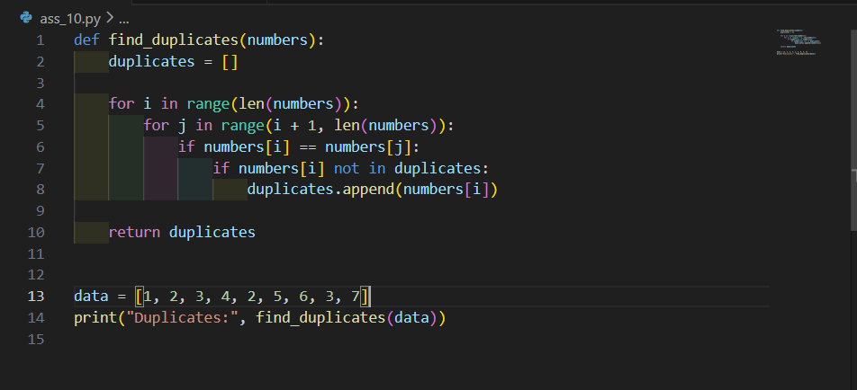

Efficient code:
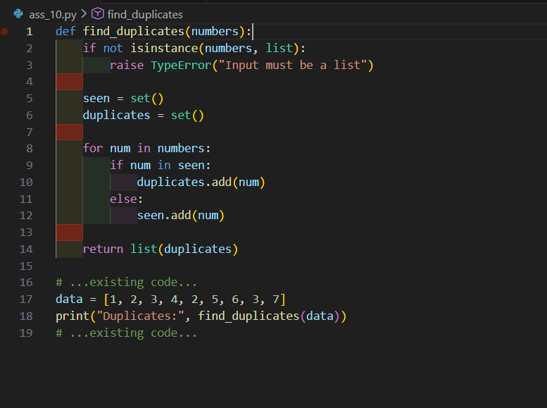
Output:

AI Review :
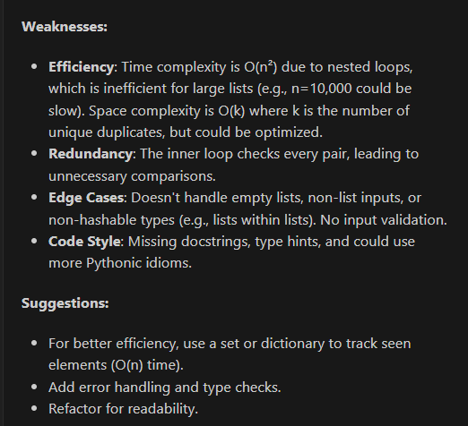
Task 3: Readability and Maintainability Refactoring
Scenario
A working script exists in a project, but it is difficult to understand due to poor naming, formatting, and structure. The team wants it rewritten for long-term maintainability.
Task Description
You are given a poorly structured Python function with:
• Cryptic function names
• Poor indentation
• Unclear variable naming
• No documentation
Use AI-assisted review to:
• Refactor the code for clarity
• Apply PEP 8 formatting standards
• Improve naming conventions
• Add meaningful documentation
Expected Outcome
• Clean, well-structured code
• Descriptive function and variable names
• Proper indentation and formatting
• Docstrings explaining the function purpose
• AI explanation of readability improvements
Poorly structured code:
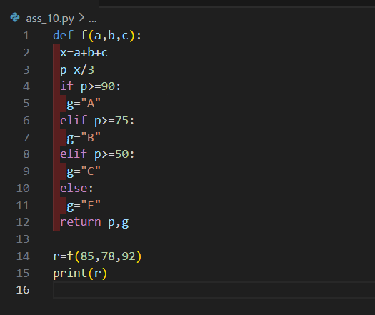

Refactored code:
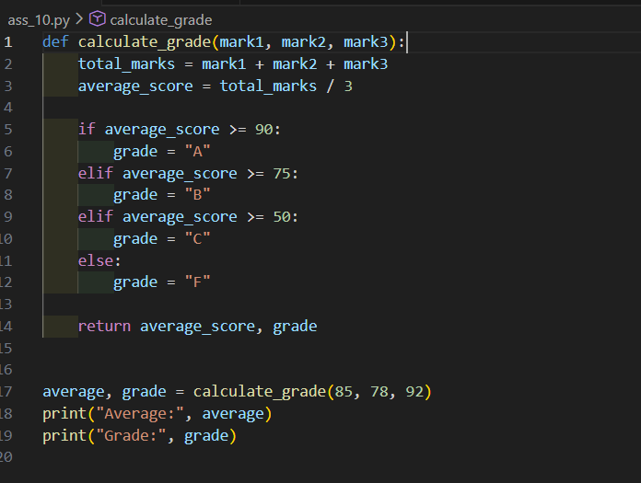

Output:
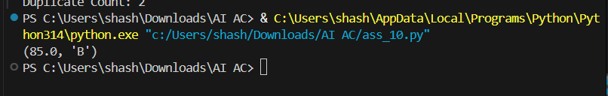

AI Review:
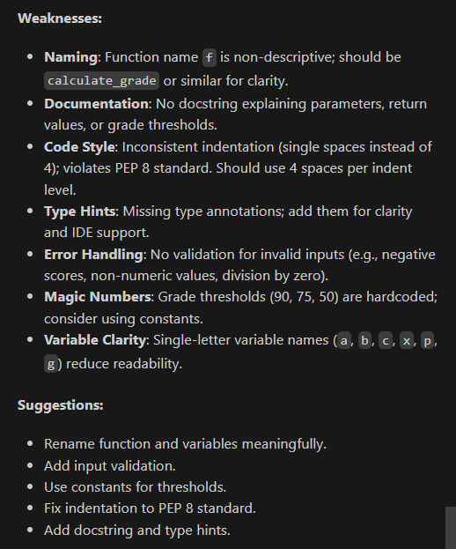
Task 4: Secure Coding and Reliability Review
Scenario
A backend function retrieves user data from a database but has security vulnerabilities and poor error handling, making it unsafe for production deployment.
Task Description
You are given a Python script that:
• Uses unsafe SQL query construction
• Has no input validation
• Lacks exception handling
Use AI tools to:
• Identify security vulnerabilities
• Refactor the code using safe coding practices
• Add proper exception handling
• Improve robustness and reliability
Expected Outcome
• Secure SQL queries using parameterized statements
• Input validation logic
• Try-except blocks for runtime safety
• AI-generated explanation of security improvements
• Production-ready code structure
Unsafe code:
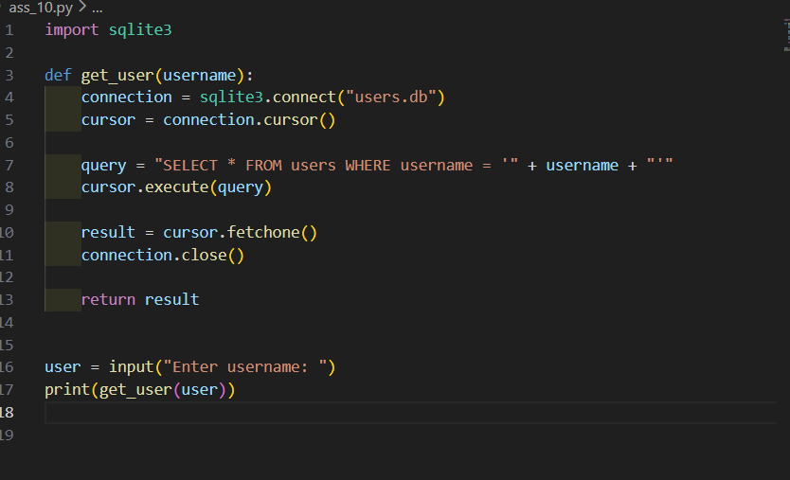

Secure code:
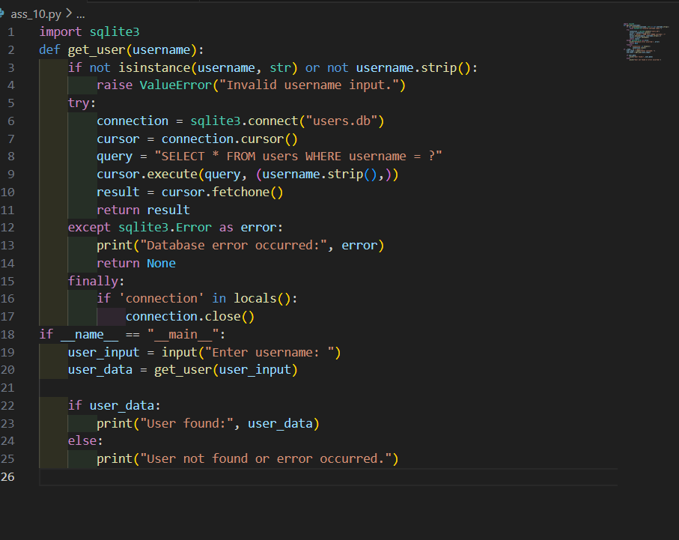
Output:
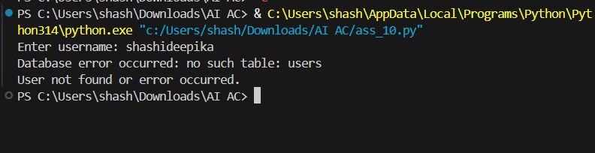

AI Review:
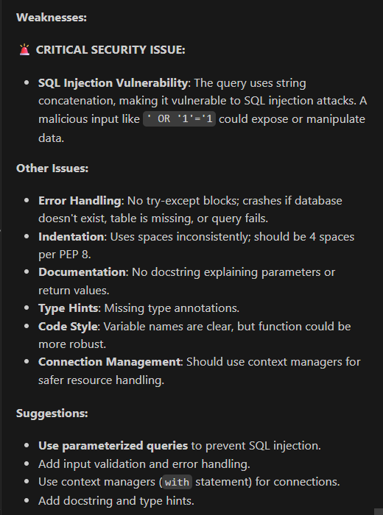
Task 5: AI-Based Automated Code Review Report
Scenario
Your team uses AI tools to perform automated preliminary code reviews before human review, to improve code quality and consistency across projects.
Task Description
You are provided with a poorly written Python script.
Using AI-assisted review:
• Generate a structured code review report that evaluates:
o Code readability
o Naming conventions
o Formatting and style consistency
o Error handling
o Documentation quality
o Maintainability
The task is not just to fix the code, but to analyze and report on quality issues.
Expected Outcome
• AI-generated review report including:
o Identified quality issues
o Risk areas
o Code smell detection
o Improvement suggestions
• Optional improved version of the code
• Demonstration of AI as a code reviewer, not just a code generator
Poorly Written Data Processing Script
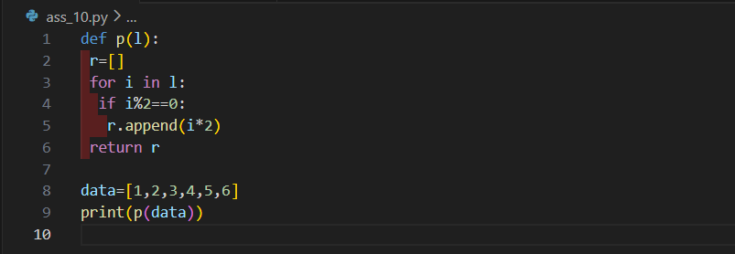

Optional Improved Version
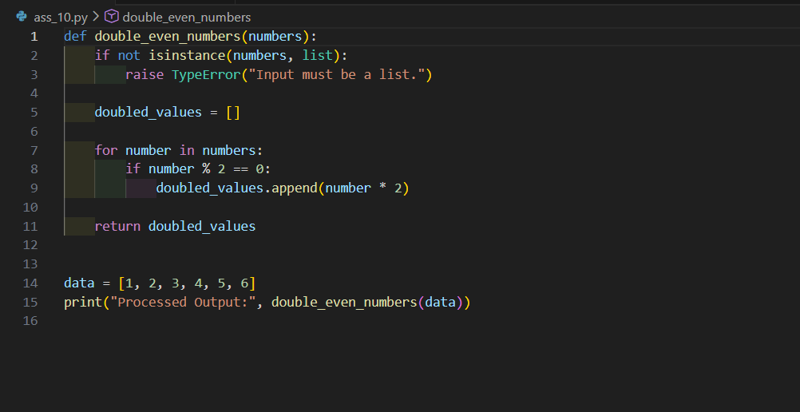
Output:
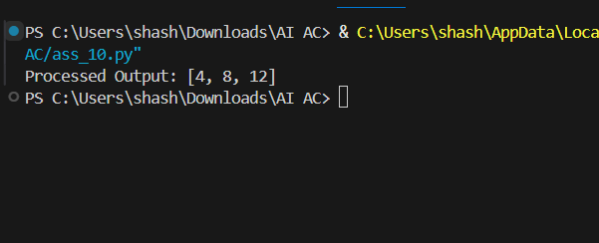

AI Review:
