Question 1: Zero-Shot Prompting (Palindrome Number Program)
Write a zero-shot prompt (without providing any examples) to generate a Python function that checks whether a given number is a palindrome.
Zero-shot prompt
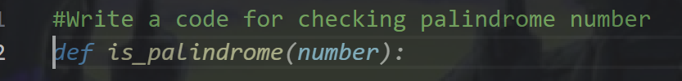
Code:
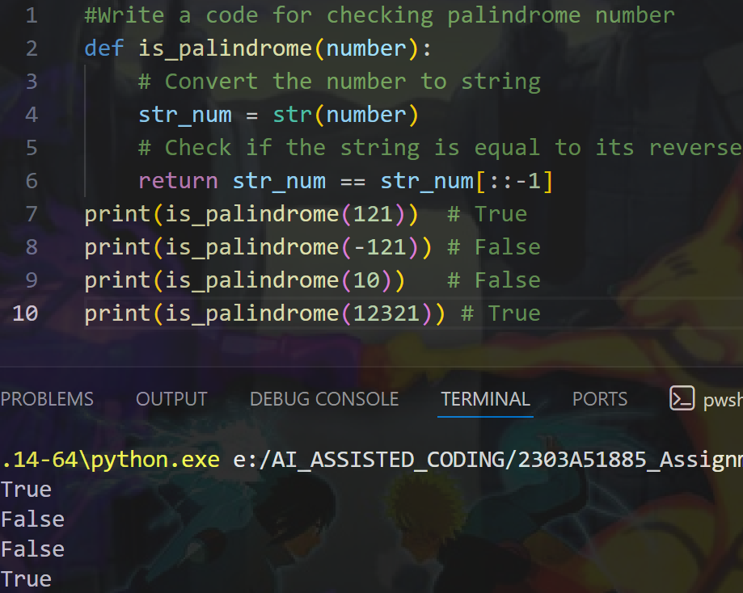
Improvements or edge cases:
So for the above code the edges cases or like it is not handling any strings or float values so when we give a string or float number we have to return enter a valid number only. This is the edge case that is missing in the code.

Question 2: One-Shot Prompting (Factorial Calculation)
Write a one-shot prompt by providing one input-output example and ask the AI to generate a Python function to compute the factorial of a given number.
Example:
Input: 5 → Output: 120
One-shot prompt
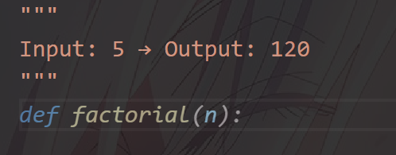
Code:
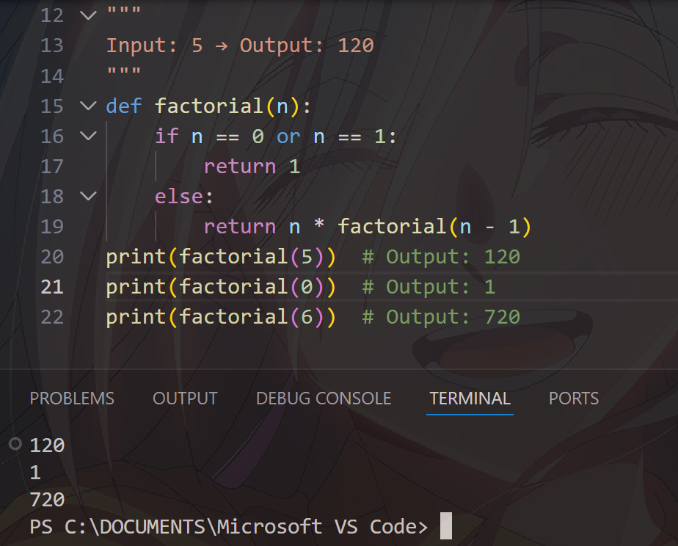

Question 3: Few-Shot Prompting (Armstrong Number Check)
Write a few-shot prompt by providing multiple input-output examples to guide the AI in generating a Python function to check whether a given number is an Armstrong number.
Examples:
- Input: 153 → Output: Armstrong Number
- Input: 370 → Output: Armstrong Number
- Input: 123 → Output: Not an Armstrong Number
Few-Shot Prompt:
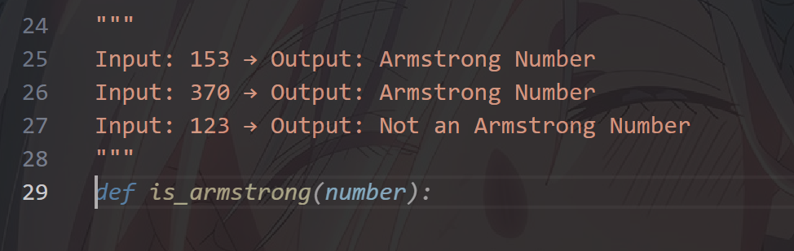
Code:
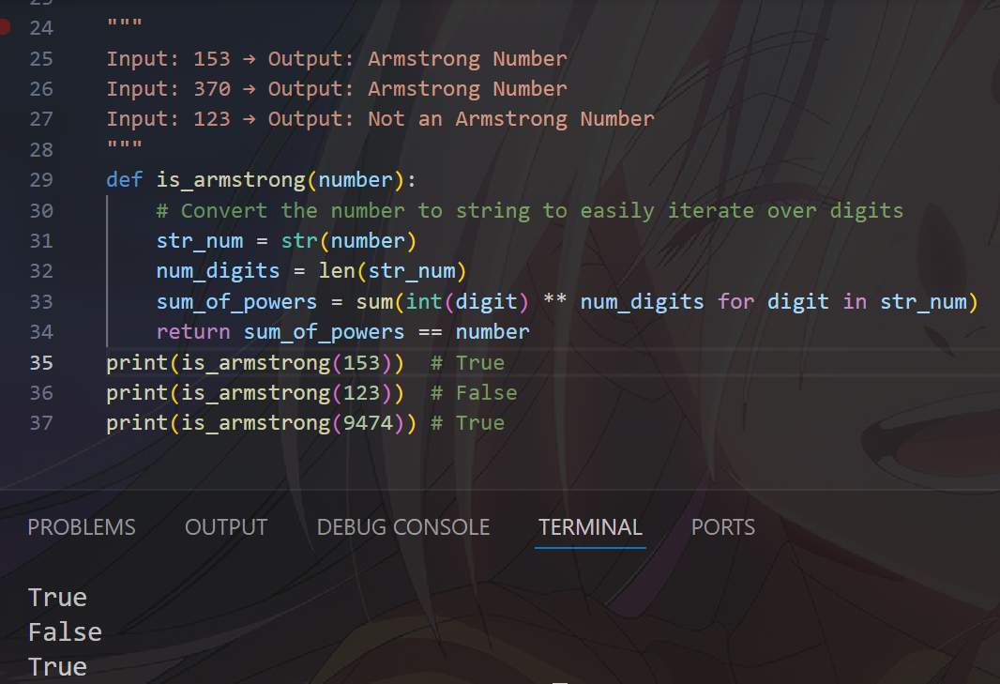
(Optional Extension)
Question 4: Context-Managed Prompting (Optimized Number Classification)
Design a context-managed prompt with clear instructions and constraints to generate an optimized Python program that classifies a number as prime, composite, or neither.
Multi- Shot prompt:
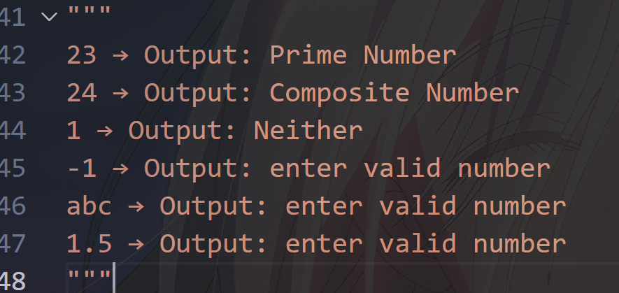
Code
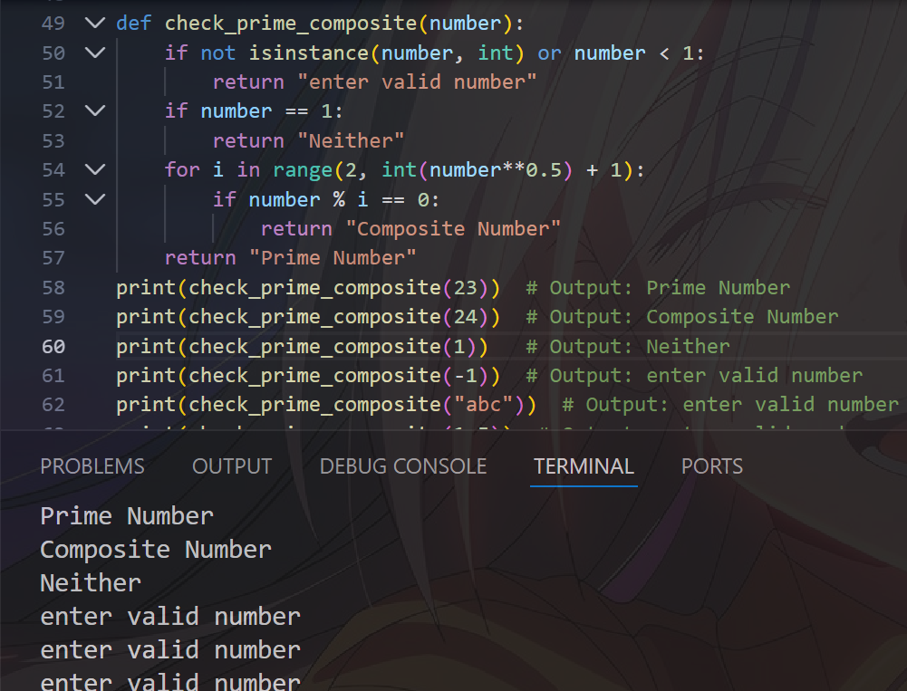
Using Multi-Shot prompt
Multi-Short prompting is a technique where we give multiple examples as a prompt by which we observes the keywords and trends in the values and the AI helps us in coding it. So Multi Shot helps us in the code

Question 5: Zero-Shot Prompting (Perfect Number Check)
Write a zero-shot prompt (without providing any examples) to generate a Python function that checks whether a given number is a perfect number.
Zero-Shot Prompt
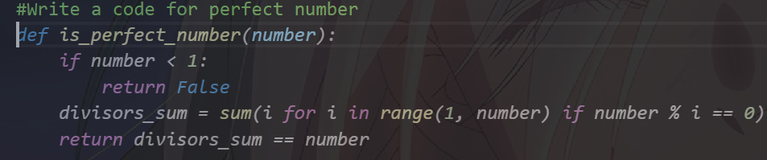
Code:
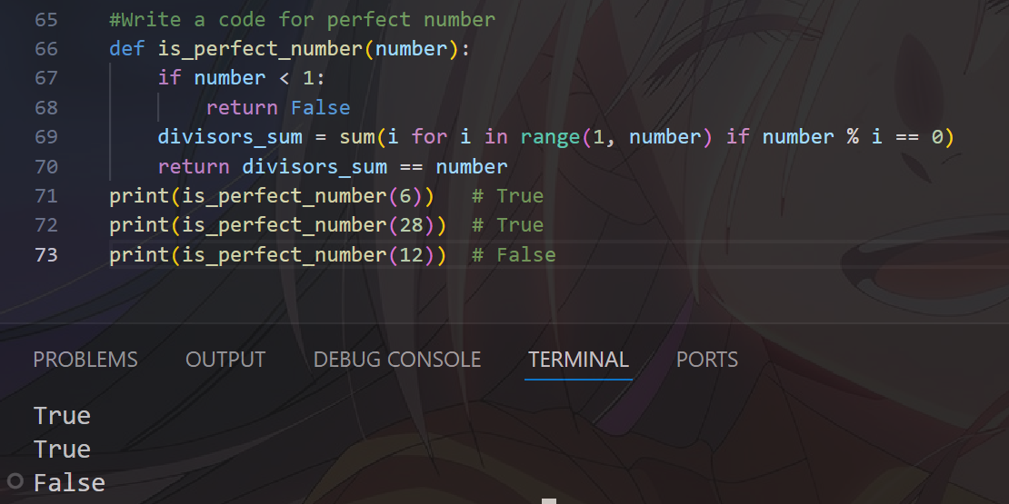

Improvements:
It is missing the negative inputs case and float input case and strings case

Question 6: Few-Shot Prompting (Even or Odd Classification with Validation)
Write a few-shot prompt by providing multiple input-output examples to guide the AI in generating a Python program that determines whether a given number is even or odd, including proper input validation.
Examples:
- Input: 8 → Output: Even
- Input: 15 → Output: Odd
- Input: 0 → Output: Even
Few-Shot Prompting
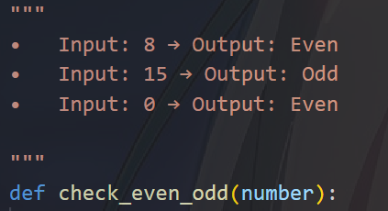
Code:
