Assignment - 6.1
2303a510j2
Batch -17
Vishnu Morthala

Task1 : Use an AI code completion tool to generate a loop-based
program.
Prompt : # generate code to print even numbers from 0 to n using loop
Code :
n = int(input("Enter a number: "))
for i in range(0, n + 1, 2):
print(i)
output :
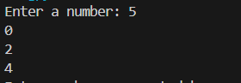

TASK – 2: Use an AI code completion tool to combine loops and
conditionals.
CODE :
numbers = list(map(int, input("Enter numbers separated by spaces: ").split()))
even_count = 0
odd_count = 0
for number in numbers:
if number % 2 == 0:
even_count += 1
else:
odd_count += 1
print(f"Even numbers count: {even_count}")
print(f"Odd numbers count: {odd_count}")

OUTPUT :
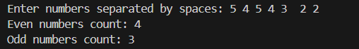

TASK – 3 : Use an AI tool to complete a Python class that validates user
input.
PROMPT : #Generate a Python class User that validates age and email using CONDITIONAL STATEMENTS by user input
CODE : import re
class User:
def __init__(self, age, email):
self.age = age
self.email = email
self.validate_age()
self.validate_email()

def validate_age(self):
if self.age < 0 or self.age > 120:
raise ValueError("Age must be between 0 and 120.")
else:
print("Age is valid.")

def validate_email(self):
email_pattern = r'^[a-zA-Z0-9._%+-]+@[a-zA-Z0-9.-]+\.[a-zA-Z]{2,}$'
if not re.match(email_pattern, self.email):

raise ValueError("Invalid email format.")
else:
print("Email is valid.")
age = int(input("Enter your age: "))
email = input("Enter your email: ")
user = User(age, email)

OUTPUT :

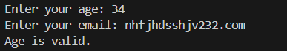

TASK- 4 : Use an AI code completion tool to generate a Python class for
managing student details.

PROMPT : # Generate a Python class Student with attributes (name, roll number,marks) and methods to calculate total and average marks.

CODE :
class Student:
def __init__(self, name, roll_number, marks):
self.name = name
self.roll_number = roll_number
self.marks = marks

def calculate_total(self):
return sum(self.marks)

def calculate_average(self):
return sum(self.marks) / len(self.marks)
name = input("Enter student name: ")
roll_number = input("Enter roll number: ")
marks = list(map(int, input("Enter marks separated by spaces: ").split()))
student = Student(name, roll_number, marks)
total_marks = student.calculate_total()
average_marks = student.calculate_average()
print(f"Total Marks: {total_marks}")
print(f"Average Marks: {average_marks}")

OUTPUT :
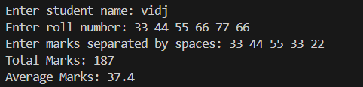

TASK-5 : Use an AI tool to generate a complete Python program using
classes, loops, and conditionals together

PROMPT : #Generate a Python program for a simple bank account system using class, loops, and conditional statements.

CODE :
class BankAccount:
def __init__(self, account_holder, balance=0):
self.account_holder = account_holder
self.balance = balance

def deposit(self, amount):
if amount > 0:
self.balance += amount
print(f"Deposited: {amount}. New balance: {self.balance}")
else:
print("Deposit amount must be positive.")

def withdraw(self, amount):
if amount > 0:
if amount <= self.balance:
self.balance -= amount
print(f"Withdrew: {amount}. New balance: {self.balance}")
else:
print("Insufficient funds.")
else:
print("Withdrawal amount must be positive.")

def display_balance(self):
print(f"Account Holder: {self.account_holder}, Balance: {self.balance}")
account_holder = input("Enter account holder name: ")
account = BankAccount(account_holder)
while True:
print("\nOptions: 1. Deposit 2. Withdraw 3. Display Balance 4. Exit")
choice = input("Choose an option (1-4): ")
if choice == '1':
amount = float(input("Enter amount to deposit: "))
account.deposit(amount)
elif choice == '2':
amount = float(input("Enter amount to withdraw: "))
account.withdraw(amount)
elif choice == '3':
account.display_balance()
elif choice == '4':
print("Exiting...")
break
else:
print("Invalid choice. Please try again.")
OUTPUT ;
