Assignment - 6.3
2303a51894
Batch -17
JADALA TEJA YADAV

TASK-1 : TO print student details includes roll no, name ,branch
Prompt: # generate a code that prints student information in a class by user-inputs includes roll number name branch and display
Code :
class Student:
def __init__(self, roll_number, name, branch):
self.roll_number = roll_number
self.name = name
self.branch = branch

def display_info(self):
print(f"Student Information:")
print(f"Roll Number: {self.roll_number}")
print(f"Name: {self.name}")
print(f"Branch: {self.branch}")
def main():
roll_number = input("Enter Roll Number: ")
name = input("Enter Name: ")
branch = input("Enter Branch: ")

student = Student(roll_number, name, branch)
student.display_info()
if __name__ == "__main__":
main(

output :
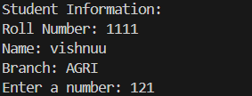

Task-2 : To print first ten multiples of user input number
Prompt: #generate a code that prints first ten multiples of a user-input number
Code :
def print_multiples():
number = int(input("Enter a number: "))
print(f"First ten multiples of {number}:")
for i in range(1, 11):
print(number * i)
print_multiples()

Output:
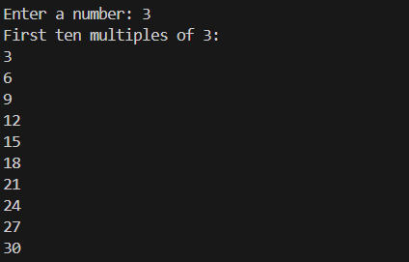

Task-3 : print that classifies age groups using if-elif-else conditional statements to classify age groups as chils d, teenager, adult, senior
Prompt: #generate a code that classifies age groups using if-elif-else conditional statements to classify age groups as chils d, teenager, adult, senior

Code:
def classify_age():
age = int(input("Enter your age: "))
if age < 13:
print("You are a child.")
elif 13 <= age < 20:
print("You are a teenager.")
elif 20 <= age < 60:
print("You are an adult.")
else:
print("You are a senior.")
classify_age()
output :


Task -4 : You need to calculate the sum of the first n natural numbers. Using for loop
Prompt : generate a code to calculate the sum of the first n natural numbers Using for-loop

Code :
def sum_of_natural_numbers():
n = int(input("Enter a positive integer: "))
total_sum = 0
for i in range(1, n + 1):
total_sum += i
print(f"The sum of the first {n} natural numbers is: {total_sum}")
sum_of_natural_numbers()
output :
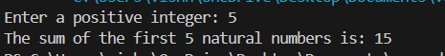

Task-5 :
Prompt : generate a code of bank acount class with deposit withdraw and display balance methods
Code :
class BankAccount:
def __init__(self, account_holder, balance=0):
self.account_holder = account_holder
self.balance = balance

def deposit(self, amount):
if amount > 0:
self.balance += amount
print(f"Deposited: {amount}. New balance: {self.balance}")
else:
print("Deposit amount must be positive.")

def withdraw(self, amount):
if 0 < amount <= self.balance:
self.balance -= amount
print(f"Withdrew: {amount}. New balance: {self.balance}")
else:
print("Insufficient balance or invalid withdrawal amount.")

def display_balance(self):
print(f"Account Holder: {self.account_holder}, Balance: {self.balance}")
def main():
account_holder = input("Enter account holder name: ")
account = BankAccount(account_holder)

while True:
print("\nOptions: 1. Deposit 2. Withdraw 3. Display Balance 4. Exit")
choice = input("Choose an option: ")

if choice == '1':
amount = float(input("Enter amount to deposit: "))
account.deposit(amount)
elif choice == '2':
amount = float(input("Enter amount to withdraw: "))
account.withdraw(amount)
elif choice == '3':
account.display_balance()
elif choice == '4':
print("Exiting...")
break
else:
print("Invalid option. Please try again.")
if __name__ == "__main__":
main()
output : 