AI & AC
ASSIGNMENT-13.1
HT NO.:2303A51644
BATCH:28

Task Description #1 :(Refactoring – Removing Code Duplication)
- Task: Use AI to refactor a given Python script that contains multiple repeated code blocks.
- Instructions:
- Prompt AI to identify duplicate logic and replace it with functions or classes.
- Ensure the refactored code maintains the same output.
- Add docstrings to all functions.
- Sample Legacy Code:
# Legacy script with repeated logic print("Area of Rectangle:", 5 * 10)
print("Perimeter of Rectangle:", 2 * (5 + 10))
print("Area of Rectangle:", 7 * 12)
print("Perimeter of Rectangle:", 2 * (7 + 12))
print("Area of Rectangle:", 10 * 15)
print("Perimeter of Rectangle:", 2 * (10 + 15))
PROMPT:
Refactor the python code to identify duplicate logic and replace it with functions or classes.
PYTHON CODE:
REFACTORED CODE:

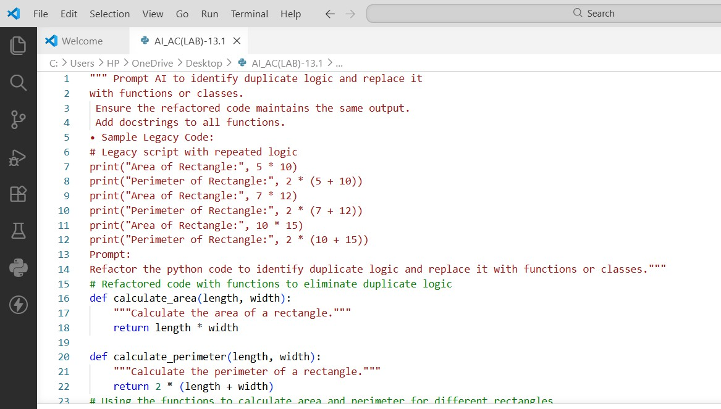
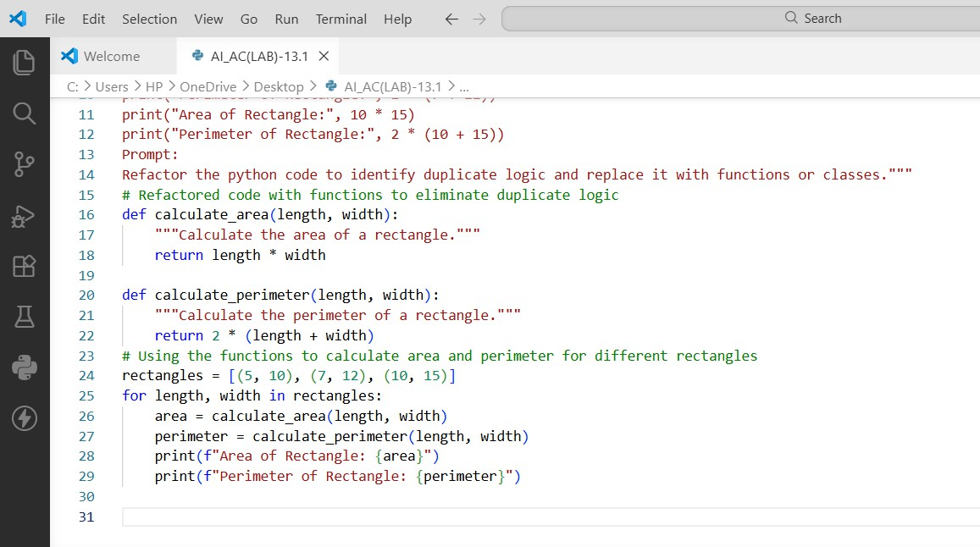
OUTPUT:
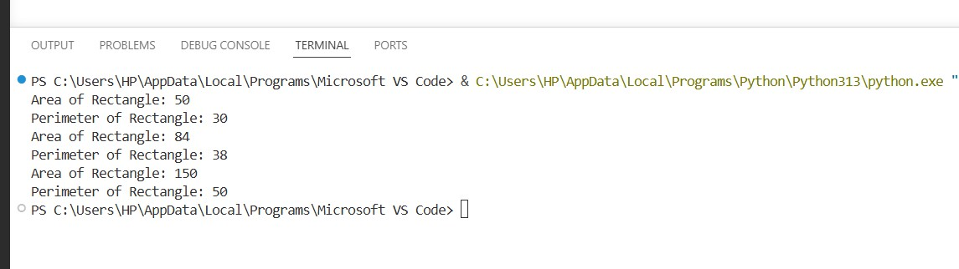

JUSTIFICATION:
- The original code repeated rectangle calculations multiple times.
- This duplication makes the program longer and harder to maintain.
- A reusable function rectangle_details() removes repeated logic.
- The function improves readability and modularity.
- The same function can be reused for different rectangle values.

Task Description #2: (Refactoring – Optimizing Loops and Conditionals)
- Task: Use AI to analyze a Python script with nested loops and complex conditionals.
- Instructions:
- Ask AI to suggest algorithmic improvements (e.g., replace nested loops with set lookups or
comprehensions).
- Implement changes while keeping logic intact.
- Compare execution time before and after refactoring.
- Sample Legacy Code:
# Legacy inefficient code
names = ["Alice", "Bob", "Charlie", "David"] search_names = ["Charlie", "Eve", "Bob"] for s in search_names:
found = False for n in names:
if s == n:
found = True if found:
print(f"{s} is in the list") else:
print(f"{s} is not in the list")
PROMPT:
Refactor the code in python to suggest algorithmic improvements (e.g., replace nested loops with set lookups or comprehensions).
PYTHON CODE:

REFACTORED CODE:
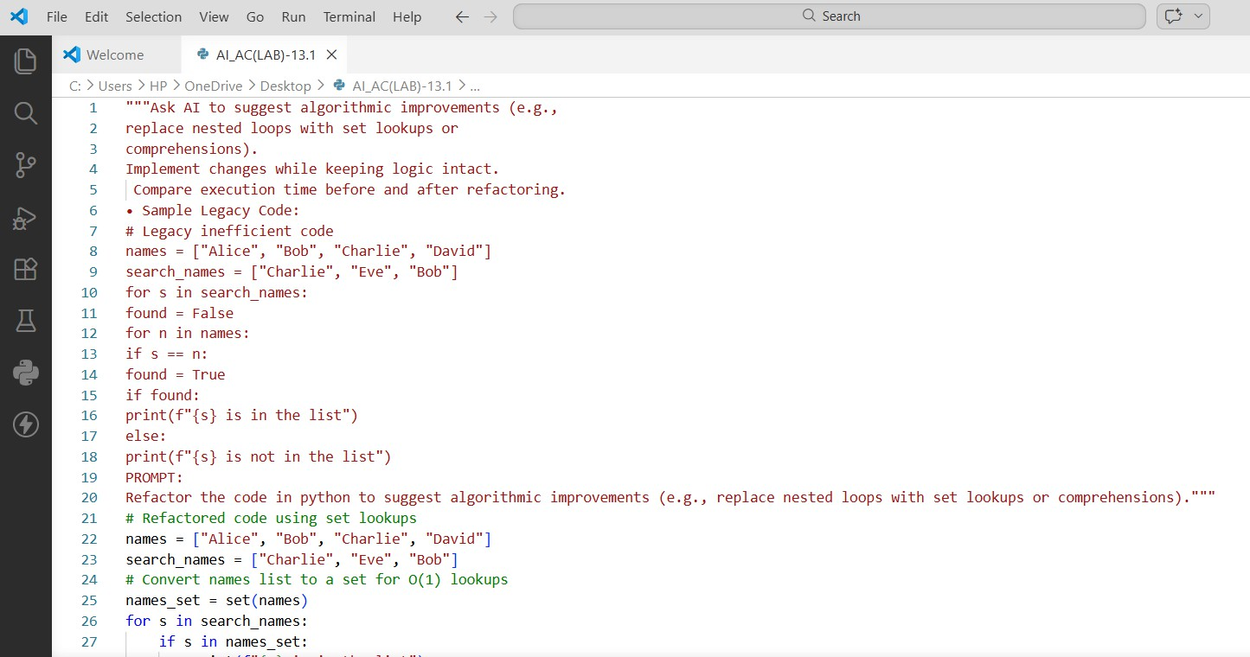
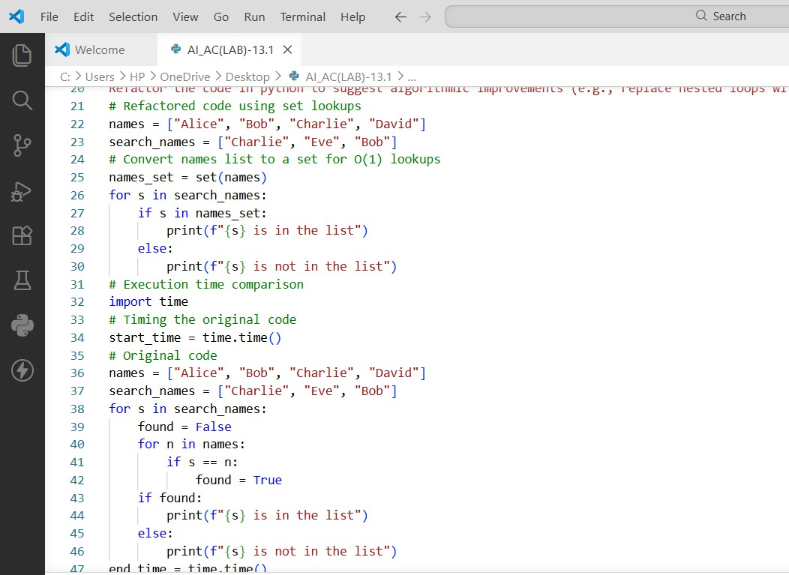

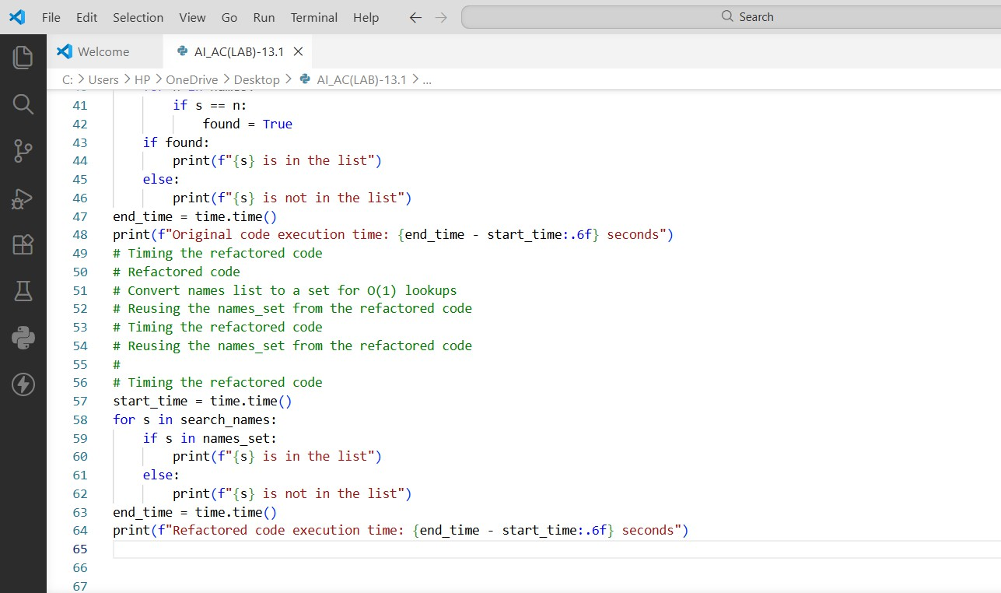
OUTPUT:
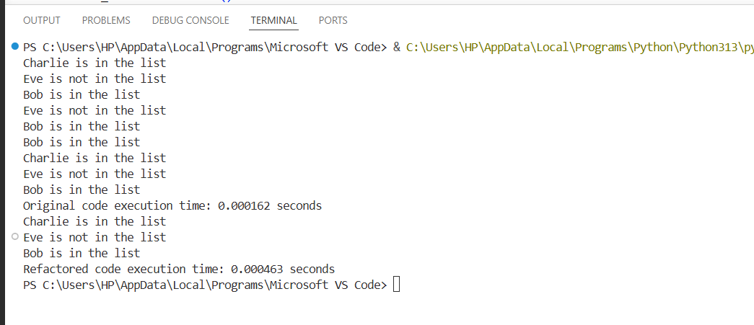
JUSTIFICATION:
- The legacy code used nested loops to search for names.
- Nested loops increase time complexity and reduce efficiency.
- Converting the list into a set enables faster membership checks.
- Set lookup works in constant time and improves performance.
- The refactored code is shorter, clearer, and more efficient.

Task Description #3: (Refactoring – Extracting Reusable Functions)
- Task: Use AI to refactor a legacy script where multiple calculations are embedded directly inside the main code block.
- Instructions:
- Identify repeated or related logic and extract it into reusable functions.
- Ensure the refactored code is modular, easy to read, and documented with docstrings.
- Sample Legacy Code:
# Legacy script with inline repeated logic price = 250
tax = price * 0.18 total = price + tax
print("Total Price:", total) price = 500
tax = price * 0.18 total = price + tax
print("Total Price:", total)
PROMPT:
Refactor the python code with a function calculate_total(price) that can be reused for multiple price inputs.
PYTHON CODE:
REFACTORED CODE:

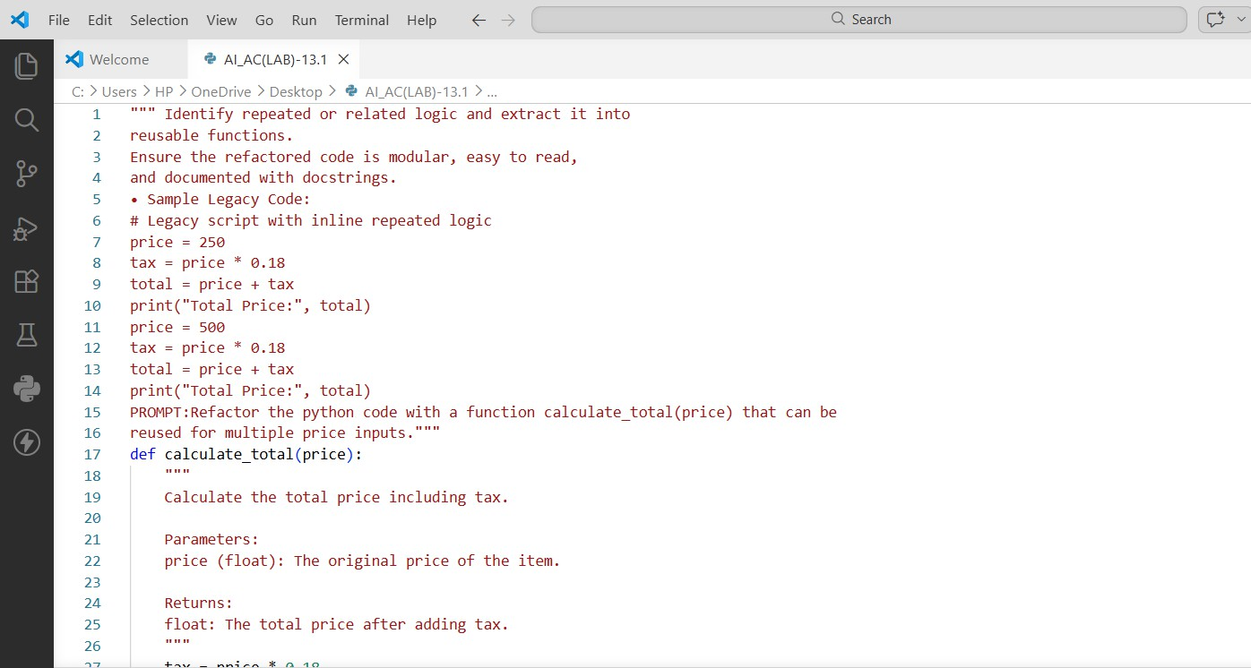
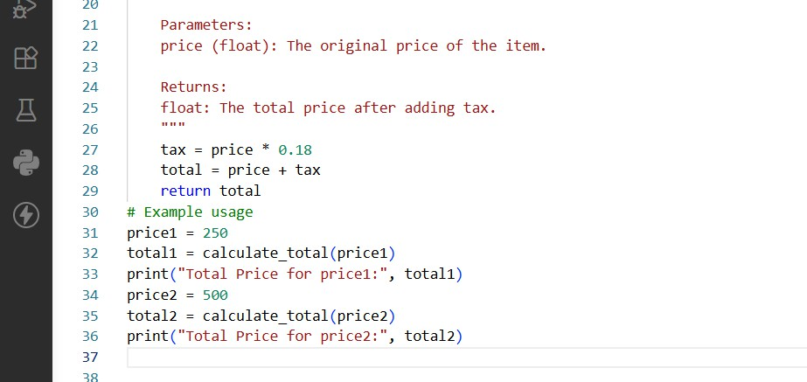
OUTPUT:
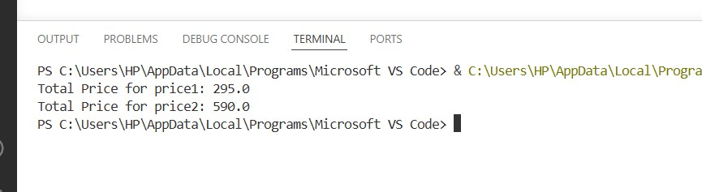
JUSTIFICATION:
- The legacy script repeated the tax calculation multiple times.

- Repeated code reduces maintainability and readability.
- Creating the function calculate_total(price) centralizes the logic.
- The function can be reused for multiple price values.
- This improves modularity and makes updates easier.

Task Description #4: (Refactoring – Replacing Hardcoded Values with Constants)
- Task: Use AI to identify and replace all hardcoded “magic numbers” in the code with named constants.
- Instructions:
- Create constants at the top of the file.
- Replace all hardcoded occurrences in calculations with these constants.
- Ensure the code remains functional and is easier to maintain.
- Sample Legacy Code:
# Legacy script with hardcoded values print("Area of Circle:", 3.14159 * (7 ** 2))
print("Circumference of Circle:", 2 * 3.14159 * 7)
PROMPT:
Refactor the python code with constants like PI = 3.14159 and RADIUS= 7 used in calculations.
PYTHON CODE:
REFACTORED CODE:

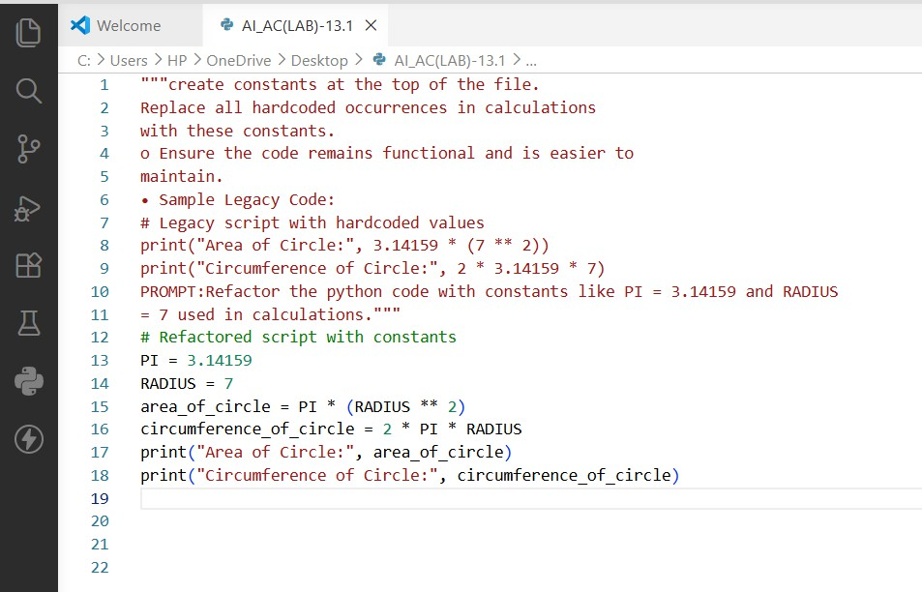
OUTPUT:
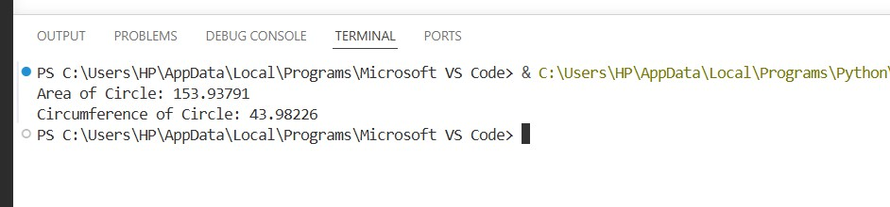
JUSTIFICATION:
- The original program used hardcoded numbers (magic numbers).
- Magic numbers reduce readability and flexibility.
- Defining constants like PI and RADIUS improves clarity.
- Constants allow easy updates if values change later.
- This approach follows good programming practices.

Task Description #5:(Refactoring – Improving Variable Naming and Readability)
- Task: Use AI to improve readability by renaming unclear variables and adding inline comments.

- Instructions:
- Replace vague names with meaningful ones.
- Add comments where logic is not obvious.
- Keep functionality exactly the same.
- Sample Legacy Code:
# Legacy script with poor variable names
a = 10
b = 20
c = a * b / 2 print(c)
PROMPT:
Refactor the code with descriptive variable names like base, height, area_of_triangle, plus explanatory comments.
PYTHON CODE:
REFACTORED CODE:
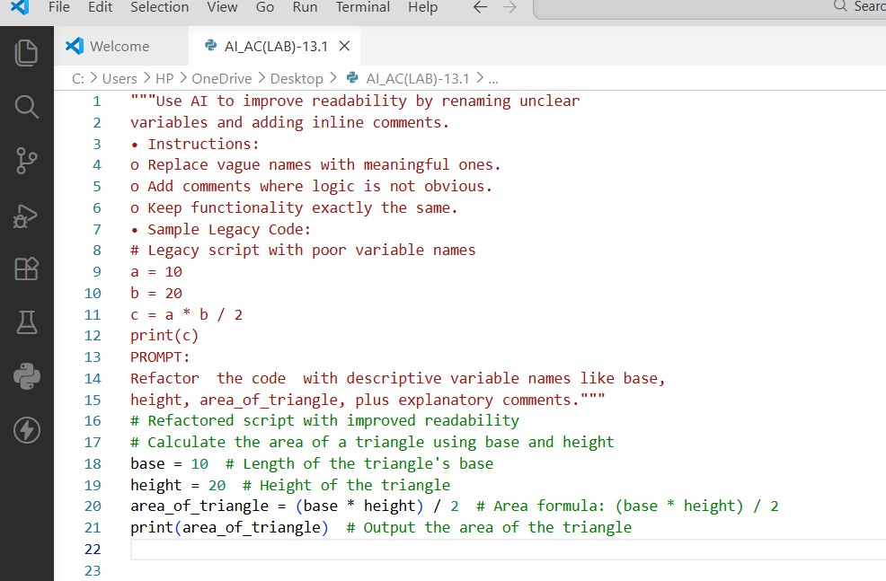
OUTPUT:

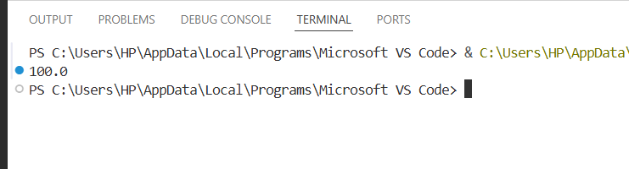
JUSTIFICATION:
- Variables a, b, and c were unclear and not descriptive.
- Meaningful names like base, height, and area_of_triangle improve clarity.
- Clear names help other programmers understand the code easily.
- Adding comments explains the calculation logic.
- This improves readability and maintainability.

Task Description #6 :(Refactoring – Removing Redundant Conditional Logic)
- Task: Use AI to refactor a Python script that contains repeated if–else logic for grading students.
- Instructions:
- Ask AI to identify redundant conditional checks.
- Replace them with a reusable function.
- Ensure grading logic remains unchanged.
- Code:
marks = 85
if marks >= 90: print("Grade A") elif marks >= 75: print("Grade B") else:
print("Grade C") marks = 72
if marks >= 90: print("Grade A") elif marks >= 75: print("Grade B") else:
print("Grade C")

PROMPT:
Refactor the python code with reusable function like calculate_grade(marks) with clean logic and
docstring.
PYTHON CODE:
REFACTORED CODE:
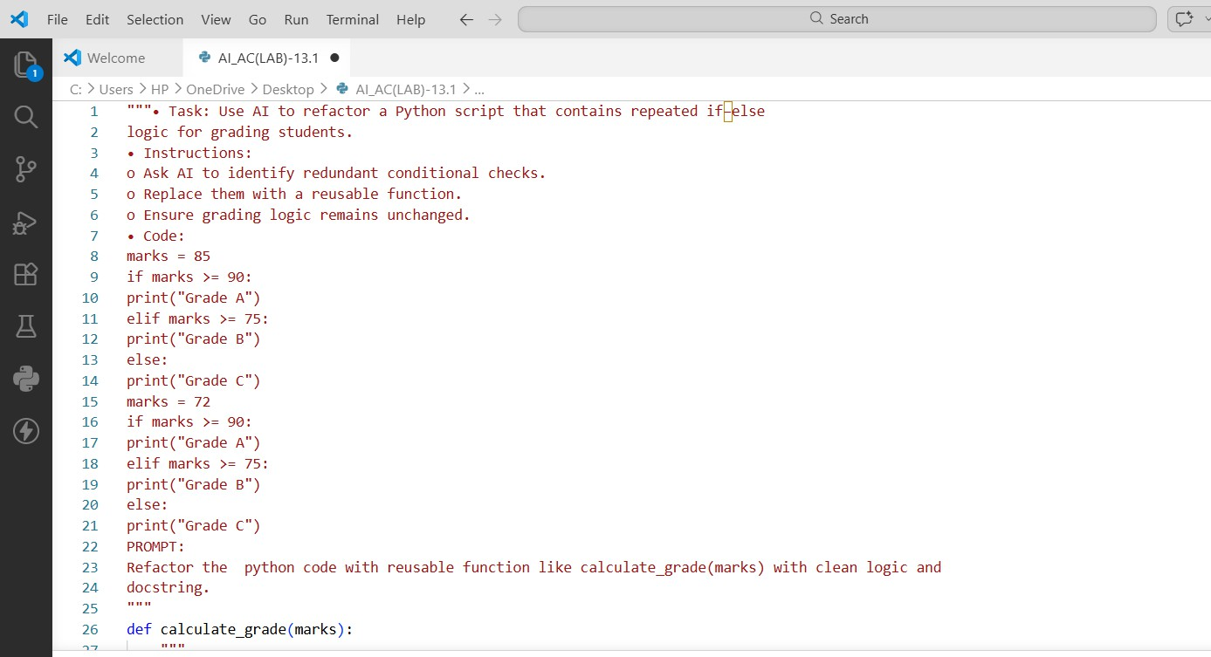
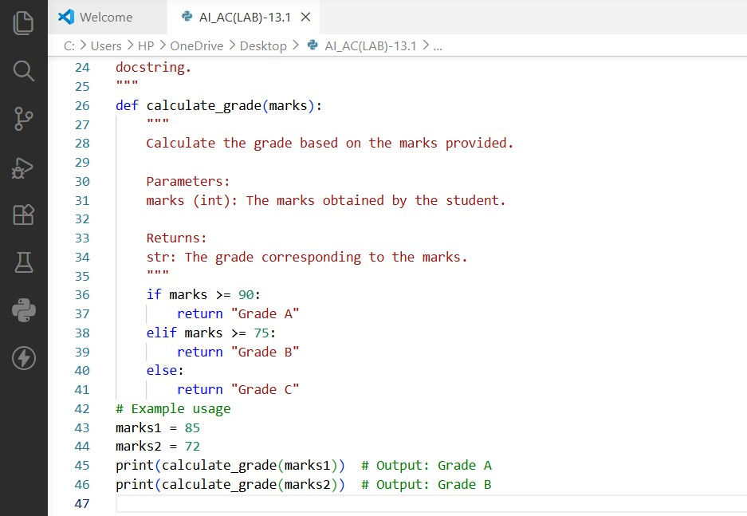

OUTPUT:
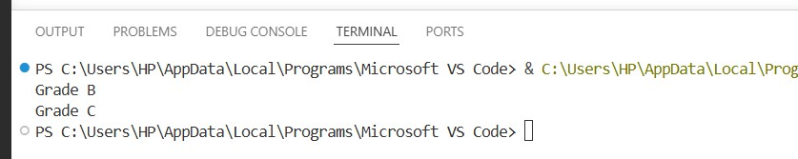
JUSTIFICATION:
- The grading conditions were repeated for multiple marks.
- Repeated conditional blocks increase code duplication.
- Creating a function calculate_grade() removes redundancy.
- The grading logic is written once and reused.
- This improves readability and maintainability.

Task Description #7: (Refactoring – Converting Procedural Code to Functions)
- Task: Use AI to refactor procedural input–processing logic into functions.
- Instructions:
- Identify input, processing, and output sections.
- Convert each into a separate function.
- Improve code readability without changing behavior.
- Sample Legacy Code:
num = int(input("Enter number: ")) square = num * num
print("Square:", square) PROMPT:
Refactor the Modular code using functions like get_input(), calculate_square(), and display_result().
PYTHON CODE:
REFACTORED CODE:

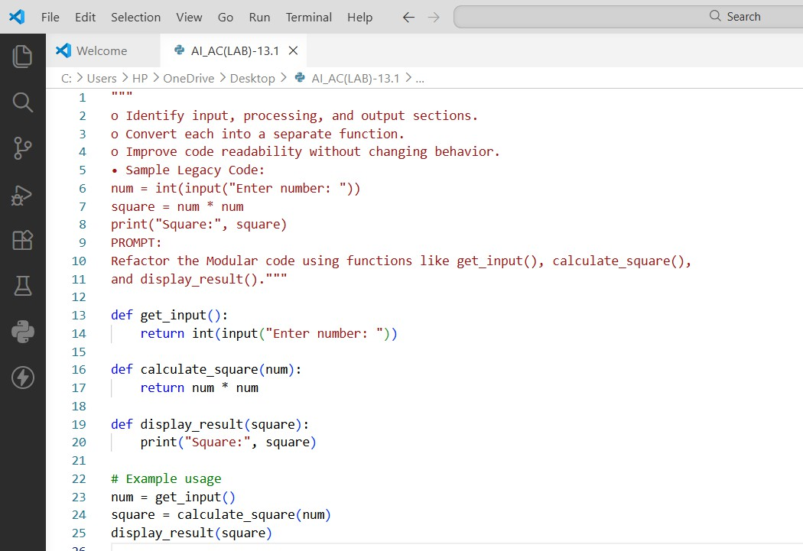
OUTPUT:
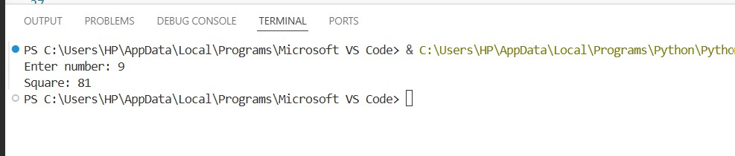
JUSTIFICATION:
- The original code handled input, processing, and output together.
- This makes the code harder to read and reuse.
- Separating logic into functions improves organization.
- Functions make debugging and testing easier.
- The program becomes more modular and readable.

Task Description #8:(Refactoring – Optimizing List Processing)
- Task: Use AI to refactor inefficient list processing logic.
- Instructions:
- Ask AI to replace manual loops with list comprehensions or built-in

functions.
- Ensure output remains identical.
- Sample Legacy Code:
nums = [1, 2, 3, 4, 5]
squares = [] for n in nums:
squares.append(n * n) print(squares)
PROMPT:
Refactor the code and give Optimized version using list comprehension with improved readability
PYTHON CODE:
REFACTORED CODE:

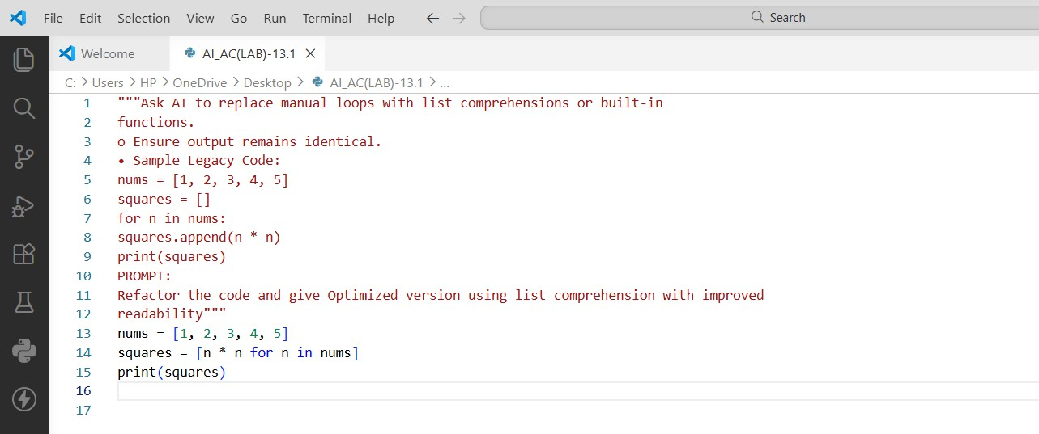
OUTPUT:
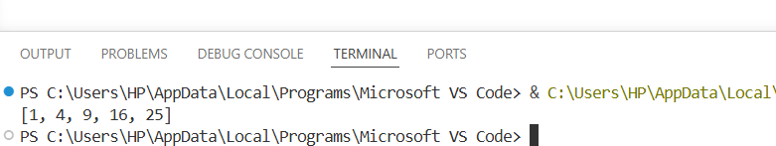

JUSTIFICATION:
- The original code used a manual loop to create a list of squares.

- This approach requires more lines of code.
- List comprehension provides a shorter and clearer solution.
- It improves readability and efficiency.
- List comprehensions are considered a Pythonic way to process lists.

