ASSIGNMENT-11.1
HT NO:2303A51910
Batch No:28
Course :AI Assisted Coding
Task Description 1:Stack Implementation
Task: Use AI to generate a Stack class with push, pop, peek, and is_empty
methods.
Sample Input Code:
class Stack:
pass
Prompt:
Improve the Stack implementation by adding meaningful comments and explaining the time complexity of each method.
Python code: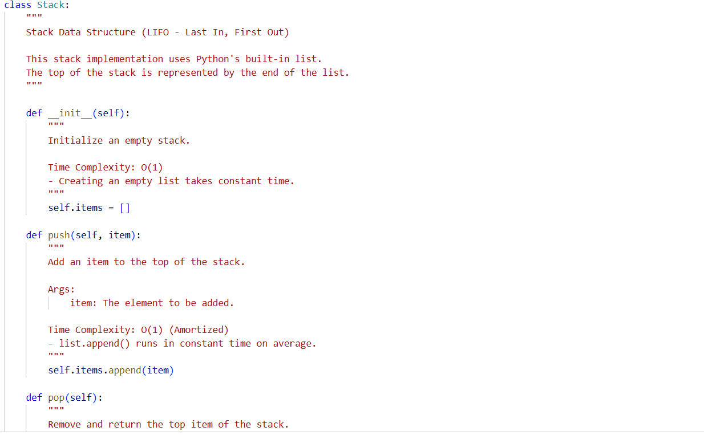
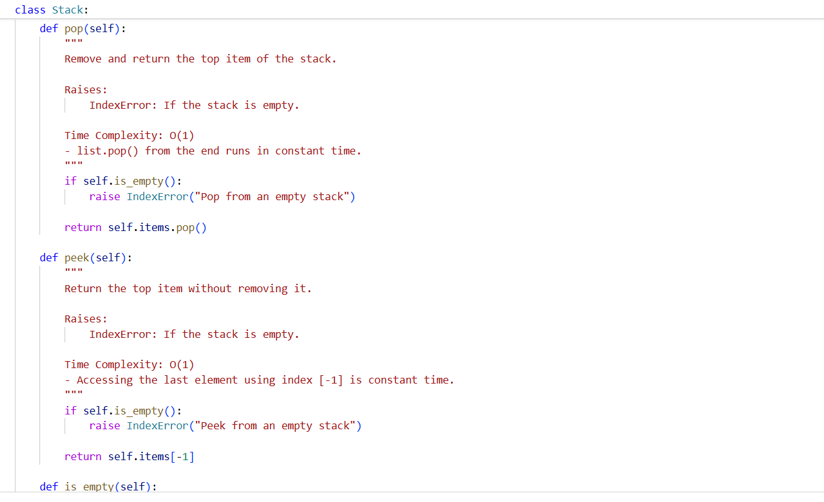
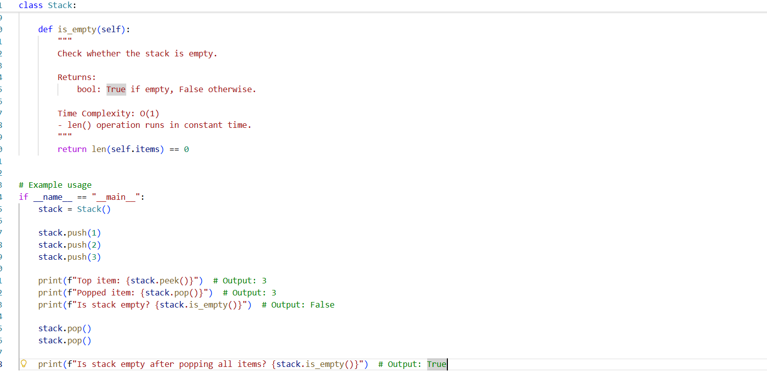
Output:
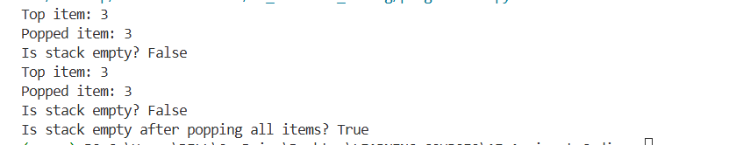
Justification:
1.A Stack follows the LIFO principle — the last element added is removed first.
2.push() adds an element to the top of the stack.
3.pop() removes and returns the top element.
4.peek() returns the top element without removing it.
5.is_empty() checks whether the stack contains any elements.

Task Description 2: Queue Implementation
Task: Use AI to implement a Queue using Python lists.
Sample Input Code:
class Queue:
pass
Prompt:
Suggest a more efficient alternative to list-based queue implementation and explain why it is better.
Python Code:
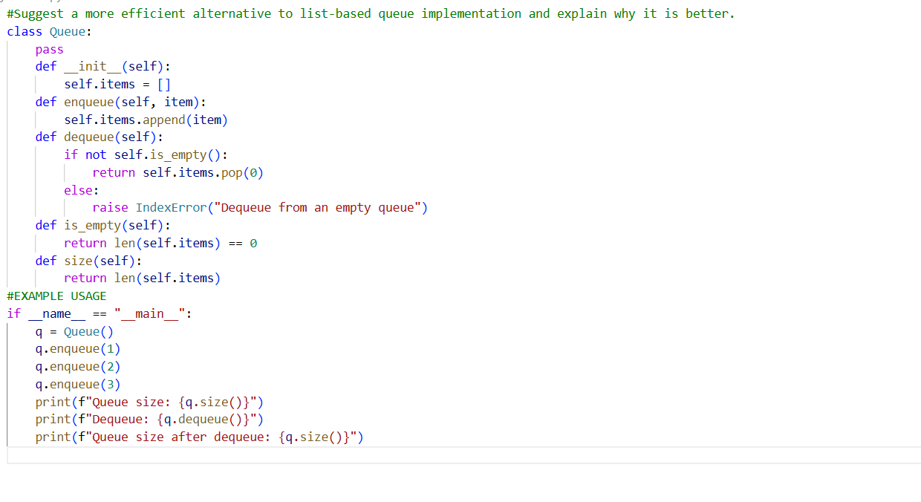
Output:
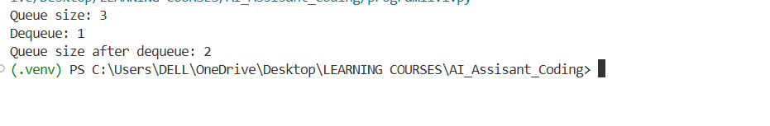
Justification:
1.Queue follows FIFO order — first inserted element is removed first.
2.enqueue() adds elements to the rear of the queue.
3.dequeue() removes elements from the front.
4.peek() returns the front element without removing it.
5.size() returns the total number of elements in the queue.
Task Description 3 : Linked List
Task: Use AI to generate a Singly Linked List with insert and display
methods.
Sample Input Code:
class Node:
pass
Prompt:
Improve the linked list implementation by adding method-level docstrings and explaining time complexity.
Python Code:
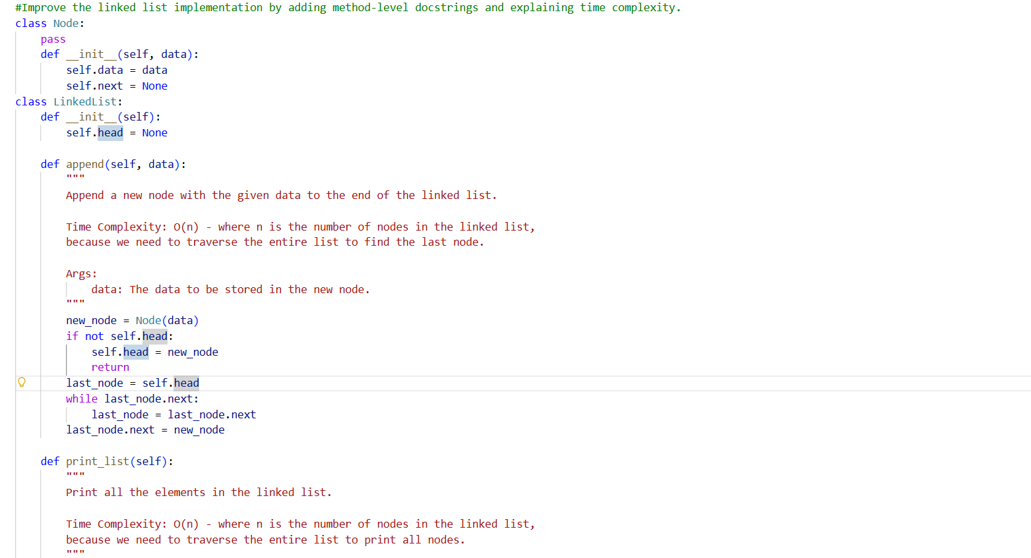
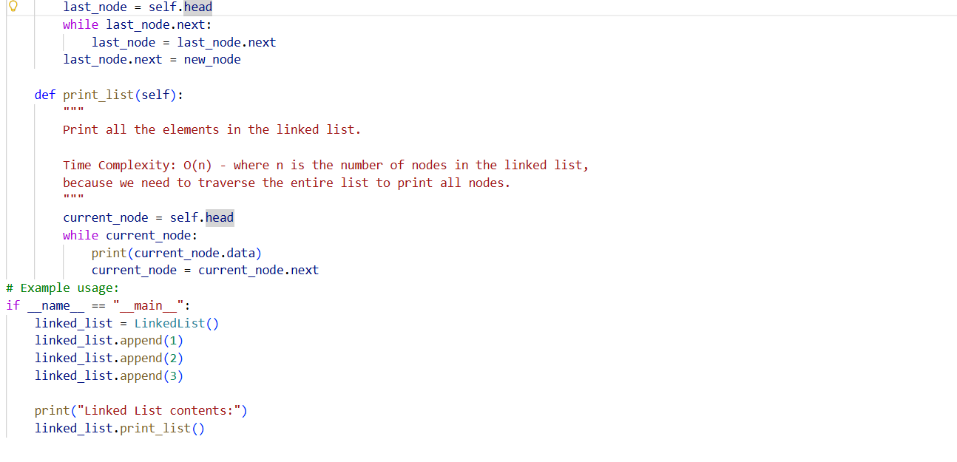
Output:
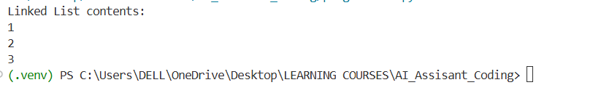
Justification:
1.A singly linked list consists of nodes connected using pointers.
2.Each node contains data and a reference to the next node.
3.insert() adds a new node (typically at the end).
4.display() traverses the list from head to end.
5.Dynamic memory allocation allows flexible size management.
Task Description 4 : Binary Search Tree (BST)
Task: Use AI to create a BST with insert and in-order traversal methods.
Sample Input Code:
class BST:
pass
Prompt:
Create a Binary Search Tree class in Python with recursive insert() and inorder() traversal methods.
Ensure proper object-oriented structure and add docstrings.
Python Code :
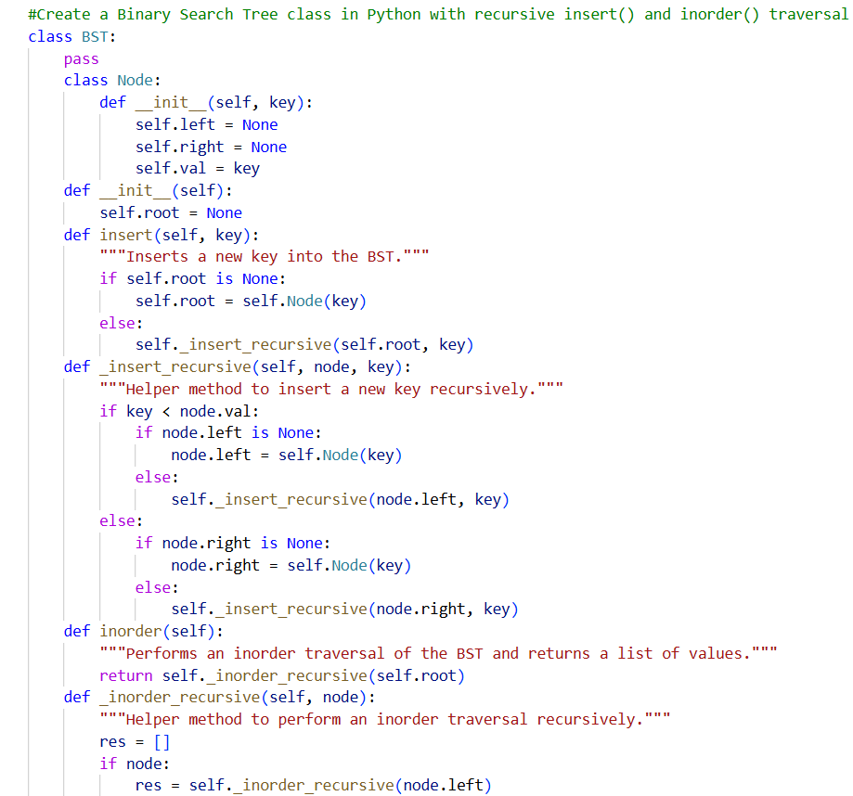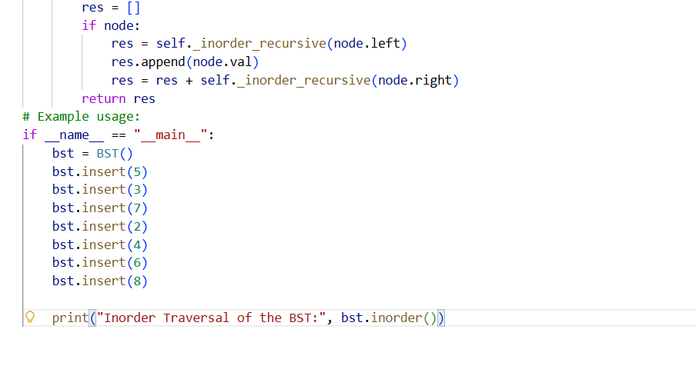
Output:
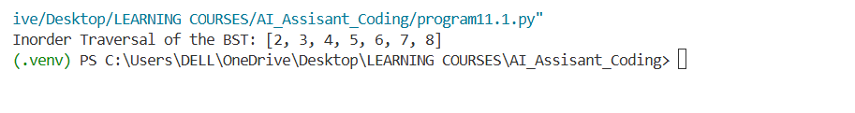
Justification:
1.BST is a hierarchical data structure with left and right children.
2.Left subtree contains values smaller than the root.
3.Right subtree contains values greater than the root.
4.Recursive insert() maintains BST property.
5.In-order traversal prints elements in sorted order.

Task Description 5 : Hash Table
Task: Use AI to implement a hash table with basic insert, search, and
delete methods.
Sample Input Code:
class HashTable:
pass
Prompt:
Implement a Hash Table in Python using chaining for collision handling.
Include methods insert(), search(), and delete().
Use a simple hash function and explain collision handling clearly in comments.
Python Code :
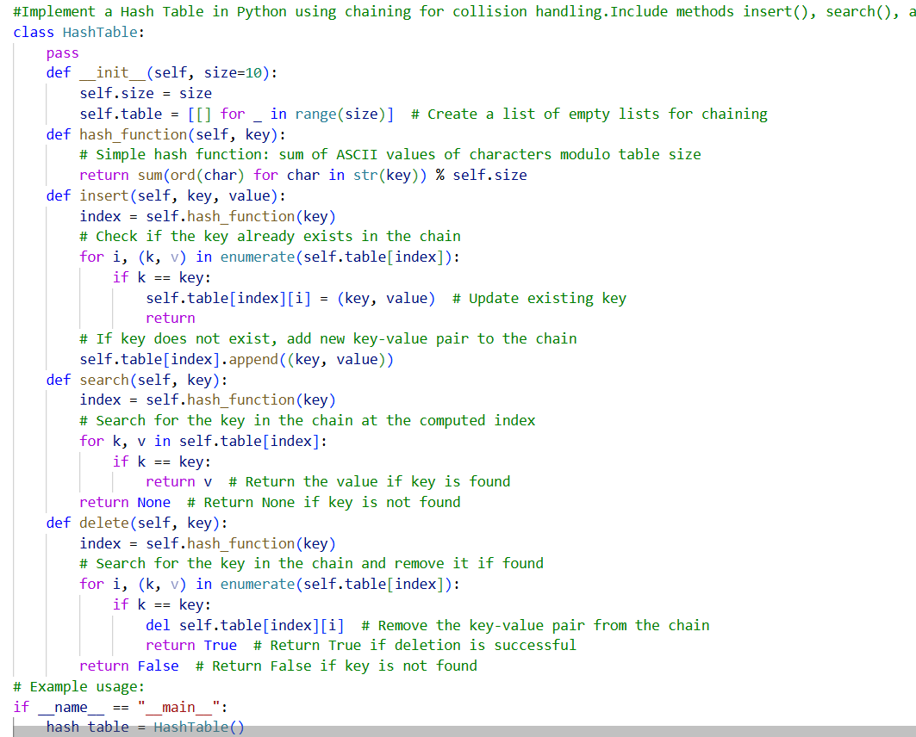
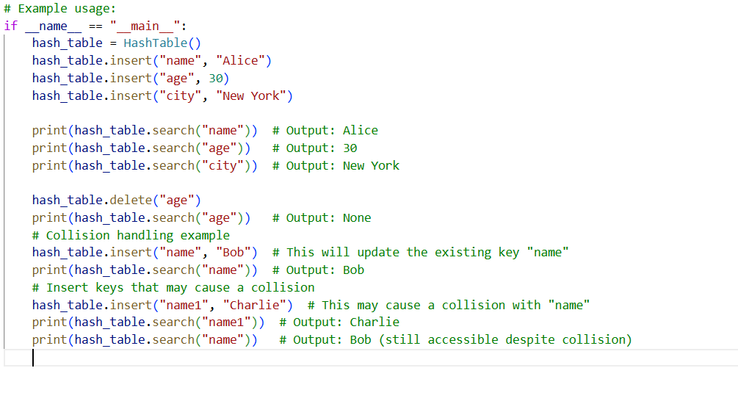
Output:
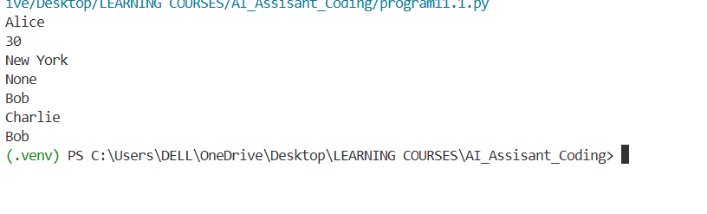
Justification:
1.Hash table stores data using key-value pairs.
2.A hash function converts keys into index positions.
3.Chaining handles collisions using lists at each index.
4.search() retrieves values quickly using keys.
5.delete() removes key-value pairs efficiently.
Task Description 6 : Graph Representation
Task: Use AI to implement a graph using an adjacency list.
Sample Input Code:
class Graph:
pass

Prompt:
Implement a Graph using an adjacency list in Python.
Include methods: add_vertex(), add_edge(), and display().
Add clear comments explaining how adjacency lists work.
Python Code :
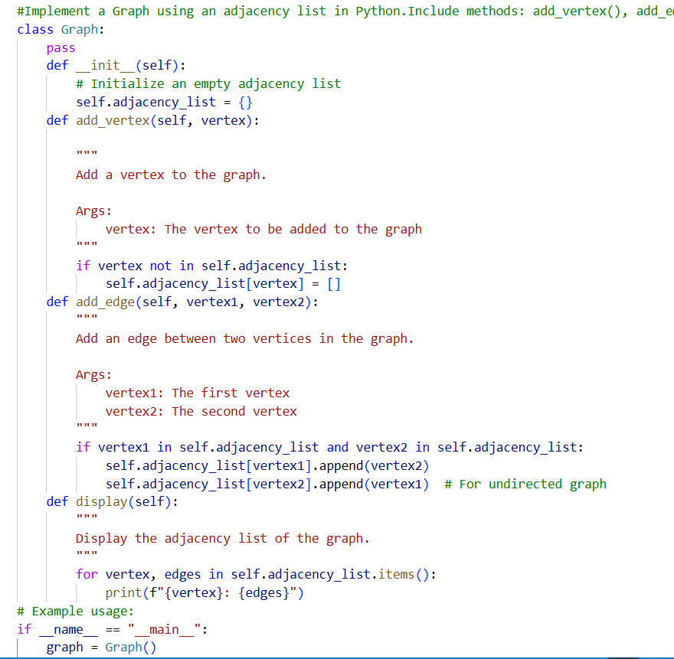
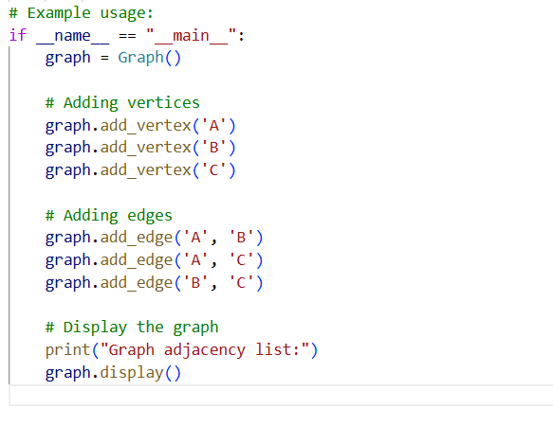
Output:
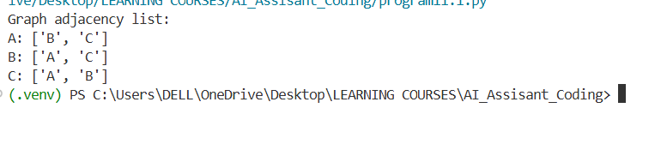
Justification:
1.Graph consists of vertices (nodes) and edges (connections).
2.Adjacency list stores neighbors of each vertex.
3.add_vertex() creates a new node in the graph.
4.add_edge() connects two vertices.
5.Efficient for representing sparse graphs.
Task Description 7 : Priority Queue
Task: Use AI to implement a priority queue using Python’s heapq
module
Sample Input Code:
class PriorityQueue:
pass
Prompt:
Implement a Priority Queue in Python using the heapq module.
Include methods enqueue(priority, item), dequeue(), and display().
Add documentation explaining how a min-heap works.
Python Code :
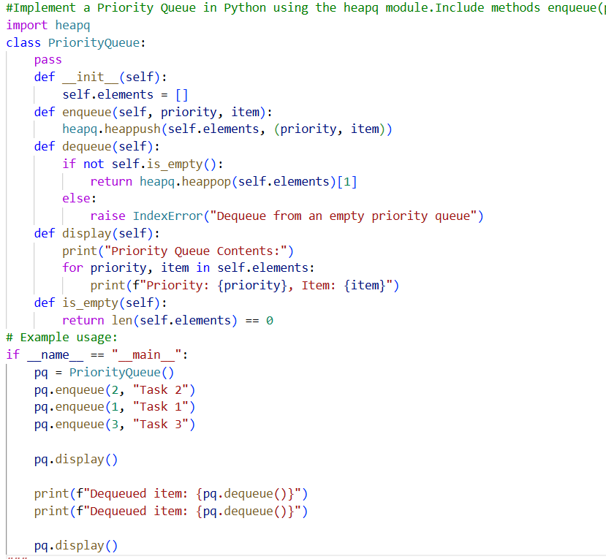
Output:
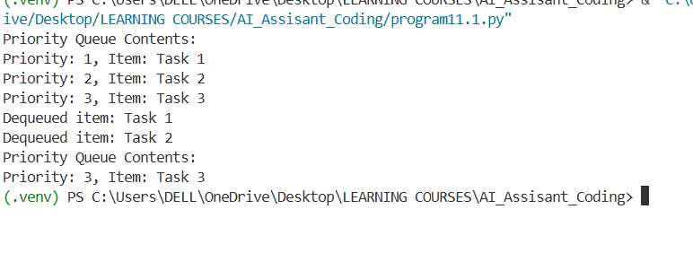
Justification:
1.Priority Queue removes elements based on priority, not order.
2.Lower (or higher) priority value determines removal order.
3.enqueue() inserts element with priority.
4.dequeue() removes highest-priority element.
5.Heap structure ensures efficient insertion and deletion.
Task Description 8 : Deque
Task: Use AI to implement a double-ended queue using
collections.deque.
Sample Input Code:
class DequeDS:
pass
Prompt:
Implement a double-ended queue using collections.deque in Python.
Include methods to insert and remove elements from both ends.
Add proper docstrings.
Python Code :
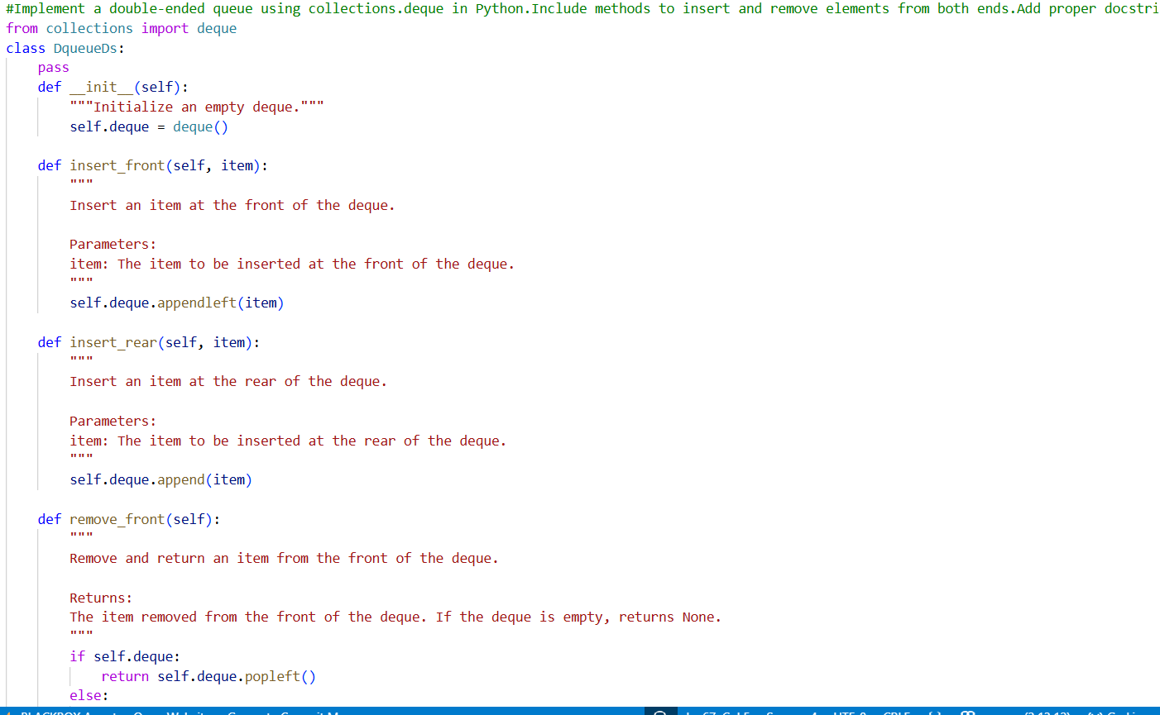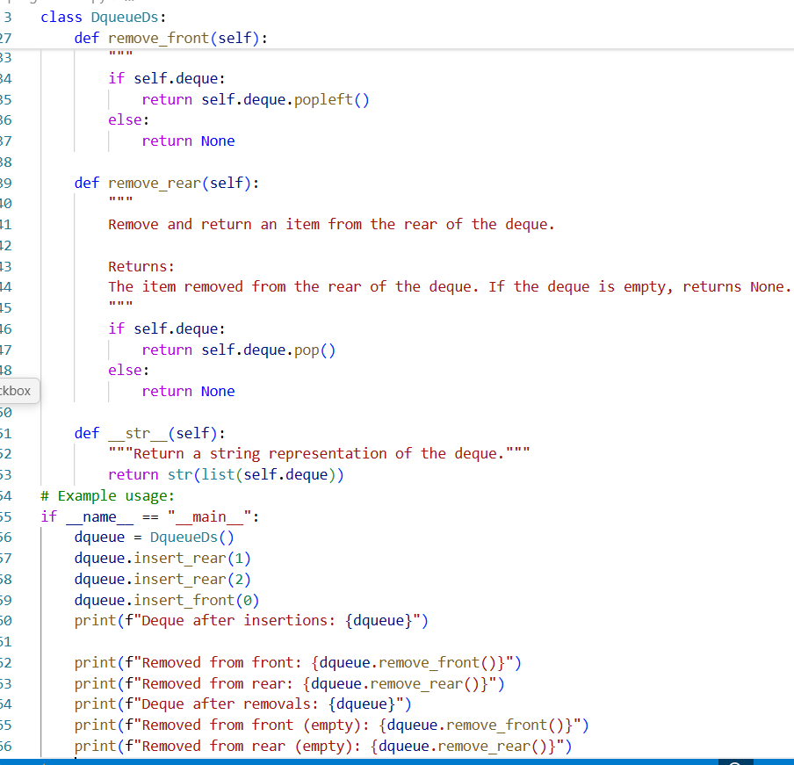
Output:
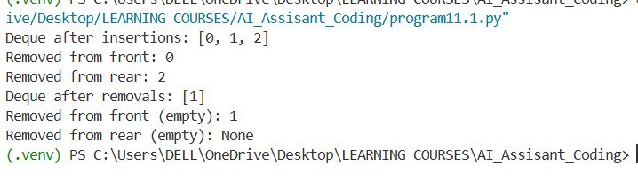
Justification:
1.Deque allows insertion and deletion at both front and rear.
2.Combines features of stack and queue.
3.Efficient O(1) operations at both ends.
4.Useful for sliding window problems.
5.Flexible data structure for bidirectional processing.
Task Description 9: Real-Time Application Challenge – Choose the
Right Data Structure
Scenario:
Your college wants to develop a Campus Resource Management System
that handles:
1. Student Attendance Tracking – Daily log of students
entering/exiting the campus.
2. Event Registration System – Manage participants in events with
quick search and removal.
3. Library Book Borrowing – Keep track of available books and their
due dates.
4. Bus Scheduling System – Maintain bus routes and stop
connections.
5. Cafeteria Order Queue – Serve students in the order they arrive.
Prompt:
Generate a complete Python program for a Campus Resource Management System feature using an appropriate data structure.
Choose ONE of the following features and implement it fully:
1. Student Attendance Tracking
2. Event Registration System
3. Library Book Borrowing
4. Bus Scheduling System
5. Cafeteria Order Queue
Requirements:
- Select the most suitable data structure (Stack, Queue, Priority Queue, Linked List, BST, Graph, Hash Table, or Deque).
- Implement a class-based solution.
- Include methods required for real-world functionality (add, remove, search, display, etc.).
- Add proper docstrings and comments.
- Include example usage at the bottom.
- Code should be clean, beginner-friendly, and well-structured.
Python Code :
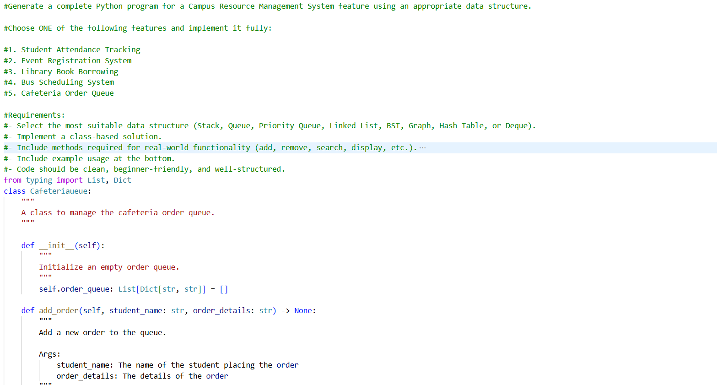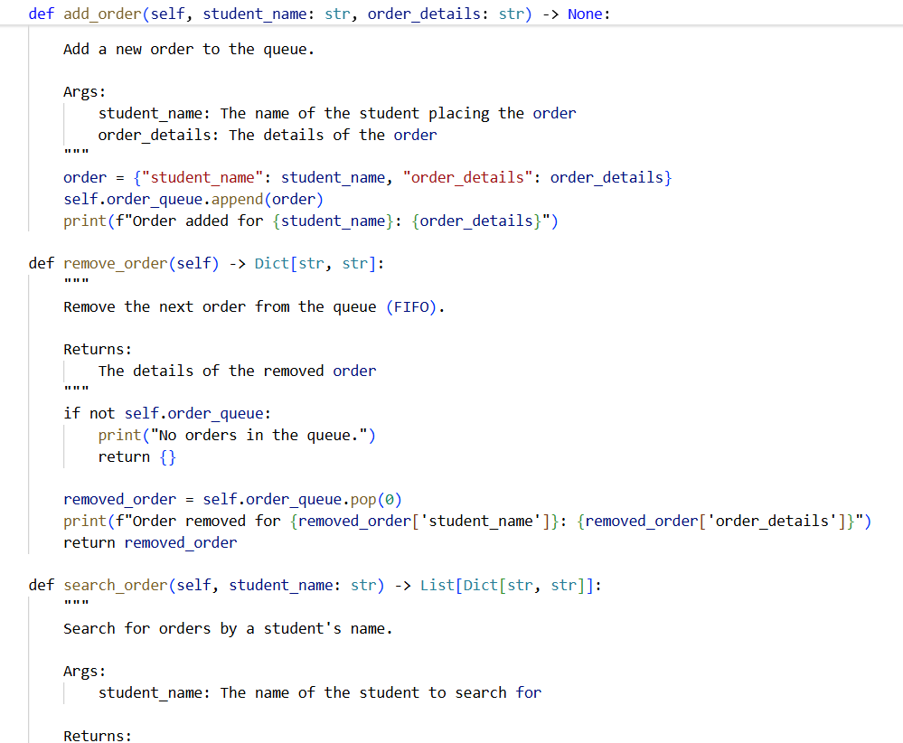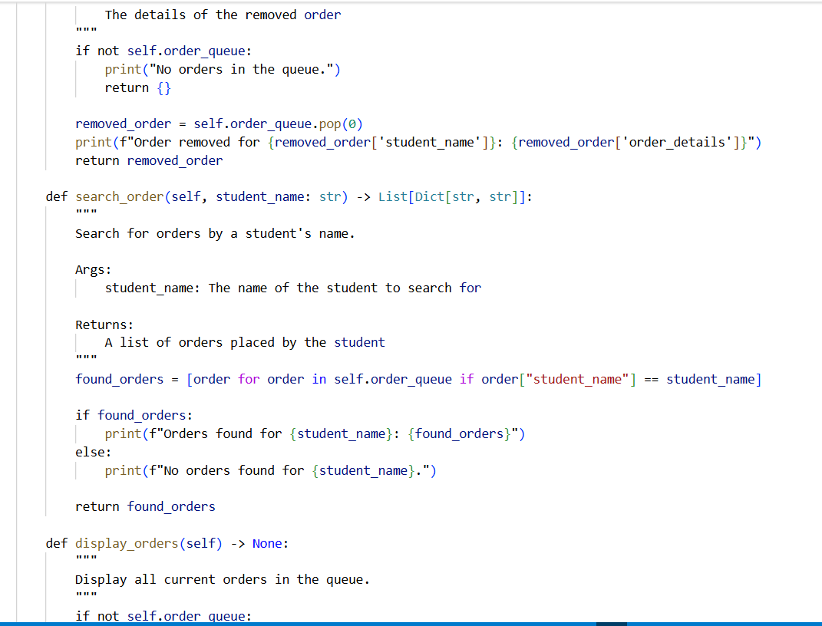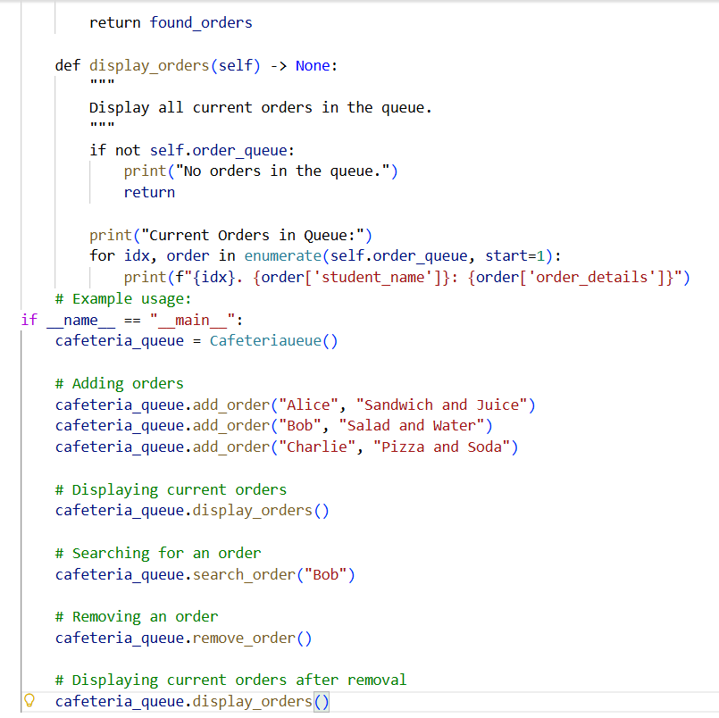

Output:
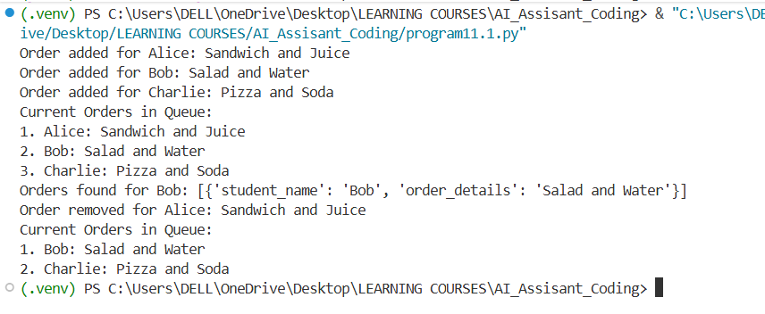
Justification:
Feature | Chosen Data Structure | Justification
Student Attendance Tracking | Deque | Students may enter and exit from multiple points. A deque allows insertion and removal from both ends efficiently.
Event Registration System | Hash Table | Quick lookup, insertion, and deletion of participants by ID is essential, which hash tables provide in O(1) average time.
Library Book Borrowing | Binary Search Tree (BST) | BST allows ordered storage of books, fast search by book ID, and easy tracking of due dates through in-order traversal.
Bus Scheduling System | Graph | Routes and stops are naturally modeled as vertices and edges, enabling path finding and route management.
Cafeteria Order Queue | Queue | Orders must be served in the order they arrive; a queue ensures FIFO behavior perfectly.

Task Description 10: Smart E-Commerce Platform – Data Structure Challenge
An e-commerce company wants to build a Smart Online Shopping System
with:
1. Shopping Cart Management – Add and remove products
dynamically.
2. Order Processing System – Orders processed in the order they are
placed.
3. Top-Selling Products Tracker – Products ranked by sales count.
4. Product Search Engine – Fast lookup of products using product ID.
5. Delivery Route Planning – Connect warehouses and delivery
locations.
Student Task:
• For each feature, select the most appropriate data structure from
the list below:
o Stack
o Queue
o Priority Queue
o Linked List
o Binary Search Tree (BST)
o Graph
o Hash Table
o Deque
• Justify your choice in 2–3 sentences per feature.
• Implement one selected feature as a working Python program with
AI-assisted code generation.
Prompt:
Generate a Python program for one feature of a Smart Online Shopping System.
Features to choose from:
1. Shopping Cart Management
2. Order Processing System
3. Top-Selling Products Tracker
4. Product Search Engine
5. Delivery Route Planning
Requirements:
- Choose the most appropriate data structure (Stack, Queue, Priority Queue, Linked List, BST, Graph, Hash Table, or Deque)
- Implement a class-based solution with relevant methods (add, remove, search, display, etc.)
- Include proper docstrings and comments
- Provide example usage at the end
- Ensure the code is clean, efficient, and beginner-friendly
Python Code :
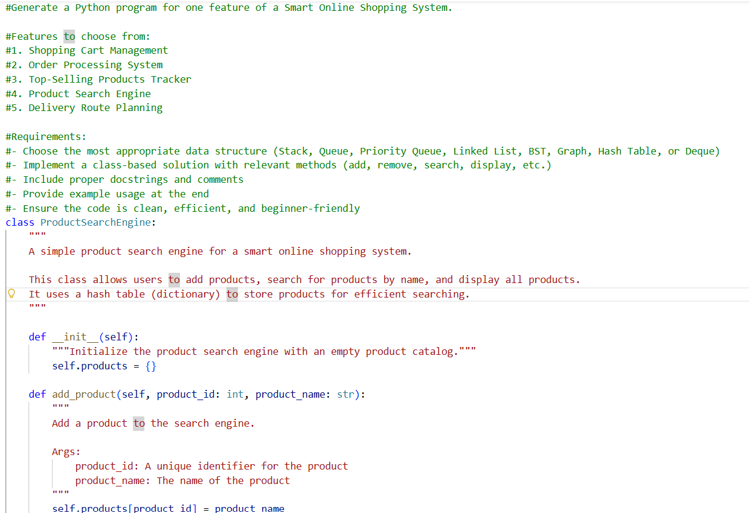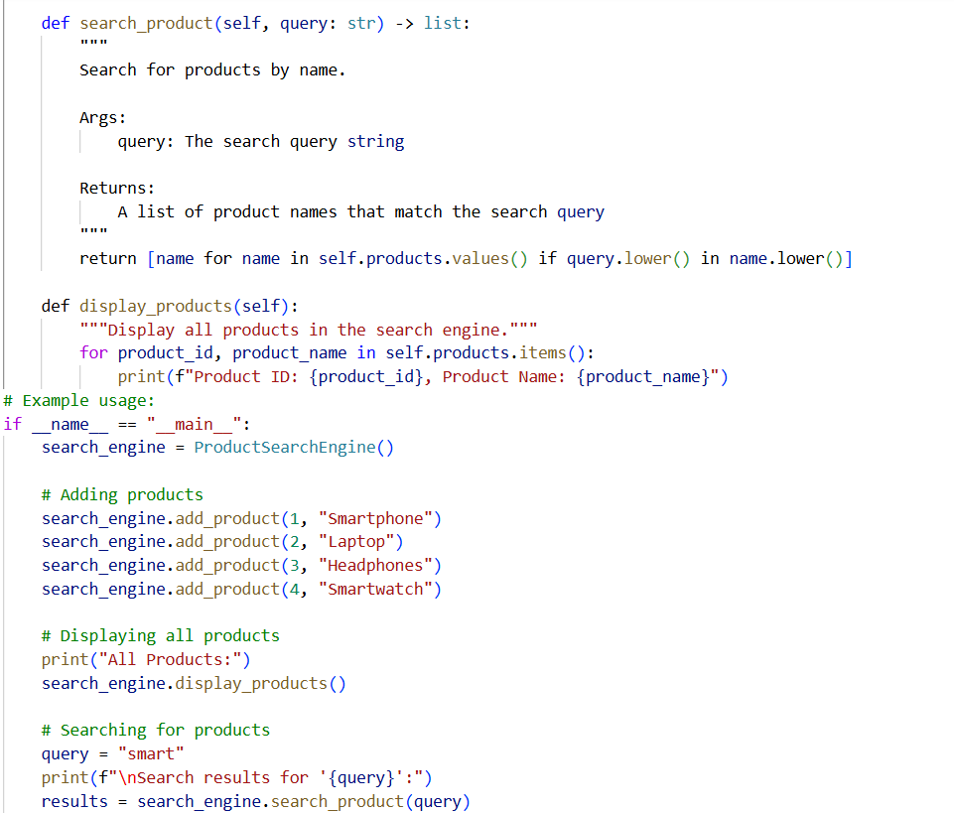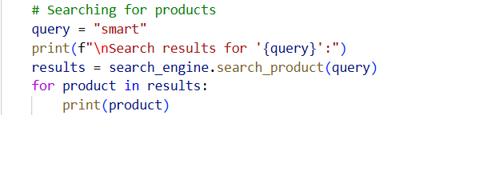
Output:
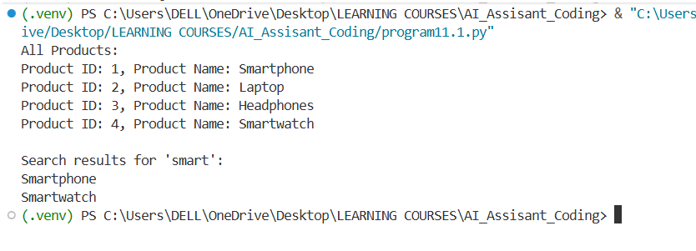
Justification:
Feature | Chosen Data Structure | Justification
Shopping Cart Management | Linked List | Users can dynamically add/remove items; linked lists allow flexible insertion and deletion without shifting elements.
Order Processing System | Queue | Orders are fulfilled in the sequence they are placed, making a FIFO queue the natural choice.
Top-Selling Products Tracker | Priority Queue | Products need to be ranked by sales count; a priority queue allows efficient retrieval of top-selling items.
Product Search Engine | Hash Table | Fast lookup of products by ID is critical; hash tables provide O(1) average search time.
Delivery Route Planning | Graph | Warehouses and delivery locations are nodes; roads/routes are edges. Graphs allow route optimization and pathfinding.

