BLOCKCHAIN
ASSIGNMENT-1
NAME-Vaishnavi
ROLL NO-2303A51943
BATCH-27
Question-1:
Objective:
To learn blockchain interaction by creating a cryptocurrency
wallet, checking wallet balance, and simulating transactions using
Python and Web3
Requirements:
• Install Python 3.x
• Set up VS Code with Python extension
• Install required Python libraries:
• pip install web3
• Use a test blockchain network (Ethereum Sepolia /
Ganache local blockchain)
• Basic understanding of blockchain wallets and private keys
Practical Description:
Step 1: Environment Setup
• Install Python and VS Code
• Install Web3.py library
• Create a Python file named wallet_interaction.py
Step 2: Wallet and Blockchain Interaction Script
Create a Python script that:
• Connects to a blockchain network
• Loads a wallet using a private key
• Fetches wallet address
• Checks wallet balance
• Demonstrates transaction preparation (without real funds)

Code:
import tkinter as tk
my_balance = 10.0
x_balance = 2.0
root = tk.Tk()
root.title("Wallet Simulation")
root.geometry("400x300")

def update_ui():
my_label.config(text=f"{my_balance:.2f} ETH")
x_label.config(text=f"{x_balance:.2f} ETH")

def send_money():
global my_balance, x_balance
amount_text = entry.get()

if amount_text == "":
return

amount = float(amount_text)

if amount <= my_balance:
my_balance -= amount
x_balance += amount
update_ui()
entry.delete(0, tk.END)

# ---- UI ----
tk.Label(root, text="My Wallet Balance").pack()
my_label = tk.Label(
root,
text="0 ETH",
font=("Arial", 16),
relief="solid",
width=20,
height=2
)
my_label.pack(pady=5)

tk.Label(root, text="X Wallet Balance").pack()
x_label = tk.Label(
root,
text="0 ETH",
font=("Arial", 16),
relief="solid",
width=20,
height=2
)
x_label.pack(pady=5)

tk.Label(root, text="Amount to Send").pack()
entry = tk.Entry(root)
entry.pack()

tk.Button(root, text="Send", command=send_money).pack(pady=10)

update_ui()
root.mainloop()

OUTPUT:

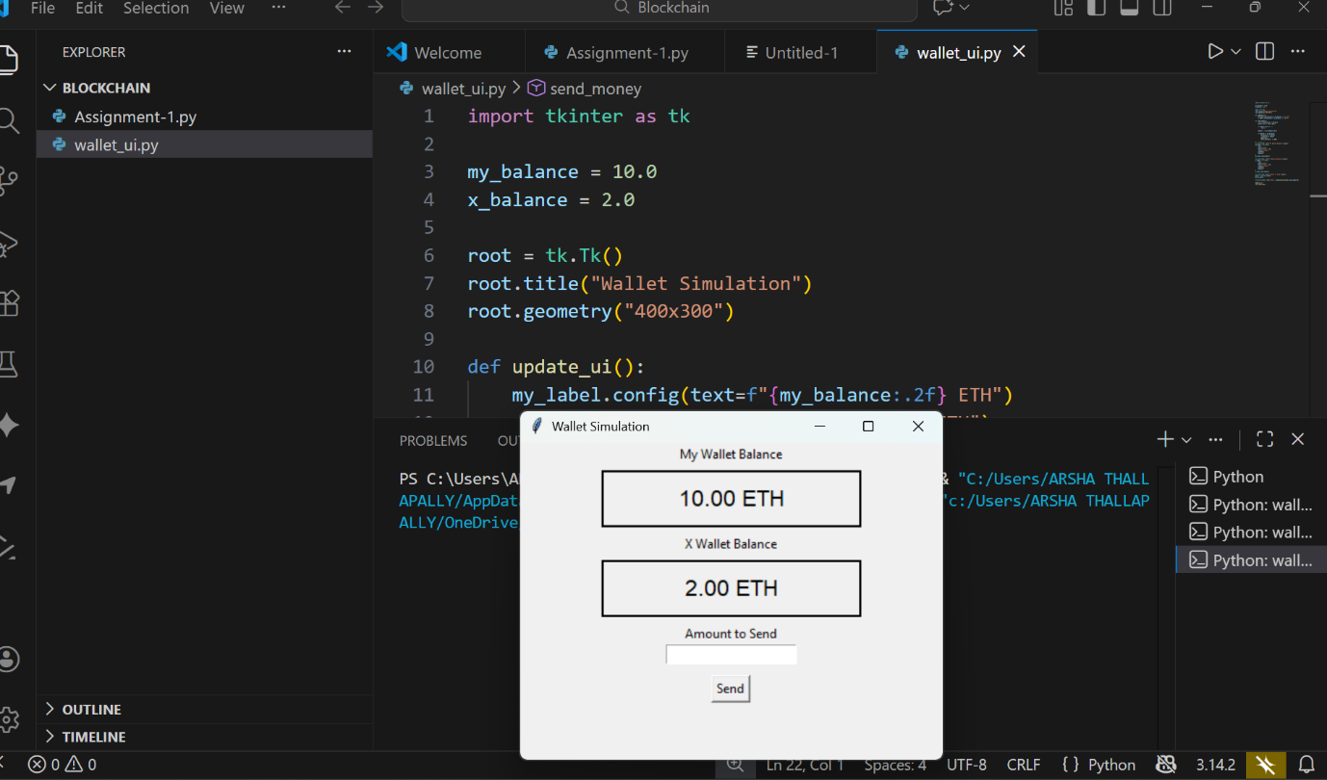

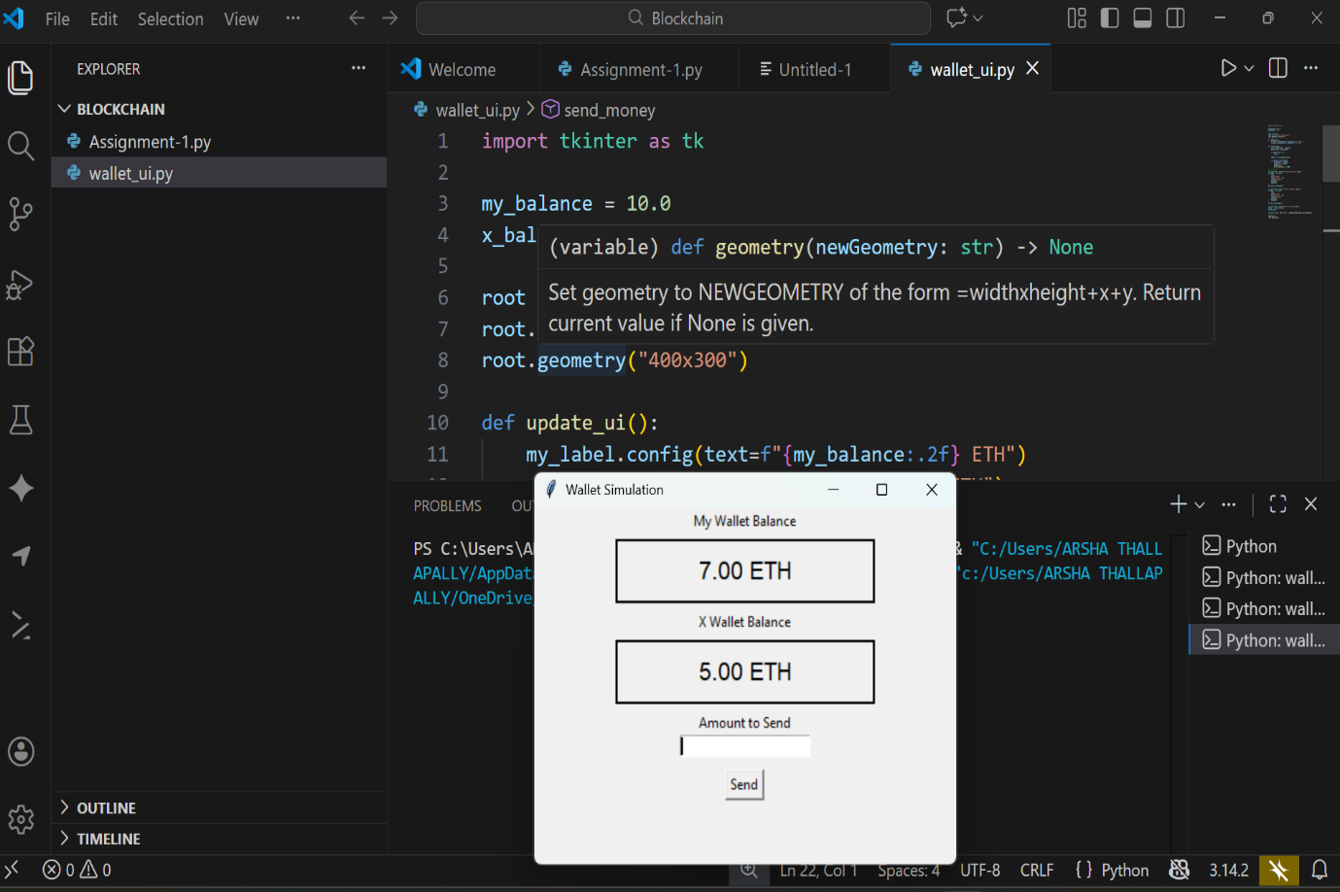
After sending the ETH (3 ETH)to ‘X’ -my wallet remained with 7 ETH

