Lab Assignment 1.3
B.Ranjith
2303A51994
BATCH 27

STEP 1:INSTALLATION OF PYTHON EXTENSION IN VS CODE

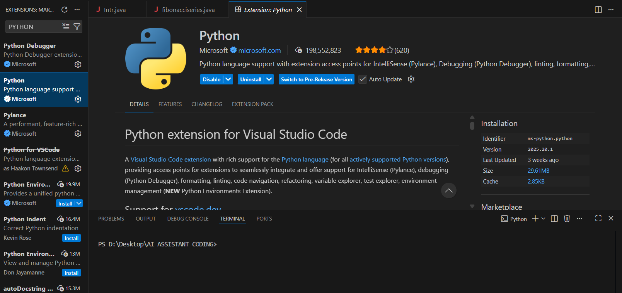

STEP 2: INSTALLATION OF GITHUB CO-PILOT

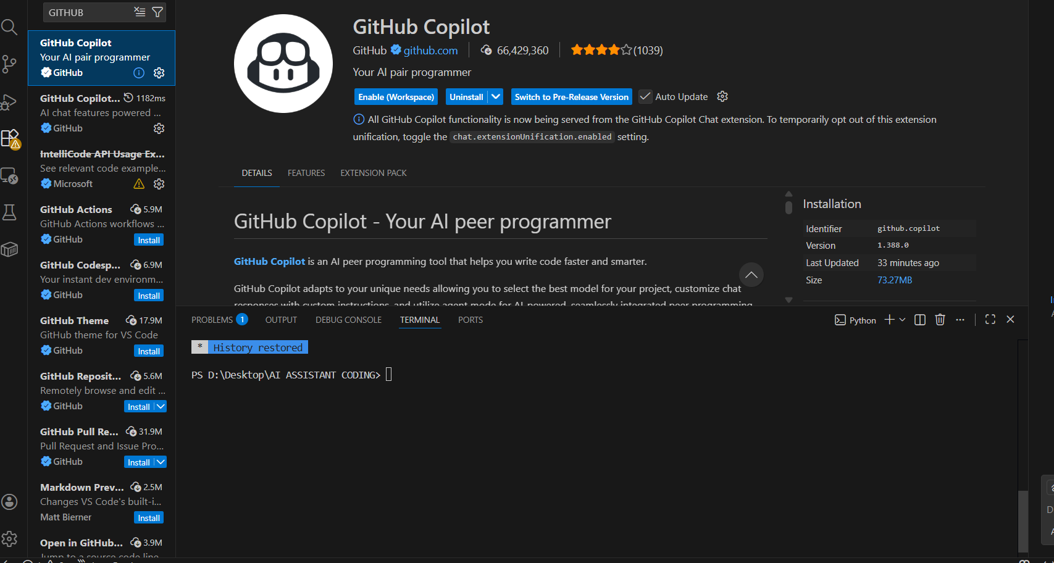
Task 1: AI-Generated Logic Without Modularization (Procedural Fibonacci) :
# Fibonacci series
CODE:
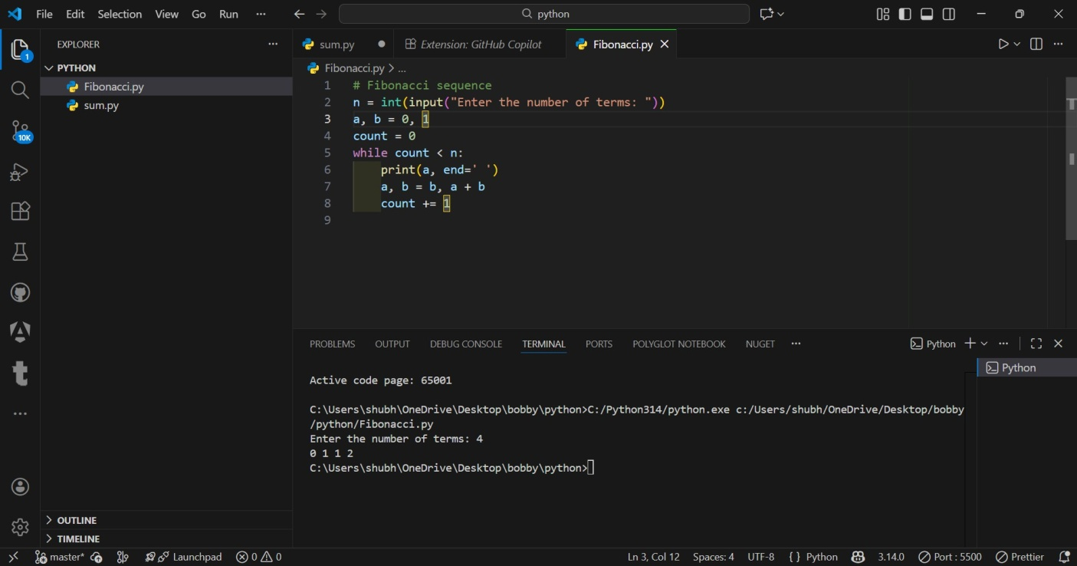
Prompt:
Write a Python program to generate Fibonacci sequence without using functions.

Output:
0 1 1 2 3 5 8 13 21 34

Explanation:
This program generates the Fibonacci sequence using a procedural approach without functions. Variables are updated step by step to compute the next number.

Task 2: AI Code Optimization & Cleanup :
Prompt:
Optimize the Fibonacci code and simplify variable usage

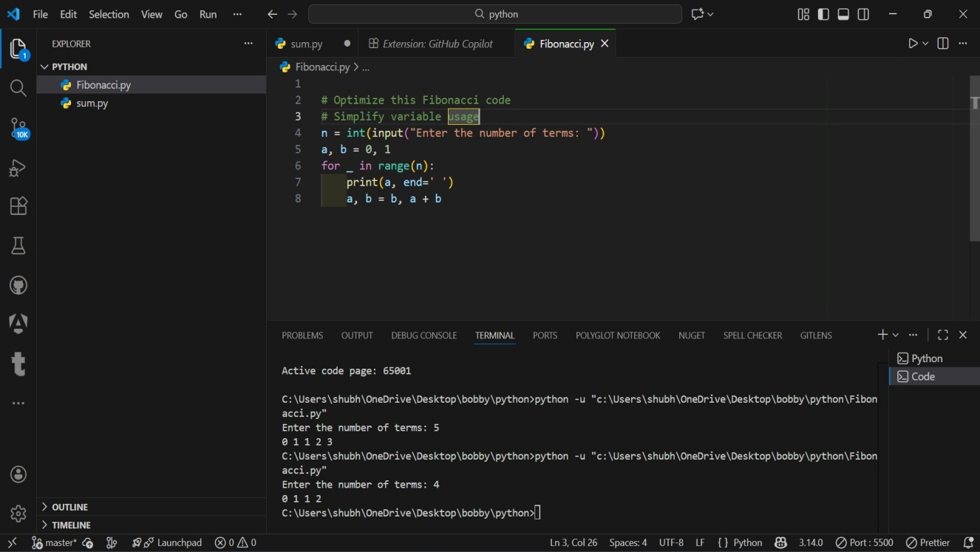
Output:
0 1 1 2 3 5 8 13 21 34
Explanation:
The optimized code reduces variables and improves readability by using tuple assignment.

Task 3: Modular Design Using AI Assistance (Function-Based Fibonacci) :
Prompt:
# Write a Python function to generate Fibonacci sequence up to n
# Use meaningful comments

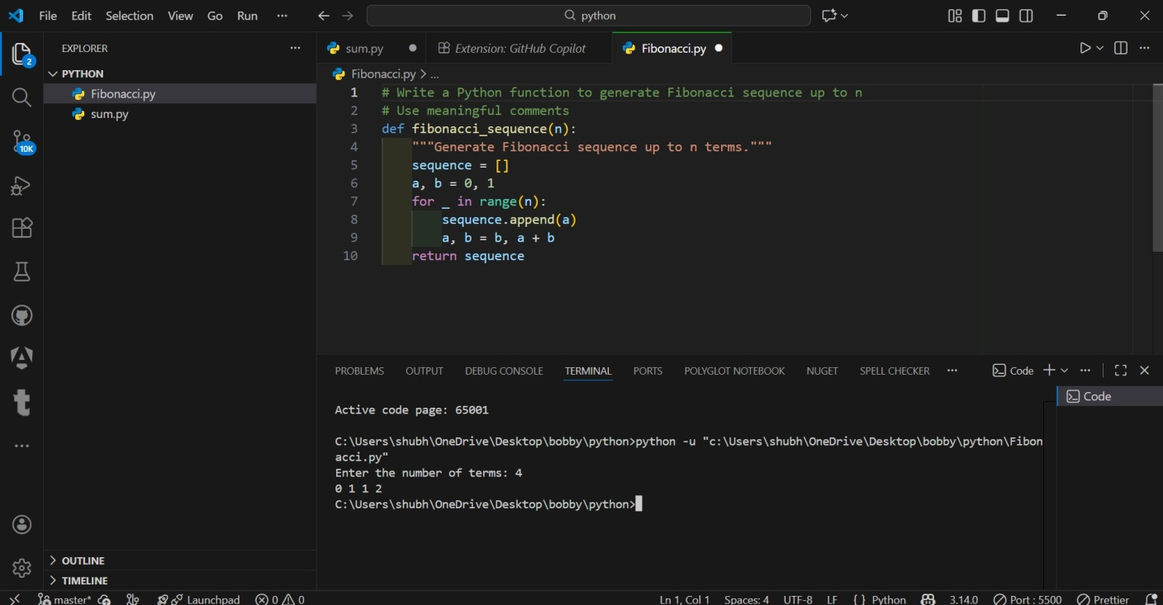

Output:
0 1 1 2 3 5 8 13 21 34
Explanation:
Using functions improves reusability, clarity, and maintainability of the code.

Task 4: Comparative Analysis – Procedural vs Modular Code

Criteria | Without Functions | With Functions
Code Clarity | Lower | Higher
Reusability | No | Yes
Debugging | Harder | Easier
Scalability | Poor | Excellent
Suitable for Large Systems | No | Yes

Task 5: Iterative vs Recursive Fibonacci (AI-Generated): # Generate Fibonacci using iterative approach
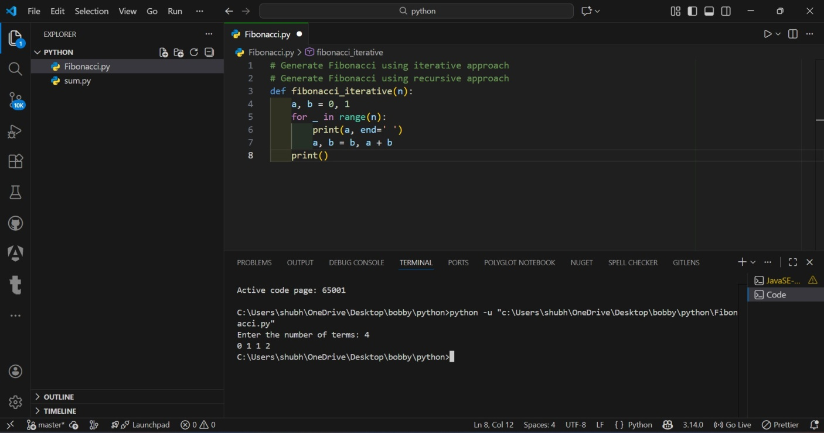

# Generate Fibonacci using recursive approach
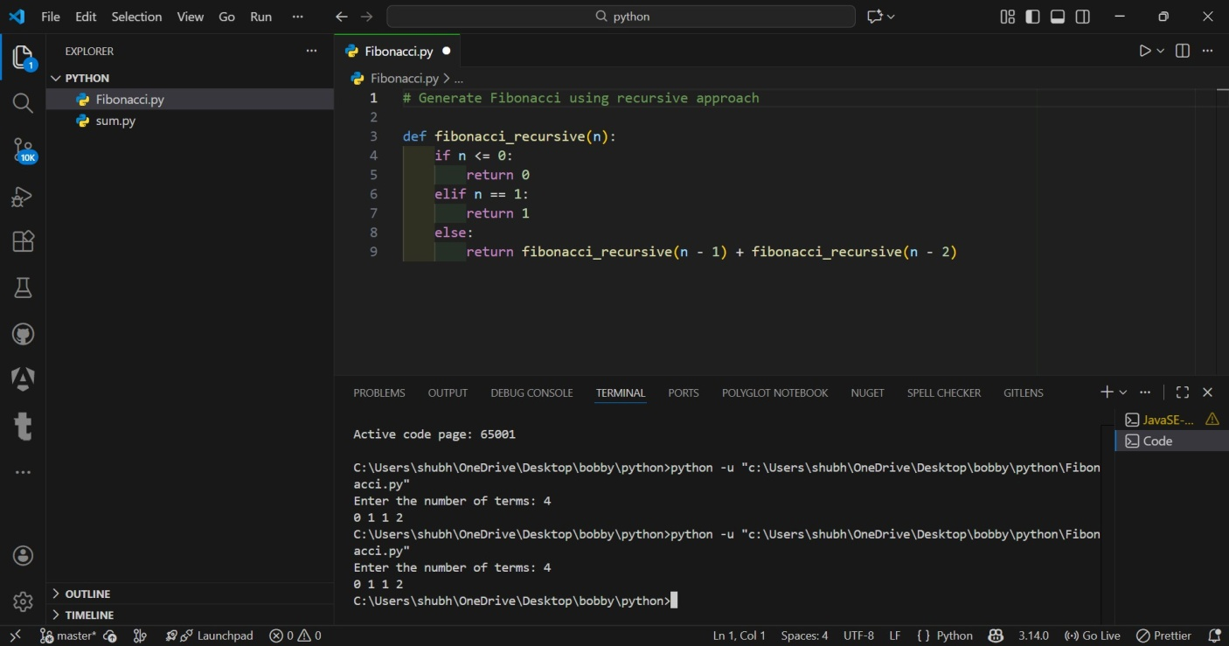

Explanation:
Iterative approach is efficient, while recursive approach is simpler but slower due to repeated calculations.

OUTPUT
0 1 1 2 3 5 8 13 21 34

