Name: K. Rishith Reddy
Hallticket:2303A52068
Batch:44
Assginment:9.4
Task:01
Auto-Generating Function Documentation in a Shared
Codebase
Scenario
You have joined a development team where several utility functions are already implemented, but the code lacks proper documentation. New team members are struggling to understand how these functions should be used.
Task Description
You are given a Python script containing multiple functions without any docstrings.
Using an AI-assisted coding tool:
• Ask the AI to automatically generate Google-style function docstrings for each function • Each docstring should include: o A brief description of the function o Parameters with data types o Return values
o At least one example usage (if applicable)
Experiment with different prompting styles (zero-shot or context-based) to observe quality differences.
Expected Outcome
- A Python script with well-structured Google-style docstrings
- Docstrings that clearly explain function behavior and usage
- Improved readability and usability of the codebase
Prompt:give me code for creating multiple functions and also give me the google style documentation in docstring Code:
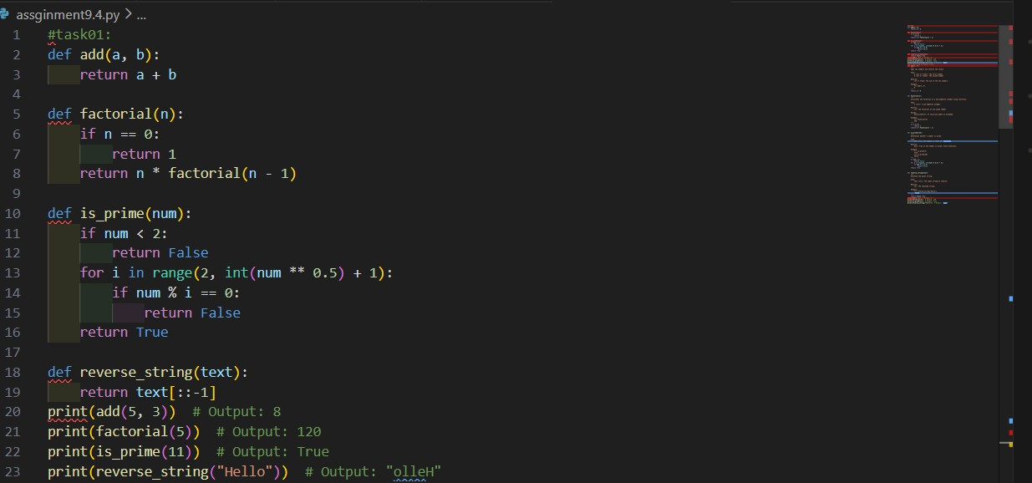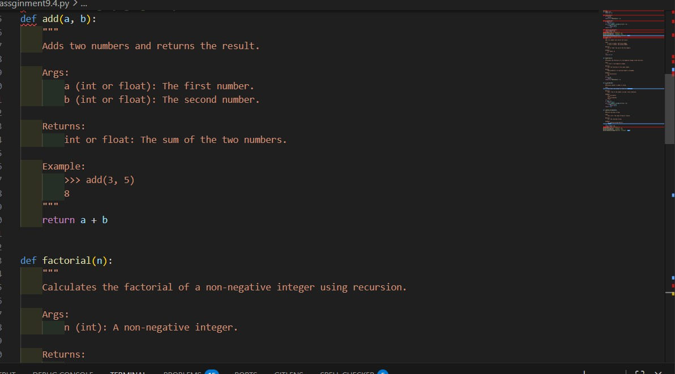
Output:
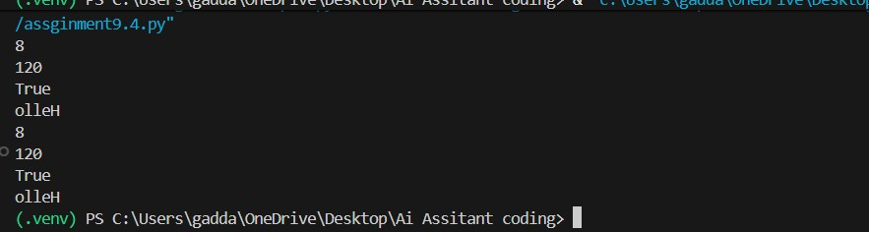
Observations:
The addition of Google-style docstrings makes each function’s purpose immediately clear.
New developers can understand functionality without reading the implementation.
The code becomes self-documenting and easier to maintain
Task:02 Prompt:
inline comments to the Python code explaining only complex or non-obvious logic (algorithms, loops, conditionals) Code:

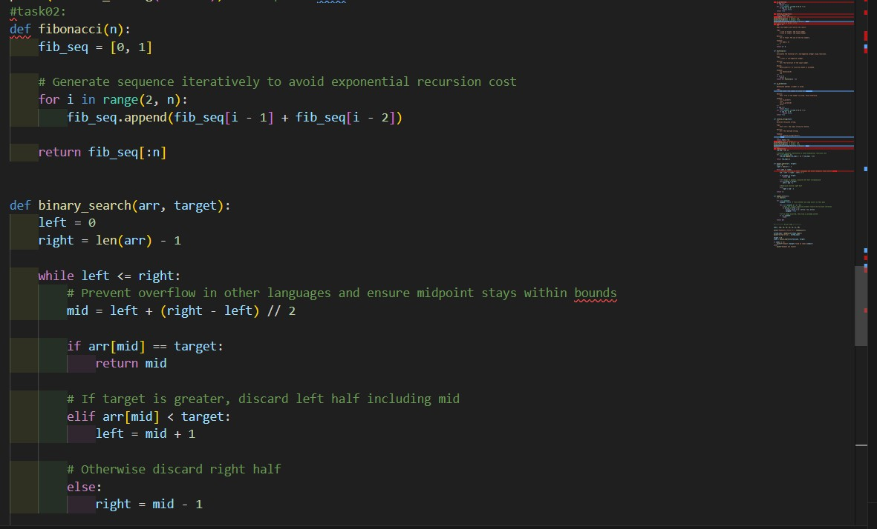
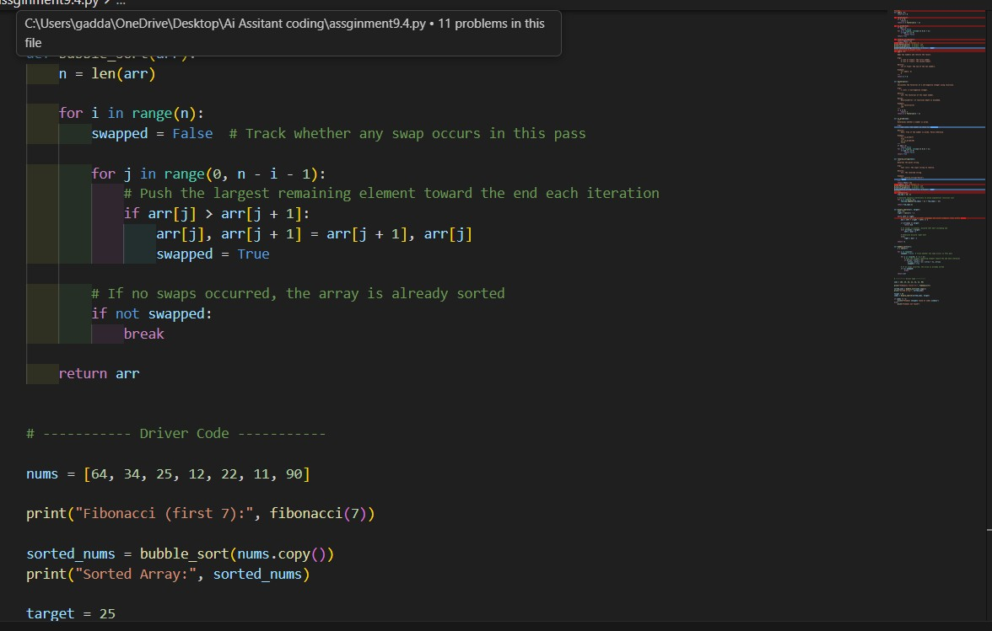

Output:
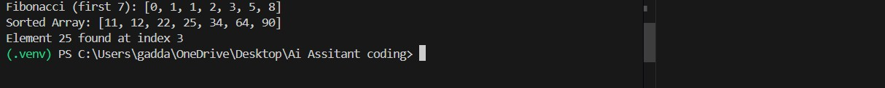

Observation:
AI added comments mainly around algorithms, nested loops, and tricky conditions.
Difficult parts of the code became easier to follow without tracing execution line-by-line.
Maintainers can quickly grasp the intent behind the logic.
Task:03
Generating Module-Level Documentation for a Python
Package
Scenario
Your team is preparing a Python module to be shared internally (or uploaded to a repository). Anyone opening the file should immediately understand its purpose and structure.
Task Description
Provide a complete Python module to an AI tool and instruct it to automatically generate a module-level docstring at the top of the file that includes:
- The purpose of the module
- Required libraries or dependencies
- A brief description of key functions and classes • A short example of how the module can be used Focus on clarity and professional tone.
Expected Outcome
- A well-written multi-line module-level docstring
- Clear overview of what the module does and how to use it • Documentation suitable for real-world projects or repositories Prompt:
Generate a professional module-level docstring for the following Python file that describes the module’s purpose, dependencies, key functions/classes, and provides a brief example of usage, without modifying the code Code:
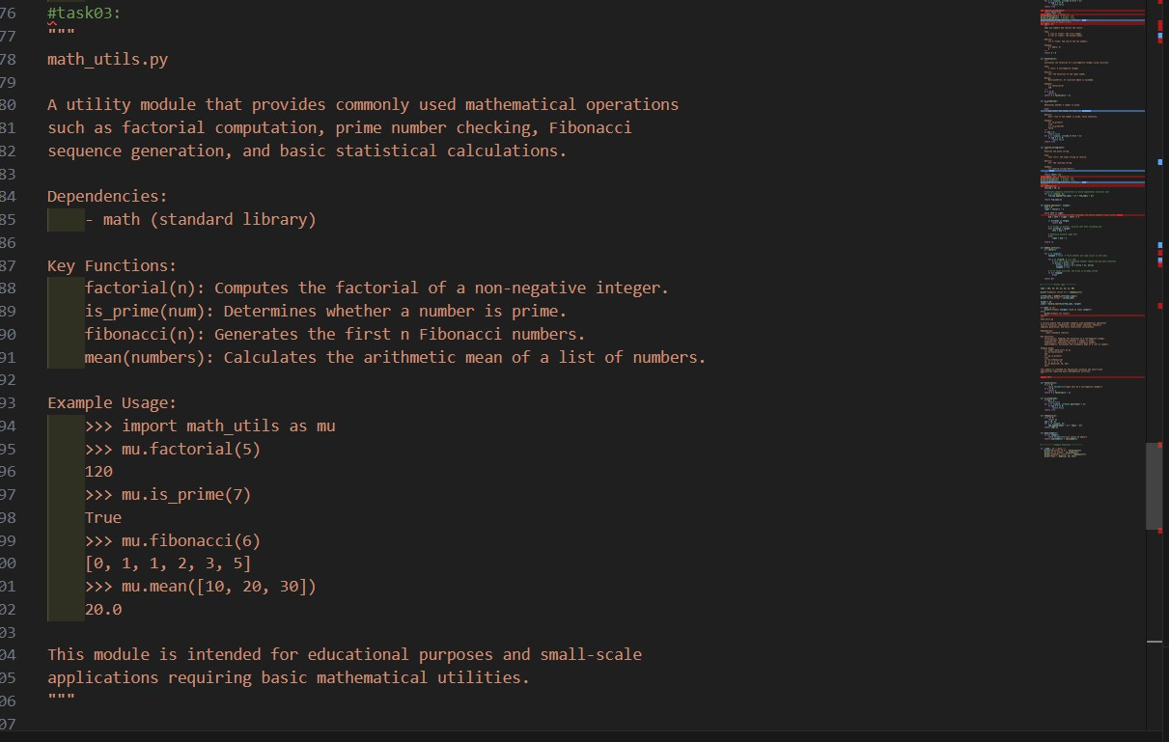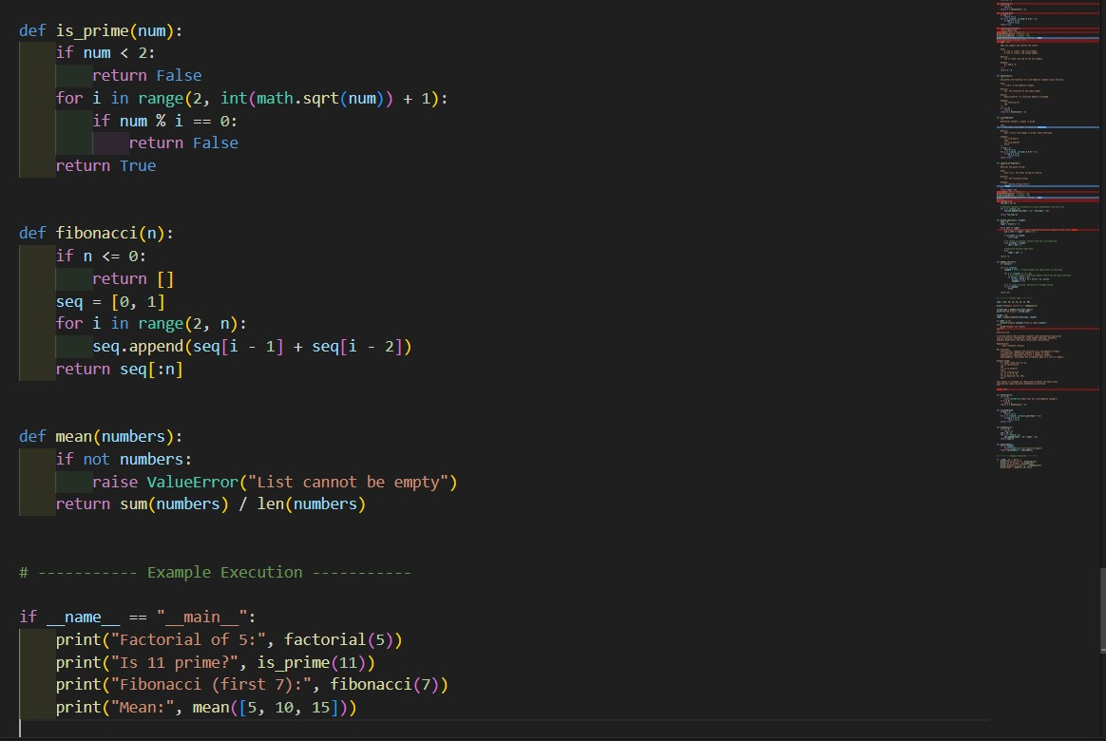
Output:
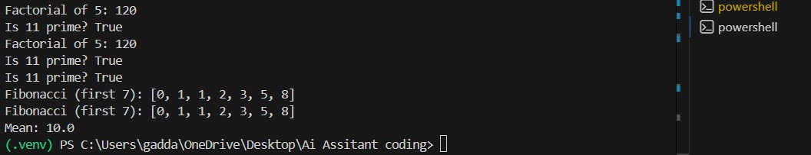

Observation:
the generated documentation provides an immediate overview of the module, making it easier for developers to understand structure and functionality.
It improves usability, maintainability, and code sharing, though accuracy depends on the clarity of the prompt and should be reviewed.
Task:04
Converting Developer Comments into Structured Docstrings
Scenario
In a legacy project, developers have written long explanatory comments inside functions instead of proper docstrings. The team now wants to standardize documentation.
Task Description
You are given a Python script where functions contain detailed inline comments explaining their logic.
Use AI to:
- Automatically convert these comments into structured Google- style or NumPy-style docstrings
- Preserve the original meaning and intent of the comments
- Remove redundant inline comments after conversion
Expected Outcome
- Functions with clean, standardized docstrings
- Reduced clutter inside function bodies
- Improved consistency across the codebase Prompt:
Convert the detailed inline comments inside each function into structured Google-style docstrings, preserving their original meaning, removing redundant comments from the function body, and keeping the code functionality unchanged.
Code:
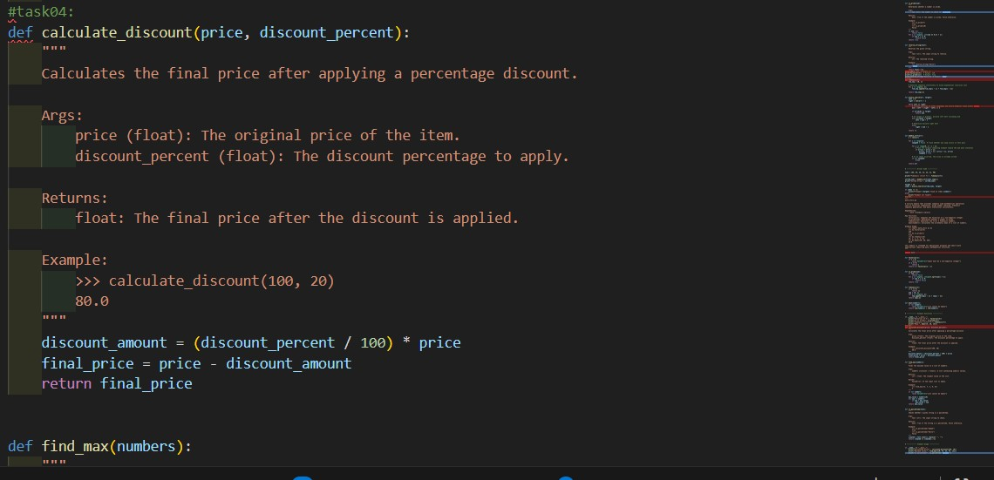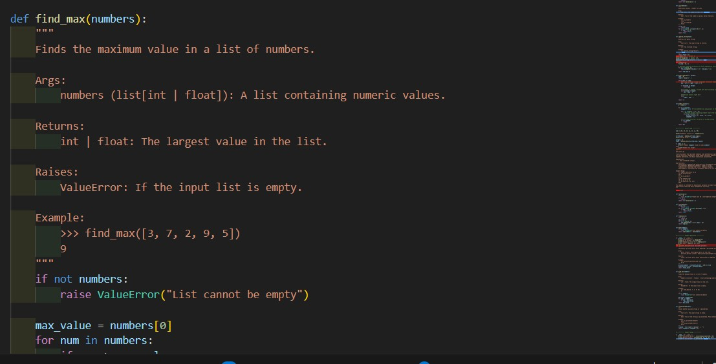
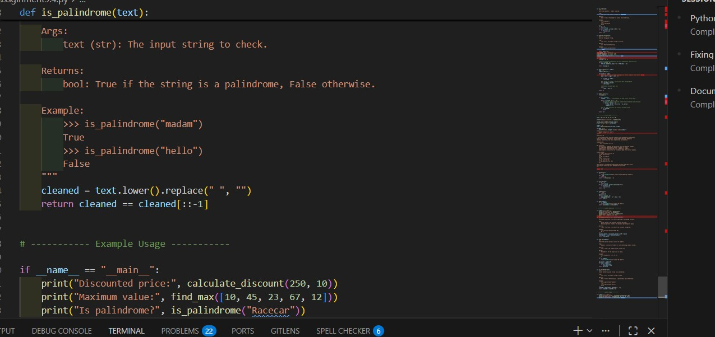
Output:
Observation:
AI successfully transformed explanatory comments into clean, standardized docstrings, making functions easier to read without scanning internal logic. The removal of redundant inline comments reduced visual clutter while preserving important documentation. Overall, the codebase became more consistent and maintainable, though results depended on how clearly the original comments described intent.
Task:05
Building a Mini Automatic Documentation Generator
Scenario
Your team wants a simple internal tool that helps developers start documenting new Python files quickly, without writing documentation from scratch.
Task Description
Design a small Python utility that:
• Reads a given .py file • Automatically detects:
o Functions o Classes
• Inserts placeholder Google-style docstrings for each detected function or class
AI tools may be used to assist in generating or refining this utility.
Prompt:
Create a Python utility that reads a .py file, detects all functions and classes, and automatically inserts placeholder Google-style docstrings where missing, without altering existing documentation or code behavior.
Code:
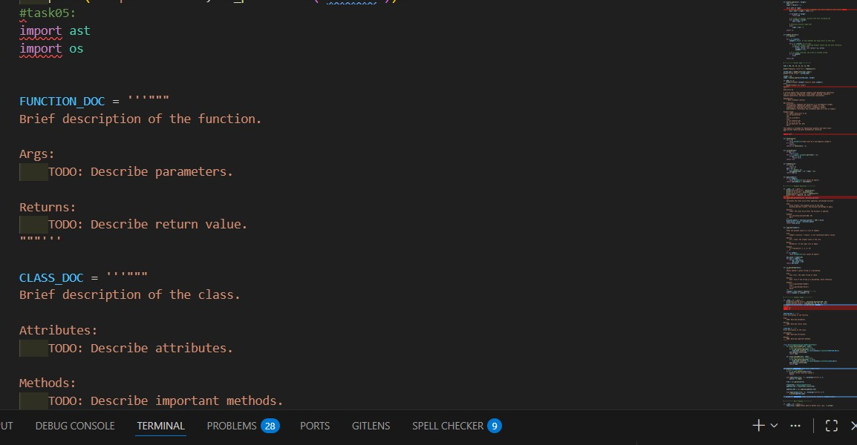
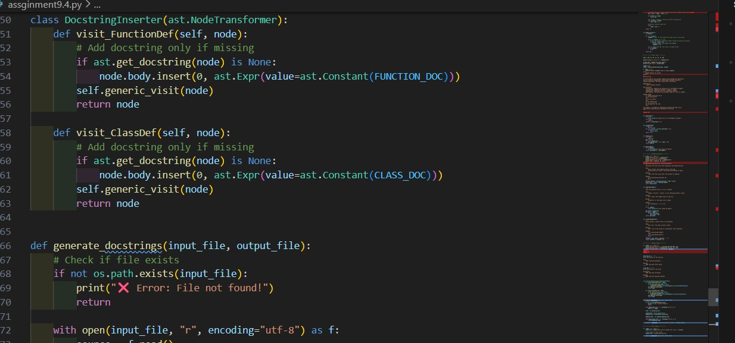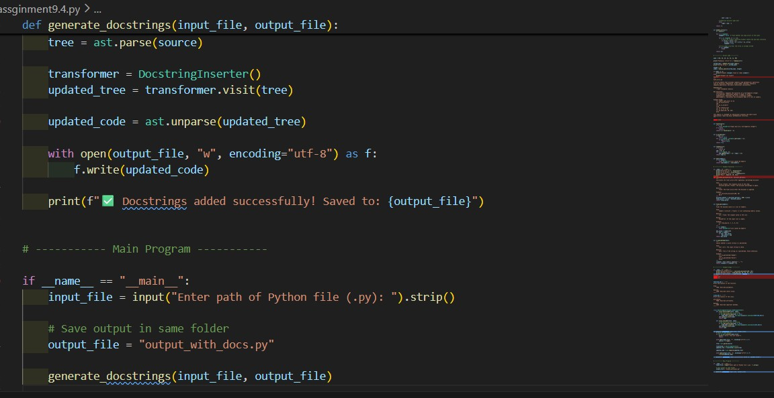
Output:
Observation:
The tool successfully identifies functions and classes using Python’s AST, ensuring accurate detection without relying on fragile text parsing.
Placeholder Google-style docstrings provide a structured starting point, enabling developers to fill in documentation quickly and consistently.
The utility improves documentation adoption and code maintainability, though manual editing is still required to replace placeholders with meaningful content.

