Assignment-3.2
P.Sravan
2303A52118
Task Description-1
Progressive Prompting for Calculator Design: Ask the AI to design a simple calculator program by initially providing only the function name. Gradually enhance the prompt by adding comments and usage examples.
Expected Output-1
Comparison showing improvement in AI-generated calculator logic and structure.

Code:
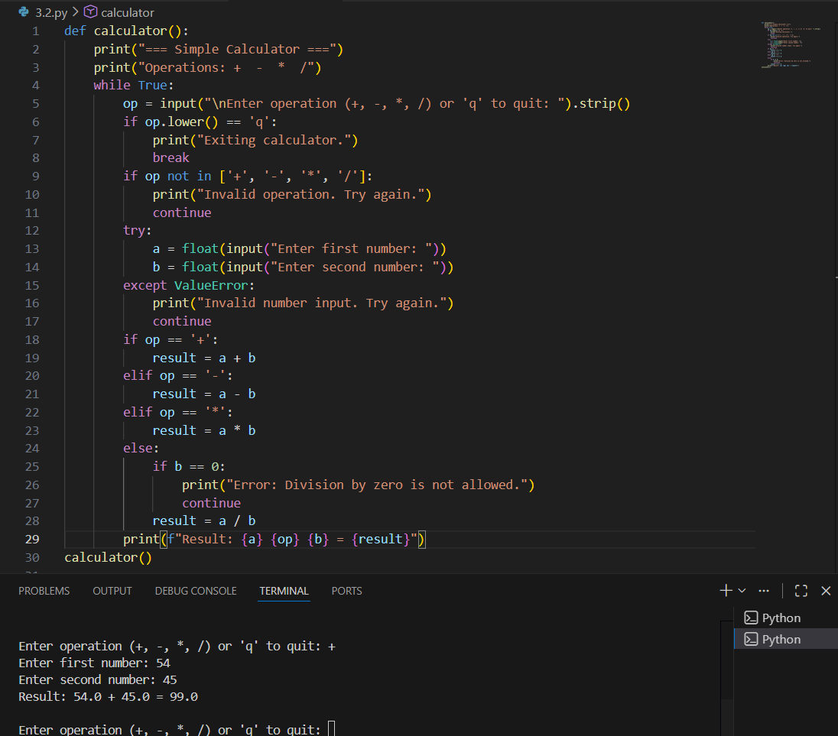
Task Description-2
Refining Prompts for Sorting Logic: Start with a vague prompt for sorting student marks, then refine it to clearly specify sorting order and constraints.
Expected Output-2
AI-generated sorting function evolves from ambiguous logic to an accurate and efficient implementation.

Code:
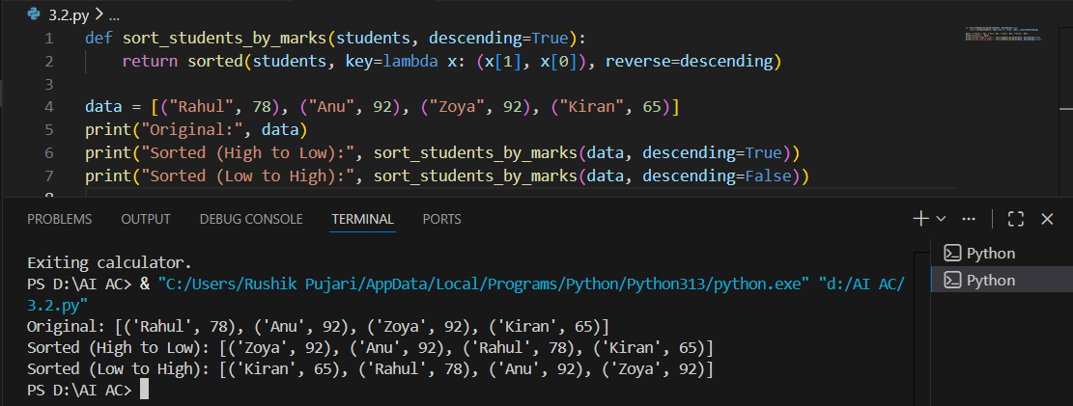

Task Description-3
Few-Shot Prompting for Prime Number Validation: Provide multiple input-output examples for a function that checks whether a number is prime. Observe how few-shot prompting improves correctness.
Expected Output-3
Improved prime-checking function with better edge-case handling.

Code:
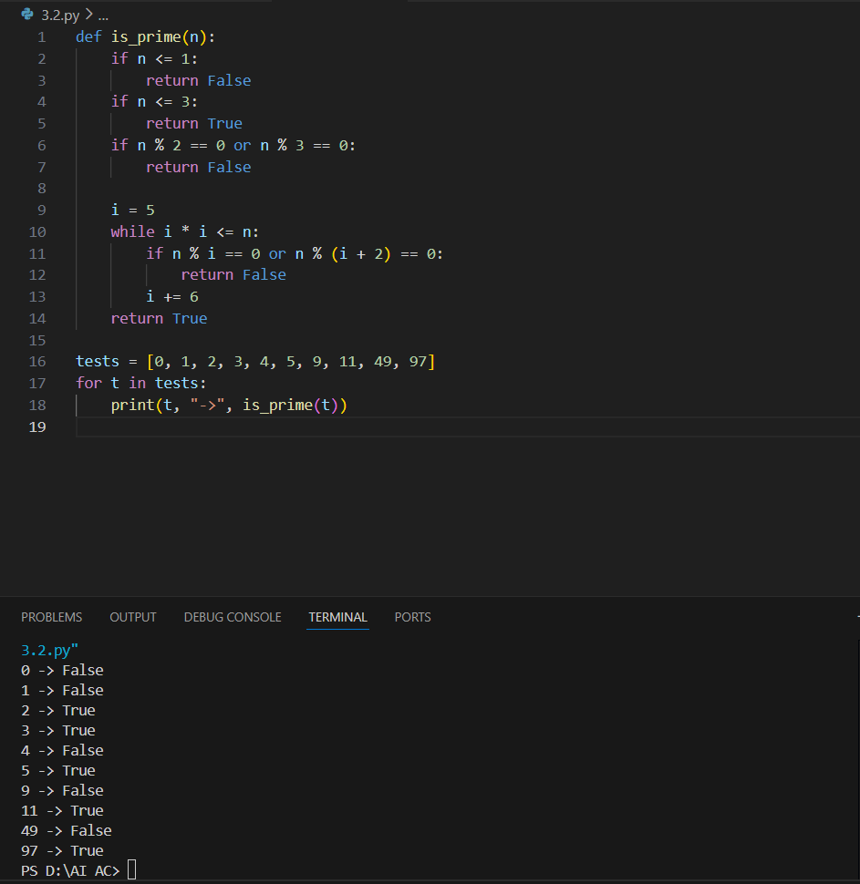
Task Description-4
Prompt-Guided UI Design for Student Grading System: Create a user interface for a student grading system that calculates total marks, percentage, and grade based on user input.
Expected Output-4
Well-structured UI code with accurate calculations and clear output display.

Code:
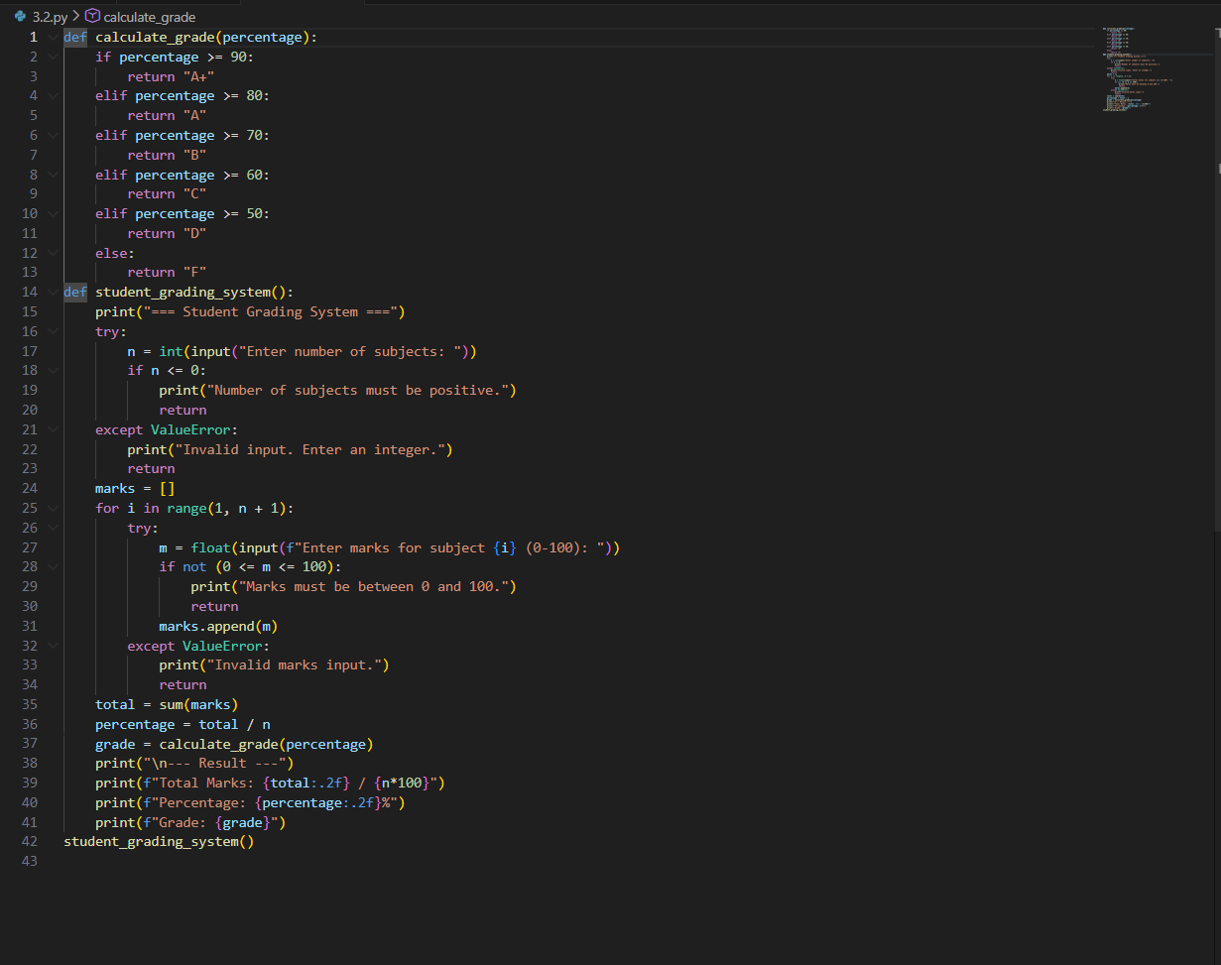
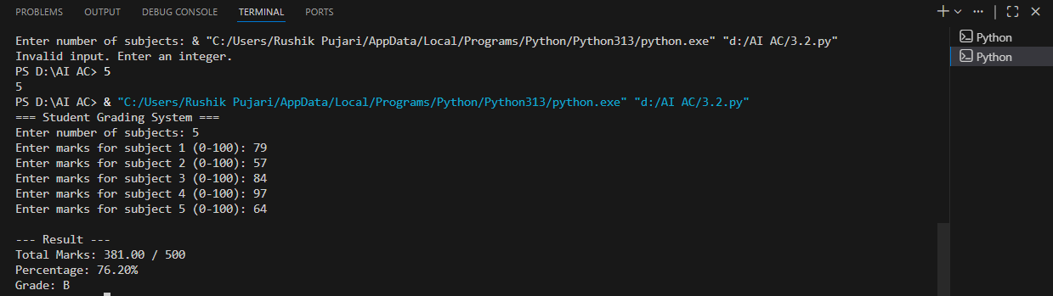
Task Description-5
Analyzing Prompt Specificity in Unit Conversion Functions: Improving a Unit Conversion Function (Kilometers to Miles and Miles to Kilometers) Using Clear Instructions.
Expected Output-5
Analysis of code quality and accuracy differences across multiple prompt variations.

Code:
