Name:P.Sravan
Roll:2303a52118
Lab 7:
Error Debugging with AI: Systematic approaches to
finding and fixing bugs
Lab Objectives:
Week4 -
Monday
• To identify and correct syntax, logic, and runtime errors in
Python programs using AI tools.
• To understand common programming bugs and AI-assisted
debugging suggestions.
• To evaluate how AI explains, detects, and fixes different
types of coding errors.
• To build confidence in using AI to perform structured
debugging practices.
Lab Outcomes (LOs):
After completing this lab, students will be able to:
• Use AI tools to detect and correct syntax, logic, and runtime
errors.
• Interpret AI-suggested bug fixes and explanations.
• Apply systematic debugging strategies supported by AI-
generated insights.
• Refactor buggy code using responsible and reliable
programming patterns.

Task Description #1 (Syntax Errors – Missing Parentheses in Print
Statement)
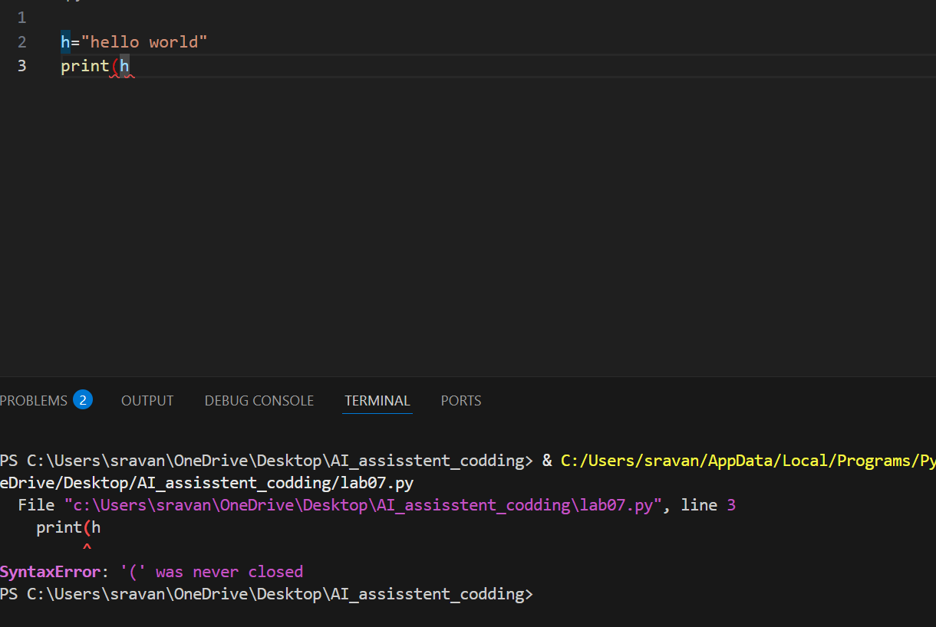
Task: Provide a Python snippet with a missing parenthesis in a print
statement (e.g., print "Hello"). Use AI to detect and fix the syntax
error.
# Bug: Missing parentheses in print statement
def greet():
print "Hello, AI Debugging Lab!"
greet()
Requirements:
• Run the given code to observe the error.
• Apply AI suggestions to correct the syntax.
• Use at least 3 assert test cases to confirm the corrected code
works.
Expected Output #1:
• Corrected code with proper syntax and AI explanation.
Task Description #2 (Incorrect condition in an If Statement)
Task: Supply a function where an if-condition mistakenly uses =
instead of ==. Let AI identify and fix the issue.
# Bug: Using assignment (=) instead of comparison (==)
def check_number(n):
if n = 10:
return "Ten"
else:
return "Not Ten"
Requirements:
• Ask AI to explain why this causes a bug.
• Correct the code and verify with 3 assert test cases.
Expected Output #2:
• Corrected code using == with explanation and successful test
execution.

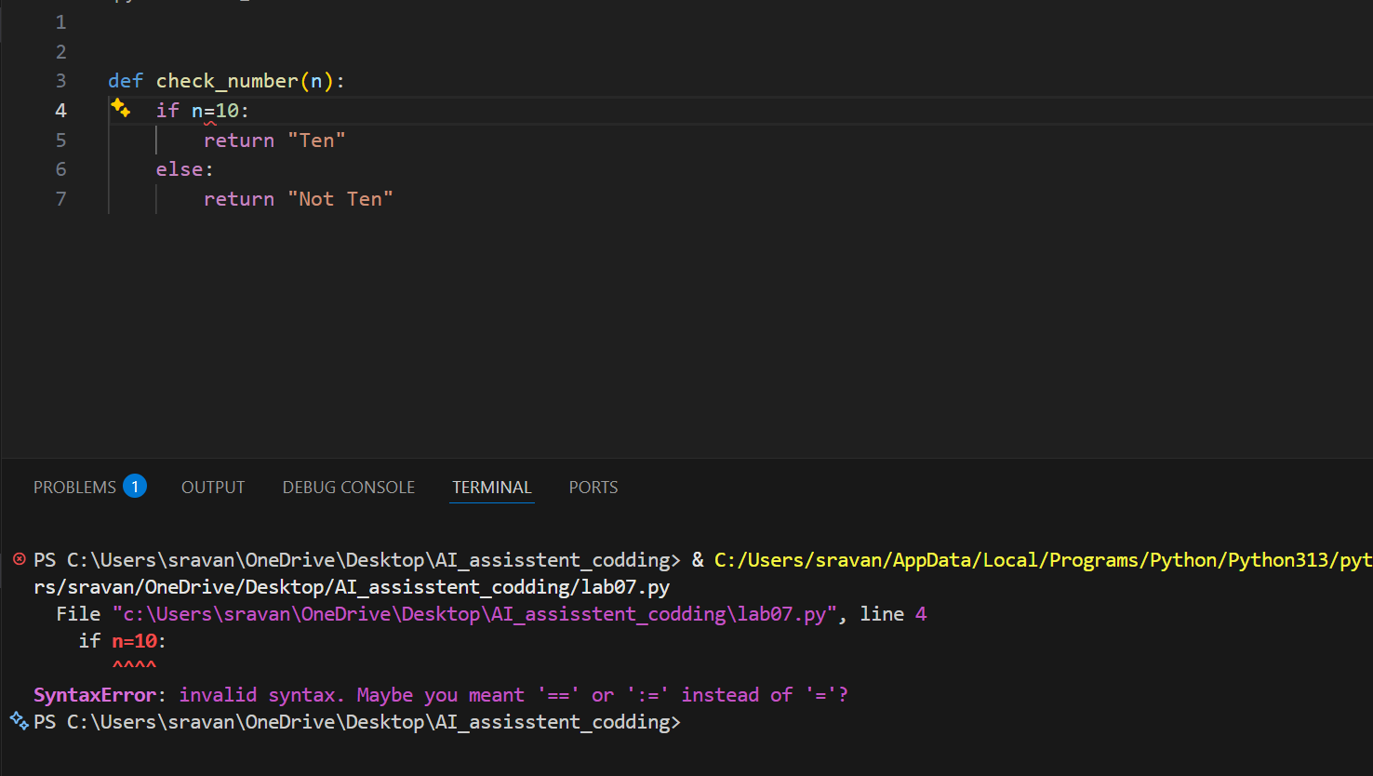
Task Description #3 (Runtime Error – File Not Found)
Task: Provide code that attempts to open a non-existent file and
crashes. Use AI to apply safe error handling.
# Bug: Program crashes if file is missing
def read_file(filename):
with open(filename, 'r') as f:
return f.read()
print(read_file("nonexistent.txt"))
Requirements:
• Implement a try-except block suggested by AI.
• Add a user-friendly error message.
• Test with at least 3 scenarios: file exists, file missing, invalid
path.
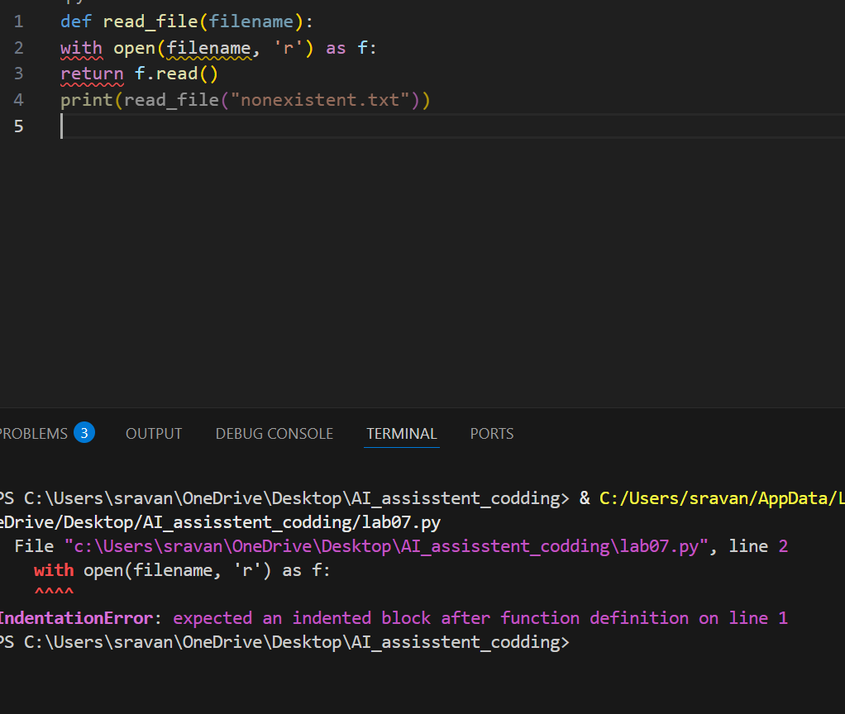
Expected Output #3:
• Safe file handling with exception management.
Task Description #4 (Calling a Non-Existent Method)
Task: Give a class where a non-existent method is called (e.g.,
obj.undefined_method()). Use AI to debug and fix.
# Bug: Calling an undefined method
class Car:
def start(self):
return "Car started"
my_car = Car()
print(my_car.drive()) # drive() is not defined
Requirements:
• Students must analyze whether to define the missing method
or correct the method call.
• Use 3 assert tests to confirm the corrected class works.
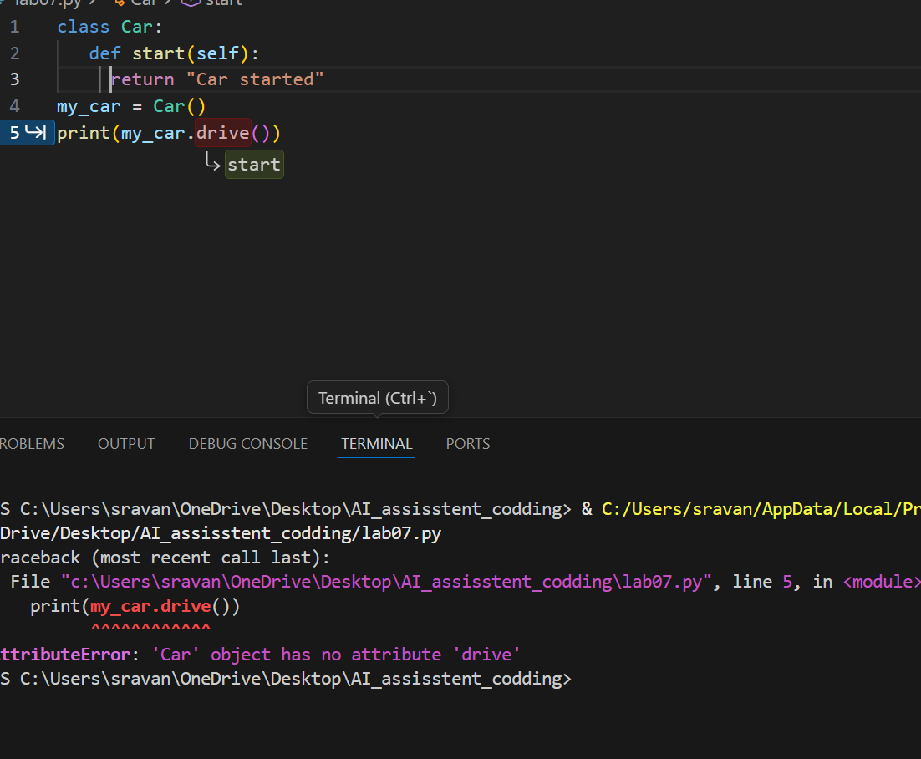
Expected Output #4:
• Corrected class with clear AI explanation.
Task Description #5 (TypeError – Mixing Strings and Integers in
Addition)
Task: Provide code that adds an integer and string ("5" + 2) causing
a TypeError. Use AI to resolve the bug.
# Bug: TypeError due to mixing string and integer
def add_five(value):
return value + 5
print(add_five("10"))
Requirements:
• Ask AI for two solutions: type casting and string
concatenation.
• Validate with 3 assert test cases.
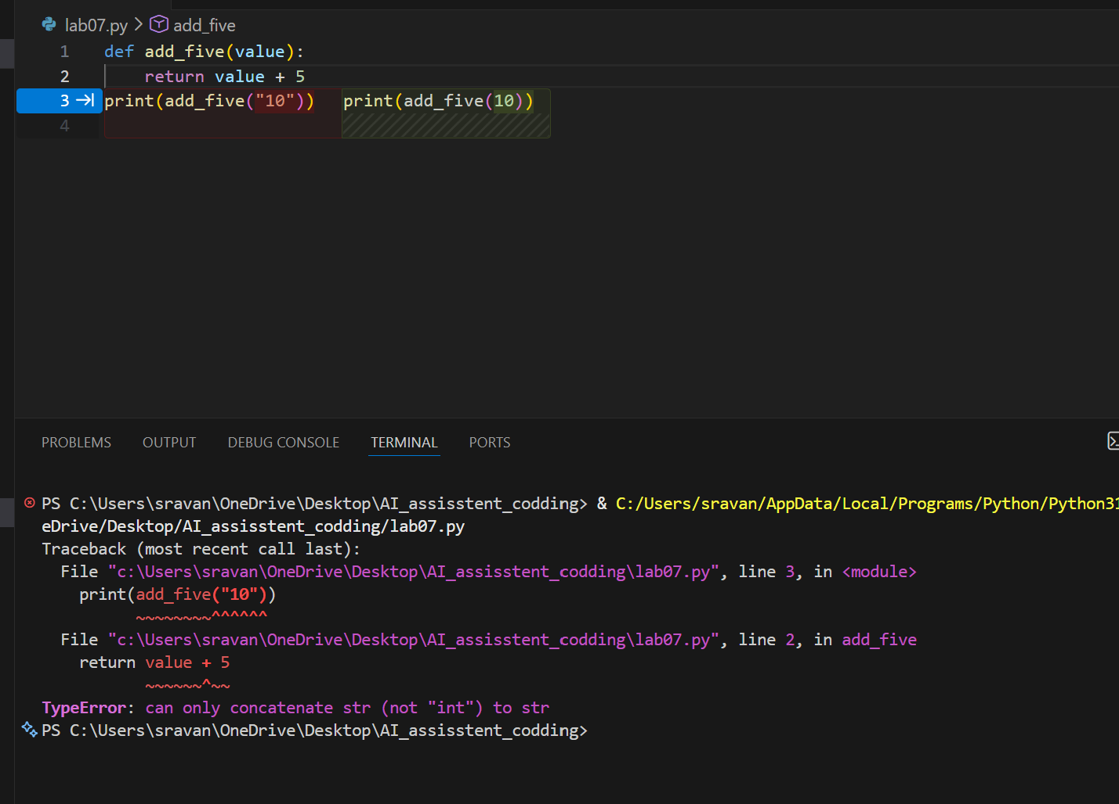
Expected Output #5:
• Corrected code that runs successfully for multiple inputs.
Note: Report should be submitted a word document for all tasks in a
single document with prompts, comments & code explanation, and
output and if required, screenshots

